Short term plan
Lesson plan
Long-term plan: Unit 9 Holiday  Transport |  |  | School: Secondary school after T.Zharokov
Date: |  |  | Teacher name: Ibraemova.S.E
Grade: 5 |  |  | Number present: | absent:
Lesson title: Transport
Learning objectives(s) that this lesson is contributing to |  | 5.L8 understand supported narratives, including some extended talk, on an increasing range of general and curricular topics  5.R4 read with some support a limited range of short fiction and non-fiction texts  5.C4 evaluate and respond constructively to feedback from others
Lesson objectives |  | All learners will be able to:  - name and define new words about transport  - read the text  Most learners will be able to:  - recognise and name some words according to the topic, follow the instruction according to the task  - read and answer the questions  Some learners will be able to:  - explain the features of types of transport and give them a full description  - can use information about their local area
Assessment criteria |  | - make paper airplane and learn the new words  - answer the questions from the text  - find a right sentences and circle the letters and will get necessary word  - solve the riddles and the crossword
Value links |  | Economic growth based on industrialization and innovation  (‘Mangilik Yel’ value 4)
Cross curricular links |  | Geography, Kazakh, music
ICT skills |  | Projector or Smart board for presenting videos, PPT
Previous learning |  | Activities
Plan
Planned timings | Planned activities |  |  |  | Resources
Start  8 min | (W) Greetings  – Hello my dear children! Say “hello” to each other. I’m glad to see you. Sit down please! How are you? Let’s start our lesson  - Brainstorming Activity 1  Divides students into 2-3 groups  Then students watch the video how to make paper airplane. After that teacher gives students some papers and they do paper airplane.  - Get a sheet of paper  - Fold it in half, lengthwise  - Fold the top corners in to the center  - Fold the angled edge into the center  - Fold along the center line  - Fold down the two top flaps to make the wings  Then they release their paper airplanes  Teacher ask the students to guess the topic of the lesson.  – Yes, our new theme is “Transport”. I think it’s very interesting theme  Teacher shows new words from PPT and they repeat the words after by teacher. |  |  |  | Video  How to make paper airplane:  https://m.youtube.com/watch?v=V-rBmbBSGIA  papers  PPT
Middle  4 min  4 min  5 min  5 min  6 min  2 min | (W) Reading Activity 2  Pre-reading  Read, find and underline about transport words  Ahmed lives in Cairo. Every day at 9 am he goes to school with his dad by car. He likes looking at all the people going by. There are many people on the bus. He is happy that he doesn’t have to go to school by bus. He would like to go by bicycle, but it’s very dangerous. He sees a policeman on his motorcycle. Ahmed wants to be a policeman when he grows up. The traffic is very fast. Suddenly the car has stopped. Look! There’s a man on a horse in the middle of the road!  While-reading  Answer the questions:  - Where does Ahmed live?  - How does he go to school?  - Does he like to look at the people?  - Would he like to go to school by bus or by bicycle?  - Why doesn’t he go to school by bicycle?  - Whom does he see on a motorcycle?  - Is the traffic fast or slow?  - Why the car has stopped?  Post- reading  (G) Writing Activity 3  Students circle the letters near the sentence which are true.  T A through train is comfortable.  R You can’t travel by train without a ticket.  K Train is faster than plane.  A I can’t go to New York by train.  N Disneyland is very large. That’s why people travel there by train.  O Paris is in Russia.  S A train is more comfortable than a bicycle.  K There are 3 railway stations in Moscow.  P A bus is less expensive than a train  O Ride the bike more useful than by car  R Cars are very expensive.  D Bikes are expensive than cars  T The tram travels on rails.  KEY: TRANSPORT  Then students will get the necessary word. They are saying name this word.  (W) Speaking Activity 4  The teacher reads and the students solve riddle.  1. He follows you though remains on the place. (a track)  2. When it is driven, it goes; when it stops, it falls down. (a bicycle)  3. What is it that resembles a cart, but has no wheels, and leaves no tracks behind it? (a boat)  4. We’re half a tram and half a bus;  Will you come and ride in us? (Trolleybuses)  5. This house on wheels is running a race,  Taking people from place to place. (a bus)  6. This wingless bird will soar, and soon  Land quite safely on the Moon. (a rocket)  7. Have a look at this fine steed.  He looks very strange, indeed:  Eats petrol, and never grazes,  Fast along the road he races. (motorcycle)  8. When I ride, I am all right.  When I stop, I flop. (a bicycle)  (W) Use of English Activity 5  Students one by one go to the board and solve a crossword horizontally and down  Across  3. A passenger bus with an electric motor that draws power from overhead wires (trolleybus)  7. Public transport provided by a line of railway cars coupled together and drawn by a locomotive (train)  8. A motor vehicle with two wheels and a strong frame. (motorcycle)  9. A car suitable for travelling over rough terrain. (jeep)  Down  1. A personal motor vehicle with four wheels; usually propelled by an internal combustion engine (car)  2. An electric railway operating below the surface of the ground (subway)  3. A car driven by a person whose job is to take passengers where they want to go in exchange for money. (taxi)  4. A large truck designed to carry heavy loads; usually without sides. (lorry)  5. An aircraft that has a fixed wing and is powered by propellers or jets. (airplane)  6. A wheeled vehicle that runs on rails and is propelled by electricity. (tram)  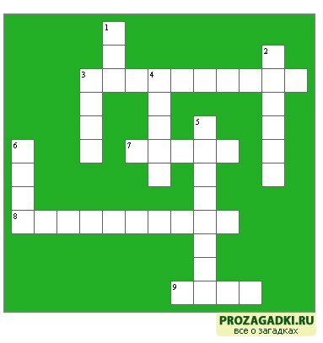  (W) Feedback Traffic lights Activity 7  Students have a set of traffic lights they can use these lights to indicate whether they fully understand (Green), or they may know this (yellow), and they don’t know this (red).  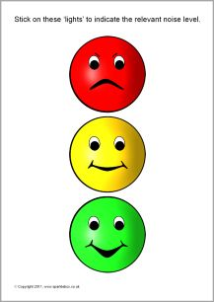 |  |  |  | Papers  PPT  cards  Smart board  cards
End  6 min | Evaluation Final Self-Assessment Tick ‘Yes’ or ‘No’ |  |  |  | cards
  Name | Very good | Good | Not very well
  I took part in…
  Vocabulary work
  Speaking about transports
  Work in groups
  Listening to the sentences
  Doing tasks (new words)
  Giving opinions about transport
  My score is…

