Short term plan
Long term plan unit: Music and film |  | School: 125
Date: |  | Teacher name: Seitkaliyeva Feruza
Grade: 9 |  | Number present: | Absent:
Theme of the lesson: Film genres around the world
Learning objectives (s) that this lesson is contributing to |  | 9.1.6.1 organise and present information clearly to others  9.4.4.1 read a wide range of extended fiction and non-fiction texts on familiar and unfamiliar  general and curricular topics  9.3.3.1 explain and justify their own and others’ point of view on a range of general and  curricular topics
Lesson objectives |  | All learners will be able to:  Define and express idea using specific basic information of the topic and apply the given vocabulary in their speech with support  Most learners will be able to:  Define and express idea using specific basic information of the topic and apply the given vocabulary in their speech with some support  Some learners will be able to:  Define and express idea using specific basic information of the topic and apply the given vocabulary in their speech without support
Assessment criteria |  | Modify and present information clearly to others.  Identify a wide range of extended fiction and non-fiction texts on familiar and unfamiliar general and curricular topics .  Illuminate and justify their own and others’ point of view on a range of general and curricular topics.
Value links |  | “The Patriot Act “ Mangilik Yel”  6th of value: Common history, culture and language.
Cross curricular links |  | Art, Geography, History
ICT skills |  | CD, IT board
Previous learning |  | Books and films: genres. Grade 8
Plan
Time | Planned activities |  |  | Resources
3min  2min  3min  7min  10min  8min  4min  3min | Organization moment  Teacher grеets students; studеnts rеspоnd to greeting and tаke their plаces.  The teacher dіvides the students into three subgroups using puzzles (pictures of movies “Star Wars”, “Spiderman”, “Sherlock Holmes”)  Brainstorming (Whole class)  The teacher asks following concept questions to elicit the topic of the lesson:  What do you see in the puzzles you’ve made?  ( films)  Are all the films in the same genres?  What genres of films do you know?  How do you think, what will our lesson will be about?  Differentiation by support: less able learners work with teacher’s support  Formative assessment: Teacher assesses students by using oral lаnguage аssessment. E.g. “Wеll dоne!”, “Great!”  Vocabulary (whole class)  The students match the genres with the pictures.  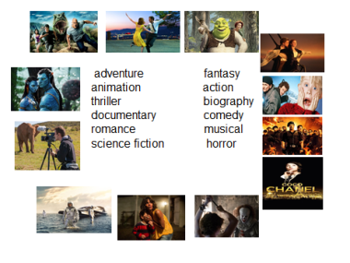  Differentiation by support: Teacher gives support where they need it by saying the words and asking them to repeat.  Formative assessment: The teacher assesses the students using his/her big thumb.  What genre is this? (group work)  Groups should find out what genre is it  The teacher gives this task in different ways in each group  1-group. Match the given genres of films with the definitions.  2-group. Shows the given genres of films with mimes.  3-group. Says films of the given genres of films.  Differentiation by learning style:  Teacher lets students demonstrate their understanding of content in a variety ways of displaying  Formative assessment: (Group assessment)  Students assess the groups by clapping their hands.   Pre-reading (individual work)  The teacher asks the students to look at the picture and the title and then elicit what type of film it is.  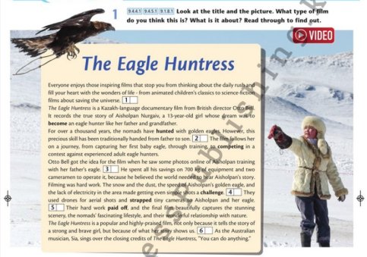  Jigsaw reading (group work)  The teacher divides the paragraphs into each groups. They read and choose from the sentences (A-G) the one that fits to the given gap (1-6). Then listen and check  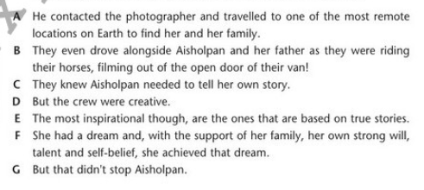  Differentiation by complexity of task: when the teacher makes sure that learners are confident of pronouncing the phrase, he/she may increase or decrease the level of difficulty using emotional drilling.  Formative assessment: The teacher assesses the students with cinema tickets.    Quiz your classmate (group work)  The teacher asks each group to make up two questions what they read and write them on the paper. After that they pass their paper to the next group. Groups answer the questions.  Descriptor  - make correct questions  - respond correct answers  Formative assessment: (Group assessment)  Students share their opinions if the answers are correct or not by putting their thumbs up/down and explaining the reasons using simple language  “One minute conversation”(pair work)    - Students stand opposite to each other in one line and talk about the films and genres they prefer. While the students are all occupied with their partners, the teacher can walk around and observe.  Descriptor  - express ideas in a given time  express thoughts clearly and briefly  Home task. Make up a short dialogue using the ideas of the lesson.  Feedback “ Five fingers”  Learners should write on these fingers  - Today’s topic  - Something I already knew  - Something I learned today  - A question I can now answer  - What I still need to learn   |  |  | puzzles with  pictures of movies  https://pbs.twimg.com/media/EAPZWEvXsAAPJaS.jpg:large  https://playboyrussia.com/upload/medialibrary/91f/91f4b949096a121269b277f905b71681.jpg  https://cdn.hiptoro.com/wp-content/uploads/2020/01/Shrek-5-Release-Date-announced-Production-and-Filming-for-Shrek-Reboot-to-Start-Soon.jpg  https://s2.best-wallpaper.net/wallpaper/2560x1920/1206/2012-The-Expendables-2_2560x1920.jpg  https://www.film.ru/sites/default/files/movies/frames/8102068-979076.jpg  https://image.tmdb.org/t/p/w600_and_h900_bestv2/dQNUOY1QSHoDRDem3d11Q9OoNCn.jpg  https://s3-eu-west-1.amazonaws.com/uploads.playbaamboozle.com/uploads/images/12453/1585908770_108651  https://wpcluster.dctdigital.com/eveningexpress/wp-content/uploads/sites/10/2017/10/Home-Alone-home-alone-31423371-1876-1027.jpg  https://www.envedette.ca/image/policy:1.1594013:1547716486/Titanic.jpg?w=2048&$p$w=f38b512  https://get.wallhere.com/photo/sea-water-futuristic-vehicle-movies-science-fiction-spacesuit-Interstellar-movie-Matthew-McConaughey-2880x1800-px-extreme-sport-631937.jpg  https://cdn1.thr.com/sites/default/files/imagecache/1350x760/2016/08/la_la_land_still.jpg  https://forexdengi.com/attachment.php?attachmentid=3230114&d=1575048666  https://i.ytimg.com/vi/Jblg4WVuuVI/maxresdefault.jpg  Excel SB p.76  Excel SB p.76  CD  https://st2.depositphotos.com/1818950/6461/i/950/depositphotos_64617275-stock-photo-cinema-ticket.jpg  https://fsd.kopilkaurokov.ru/uploads/user_file_58175f9e731e0/img_user_file_58175f9e731e0_13.jpg  http://cdn.onlinewebfonts.com/svg/download_324413.png
Additional information
Differentiation – how do you plan to give more support? How do you plan to challenge the more able learners? |  | Assessment – how are you planning to check learners’ learning? |  |  | Health and safety check
Brainstorming  Differentiation by support: less able learners work with teacher’s support  Vocabulary  Differentiation by support: Teacher gives support where they need it by saying the words and asking them to repeat.  What genre is this?  Differentiation by learning style:  Teacher lets students demonstrate their understanding of content in a variety ways of displaying  Jigsaw reading  Differentiation by complexity of task: when the teacher makes sure that learners are confident of pronouncing the phrase, he/she may increase or decrease the level of difficulty using emotional drilling.  Quiz your classmate  Descriptor  - make correct questions  - respond correct answers  “One minute conversation”  Descriptor  - express ideas in a given time  express thoughts clearly and briefly |  | Brainstorming  Formative assessment: Teacher assesses students by using oral lаnguage аssessment. E.g. “Wеll dоne!”, “Great!”  Vocabulary (whole class)  Formative assessment: The teacher assesses the students using his/her big thumb.  What genre is this?  Formative assessment: (Group assessment)  Students assess the groups by clapping their hands  Jigsaw reading  Formative assessment: The teacher assesses the students with cinema tickets.  Quiz your classmate  Formative assessment: (Group assessment)  Students share their opinions if the answers are correct or not by putting their thumbs up/down and explaining the reasons using simple language
Reflection
Were the lesson objectives/learning objectives realistic?
Did the learners achieve the LO?
If not, why?
Did my planned differentiation work well?
Did I stick to timings?
What changes did I make from my plan and why?

Summary evaluation
What two things went really well (consider both teaching and learning)?

1:

2:
What two things would have improved the lesson (consider both teaching and learning)?

1:

2:

What have I learned from this lesson about the class or achievements/ difficulties of individuals that will inform my next lesson?

