Short term plan

Lesson plan

Unit of a long term plan: |  |  |  |  | Our health
Date: |  |  |  |  | Teachername:Turapbai A.
CLASS: 6 |  |  |  |  | Numberpresent: |  |  | absent:
Lessontitle |  |  | Illnesses
Learning objectives(s) that this lesson is contributing to (link to the Subject programme) |  |  | 6.3.6.1- communicate meaning clearly at sentence and discourse level during pair, group and whole class exchanges;  6.4.5.1- deduce meaning from context on a limited range of familiar general and curricular topics, including some extended texts.
Levelofthinkingskills |  |  | High order level of thinking skill
Lessonobjectives |  |  | All learners will be able to :  - Describe pictures about healthy/unhealthy lifestyle, name the kinds of illnesses;  - Read the text and understand the content with support;
Most learners will be able to :
- Express their ideas in a group;
- Read and understand the text and do exercises with some mistakes;
Some learners will be able to :
- Express their idea in front of the class individually;
- Understand the text clearly and do exercises without mistakes.
Assessmentcriteria |  |  | - Interact in a pair, group and a whole class work presenting logically connected information with ideas of other people;  - Identify the meaning and details of the reading texts.
Valueslinks |  |  | From the bitterness of disease, man learns the sweetness of health.
Cross-curricularlinks |  |  | Biology
Previouslearning |  |  | Students know some kinds of disease and remedies.
Plan
Plannedtimings | Planned activities (replace the notes below with your planned activities) |  |  |  |  | Resources
Start  3min.  4min. | Organization moment.  Teacher greets students:  Good afternoon! Glad to see you!  How are you?  What date is it today?  What is the weather like today?  Warm-up  Task 1: “Picture prompt” Activity  There are some pictures on the blackboard.  Look at the pictures and answer the questions.  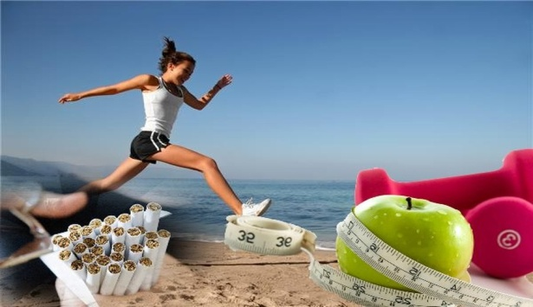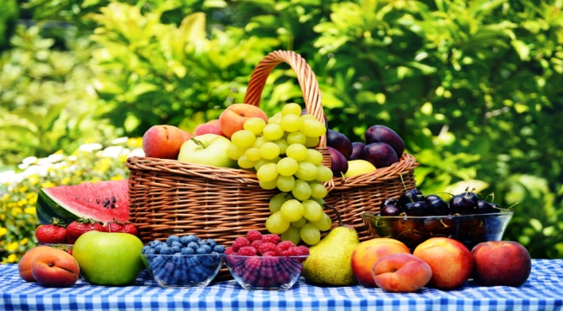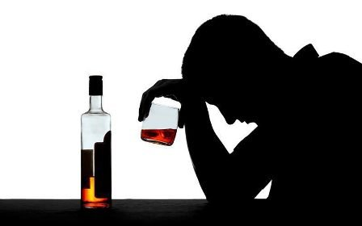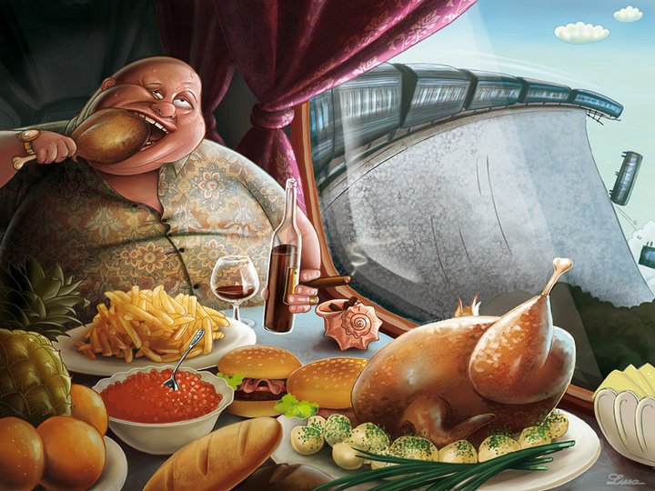  What do you see in these pictures?  What kind food is helpful forour health and which one is harmful?  How can we distinguish helpful with harmful? |  |  |  |  | Pictures
Middle  3min.  10min.  5min.  10min. | Pre-reading  W.Task2.“Basketball questioning”Activity  The teacher serves a question to a students who replies an answer for following questions:  Name the illnesses.  How can we cure ourselves?  While-reading  “Fill in” Activity  (I)Task 2. Read the text. Learners are going to work individually. They read the text and choose the correct answer:feel, runny, headache, got, sore, flu, medicine, better. To, stay, watch, great, fun, at.  1-whats the matter with you, Sam?  - I…… bad. I`ve got a …. .  - Have you … a cough?  – No, only a …. throat.  – Well, my dear. I think you’ve got…. . Stay in bed,, take …. And you`ll fell …. In a few days.  –Shall I go …. School tomorrow?  –No, you should… in bed for two or three days.  – It’s great. Tomorrow the olimpic games will begin and I can …sports from morning till night.  – Oh, you are a …. fan. Aren’t you?  –Yes, but I’m not just a …., I’m good …. football and basketball.  Differentiation by support: Less able students will be given the definition/translation of unknown words.  Descriptor: A learner  - Reads the text;  - Choses an appropriate answer.  AFL-Laminated paper  - Task 3. “True false”  Learners read the text again and match the true or false  - Sam has got a headache.  true  false  2. Sam should stay in bed for two or three days.  True  False  - The Olympicgames will start next week.  True  False  - Sam can do sports from morning till night.  True  False  - Sam is good at volleyball and swimming.  True  False  - Sam will feel better in a few days.  True  False  Descriptor  A learner:  - Reads the text again;  - Chooses the right answer.  AFL- True/False cards.  G.Task 4 “Ask for five” Activity  Students work in a small groups. Create a poster on the topic “Healthy habit”  Poster criteria:  Main information  Give recommendations why to do sports  Duration of the presentation is 2min.  When classmates are presenting a poster ask them questions on the content of the presentation.  Possible questions:  Why should we do sport?  What should we eat to keep fit?  What are the popular ways of keeping healthylifestyle in our country?  Differentiationby learning style:students will be given some pictures according to the topic  Descriptor A learner:  - Works in a group;  - Creates a poster on a topic;  - Uses topical pictures;  - Gives recommendations to do sports;  - Presentsposter in2 minutes;  - Asks questions and gives a responses to classmates questions;  Assesses classmate`s presentation using assessment list and gives feedback.  Peer assessment list  Criteria Yes No  Clearly explains the topic  Gives recommendations  Speaks for two minutes  AFL– group assessment |  |  |  |  | Pictures  https://zhansaija.com/task/2337739  Poster, markers, Assessment sheet
End  5min. | “5-5-1” Activity  Learners complete the lesson in 1 or 5 sentences. Speaks about what they have learnt.
Additional information
Differentiation – how do you plan to give more support? How do you plan to challenge the more able learners? |  |  |  | Assessment – how are you planning to check learners’ learning? |  |  | Healthandsafetycheck
Less able students will be given the definition/translation of unknown words.  Differentiation by learning style: students will be given some pictures according to the topic. |  |  |  | Individual checking  True/False cards  Peer assessment  5-5-1 |  |  | Observe safety precautions
Reflection  Were the lesson objectives/learning objectives realistic?  Did all the learners achieve the lesson objectives/ learning objectives? If not, why?  Did my planned differentiation work well?  Did I stick to timings?  What changes did I make from my plan and why? |  | Use the space below to reflect on your lesson. Answer the most relevant questions from the box on the left about your lesson.
Summary evaluation

What two things went really well (consider both teaching and learning)?

1:

2:

What two things would have improved the lesson (consider both teaching and learning)?

1:

2:

What have I learned from this lesson about the class or individuals that will inform my next lesson?

