Unit: Module 1 |  |  |  | School:Жамбыл ауданы Қайназар ауылындағы Қайназар № 1орта мектеп Бастауыш мектебімен КММ
Lesson Tiltle:Body parts |  |  |  | Teacher name: Bakytzhan Daniya
Grade : 3 |  | Date:16.05.2019 |  | Number present: 18 |  | absent:
Learning objectives(s) that this lesson is contributing to |  |  | 3.3.1.1recognise, identify and sound with support a limited range of familiar words in simple sentences  3.1.6.1 understand some specific information and detail of short, supported information or talk on a limited range of general and some curricular topics;  3.2.1.1 make basic statements which provide personal information on a limited range of general topics;
Lesson objectives |  |  | All learners will be able to:
To recognise keywords.
To translate keywords
To identify keywords.
 |  |  | Most learners will be able to:
To use keywords make basic statements.
To understand some specific information.
 |  |  | Some learners will be able to:
 |  |  | To ask question use keywords and about some specific information.
Language objectives |  |  | Key words: hair, legs, nose, head,hands, ears, mouth, eyes  Key phrases:I have got…. It has got ….  Questions:How we to be healthy?what we should do and shouldn’t do?
Assessment criteri |  |  | Should identify keywords,  Should use keywords make basic statements.  Should understand some specific information.
Value links |  |  | According to Mangilik el is community of history ,culture,and language.
Cross curricular links |  |  | Art
Previous learning |  |  | Learners know some nouns of body parts,and the phrase have got.
Plan
Planned timings | Planned activities (replace the notes below with your planned activities) |  |  |  | Resources
Start  5  minutes | - Greeting  - Revise new words from last lesson use snowflakes  - Devided class into tree groups by their favourite things. |  |  |  | snowflakes
Middle  25 minutes  5 minutes  5 minutes  5 minutes  10 minutes | Task 1  Exercise 4 at the page of 6 in student’s book  5 Listen, point and repeat. Then number.  hair 2  legs ____  nose ____  head ____  hands ____  ears ____  mouth ____  eyes ____  Skill:listening  Collaborative learning:Individual work  Activity:Matching  Actions:learners listen to the CD,point the words and match the keywords to the pictures.  Formative assessment:Teacher use red ,yellow,and green card to evaluate pupils.  Should identify keywords He/she can read keywords 1  He/she can translate keywords 1  He/she can match all words correctly. 1  3-green card  2-yellow card  1-red card  Differentiation All learners could: Could read keywords.  Most learners could:  Could translate keywords  Some learners:  Could match all words correctly  Task 2  Exercises 6 Rearrange the letters and write the words  At the page 6 in the pupil’s book.  Skill:writing  Collaborative learning :Group work  Activity :Ranking  Actions:There are pictures of objects and letters,learner ranking the letters of object’s name on a A4 paper with group.  Formative assessment:Group assessment(learners use red,yellow.green cards to evaluate each other )  Should identify keywords. He/she can read keywords 2  He she can rank all keywords correctly 2  4-green cards  3-yellow cards  2-red cards  Differentiation All learners could : Could recognise the objects  Most learners could:  Could read the keywords.  Some learners could:  Could rank all keywords correctly,  Task 3  Exercise 7 .Complete. Use have got or has got.  1 We have got green eyes.  2 Nurlybek _______________ big hands.  3 They ___________________ brown hair.  4 I _____________________ a small nose.  5 My sister __________________ red hair.  6 You _________________ a small head.  Skill:Writing and reading  Collaborative learning:Pair work  Activity: Magic box  Action:.There are exercises papers in the magic box,and learners should choose a paper in magic box to themselves,and do them.  Formative assessment :Pair assessment (learners use stiker to evaluate each other.)  Should understand specific information. He/she can understand main phrases.have got/has got. 1  He/she can use have got/has got 1  He/she can translate the sentences . 1  3-Sun  2-star  1-moon  Differentiation All learners could : could understand have/has got  Most learners could :  could use have got/has got  Some learners could:  could translate the sentences.  Task 4  learners draw an special monster on the poster  For example.It has three eyes,it has two mouth .then they should describe their monster.  Skill:speaking  Collaborative learning :Group work  Activity:Draw a picture  Actions:learners should creat a monster and draw it,then explain what they draw and describe their monster.  Formative assessment:Group assessment(learners use sun,star,moon to evaluate each group )  Should basic statement He/she can use keywords 1  He/she can use key phrases 1  He/she can describe project correctly. 2  He/she can draw a beautiful picture 1  5-4 sun  3-2 star  1-2 moon |  |  |  | Pupil’s book page 6  CD tack  Red,yellow,  green cards  Letters  A 4 papers  Pupil’s book page 7  Magic box  Exercises papers  Stikers  Poster  Colour pencils  The stiker sun,star,moon
10minutes  minutes | Reflection  By ask these questions  -Do you understand this lesson?  -What is difficult for you?  -Which strategies do you like?  Answer these questions and write the answer on the stikers then put the stikers on the traffic light. 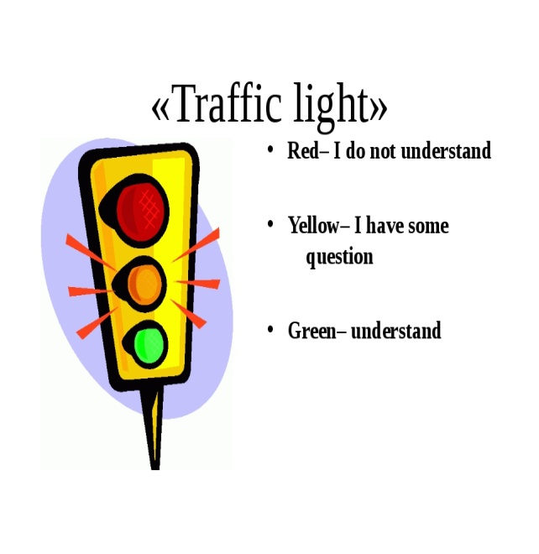 |  |  |  | Stikers and traffic light

Түйіндеме

Аты жөні:Курмангалиева Жулдыз Талгатовна

Туған күні, ай, жылы: 22.09.1987

Мекен –жайы: Алматы обл. Жамбыл ауданы Узынағаш ауылы Көкбастау 1

Білімі: Жоғары І. Жансүгіров атындағы Жетісу мемлекеттік университеті
Бастауыш сынып мұғалімі

Жалпы еңбек өтілі: 9 жыл

Біліктілік санаты: 1санат

Телефоны:87474161983 zhuldyz_kurmangalieva@mail.ru

Отбасы жағыдай: үйленбеген
Шет тілдер : Ағылшын сөздікпен орыс тілі еркін
Қосымша мәлімметтер: Басқарушылық қабілеті жақсы дамыған:

