Lesson plan

LESSON: Unit: 3 Entertainment and the Media  TV Programmes |  |  |  | School: Secondary school №6 , Shalkar
Date: |  |  |  | Teacher’s name: Abduldina Gulbakyt Terekbayevna
CLASS: 8  Time: 40 min |  |  |  | Number present: | absent:
Learning objectives(s) that this lesson is contributing to |  | 8.4.2.1 understand specific information and detail in texts on a growing range of familiar general and curricular topics, including some extended texts  8.3.3.1 give an opinion at discourse level on a wide range of general and curricular topics  8.5.3.1 write with moderate grammatical accuracy on a growing range of familiar general and curricular topics
Lesson objectives |  | All learners will be able to:
- define specific information on a limited range of general topics
- give basic personal information concerning TV Programmes
- write a short topic about TV Channels (CNN, BBC, Khabar)
 |  | Most learners will be able to:
- define specific information and details on some curricular topics
- give basic personal information and share with facts concerning TV Programmes
- write a detailed topic using dates about TV Channels (CNN, BBC, Khabar)
 |  | Some learners will be able to:
- define specific information and details in supported talk and some curricular topics
- give full information using dates, facts with samples concerning TV Programmes
- write a complicated topic using dates, facts about TV Channels (CNN, BBC, Khabar)
Assessment criteria |  | Students achieve the learning objectives if they are able to :  - Can define short supported information and details from the text  - Can give information and share facts on the theme  - Can write a topic about TV Channels
Previous learning |  | Names of the TV Programmes, channels
Plan
Planned timings | Planned activities |  |  |  |  | Resources
3 min  5 min  5min  10min  5 min  10 min  2 min | ORGANIZATIONAL MOMENT  Greeting  (W) Grouping by names of channels. Cards will be on the table upside down.After greeting T orders to divide into three groups.  1st group BBC  2nd group CNN  3rd group Khabar  INTRODUCING NEW MATERIAL  Brainstorming activity.  Lead-in. Speaking. S-T.  (W)FA T puts questions to make students to find the theme:  e.g. Do you watch TV?- Yes, we do  What kind of programmes do they watch?- They are sports programmes, cartoons, soap operas and etc.  What do they know about BBC, CNN, Khabar?  Have they ever watched these channels?  Do they have favourite TV program? Today’s lesson theme is “TV Programmes”  Word Game Domino  (FA) Ss read and match the words with their definitions. T distributes cards Ss find the definitions they are on the desk. S-S. CCQ (Should we play word game? Should we find the definitions?)  Documentary is a television or radio drama serial dealing typically with daily events in the lives of the same group of characters.  Soap opera is a motion picture that shapes and interprets factual material for purposes of education or entertainment.  Talent show is a broadcast entertainment programme in which people compete in a quiz, typically for prizes.  Quiz show is a competition or show consisting of performances by a series of amateur entertainers.  Sitcom is a television genre that presents food preparation, often in a restaurant kitchen or on a studio set, or at the host's personal home.  Cookery programme is a situation comedy.  Reality show is an event or series of events that happens outside the course of the protagonist's ordinary life, usually accompanied by danger, often by physical action.  Action/adventure series is a television programme in which ordinary people are continuously filmed, designed to be entertaining rather than informative.  Differentiation:  More able students read the cards , find out the new words and match these new words with their definitions and make up their own sentences.  Less able students only read the cards and find out the new words match these new words with their definitions ..  Pre-reading task: Anticipation guide  Anticipation guide. Before reading the text students put -; + signs guessing if these sentences right or wrong. Ss do only before reading part. CCQ (should you do only one part?) Ss check answers after reading the text.  Before reading Statements After reading  The BBC was founded in 1932. +  + The first broadcast was on the radio after the World War II.  The BBC is well known only in the UK +  The BBC only producers current affair programmes +  While reading task: Groups are given handouts to find dates, numbers, abbreviations, names of people. Answering what they mean in the text. Groups have to underline sentences with red pen, green ,blue pen and read them. S-text.CCG(should you underline the words? should you use red ,blue, green colours)  1st group 1932,100,1953  2nd group BBC,UK  3rd group Elizabeth II, World War II  What is the BBC?  The BBC was founded in 1922, almost 100 years ago, and it is the oldest national broadcaster in the world. Since then it has become a trusted news source for people everywhere and a symbol of national identity for British people. Broadcasting on radio, television and online, it is also the largest broadcaster in the world. Nowadays, BBC programmes are shown all over the world.  Unifying the nation.  The first BBC broadcasts were on the radio, but after World War II it started broadcasting on television. At the time, many people didn't think that television would ever become popular! But in 1953, thousands of families hurried to buy television sets to watch the live broadcast of the coronation of Queen Elizabeth II. This event, unified the whole nation and made the BBC an even stronger part of the British national identity.  BBC programmes  The BBC is well-known for its news reports and its current affairs programming, which help people keep up with what is happening both in the UK and abroad. However, the BBC is not just about the news. It also produces an exciting range of dramas, sitcoms and game shows as well as hundreds of educational documentaries, where viewers can learn about topics such as nature, music, sports and science.  G, F.A(peer assessment)Post- reading task:  Anticipation guide. Students do after reading task and check before reading task activity, compare answers. S-S.  Group assessment.  1st group gives answer paper to the group on the right and 2nd group to the 3rd group, 3rd group to the 1st group.  Hot Chair activity  Writing. S-S.7 min. Students in groups write a short topic about CNN, Khabar, BBC following the plan and using resources like internet. After finishing one student from each group seats on “Hot Chair” and presents groups writing.  1) When was it founded?  2) Do they broadcast all over the world?  3) What kind of interesting facts do you know?  Evaluation card  Organize ideas logically 1  Use a topic related vocabulary 1  Grammar accuracy 1  Gives additional information 1  total 4  Students’ reflection  W Students’ Feedback  Students answer the questions about the lesson. Writes on stickers |  |  |  |  | Cards        Word game Domino  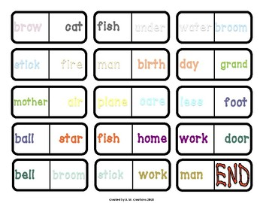  Verbal assessment  Good Job!  Well done!  https://www.bbc.co.uk/rd/about/history  Excel 8grade .  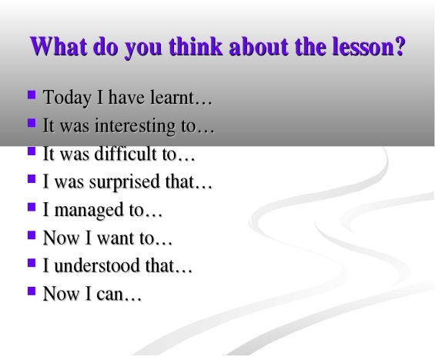
Additional information
Differentiation – how do you plan to give more support? How do you plan to challenge the more able learners? |  |  | Assessment – how are you planning to check learners’ learning? |  |  | Cross curricular links  ICT links  Value links
Using the method “Hot Chair Activity” |  |  | Teacher plans to check by students writing, by descriptors |  |  | History, ICT

