DEMO LESSON

LESSON: Unit 5: Creativity. |  |  |  | School: School-gymnasium №38
DATE: Time: |  |  |  | TEACHER: Bakirova Ainur Sansyzbaykizi
CLASS: 5th “A” grade Room: 34 |  |  |  | Number Present: 15 |  | Absent:x
The Theme of the Lesson: «FILMS and STORIES»

Learning objective(s) that this lesson is contributing to: |  | 5.L8 understand supported narratives, including some extended talk, on an increasing range of general and curricular topics  5.S1 provide basic information about themselves and others at sentence level on an increasing range of general topics  5.S8 recount basic stories and events on a range of general and curricular topics
Lesson objectives: |  | All learners will be able:  - To say their favourite kind of stories  - To write proper nouns with capital letters  Most learners will be able:  - To put the words in order correctly  - To say/write sentences grammatically correct  Some learners will be able:  - To recognize the legend by pictures
Language objective: |  | - Use vocabulary from the story to answer the questions.  - Make grammatically right sentences. (Word order; present and past tenses)
Assessment criteria: |  | - Peer assessment
Value links: |  | Remind about “Mangilik Yel” – “The Eternal Country (Land)- Strategy 2050” with the great future “path of Kazakhstan”. Listen/respect to the teacher and each other, take turn, encouraging and helping each other, cooperation.
Cross curricular links: |  | - Literature, history
ICT skills: |  | - PPT, YouTube, Active studio etc.
Previous learning |  | Leisure activities - Cinema
PLAN
Planned timings | Planned activities |  |  |  |  | Resources
Beginning  2 min  4 min | Organizational moment  - Greet learners. Have them take their places.  Learning and lesson objectives presentation  Task. Now I should divide the class into two groups. Each student will take a cup of popcorn. They should look for a ticket for cinema and say the type of film. Then they should sit to the group which film genre they’ll say .  1-st group "Legends"  2-nd group "Fairy tales"  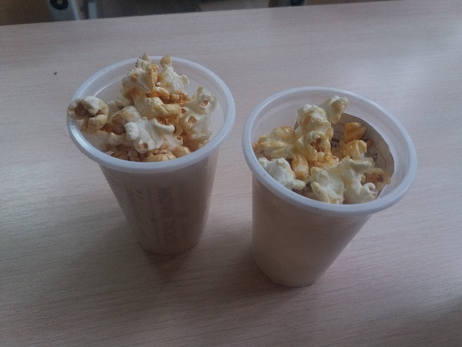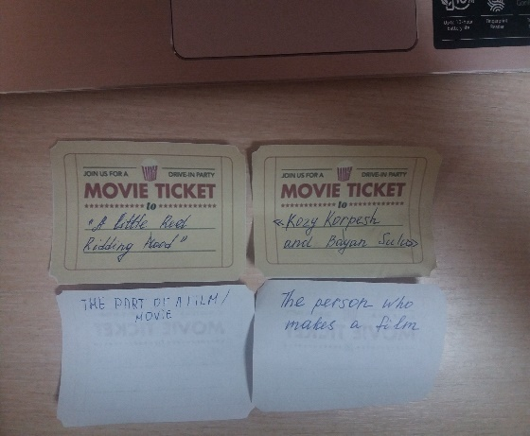  Warm-up: Task on the ticket: There is given the definition of the word connected on the previous learning. The students will give the meaning in one word.  Task. Match the types of film Students book page 100 exercise 1  1 A fantasy film a) is about wizards and magic  2. A horror film b) is about ghosts and monsters  3. A historical film c) has lots of knights and sword fights  4. An action film d) has lots of fights and car chases  5. A musical film e) has lots of dancing and singing  6. A science-fiction film f) has lots of aliens and spaceships  7. A romance film g) has a boy and girl falling in love  8. A comedy film h) makes people laugh |  |  |  |  | PowerPoint Presentation  Cups of popcorn with tickets  Board, book  Students Book p100, exercise#1
Middle  3-4 min  1 min  5min  4min  5min  5min  10min | Task. Listening the stories. For each group will bе given their own story. They listen and watch videos.  1-st group "Legends" – “Goldilocks and the tree bears.”  2-nd group "Fairy tales" – “Little red riding hood”  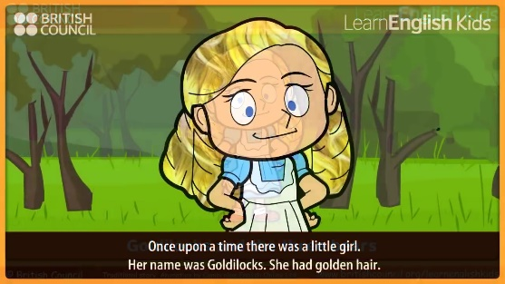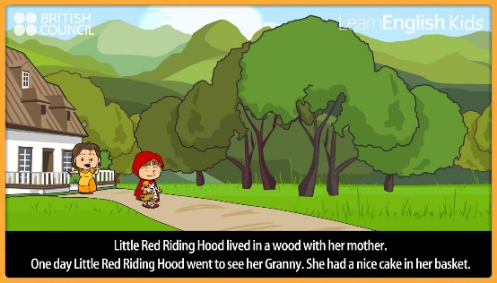  Differentiation by the task: For leasable students will be given worksheets with the written text of the story.  “Goldilocks and the tree bears.”  Once upon a time there was a little girl. Her name was Goldilocks. She had golden hair. One day Goldilocks was walking in the forest. She saw a house and knocked on the door. She went inside. Nobody was there. Goldilocks saw three bowls on the table. She was hungry. “This porridge is to hot!” “This porridge is too cold!” “This porridge is just right!” Goldilocks ate all the porridge.  Goldilocks was tired now. “This chair is too big!” “This chair is too big , too!” “This chair is just right!” But the chair broke! Goldilocks was very tired. She went upstairs. “This bed is too hard!” “This bed is too soft!” “This bed is too soft!” “This bed is just right!”  Soon, the bears came home. “Someone`s been eating my porridge!” said Daddy Bear. “Someone`s been eating my porridge!” said Mummy Bear. “Someone`s been eating my porridge – and it`s all gone!” said Baby Bear.  “Someone`s been sitting on my chair!” said Daddy Bear. “Someone`s been sitting on my chair!” said Mummy Bear. “Someone`s been sitting on my chair-and it`s broken!” said Baby Bear. “Someone`s been sleeping in my bed!” said Daddy Bear. “Someone`s been sleeping in my bed!” said Daddy Bear. “Someone`s been sleeping in my bed – and she`s still there!” said Baby Bear.  Goldilocks woke up and saw the three bears. “Help!” She ran downstairs and into the forest. She never came back again.  “Little red riding hood”  Little Red Riding Hood lived in a wood with her mother. One day Little Red Riding Hood went to see her Granny. She had nice cake in her basket. On her way Little Red Riding Hood met a wolf. “Hello!” said the wolf. “Where are you going?” “I`m going to see my Granny. She lives in a house behind those trees.”  The wolf ran to Granny`s house, and ate Granny up. He got into Granny`s bed. A later, Little Red Riding Hood reached the house. She looked at the wolf. “Granny, what big eyes you have!” “All the better to see you with!” said the wolf. “Granny, what big ears you have!” “All the better to hear you with!” said the wolf. “Granny, what big nose you have!” “All the better to smell you with!” said the wolf. “Granny, what big teeth you have!” “All the better to smell you with!” shouted the wolf.  A Woodcutter was in the wood. He heard a loud scream, and ran to the house. The woodcutter hit the wolf over the head. The wolf opened his mouth wide and shouted – and Granny jumped out. The wolf ran away, and Little Red Riding Hood never saw the wolf again.  Physical-training: Ramsamsam    Task. Individual work. Strategy “Cubism”. There will be given a cubic for each group with pictures, words and word phrases on its sides. The task is to translation of the giving word or phrase.  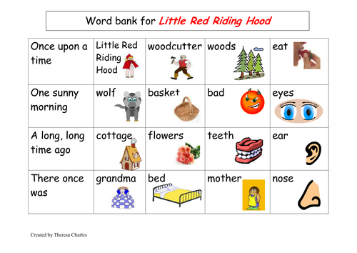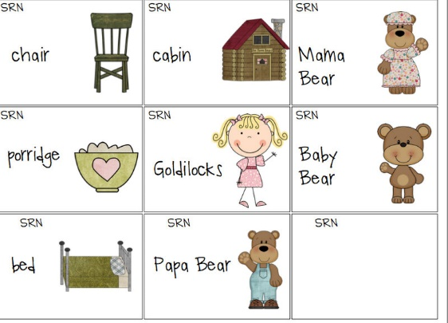  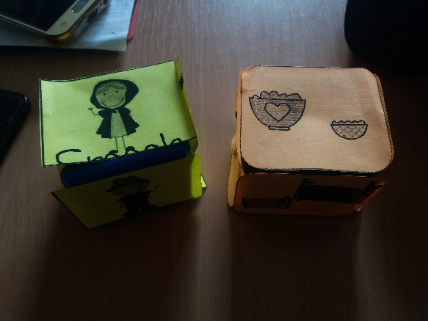  Task. Group work. Strategy “Block words”. Grammar theme Past Simple.  Both groups will have blocks with words. They should make sentences with them.  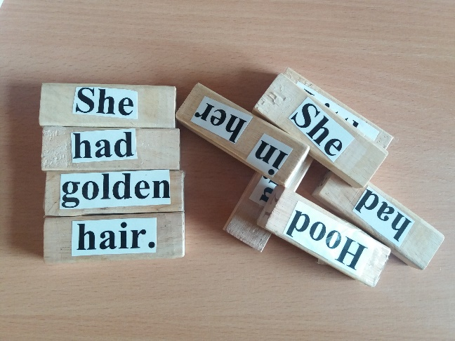  Task. Describe the characters.  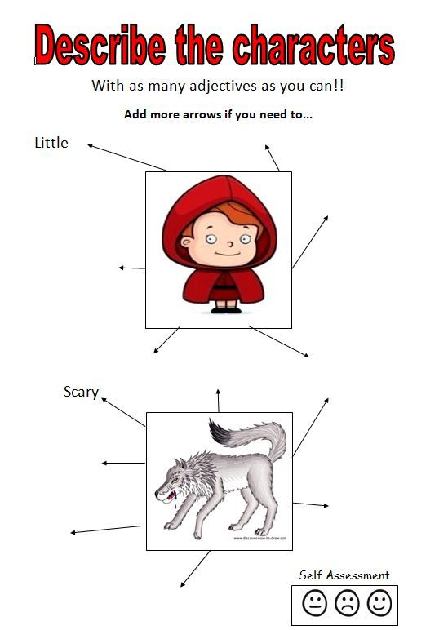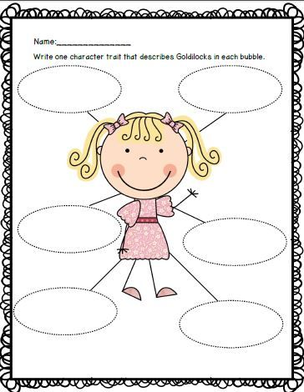  Task. Pair work. Strategy “Nomination question cards”. Each learner will take one card with direction on one side and question on the other side. They`ll ask and answer the questions.  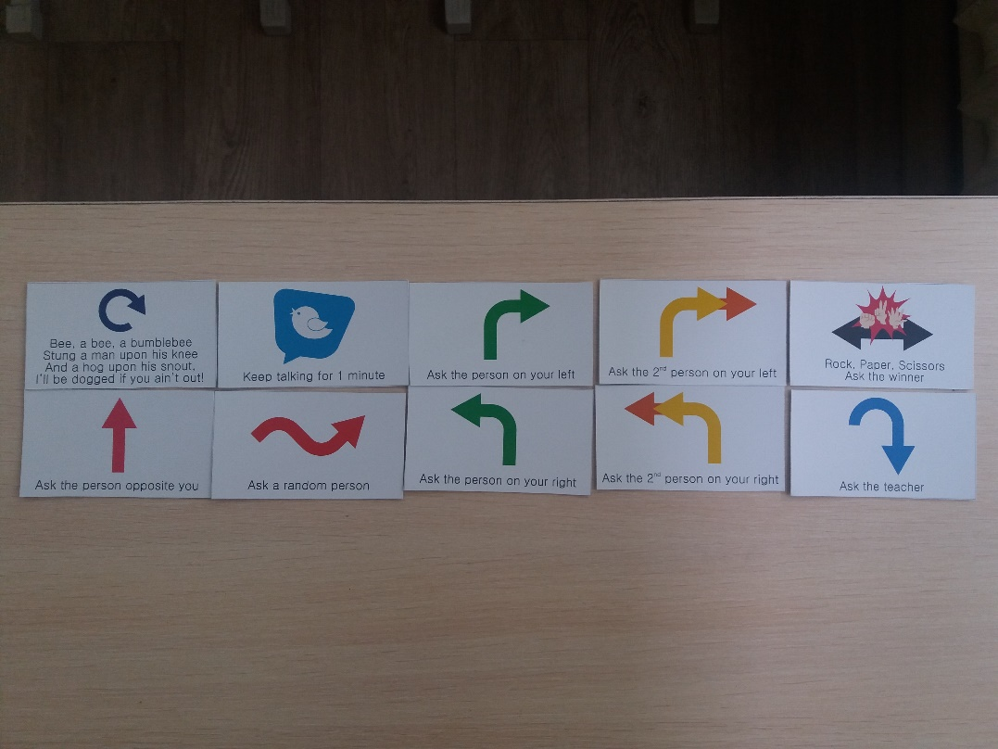  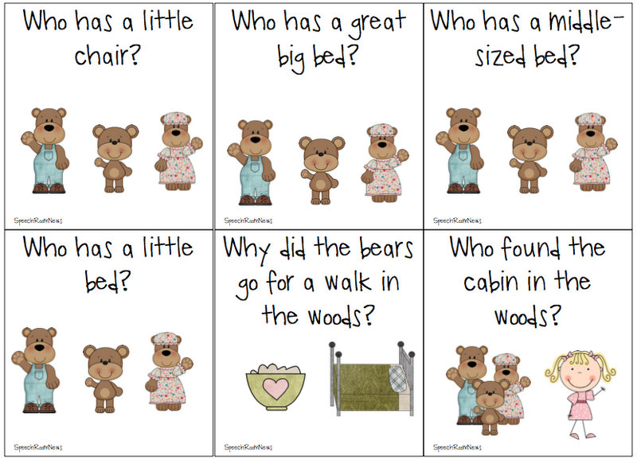  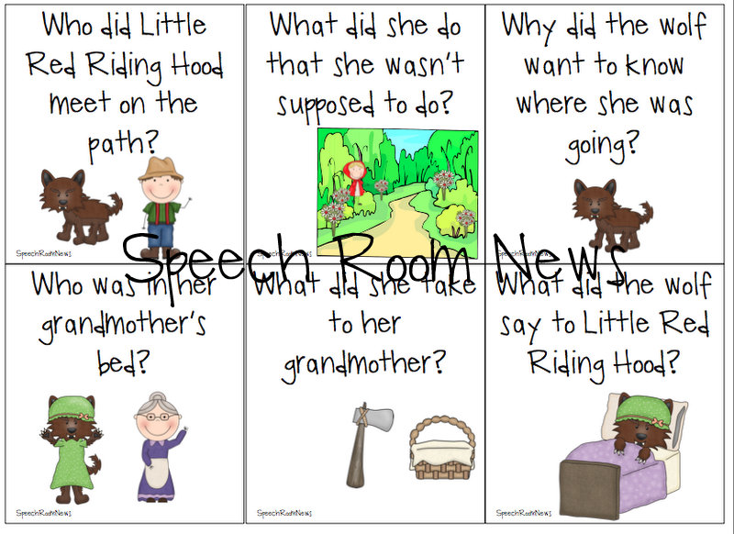  Task. “Five Finger Retell Reading” Strategy. Now they remember. The students will recall the five key elements of a story. The five key elements of a story are the settings, characters, problems, events and solution.  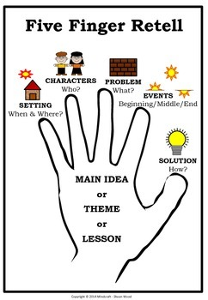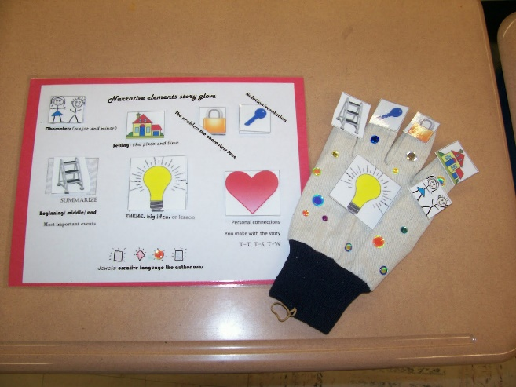 |  |  |  |  | https://youtu.be/bNcUelwmC20  https://youtu.be/GbzMC6qAzVU  laptops  worksheets  https://youtu.be/ZcqmtMwPrzM  Cubs  Blocks  Posters  Cards  Gloves
End | Reflection: “Mausoleum of Khoja Ahmed Yasawi”  Homework: To make “a project work”
Additional information
DIFFERENTIATION – how do you plan to give more support? How do you plan to challenge the more able learners? |  |  | ASSESSMENT – how are you planning to check learners’ learning? |  | Cross-curricular links
- More support can be given at the start and in middle of lesson by providing less-able learners with story vocabulary in a word list so they can read examples of words seen or heard.  - Less –abled students are given cards with gaps to discuss their favourite kind of stories |  |  | - Monitor learners as they read the story and groups of learners as they agree on discussion. Do they take turns to speak? Do they contribute appropriate language for discussion |  | - Russian literature  - Kazakh literature  - History  - All handouts prepared by teacher no need to cut
Reflection  Were the lesson objectives/learning objectives realistic?  What did the learners learn today?  What was the learning atmosphere like?  Did my planned differentiation work well?  Did I stick to timings? What changes did I make from my plan and why? | Use the space below to reflect on your lesson. Answer the most relevant questions from the box on the left about your lesson.  The lesson objectives were realistic.  Learners learned to pronounce sounds right and made grammatically correct sentence.  Atmosphere were friendly and respectful.
Summary evaluation

What two things went really well (consider both teaching and learning)?

1:

2:

What two things would have improved the lesson (consider both teaching and learning)?

1:

2:

What have I learned from this lesson about the class or individuals that will inform my next lesson?

