Short-term plan
Lesson plan
Long-term plan: Unit 7 Travel and Transport |  |  |  | School : Secondary school №
Date: |  |  |  | Teacher name:
Grade: 8 |  |  |  | Number present: |  | absent:
Lesson title: Island Destinations with a difference
Learning objectives |  | 8.1.5.1. use feedback to set personal learning objectives  8.3.3.1. give an opinion at discourse level on a wide range of general and curricular topics  8.4.1.1.understand the main points in texts on a growing range of unfamiliar general and curricular topics, including some extended texts  8.4.2.1.understand specific information and detail in texts on a growing range of familiar general and curricular topics, including some extended texts
Lesson objectives |  | Аll learners will be able to  - understand the main points of the topic  - apply phrases connected with theme  - answer the questions  - use feedback through the all skills  Most learners will be able to  - complete the map character and problem- solution chart  - give an opinion  Some learners will be able to  - research detail information about topic  - express their own ideas  - analyze and summarize all information
Assessment criteria |  | - understand the specific information  - explain the problem-solution and map character  - research the information about the island  - answer the questions  - make up the mind map
Value links |  | Recognition of culture in other countries, expansion of knowledge on the direction of country studies  Common history and culture and language (‘Mangilik Yel’, 6)
Cross curricular links |  | ICT, geography
ICT skills |  | Active board, internet
Previous learning |  | Travelling around the world
Plan
Planned timings | Planned activities |  |  |  |  |  | Resources
Start  2 min | (W) Brainstorming  - Modern life impossible without travelling. Almost all people are fond of travelling. It’s very interesting to see new places, another towns and countries. People may travel either for pleasure or on business. There are various methods of travelling. For me there is nothing like travel by air. It’s more comfortable and of course, far quicker than any other method  - Do you like travelling?  - Why do people travel?  Strategy “Why?”  Make up the diagram  Why?  (to know customs, traditions, to discover new places, to visit new places, to learn a language, to know the history, culture, to meet people, to make friends, to see sights)
Middle  1 min  5 min  5 min  5 min  5 min  5 min | (W,f) Pre-Reading  - Look at these photos and guess, what kind of place is it?  - An island  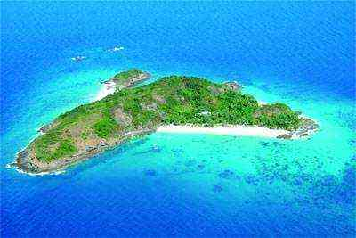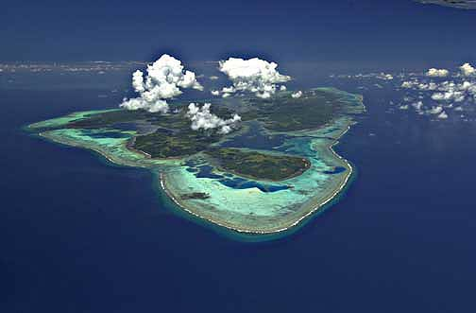  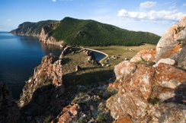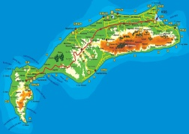  Descriptor  - guess the pictures  - say about island  - give an opinion  Assessment self assessment  So, we are going to read about islands. Teacher gives resources  Dividing into two groups by strategy “Counting” learners name the numbers 1 and 2  Number 1- the 1st group  Number 2 – the 2nd group  Differentiation by tasks and by resources  (G,f ) While – Reading  Group 1  Read the text and complete the chart  “Socotra Island”  The small island off the east coast of Japan has only around 100 human residents – but thousands of stray cats. In fact, the island’s nickname is Cat Island. In the 18th and 19th centuries, thousands of people lived there and raised silkworms to make silk for clothes. But mice were destroying these silkworm farms- so farmers brought in cats from the mainland to chase them away! When silk stopped being made there, most people left, but cats remained and their numbers exploded! Nowadays, the island’s fishermen feed the cats so that their furry friends bring them good luck at sea! Lots of tourists visit the island and you can stay there overnight in cat-shaped cabins! You can also take part in regular cat photo contests! There’s one important rule, though- visitors mustn’t bring their dogs!  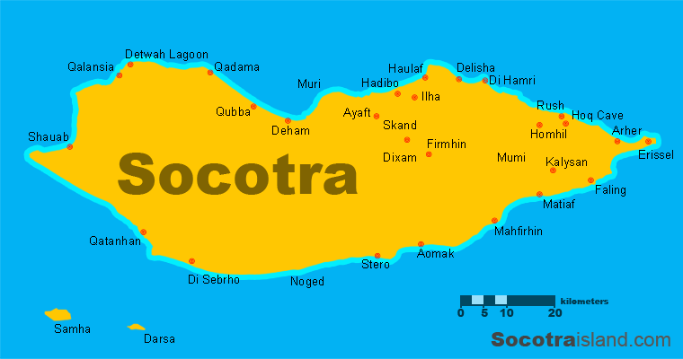  Strategy “Map the character”  Give traits and evidence of the traits  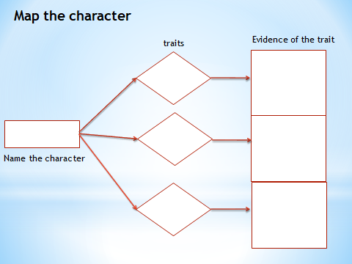  Descriptor  - read the text  - complete the map character  - give traits and evidence of the traits  Group 2  Read the text and complete the chart  “Tashirojima Island”  If you’re looking for somewhere unlike anywhere in the world, make for Socotra Island off the coast of Yemen. When you arrive, you might think that you’ve landed on an alien planet. It’s definitely a place where you could make a sci-fi film. Unlike most islands, Socotra hasn’t been connected to a continent for about 18 million years – so its wildlife developed on its own. This means it has plants and animals that you can’t find anywhere else on Earth! In the 1990s, a team of UN biologists discovered 825 plant species there and 37% of them are only found on Socotra. Many of them look very strange! For example, the dragon’s blood tree looks like an inside-out umbrella, and the bottle tree looks like a flower in a thick vase! Also, Socotra has a lot of unique species of birds and reptiles. It’s hard to get to Socotra, and you have to start planning a long time before your trip, but everyone should to see this fairy tale island.  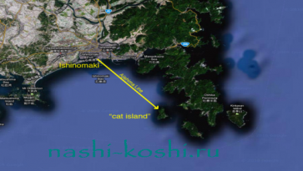  Strategy “Problem – Solution Chart”  Complete problem- solution chart, guess what’s the problem and give solution tried and results  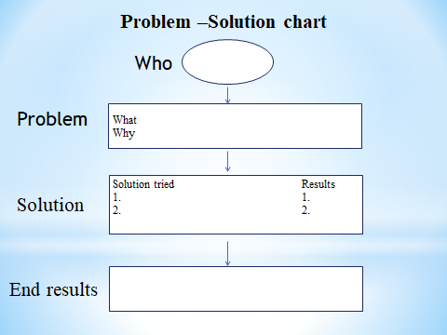  Descriptor  - read the text  - complete problem- solution chart  - guess what’s the problem  - give solution tried and results  Assessment observe another group (to give criteria to learners)  Differentiation by outcomes  (G,f) Post- Reading “Mind map”  Learners make up the mind map on the poster about two islands, after that they change their mind map. Pass your mind map the second group  1st group “Socotra Island”  2nd group “Tashirojima Island”  Descriptor  - make up the mind map about the island  - add more information from the internet  (I,f) Pre- Speaking “Favourite numbers”  Choose one of the number and answer the question  1 2 3  4 5 6  7 8 9  10 11 12  Questions  - Where is the Tashirojima Island? (on the east coast of Japan)  - What is the nickname of Tashirojima Island? (Cat Island)  - What did people raise in the 18th and 19th centuries? (silkworms)  - Who destroys silkworm farms? (Mice were destroying)  - Where is the Socotra Island? (in Yemen)  - What “landed on an alien planet” mean?  - Have the any plants and animals in Socotra? (yes)  - What’s the trees look like in Socotra? (Dragon’s blood tree looks like an inside-out umbrella)  - How many species of plants in Socotra? (Biologists discovered 825 plant species)  - Why is the wildlife of Socotra so different from anywhere else?  - Why did fisherman start bringing cats to Tashirojima Island?  - What is the important rule for visitors? (Mustn’t bring the dogs)  Descriptor  - choose your favourite number  - answer the question  (P,f) While- Speaking “Splendid questions”  Learners ask question to each other using the chart for the topic Travelling and Island  What Who Where Why When How Which  is  are  can  did  didn’t  could  has  have  must  mustn’t  can’t  Descriptor  - work in pears  - ask questions using the chart  Assessment teacher assesses learners orally (excellent, good, super, ok, etc.)  Differentiation by resources  (G,f) Post- Speaking  The 1st group  Teacher gives cards with phases  Sentences  - Socotra island of the … of Yemen. (coast)  - It’s definitely a place where you could make … (a sci-fi film)  - Socotra also called Soqotra, located between the … and … (Guardafui Channel, the Arabian Sea)  - The island of Socotra constitutes around … of the landmass of the Socotra archipelago (95%)  - The Island measures … in length and … in width (132km, 49,7 km)  - The island is very … , home to a high number of … species (isolated, endemic)  Descriptor  -complete the sentence with the words  The 2nd group  Teacher gives resources for retelling (pictures, maps, island)  Descriptor  - use the resources  - to retell the topic  Peer assessment |  |  |  |  |  | photos  Excel 8 grade, Express Publishing,  Virgina Evans Jenny Dooley, Bob Obee p. 82  Strategies  “Map the character” “Problem – Solution Chart”  Posters  The internet  Notebooks  Numbers  1-12  Questions  Chart  “Splendid questions”
End  2 min  5 min | (W,f) Conclusion  Strategy “5 Whs”  1. What have we spoken today?  2. What is the difference of between two islands?  3. Why is the wildlife of Socotra so different from anywhere else?  4. In what island people have a silkworm farm?  5. If you have a chance, which island will you choose? Why?  Feedback  Learners write a letter and post in the post box    Strategy “Letter”  - What have I learnt?  - What have I found easy?  - What have I found difficult?  - What do I want to know? |  |  |  |  |  | Post box
ADDITIONAL INFORMATION
Differentiation – how do you plan to give more support? How do you plan to challenge the more able learners? |  |  | Assessment – how are you planning to check learners’ learning? |  | Health and safety check
- While-Reading  Differentiation by tasks  In group’s students are in different levels, that’s why low level students have opportunity for support. High level students by creating their own ideas will help them and share ideas together, so they teach each other  Post-Reading  Differentiation by outcomes  High level students analyze and summarize all information by criteria  (G,f) Post- Speaking  Differentiation by resources  Teacher gives cards with phases and learners complete the sentences with words  In reading skill teacher gives resources to collect their ideas and thoughts |  |  | While – Reading  In group work learners observe another group (to give criteria to learners)  Pre-Reading  Teacher assesses learners orally. Excellent, good, super, ok, etc.  Give self assessment for whole learners

