Long-term plan unit:3 |  |  |  | School: named after G.Abdullin
Date:18.11-19.11.2020 |  |  |  | Teacher name: Zakharova Aikorkem Talgatovna
CLASS: 2 B |  |  |  | Number present: |  | absent:

Theme of the lesson:School Days(2)
Learning objectives(s) that this lesson is contributing to |  |  | 2.L3recognise with  support common names and names of places and the spoken form of a limited range of everyday and classroom words  2.L2 recognise with support a limited range of basic common personal questions spoken slowly and distinctly
Lesson objectives |  |  | Learners will be able to:
- recognise and write days of the week
- recognise and action verbs
- learn Hh, Ii, Jj, Kk, Ll, Mm letters
- listen and describe their days
Success criteria |  |  | Learners have met this learning objective 2.L.3, if they canindicate 5-7 words correctly
ICT skills |  |  | Smart board
Previous learning |  |  | School days (1)
Plan
Planned timings | Planned activities (replace the notes below with your planned activities) |  |  |  |  |  | Resources
Beginning | ORGANIZATIONAL MOMENT  Teacher: Hello, children!  Children: Hello, teacher!  CHECKING HOMEWORK  Let’s remember homework  - Monday-дүйсенбі  - Tuesday-сейсенбі  - Wednesday-сәрсенбі  - Thursday-бейсенбі  - Friday-жұма  - Saturday-сенбі  - Sunday-жексенбі  Repeat:Aa Bb Cc DdEe FF.  And start our lesson!  I. PRESENTATION NEW MATERIAL  1. We know some action verbs:  Help-көмектесу  Look-қарау  Read-оқу  Write-жазу  Play-ойнау  Run-жүгіру  Listen-тыңдау  Jupm-секіру  LISTENING  Learners recognize action verbs.  But we learn new action verbs:  Eat-жеу  Drink-ішу  Wait-күту  Work-жұмыс істеу  Painting- бояу  Drawing-суретсалу  Walk-серуендеу  Sleep-ұйықтау  Talk-сөйлесу  Think-ойлау  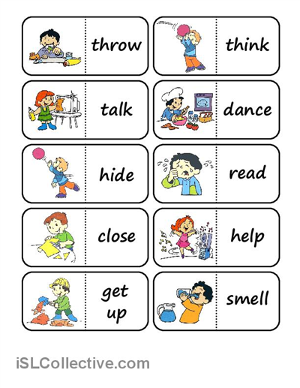  2. Today, we repeat: Gg Hh Ii Jj Kk Ll  - Trace the capital and small letters. Capital letters are big letters take a look at this: H-this is G big. Next is small g. Now you need to go ahead and fill the lines right out a remember to say it as you are writing Gg alright!  - Next is Hh. H capital H. This is a big H letter. Small h ha. Write it out and say it as you are writing Hh.  - I capital I I and then small i point your finger as you are reading i Ii.  - J capital J and small j jj. Go ahead and fill the lines writing and saying as you write.  - Big K then we have small k and go ahead and fill out line saying k kk.  - Write capital L this is a big letter L. Small letter l ll so go ahead and write out L. Repeat:GgHh Ii JjKkLl  II. PRACTICE:  Learners name simple verbs and week days.  1) Teacher: Now, work in pairs and tell your partner 3 things what you do on this and that day of the week. Your partner will tell us later about your activities. This table will help you to make your choice.  2) Teacher: I know that you are very busy, you attend different hobby and sport clubs during the week. Now let's have a look at the activities we may do.  (Have an English class, meet friends, go to the sport center, visit grandparents, go for a walk, and come home late).  So, try to fill in the timetable with the activities you do each day of the week. It will help you not to forget about them.  Pupils put actions cards on the corresponding blank field in the schedule.  Teacher demonstrates simple verbs.  - Sing an action song to demonstrate common verbs  - Look at the photos of Jim and Jill how they do different things on different days of the week. Use the example and makeup the sentences about yourself.  I play football on Monday.  Dance Thursday  Read books Tuesday  Sing songs Friday  Visit my friends Saturday  Have porridge Sunday  Run in the park Wednesday  Ride a bike  2. PHONETIC DRILLS  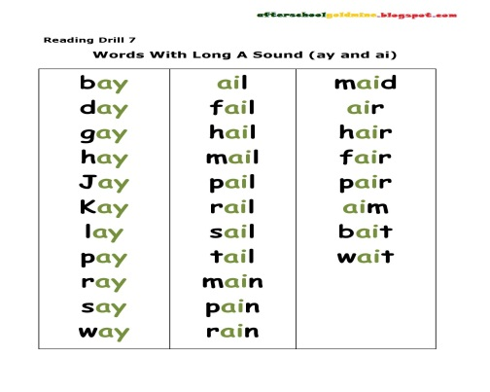  PHYSICAL TRAINING  Stand up, listen, look and mime.  Sunday, Monday  Clap, clap, clap.  Tuesday, Wednesday,  Step, step, step.  Thursday,  Hop.  Friday,  Stop.  Saturday,  Turn around, like a top.  Seven days are in a week.  Now, sit down or take a seat.  III. PRODUCTION:  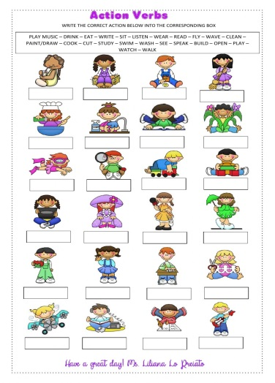  Write the correct action verbs below into the corresponding box.  WARMING UP  Teacher: Children sing a song “Action verbs”. |  |  |  |  |  | PPT  flashcards  PPT  flashcards  Worksheet 1  Worksheet2  PPT  Worksheets  Action song  https://www.youtube.com/watch?v=caZwVE4Ij5I
End | Reflection:  Have you like today’s lesson?  If you like show me   If you don’t like show me   Well what did we do in our lesson?  - Evaluation of the lesson  Give the home task. Learn the spelling of week days.
Additional information
Differentiation – how do you plan to give more support? How do you plan to challenge the more able learners? |  | Assessment – how are you planning to check learners’ learning? |  |  | Health and safety check  ICT links
- More support will be given to weaker learners by giving them a modified worksheets in some tasks with greater support |  | - Through formative assessment  - Through observation of the stage of practice |  |  | - Health promoting techniques  - Breaks and physical activities used.  - Points from Safety rules used at this lesson.  - Use video 10 minutes

