Lesson plan
LESSON: Unit 9. Sea Transport |  |  | School: Secondary school Sagiz
Date: |  |  | Teacher name: Tanbai Zhanserik  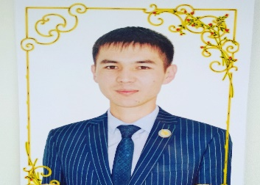
CLASS: 6 |  |  | Number present: |  |  | absent:
Learning objectives(s) that this lesson is contributing to (link to the Subject programme) |  | 6.S2. ask simple questions to get information about a growing range of general topics  6.L4 understand with limited support the main points of extended talk on a range of general and curricular topics  6.W3. write with some support about personal feelings and opinions on a limited range of familiar general and curricular topics  6.UE.8 use future form will to make offers, promises, and predictions on a growing range of familiar general and curricular topics
Lesson objectives |  | All learners will be able to:  - Listen and understand the main idea of the topic  - Make up and speak 2-3 question from the topic with a little support  - Recast and write 2-3 questions using future simple in their speech  - Write simple 2-3 sentences about Transport  Most learners will be able to:  - Listen and understand specific information and details of the topic  - Make up and speak 4-5 questions from the topic using new vocabulary  - Make up dialogue about transport using 4-5 sentences  Some learners will be able to:  - Make up and speak 6-7 question from the text with answer  - Write essay about the Transport using 6-7 sentences
Previous learning |  | Names of Transport, Words of action, Future simple.
Plan
Planned timings | Planned activities (replace the notes below with your planned activities) |  |  |  |  | Resources
Beginning  2min  4min  4min | (W)Lead-in:  Teacher greets the class and explains lesson objectives in a simplified form. The students collect the mosaic and are divided into 2 groups.  Brainstorming (G)  Look at the pictures and guess the theme of our lesson.  (W) Presentation of new vocabulary  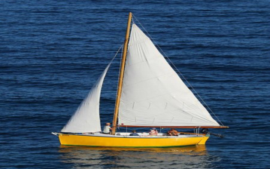  Oars Sails  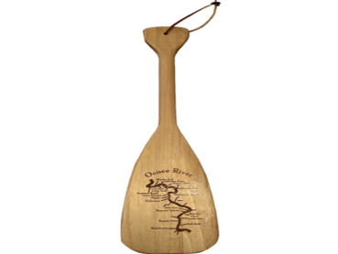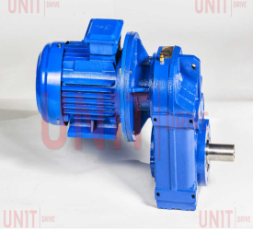  Paddles Motor  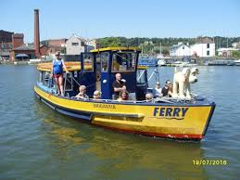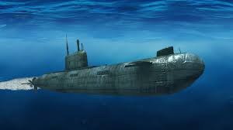  Ferry boat Submarine  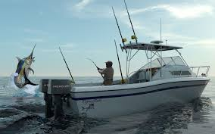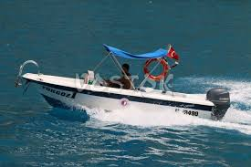  Fishing boat Speed booat  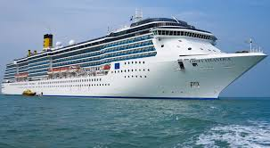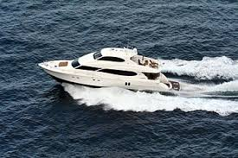  Cruise ship Yacht  Teacher Clarifies and announces the topic and objectives of the lesson. |  |  |  |  | PPP  PPP (slide-1)
Middle  4min  5min  4min  2min  5min  6min  End  4min | (W) Pre-listening: To show the fragment  Teacher asks questions about video  What about this text?  -What kinds of ships are they talked about?  First listening: (Topic about Sea Transport)  T. Answer the general questions  Teacher asks questions about video in detail understanding:  How many sea transport describing in the video?  Name sea transport ?  (W) Second listening  (G) True or False  1.This is a ferry boat.  2.This is a speed boat. This is big boat.  3.It’s maximum speed is 100 km per hour.  4.This is a submarine. It is the ship that can go underwater.  5.This is a yacht. It is the medium sized boat used for long journeys.  Key: T, F, F, T, T  Match the words with pictures  1.Ferry boat A  2.Submarine B  3.Fishing boat C  4.Speed boat D  5.Cruise ship E  6.Yacht F  (FA)   - (FA) Make up and speak 2-7 questions from the topic using new vocabulary by “6W questions” methods (Who, What, Why, When, Where, How).  Descriptors  1.Correct speak questions  2.Correct make up 1st question using “Who” question  3 Correct make up 2nd question using “What” question  4. Correct make up 3rd question using “Why” question  5. Correct make up 4th question using “When” question  6. Correct make up 5th question using “Where” question  7. Correct make up 7th question using “How” question  (P) Make up and write sentences, dialog, essay about Sea Transport.  Differentiation  All learners - make up and write 2-3 sentences about Sea Transport  Most learners make up and write dialog about Sea Transport  Some learners – write short essay about Sea Transport  Teacher’s oral feedback  Reflection. Learners reflect on their own actions at the lesson  Colour the ship - green if you like the lesson  Yellow if you have any questions  Red if you don’t like the lesson |  |  |  |  | hhts://youtu.be/t5FuWuCKbJU  hhts://youtu.be/t5FuWuCKbJU  hhts://youtu.be/t5FuWuCKbJU  PPT  hhts://youtu.be/t5FuWuCKbJU  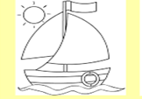
Additional information
Differentiation – how do you plan to give more support? How do you plan to challenge the more able learners? |  |  |  | Assessment – how are you planning to check learners’ learning? | Health and safety check
All - make up 2-3 questions  Most – make up 4-5 questions  Some – make up 6-7 questions |  |  |  | FA  Smile  Colour the ship  Hand signal | Geography

