Unit 7.2 Space and Earth |  |  |  | School: № 25
Date: |  |  |  | Teacher name:
Grade: 7 “B” |  |  |  | Number present: | absent:
Learning objectives(s) that this lesson is contributing to |  | 7.L3 Understand with some support most of the detail of an argument in extended talk on a limited range of general and curricular topics.  7.S5 Keep interaction with peers to negotiate, agree and organise priorities and plans for completing classroom tasks.
Lesson objectieves |  | All learners will be able to:
 |  | - identify the name of the planets
 |  | Most learners will be able to:
 |  | - complete listening correctly
 |  | Some learners will be able to:
- use taught information to vocabulary task
- use learnt vocabulary from the listening task while speaking in groups
Language objective |  | To review vocabulary
Value links |  | Respect
Cross curricular links |  | Astronomy
Previous learning |  | Prior knowledge from the previous lessons about the solar system
Use of ICT |  | Projector or Smart board to show a presentation
Intercultural awareness |  | Students will be able to understand what other nations do to investigate Space
Kazakh culture |  | Students will be able to understand what our country do to search Solar System
Pastoral Care |  | Students will be able to understand the importance of investigating of Solar System nowadays
Health and Safety |  | Everyday classroom precautions will ensure that safety measures are provided to prevent the exposure of electrical power cords
Planned timings | Planned activities |  |  |  |  |  | Resources
Start 2 min  2 min  3 min  3 min  7 min  10 min  10 min  3 min  2 min | - 1. Dive in:  T greets Ss, asks them to tell each other good wishes for the lesson.  Warm-up  T checks the vocabulary using the box with new words. Ss should read and translate all the words.  - 2. (W, I) Pre – Listening  T shows the video and asks Ss to predict the theme and the objectives of the lesson.  - 3. (P) Listening  Tell Ss that they will hear a formal debate about space exploration. Give each S a copy of the card. Explain that they must listen to the debate and complete the missing information in the card. When Ss  are ready, play the recording  Self-Assessment: When students have finished, T gives them right answers. Ss should put suitable cards with smiles to assess themselves.  - 4. Post-Listening  Grammar revising:  T pays Ss attention to the 5th paragraph of the text and elicits the time the author is describing in here: What is the author doing?  Ss answer: The author is predicting the future.  Ss revise the usage and form of will.  Then T gives worksheets with sentences with missed verbs. Ss should open the brackets and use Future Simple tense.  Self-Assessment: “Gymnastics” activity  - 5. (G) Feedback  T divides the class into three groups with a help of pictures of the planets. Tells the first group to make a poster with a help of pictures, the second group to complete the passport of the planet Mars and the third group to write a poem. When Ss are ready, groups explain their arguments  Assessment: Tick an assessement sheet on the blackboard.  - 6. (I) Plenary  T asks Ss to tell a reflection of the lesson. What do you feel?  I feel happy, because…  I feel good, because….  I feel sad, because…..  - 7. Hometask  T gives worksheets and asks Ss to find information about the other planets and fill the passport of these planets. Ss should do this task in pairs. |  |  |  |  |  | Vocabulary Worksheet  Listening Worksheet  Listening audio  
Additional information
Differentiation – how do you plan to give more support? How do you plan to challenge the more able learners? |  |  | Assessment – how are you planning to check learners’ learning? |  |  | Critical thinking
Differentiation by support  More support:  - Some questions are more difficult than others  - Allow thinking time.  More-able learners:  Encourage students to use previously learned vocabulary. |  |  | - The teacher will observe and guide the students helping with their questions. |  |  | Students try to express opinions
Summary evaluation
What two things went really well (consider both teaching and learning)?
1:
2:
What two things would have improved the lesson (consider both teaching and learning)?
1:
2:
What have I learned from the lesson about this class or individuals that will inform my next lesson?

Appendix 2 (Home task)
Task. Write information about the Earth you know. Write only key words.
The passport of the Earth | 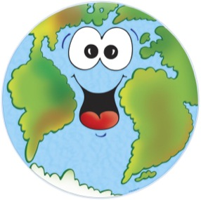  PASSPORT
Name: the Earth
Other name:
Address:
Weight:
Age:
Colour:
Closest neighbours:
Occupation:
Hobbies:

Task. Write information about the Uranus you know. Write only key words.
The passport of the Uranus | 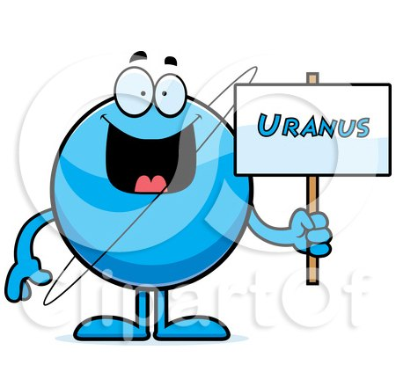  PASSPORT
Name: the Uranus
Other name:
Address:
Weight:
Age:
Colour:
Closest neighbours:
Occupation:
Hobbies:

Task. Write information about the Saturn you know. Write only key words.
The passport of the Saturn | 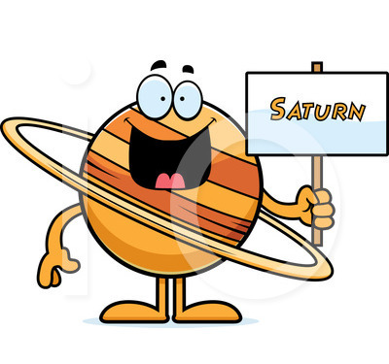  PASSPORT
Name: the Saturn
Other name:
Address:
Weight:
Age:
Colour:
Closest neighbours:
Occupation:
Hobbies:

Task. Write information about the Mercury you know. Write only key words.
The passport of the Earth | 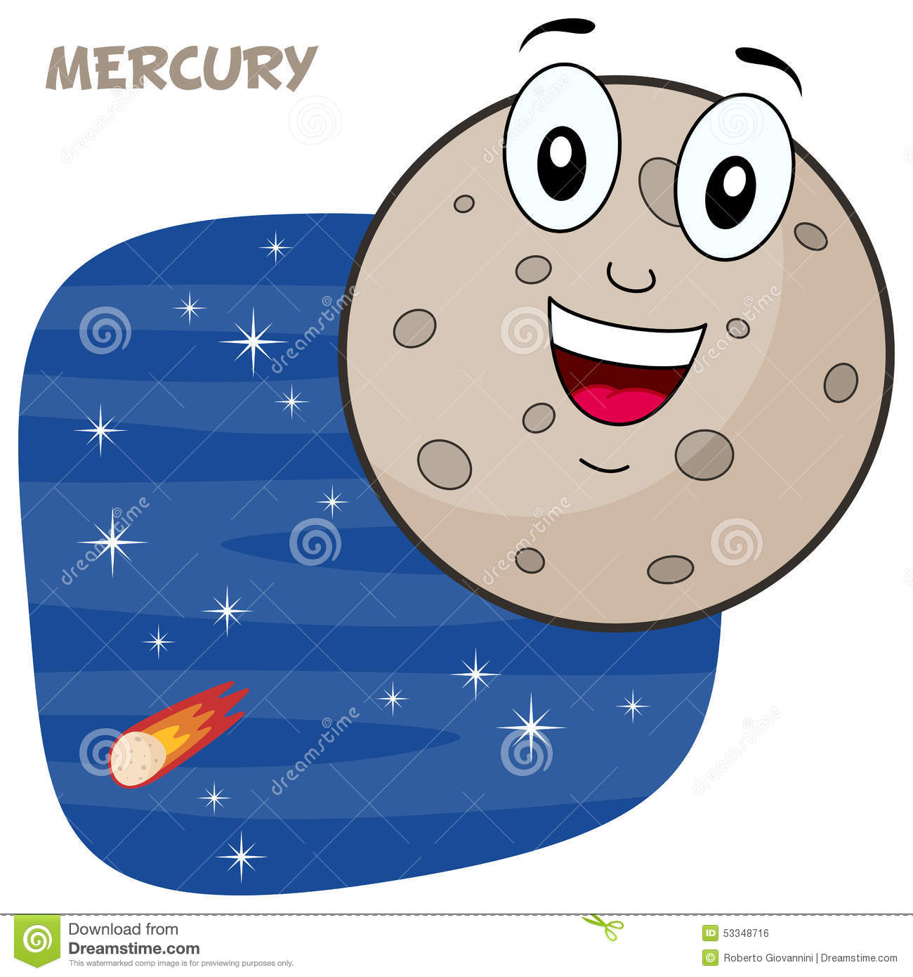  PASSPORT
Name: the Mercury
Other name:
Address:
Weight:
Age:
Colour:
Closest neighbours:
Occupation:
Hobbies:

Task. Write information about the Neptune you know. Write only key words.
The passport of the Neptune | 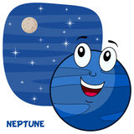  PASSPORT
Name: the Neptune
Other name:
Address:
Weight:
Age:
Colour:
Closest neighbours:
Occupation:
Hobbies:

Task. Write information about the Sun you know. Write only key words.
The passport of the Sun | 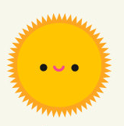PASSPORT
Name: the Sun
Other name:
Address:
Weight:
Age:
Colour:
Closest neighbours:
Occupation:
Hobbies:

MISSION TO MARS (Card)

Complete the missing information

A: Humans love to explore. We crossed oceans to discover new ________1. We explored the highest, coldest and most remote places on Earth. In 1961, Yuri Gagarin boarded Vostok 1 at Baikonur Cosmodrome and became the first person in space. Eight years later, Neil Armstrong was the first human to walk on the Moon. Now, we’re turning our attention to Mars as the next stop on our _________2 of exploration.
B: Why Mars? Well, firstly, it’s not too far. Apart from Venus, it’s our closest neighbor, so the journey will take months and not years. Temperatures on Venus are over 400°C so ________3 can’t go there, but on Mars the average temperature is about -63°C. Other planets like Jupiter and Saturn are big balls of ____4 with extremely strong winds, but Mars has a solid rocky surface.
C: We are learning more about Mars with the help of rovers. These are robots with ________5, and two American rovers, Opportunity and Curiosity, are already there. They are exploring and sending information to Earth for scientists to study. It’ll soon be like ______ _______6 on Mars as a European and Russian rover and a third American rover are going to join _______7 and ___________ 8 soon.

