Short term plan

Lesson plan

Unit: 5 Health and body |  |  | School: Multi-profile gymnasium named after Shakarim teaching in three language
Date: |  |  | Teacher name: Nauryzova G.D
CLASS: 2 «A» |  |  | Number  present:
Lesson title |  | Parts of the body
Learning objectives  that this lesson is contributing to (link to the Subject programme) |  | 2. S 3 use a limited range of basic words, phrases and short sentences to describe objects, activities and classroom routines  2.R1 read and spell out words for others
Lesson objectives |  | All learners will be able to:  - name parts of the body in a picture correctly  - remember and define parts of the body  Most learners will be able to:  -describe his/her own and partner’s picture with some support  - make up grammatically correct sentences about their body using verbs “have/has got” with little support  Some learners will be able to:  - select one of the pictures which they like and describe it  - make up grammatically correct sentences about their body using verbs “have/has got” without support.
Assessment criteria |  | - Apply “Parts of the body” vocabulary in speech  - Read and spell words.  - Describe the picture using verbs “have\has got”
Level of thinking skills |  | Knowledge;  Comprehension;  Application.
Values links |  | All learners respect each-other, when they are working in the group
Cross-curricular links |  | Biology and Primary science
Plan
Planned timings | Planned activities (replace the notes below with your planned activities) |  |  | Resources
Start  2 min. | (W,I,G) Leading in stage  Greeting.  Teacher greets children.
Middle  5  min.  6  min.  5  min.  5  min.  4  min.  .  5  min.  5  min. | (W,G) Video.  Task 5. Activity. Students watch, sing and dance following the actions. After finishing the dance teacher asks some questions.  What have you watched?  What do think about today’s topic?  Teacher speaks about the lesson topic, objectives and assessment criteria, elicits students’ answers.  Pre- reading task. Vocabulary  (W, I) Task 1  The teacher presents new words using a picture. Children repeat after the teacher, individually and chorally.  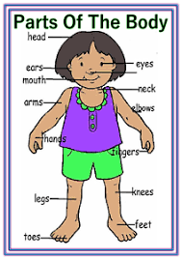  Hair [heə] Шәш  Eyes [aɪs] Көздер  Ears [ɪəs] Құлақтар  Nose [nəʊz] Мұрын  Mouth [maʊθ] Ауыз  Head [hed] Бас  Shoulders [ˈʃəʊldəz] Иық  Knee [niː] Тізе  Toes [təʊz]] Бақайлар  While-reading.  (W,G) Students read and guess the riddles.  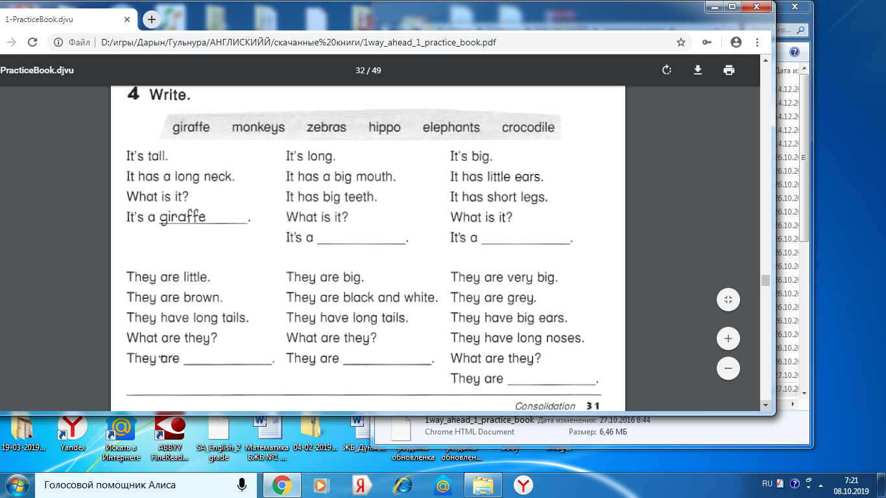  Differentiation by scaffolding.  - Teacher gives riddles with key words for guessing.  Post-Reading  (W) Game: Simon Says  Teacher explains the rule of the game “Simon Says”. Players should only do commands that begin with the words “Simon Says”. If teacher says: “Simon Says touch your nose”, players should touch their nose. But, if teacher says,-“jump” without saying “Simon says”, players shouldn’t jump.  Use of English. Grammar structure: “Have /has got”  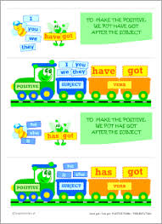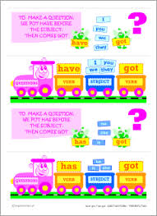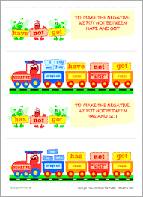  (W,G ) Group work. Connect the pictures.  Students should describe given pictures using verbs “have/has”  Example: It’s got two ears. It’s got one mouth.  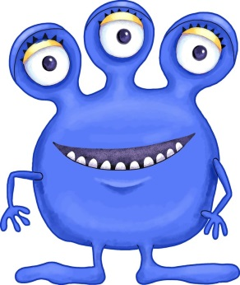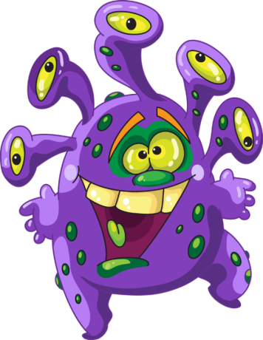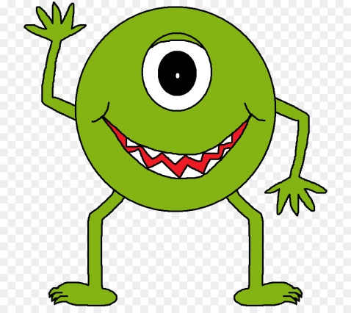  FA: Peer assessment:  Students assess each other by showing cards with smiley faces.  Descriptors:  A learner  - works in a group,  - uses grammar structure have/has got appropriately,  - makes up sentences correctly.  (G) Game “Day/night”.  To consolidate students` vocabulary teacher show 10 pictures on the board, then student should repeat them after the teacher and when the teacher says “night” students should sleep. When the teacher says “day” students should wake up and say missing card. The teacher cleans the words one by one. The group which find the word correctly will get a score for each right answer.  Descriptor:  A learner  - repeats words correctly  - finds out missing words on the board  FA: students count their scores and teacher gives praise and constructive feedback to encourage students.  Differentiation by support.  - Low level students will be supported by high level students  - while completing the sentences with the grammar, describe the picture and playing “Day/night” |  |  | https://www.youtube.com/watch?v=h4eueDYPTIg  https://www.google.com/search?biw=1366&bih=608&tbm=isch&sa=1&ei=41-fXfG0HoHRrgSOtL6oDw&q=parts+of+body+for+kids&oq=parts+of+body+for+kids&gs_l=img.3..0j0i30l3j0i5i30j0i8i30l5.209774.225029..225590...1.0..1.291.4291.0j22j5......0....1..gws-wiz-img.....0..0i67j0i10i67.RjDeMuDWUys&ved=0ahUKEwixspTnkZLlAhWBqIsKHQ6aD_UQ4dUDCAc&uact=5#  https://slideplayer.com/slide/10899715/  https://www.google.com/url?sa=i&source=images&cd=&cad=rja&uact=8&ved=2ahUKEwjp5t7MmJLlAhWRqIsKHbtjBewQjRx6BAgBEAQ&url=%2Furl%3Fsa%3Di%26source%3Dimages%26cd%3D%26ved%3D%26url%3D%252Furl%253Fsa%253Di%2526source%253Dimages%2526cd%253D%2526ved%253D2ahUKEwjXifOrmJLlAhVilIsKHYkNBtwQjRx6BAgBEAQ%2526url%253Dhttps%25253A%25252F%25252Fwww.anglomaniacy.pl%25252Fverbs-have-printables-sets.htm%2526psig%253DAOvVaw2ECp5lzun14oRvG1uUgHOf%2526ust%253D1570813999843554%26psig%3DAOvVaw2ECp5lzun14oRvG1uUgHOf%26ust%3D1570813999843554&psig=AOvVaw2ECp5lzun14oRvG1uUgHOf&ust=1570813999843554  https://www.google.com/url?sa=i&source=images&cd=&cad=rja&uact=8&ved=2ahUKEwj59_3UmZLlAhWv_CoKHUPgCksQjRx6BAgBEAQ&url=%2Furl%3Fsa%3Di%26source%3Dimages%26cd%3D%26ved%3D%26url%3Dhttps%253A%252F%252Fwww.anglomaniacy.pl%252Fpdf%252Fverbs-have-positive_form.pdf%26psig%3DAOvVaw2ECp5lzun14oRvG1uUgHOf%26ust%3D1570813999843554&psig=AOvVaw2ECp5lzun14oRvG1uUgHOf&ust=1570813999843554  https://www.google.com/url?sa=i&source=images&cd=&ved=2ahUKEwiC18LzmZLlAhVKtIsKHV2NAUUQjRx6BAgBEAQ&url=%2Furl%3Fsa%3Di%26source%3Dimages%26cd%3D%26ved%3D%26url%3Dhttps%253A%252F%252Fwww.anglomaniacy.pl%252Fpdf%252Fverbs-have-negative_form.pdf%26psig%3DAOvVaw2ECp5lzun14oRvG1uUgHOf%26ust%3D1570813999843554&psig=AOvVaw2ECp5lzun14oRvG1uUgHOf&ust=1570813999843554  https://i.pinimg.com/736x/4d/ae/de/4daede3c44ed3d800af5aecabd300ca0--cartoon-monsters-cute-monsters.jpg  http://clipart-library.com/img/1786688.png  https://img2.freepng.ru/20180206/xwq/kisspng-cookie-monster-blog-clip-art-mean-monster-cliparts-5a795508e96941.0870277315179010649561.jpg
End  3 min. | - Teacher gives feedback for learners. Learners reflect on their learning.  - Learners will be assessed by educational platform “Plickers”.  Test for feedback  - What is it? 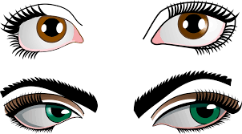  a)Eyes b) nose c)hair d)ears  - What is it? 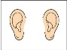  a)Eyes b) nose c)hair d)ears  - What is it? 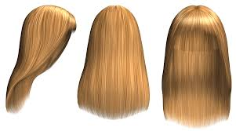  a)Eyes b) nose c)hair d)ears  - What is it? 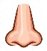  a)Eyes b) nose c)hair d)ears  - What is it? 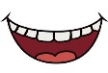  a)mouth b) head c)shoulders d)knee  - What is it? 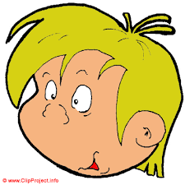  a)mouth b) head c)shoulders d)knee  - What is it? 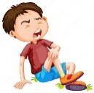  a)mouth b) head c)shoulders d)knee  - What is it? 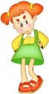  a)mouth b) head c)shoulders d)knee  - What is it? 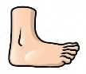  a)toes b) head c)shoulders d)knee |  |  | Pictures are taken from:  https://www.google.com/url?sa=i&source=images&cd=&ved=2ahUKEwj4m9_CopLlAhUOqIsKHT7gBJoQjRx6BAgBEAQ&url=http%3A%2F%2Fkira-scrap.ru%2Fdir%2Fraznoe%2Fchelovek%2F261-3&psig=AOvVaw1v4ykAUonBcMoSETrEbmYa&ust=1570816698868517  https://www.google.com/url?sa=i&source=images&cd=&ved=2ahUKEwijrqC1o5LlAhUFpIsKHTJJDpcQjRx6BAgBEAQ&url=http%3A%2F%2Fals-travel.spb.ru%2Fkartinka-ushi-dlya-detej.html&psig=AOvVaw1Zd9FLNEDFMyr73xIWhxId&ust=1570816960555787  https://www.google.com/url?sa=i&source=images&cd=&ved=2ahUKEwjsmLSNpJLlAhVli8MKHXeCBssQjRx6BAgBEAQ&url=%2Furl%3Fsa%3Di%26source%3Dimages%26cd%3D%26ved%3D%26url%3Dhttp%253A%252F%252Flenagold.ru%252Ffon%252Fclipart%252Fv%252Fvolos.html%26psig%3DAOvVaw2irL-1Lo2dSXYSPNrDcUIv%26ust%3D1570817145607093&psig=AOvVaw2irL-1Lo2dSXYSPNrDcUIv&ust=1570817145607093  https://www.google.com/url?sa=i&source=images&cd=&cad=rja&uact=8&ved=2ahUKEwjz-aDa75blAhXkAhAIHR4ZDooQjRx6BAgBEAQ&url=%2Furl%3Fsa%3Di%26source%3Dimages%26cd%3D%26ved%3D%26url%3Dhttps%253A%252F%252Fru.depositphotos.com%252F45523345%252Fstock-illustration-children-nose.html%26psig%3DAOvVaw2xISZVCqYD2SgyiLwn6ZR-%26ust%3D1570974903237330&psig=AOvVaw2xISZVCqYD2SgyiLwn6ZR-&ust=1570974903237330  https://www.google.com/url?sa=i&source=images&cd=&ved=2ahUKEwietZzJ8JblAhVaAxAIHarWAEQQjRx6BAgBEAQ&url=https%3A%2F%2Fzabavnik.club%2Fkartinki%2F5343-kartinki-dlya-detej-pro-rot&psig=AOvVaw1gSvfRnR5C3dgjQ7PLFnY6&ust=1570975117338246  https://www.google.com/url?sa=i&source=images&cd=&ved=2ahUKEwiVy6Ww8ZblAhXGwosKHQuJDHsQjRx6BAgBEAQ&url=http%3A%2F%2Fwww.cartoonclipartfree.com%2FCliparts_Free%2FKinder_Free%2FCartoon_Clipart_Free_Page_3.html&psig=AOvVaw3d0SWpMqOMcpHr0k5YJfyK&ust=1570975333938433  https://www.google.com/url?sa=i&source=images&cd=&ved=2ahUKEwjsqP6Z8pblAhVI_SoKHWVgByAQjRx6BAgBEAQ&url=https%3A%2F%2Fru.depositphotos.com%2F124489274%2Fstock-illustration-boy-hurting-from-accident.html&psig=AOvVaw0e89pw-9yBtX-JCJPyQFVB&ust=1570975522829202  https://www.google.com/url?sa=i&source=images&cd=&cad=rja&uact=8&ved=2ahUKEwj38oaJ85blAhVplIsKHb06DM8QjRx6BAgBEAQ&url=%2Furl%3Fsa%3Di%26source%3Dimages%26cd%3D%26ved%3D%26url%3Dhttp%253A%252F%252Fsadluchik0615.caduk.ru%252Fp285aa1.html%26psig%3DAOvVaw3eGoGSzuE8LLo6Pw9qbFPU%26ust%3D1570975735554627&psig=AOvVaw3eGoGSzuE8LLo6Pw9qbFPU&ust=1570975735554627  https://www.google.com/url?sa=i&source=images&cd=&cad=rja&uact=8&ved=2ahUKEwjxpZjc85blAhWIxosKHW0wB04QjRx6BAgBEAQ&url=https%3A%2F%2Fru.depositphotos.com%2F24797897%2Fstock-illustration-raised-toes.html&psig=AOvVaw2N4FpWNbiE7EdkVIucI0at&ust=1570975960265678

