Date: |  |  | School:
Teacher’s name: |  |  | Diana Tuleuova
Long-term plan unit: |  |  | Unit 6. Explorers and inventors
Grade: 3rd |  |  | Number present: | Absent:
Theme of the lesson: |  |  | The Past Simple
Learning objectives |  | 3.L.6 understand some specific information and detail of short, supported information or talk on a limited range of general and some curricular topics  3.R.3 recognise, identify and sound with support a limited range of familiar words in a simple sentences  3.S.5 pronounce familiar words and short phrases intelligibly when reading aloud
Lesson objectives: |  | All learners will be able to:  - identify the pronunciation of the ending of regular verbs  Most learners will be able to:  - build interrogative and negative sentences  Some learners will be able to:  - change verbs from the Present to the Past tense
Assessment criteria: |  | - identify Present and Past tense  - put the second form of the verb  - change sentences from Present to Past tense
Level of thinking: |  | Knowledge and comprehension  Application
ICT skills |  | The lesson materials are presented by the PPT.
Previous learning |  | NASA and the Baikonur Cosmodrome
Plan
Planned timings | Planned activities |  |  |  | Resources
Beginning | Organization moment: greetings and discussing learning objectives.  Before start the lesson Teacher asks the question: «What do you usually do in the morning?».  Learners answer the question e.g. «I wash my face/read a book/have breakfast». Teacher asks: In what tense are built all the sentences? (In present tense)  But how to tell about what did you do yesterday?  What do you think, what we will study today at the lesson? (The inscription of the Past Simple is hung on the board and the Present Simple is next to it)  So, the theme of our lesson is the Past Simple.  Today we are going to learn some grammar rulers, do exercises, and play games, work in pairs and in group. |  |  |  | Poster of the Present and Past Simple
 | Phonetic drill:  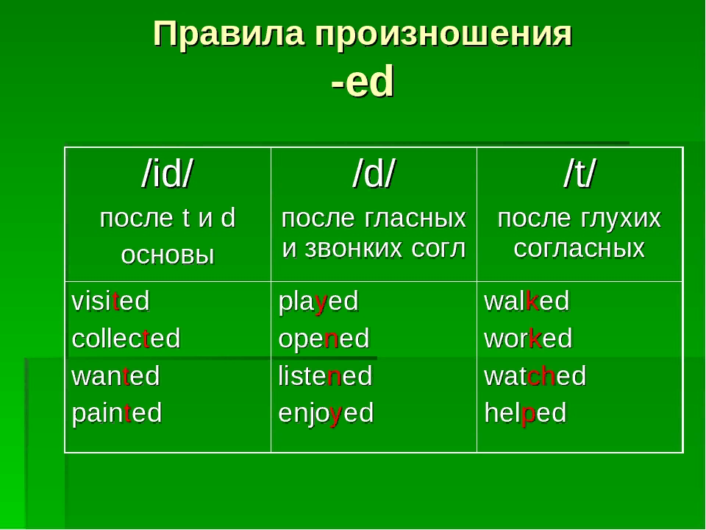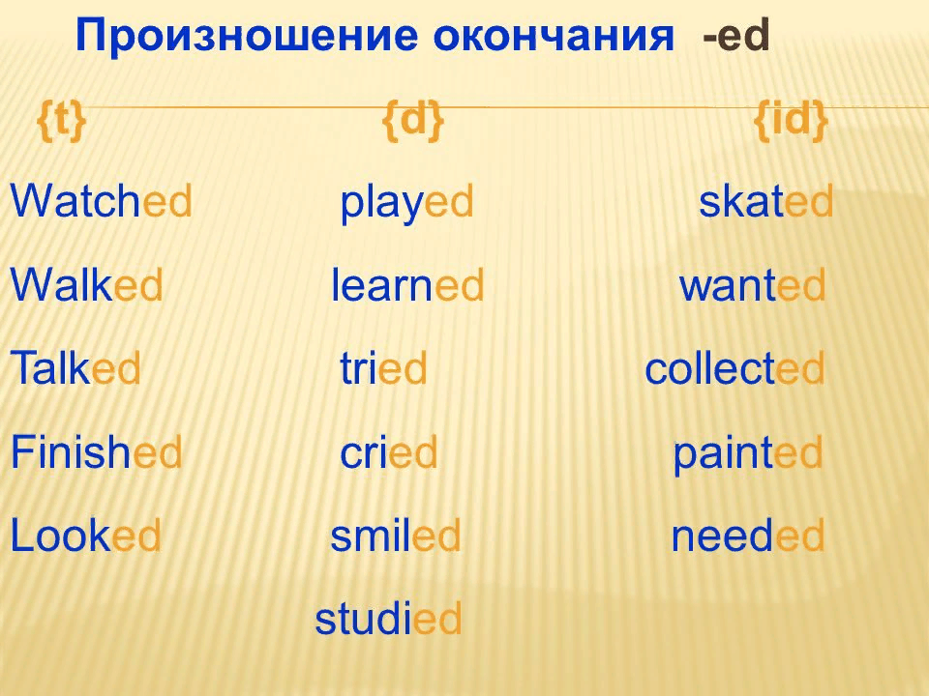  Phonetic task  Let's decompose the regular verbs depending on the pronunciation of the ending [d], [t], [id] in baskets.  watched learned collected cried skated  played finished painted walked wanted  looked talked tried smiled needed  Answer key:  [t] – washed walked talked finished looked  [d] – played learned cried smiled  [id] – skated wanted collected painted  Individual work «Fishing»  Teacher says we are going to fish, but we will get an unusual fish. Each fish will have a sentence in the Present or Past Tense. You should identify what tense it is and put your «fish» in a basket.  Learners should take «fish» one by one and put into the right basket.  - I play football  - I had breakfast in the morning  - I didn`t go to school yesterday  - I don`t like fish  - I played computer yesterday  - I watch TV every day  - I washed my face  - I didn`t clean my home  - I did my homework  - I get up at 10 o`clock  Descriptor: Find and put the sentences of Present and Past tense in right order  Work in pair: «Find a pair»  Teacher asks the question. What verbs do you know? Let`s remember irregular verbs. You should find the second form of the irregular verbs and put them in one chain.  take, took/ do, did/ write, wrote / drive, drove / come, came / get, got / go, went / have, had / write, wrote  Descriptor: Put sentences in the second form of the Irregular verbs correctly  Games for fixing grammar rules  Teacher: Let`s play a little. Who wants to play?  The first game is «Guess who?»  Learner: Come to the board and close his/her eyes. Other Learners say to him/her sentences in Present Simple, and other Learner tries to guess who says and repeats this sentence.  E.g.  Kairat: I cleaned my teeth  L: Kairat, cleaned his teeth  Asel: I watched TV  L: Ainur, watches TV.  The second game is «Step by step» Present/Past  Two Learners come to the board. The first Learner should take one step and say sentence in Present tense, the second Learner should take one and say the same sentence, but in the Past tense.  E.g.  L1: I get up  L2: I got up  L1: Do you like?  L2: Did you like?  L1: I don`t like?  L2: I didn`t like?  Work in group  Dividing into 2 group with the help of worksheets. The 1st group have cards of Present simple tense, and the 2nd group with the Past simple tense.  Each group are given the texts. They should change from the Present to the Past tense.  - I get up at 7 o`clock. I wash my face and clean my teeth. Then I have breakfast. I take my bag and go to school. I come home at 2 o `clock. I watch TV and at 10 o`clock I go to my bed.  - On my weekend I have breakfast and then I listen to music. My mummy comes home at 2 o`clock. We have dinner and clean our home. Then I with my mummy go to the park. We eat ice-cream and drink cola. We ride bile and play volleyball. We come home at 6 o`clock.  Descriptor: Learner read the text and change from Present to the Past tense. |  |  |  | Baskets with the inscriptions [t], [d], [id]  Answers sheet  Figurines of fish with the sentences 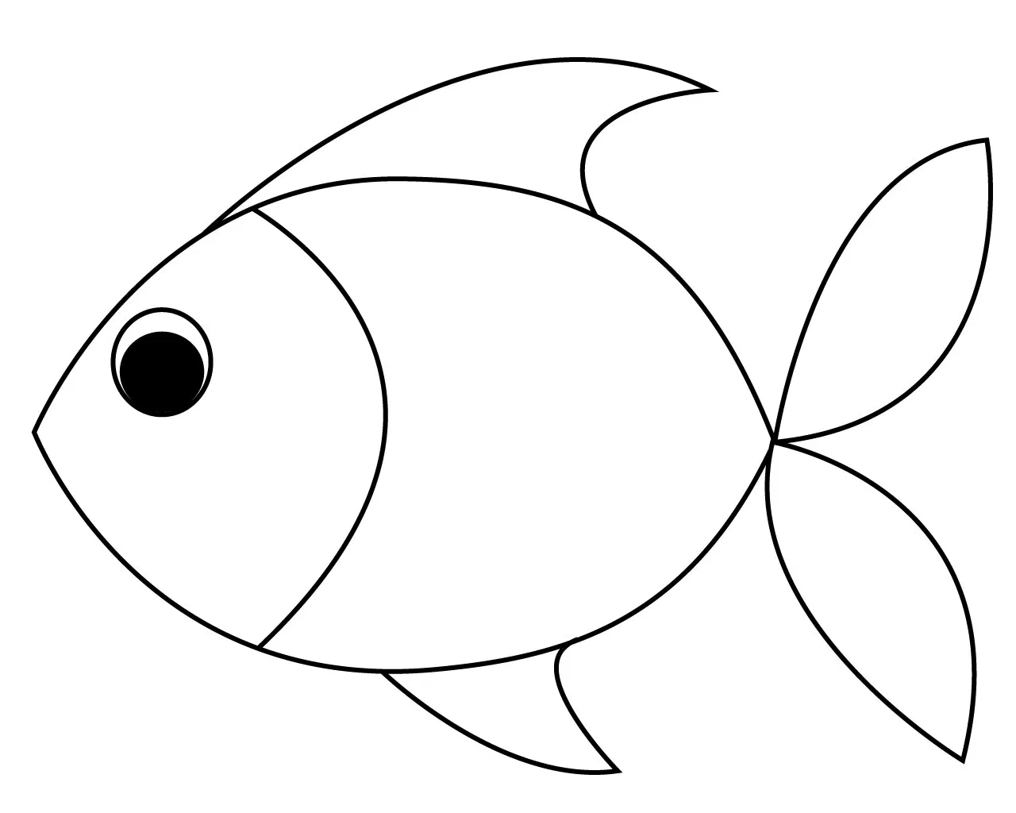  Envelopes with irregular verbs  TPR  TPR
End | Reflection:  Teacher What tense did you learn?  How does the verb change in the Past simple?  How the endings of verbs are read?  Self-assessment sheet  Learners should check the box next to those phrases that match their feelings from the lesson.  Criteria  1. I can identify and distinguish the endings of regular verbs»  2. I can put a verb in the past tense  3.I can tell about what happened before  Now I can identify and distinguish the endings of regular verbs»  «Now I know how to put a verb in the past tense»  «Now I can tell about what happened before»  «I cannot identify and distinguish the ending of regular verbs»  «I don’t know how to put a verb in the past tense»  «I can't tell about what happened before»
Additional information
Differentiation – how do you plan to give more support? How do you plan to challenge the more able learners? |  | Assessment – how are you planning to check learners’ learning? | Health and safety check ICT links
Differentiation was made by task to read and change from Present to Past tense |  | Assessment of my students were made by their active work, some of them were ready to get new information  Descriptor a learner  reads the text  change from Present to Past tense
Reflection  Were the lesson objectives/learning objectives realistic? Did all learners achieve the LO?  If not, why?  Did my planned differentiation work well?  Did I stick to timings?  What changes did I make from my plan and why? | Use the space below to reflect on your lesson. Answer the most relevant questions from the box on the left about your lesson.  - The lesson objectives were indicated to SMART requirements and Bloom`s Taxonomy sequence.  Differentiation was made by task, in group task all of the students mixed, more able Lrs help to less able Lrs. This framework was successful with reading skills, Lrs learn the new topic and comprehend faster. All planned timings were done. In my today’s lesson I put some changes into my plan, I took only two tasks to read and to match, because it will be not easy to take many tasks, some of my pupils can’t work individually, they always need support of teacher or classmates.

