Short term plan Lesson plan

Date: 04/02 |  | Teacher name: Seidalieva N
Theme: |  | Present perfect with never/ ever
Class: 7b |  | Number present: |  |  | Absent:
Learning objectives that this lesson is contributing to |  | 5.C use imagination to express thoughts, ideas, experiences and feelings  5.S pronounce an increasing range of words, short phrases and simple sentences  5.R understand the main points of short simple texts
Lesson objectives |  | All learners will be able to:  - Lіstеn аnd pronounce wоrds correctly;
Most learners will be able to:
- understand the rule and can make sentences and questions on general
Some learners will be able to:
- make sentences and questions on general
Language objective |  | Learners can:  - learn the using of perfect tense  - write and make up sentences  - Imagine and recite the stories
 |  | Key words and phrases: never, ever, just already, since for
 |  | Useful classroom language for dialogue/writing:
Discussion points: have you been to ….
Have you gone….
 |  | Can you say the sightseeing of Astana? Why do you like Astana?
 |  | Writing prompts: Learners make up a short stories and dialogues.
Previous learning |  | In the previous lesson: learners developed listening and speaking on the theme ‘Instuments’
Plan
Planned timings | Planned activities (replace the notes below with your planned activities ) |  |  |  |  | Resources
Start  7 m | Greeting  A1. T-G. Dividing into groups. Teacher divides learners into three groups by taken pictures with “Noun”, “VERBS” and “ADJECTIVES”.  A2.: T-W.C. Brainstorming. Teacher asks the questions.  - Do you play any instrument?  - Who is a busker?  - Do you like playing musical instruments?  Learners should ask the questions.  Checking up home task: Ex 1 p 64 listening and checking up the answers |  |  |  |  | Slide  Cards  CD  Pictures  Stickers
Middle  15m  10m | T-WC. A.: Introduce new theme. Teacher introduces new tense on the slide. Learners say and make the sentences  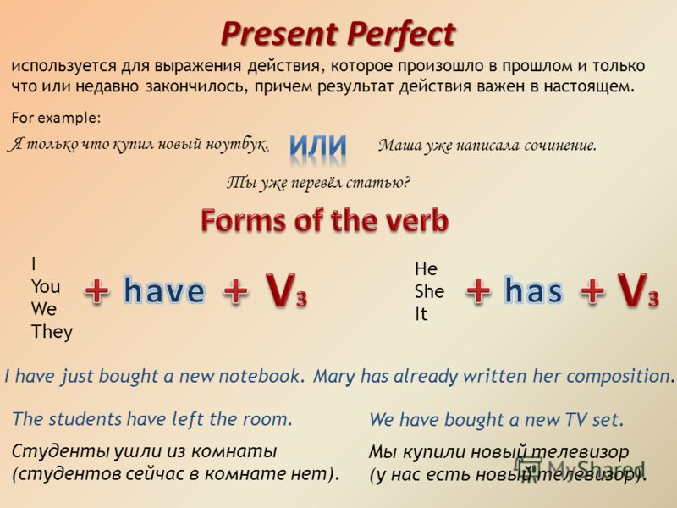  Using of never/ever:  I have ever been to Astana.  I have never been to Astana.  Have you ever been to Astana?  Feedback. Teacher assess by giving the stickers.  Game “Who is faster?” Complete the irregular verbs:  verb Past simple Past participle Translation  go  took  watch  written  got  read  become  bought  еaten  played  A-1. Ex1. P65. Game “Missing words”  Complete the sentences with never/ever:  - He`s never played here at the festival.  - Have you ever played at the festival?  - I`ve never played the banjo.  - Have you ever played in a group?  - I`ve never played the cello.  - We have ever visited London.  A2. Game “Domino”  Pupils make sentences with the cards. They should keep the order of the sentences.  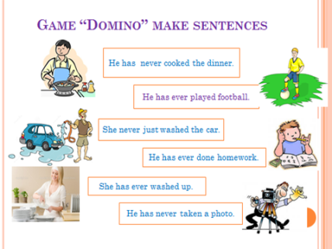  He has never cooked the dinner.  He has ever played football.  She has never washed a car.  He has ever done homework.  She has ever washed up.  He has never takes photo.  Feedback: Students assess themselves formatively by giving assessment paper.  Assessment criteria Descriptor Mark Student`s mark  Using of present perfect with never/ever in sentences to understand the using of P.P 10  to use in the sentences 10  to make up the questions 10  30  Let’s rest. Sing a song and dance.  C-S,S,S. Strategy 1.: Ex 3 “Hot chair”. One student of the group is asked. The other students ask questions using the present perfect with never/ever.  Feedback. Teacher assess by giving the stickers. |  |  |  |  | Slide 1  Table  Text book  Stickers  Worksheets  Paper  crayons  glue  Assessment paper
End 8m | Strategy 3 S-S “Pair works” The learners choose one/ two pictures and make up the dialogue.  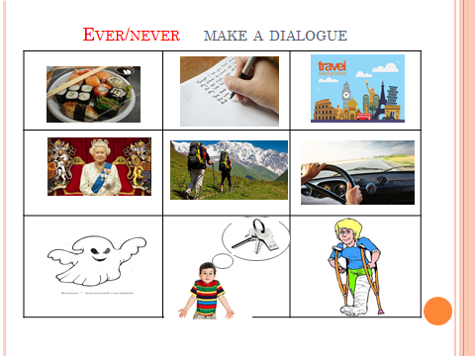  Feedback. Teacher assess by giving the stickers.  Reflection: “Stairs of success”  At the end of the lesson students share their getting knowledge, emotions and feelings.  I can  - use new words  - make up phrases  - understand the sentences  - read the text |  |  |  |  | Stickers for assessment  Assessment paper
Additional information  Differentiation – how do you plan to give more support? How do you plan to challenge the more able learners? |  |  | Assessment – how are you planning to check learners` learning? | Cross-curricular links  Health and safety check  ICT links  Values links
Reflection |  |  | Use the space below to reflect on your lesson. Answer the most relevant questions from the box on the left about your lesson.
Were the lesson objectives /learning objectives realistic?

What did the learners learn
today?
What was the learning
atmosphere like?
Did my planned
differentiation work well?
Did I stick to timings?
What changes did I make
from my plan and why?

Summary evaluation:
What two things went really well (consider both teaching and learning)?
1:________________________________________________________________________
2:________________________________________________________________________
What two things would have improved the lesson (consider both teaching and learning)?
1:________________________________________________________________________
2:________________________________________________________________________
What had learners from this lesson about the class or individuals that will inform my next lesson?
1:________________________________________________________________________
2:________________________________________________________________________

