Long term plan unit: |  | Secondary School No.60
Date: |  | Teacher name: Mamyrova Mukhabbat.
Grade: |  | Number present: | Absent:
Theme of the lesson: Outdoor sports and activities
Learning objectives (s) that this lesson is contributing to |  | 5.C6 organize and present information clearly to others.  5.L3 understand the main points of short supported talk on an increasing range of general and curricular topics.  5.S4 respond to questions on an increasing range of general and some curricular topics.  5.R6 understand the main points of short simple texts on a growing range of general and some curricular topics using contextual clues.
Lesson objectives |  | All learners will be able to: define topical vocabulary from supported talk about Outdoor sports and activities and interact the topical vocabulary during group and whole class exchanges when speaking with lots of support;  Most learners will be able to: define topical vocabulary from supported talk about Outdoor sports and activities and interact the topical vocabulary during group and whole class exchanges when speaking with some support;  Some learners will be able to: define topical vocabulary from supported talk about Outdoor sports and activities and interact the topical vocabulary during group and whole class exchanges when speaking without support;
Assessment criteria |  | Demonstrate information clearly to others.  the main points of short supported talk on an increasing range of general and curricular topics.  Recognize short supported questions on general and some curricular topics.  Give answers to questions on an increasing range of general and some curricular topics.  Perceive the main points of short simple texts on a growing range of general and some curricular topics using contextual clues.  Apply conjunctions and, or, but, because to link words and phrases.
Value links |  | “Mangilik Yel”: 3rd value, “A secular society with high spirituality”.
Cross curricular links |  | PE , Kazakh, Russian.
ICT skills |  | Whiteboard.
Previous learning |  | Grade 5 “Expressing interest”
Plan
Time  2min | Planned activities  Organization moment |  |  |  |  | Resources
 | Greeting: The teacher greets the learners, and they respond. –Good day! How are you?  -Who is on duty today?  Psychological atmosphere  The teacher asks the learners to stand in a circle and wish each other their good wills: Be happy, Be wise, Be smart, Be lucky, Be kind, Be joyful, Be honest, Be generous, Be lovely, Be hard-working, Be friendly, Be famous.  . Learners wish each other by giving this heart. |  |  |  |  | https://go.mail.ru/search_images?q=Heart&fr=ps&gp=821605#urlhash=911418108349800889
3min  5min  5min  8min  5min  9min  1min  2min | 1) Slowly, slowly (Whole class activity).  The teacher shows the pictures slowly, slowly and the learners guess what picture it is .E.g: cycling, bowling, skateboarding, snowboarding, windsurfing, surfing, volleyball, basketball, baseball, cricket.  Formative assessment: by smiling faces.    2) 5Ws and hot-seating activity(Whole class activity).  A learner sits on the chair and takes several questions from the class and teacher. The questions should be started with the Ws : What ? Where? When? Who? Why?  -What sport is it?  -Where do you do this sport?  -When do you do this sport ?  -Who do you go with?  -Why do you like this sport?  Differentiation by support : More able learners will make up and answer the questions without any support. While less able learners will get support from my part.  Formative assessment: by thumbs :good job, well done.    Dividing the class into 3 groups by types of sports :land water and air .  3)Eliciting (Whole class activity).  The teacher shows the slides and asks some questions. The reason of asking such questions is to elicit the topic of the lesson from learners as in the example:  -What can you see at these pictures?  -What sports are they?  -What is this man doing?  -What is the girl doing?  -Where is this man flying?  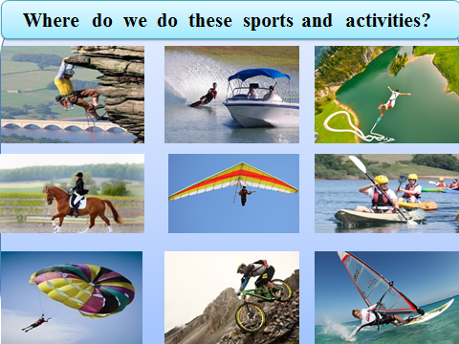  Formative assessment: assesses orally: excellent, well done, good, try more etc.  4) Mind map (Group work)  The learners classify the types of sports into land, water and air sports:  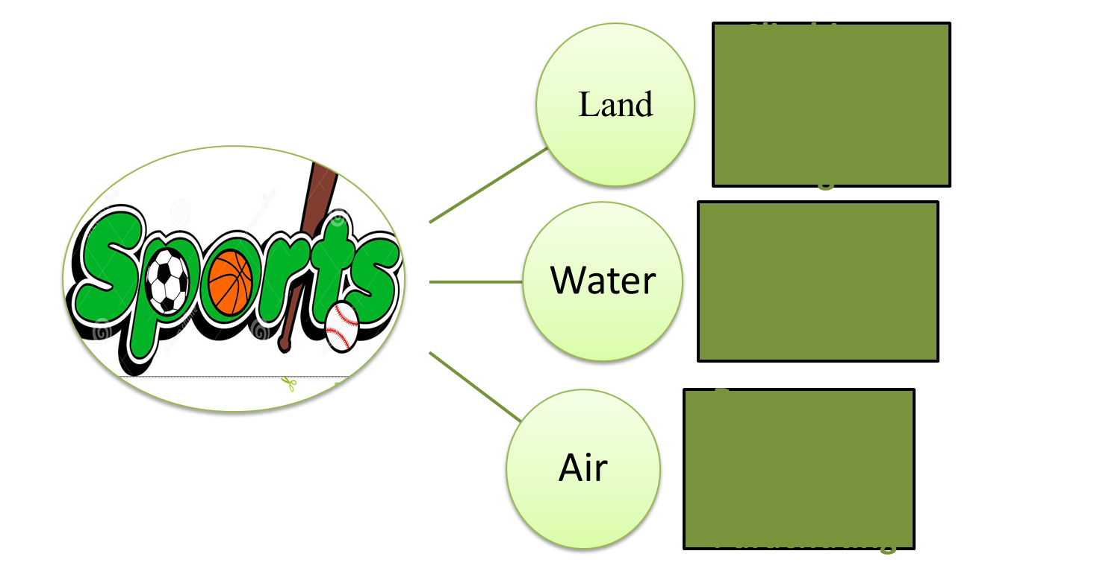  -Climbing -Windsurfing -Bungee jumping  -Horse riding -Waterskiing -Paragliding  -Mountain biking -Canoeing -Parachuting  Differentiation by levels: The teacher uses easier questions and gestures for less able learners to make them understandable.  Assessment: by descriptor:  A learner :  *classifies the types of sports into 3 groups;  *writes the words correctly;  *reads the words clearly.  5) Bottom-up/skimming (Group work).  The learners read the whole text one by one .Then they should perform the following tasks:1)identify the land, water and air sports; 2)write them on the posters; 3) match the pictures with necessary words.  Differentiation by learning style: audial learners look for and identify land, air, water sports , visual learners match the words with the pictures, while kinesthetic learners write the words on the posters.  Formative assessment: by stars:    6 ) Listen and identify (Group work)  1) Before playing the recording I’ll ask the learners to identify 5 outdoor sports(mountain biking, canoeing, climbing, skiing, snowboarding).  2)Differentiation by the complexity of the task:  Land group: Cohesion :learners should find out the lost  words: skiing, snowboarding,  canoeing, climbing and mountain biking.  Water group: Spotting text changes: learners should  determine changed words : outdoor-indoor,  helmet-cap, goggles-glasses, snow -  winter , dangerous –safety.  Air group: Find out the adjectives from the text: outdoor, special, dangerous, hard, different, important, snow.  *The teacher refers students to the highlighted words in the text and explains that they are examples of equipment, i.e. objects that we use when doing a particular activity.  Audio script  OK class, for the outdoor sports and activities school trip there are some special clothes and equipment you need to take. Can you listen and make a list please? Outdoor sports and activities can be dangerous so you must protect yourselves. You must have a helmet like this one. A helmet is a hard hat and it protects your head in lots of different sports like (1) mountain biking, (2) canoeing and (3) climbing – so, very important. Right, two more things you must take are goggles, to protect your eyes, and gloves to protect your hands. You need goggles and gloves for snow sports like (4) skiing and (5) snowboarding, so don’t forget those.  Formative assessment: by sweets.  Homework: make a word square about sports.  Feedback. Apple tree.  - Apples on the tree- It’s clear for me.  - Apples in the basket – I have some questions . - -----Apples on the ground- It’s not clear for me. The learners write their opinions about the lesson in stickers and stick on the tree.  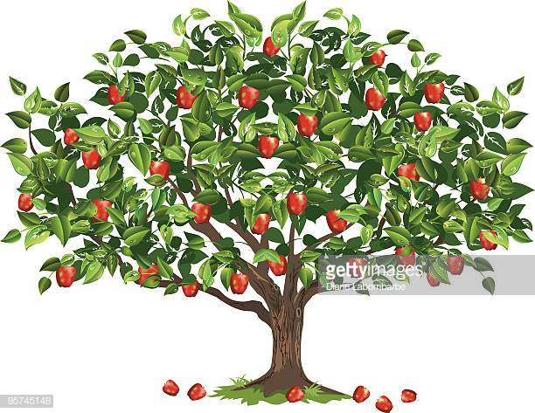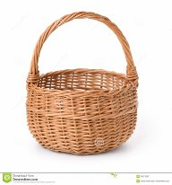 |  |  |  |  | flashcards  https://go.mail.ru/search_images?src=go&fr=ps&sbmt=1555773058454&gp=821605&q=smiles#urlhash=9183891665172558314  worksheets  flashcards  https://go.mail.ru/search_images?src=go&fr=ps&sbmt=1555772792664&gp=821605&q=thumbs&us=5&usln=1&usstr=Thumb&usqid=2ecd2d8fad07ebfc&hasnavig=0&sbmt=1555772792664#urlhash=4866857338690325176  whiteboard  slide  whiteboard  slide  Eyes Open Grade 5,ex:2,p:92  posters  https://go.mail.ru/search_images?q=stars%20photos&fr=ps&gp=821605  Eyes Open Grade 5,ex:4,p:92  Audio scripts  https://go.mail.ru/search_images?q=Apple%20tree&fr=ps&gp=821605  https://go.mail.ru/search_images?src=go&fr=ps&sbmt=1555857066342&gp=821605&q=basket
Additional information
Differentiation – how do you plan to give more support? How do you plan to challenge the more able learners? |  | Assessment – how are you planning to check learners’ learning? |  |  | Health and safety check  ICT links
5Ws and hot-seating activity  Differentiation by support : More able learners will make up and answer the questions without any support. While less able learners will get support from my part.  Mind map  Differentiation by levels: The teacher uses easier questions and gestures for less able learners to make them understandable.  Bottom-up/skimming  Differentiation by learning style: audial learners look for and identify land, air, water sports , visual learners match the words with the pictures, while kinesthetic learners write the words on the posters.  Listen and identify  Differentiation by the complexity of the task:  Land group: Cohesion :learners should find out the lost words.  Water group: Spotting text changes: learners should determine changed words.  Air group: Find out the adjectives from the text. |  | Slowly,slowly  Formative assessment: by smiling faces.  5Ws and hot-seating activity.  Formative assessment: by thumbs :good job, well done.  Eliciting  Formative assessment: assesses orally: excellent, well done, good, try more etc.  Mind map  Assessment: by descriptor:A learner :*classifies the types of sports into 3 groups;  *writes the words correctly;  *reads the words clearly.  Bottom-up/skimming  Formative assessment:by stars:  Listen and identify Formative assessment: by sweets. |  | -Let’s go in for sports;  -Let’s do morning exercises ;  -Let’s invite our friends to do more sports.  To pay attentions to learners safety during the doing activates: be careful in moving to places, in dividing to groups
Reflection
Were the lesson objectives/learning objectives realistic?
Did the learners achieve the LO?
If not, why?
Did my planned differentiation work well?
Did I stick to timings?
What changes did I make from my plan and why?

Summary evaluation
What two things went really well (consider both teaching and learning)?

1:

2:
What two things would have improved the lesson (consider both teaching and learning)?

1:

2:

What have I learned from this lesson about the class or achievements/ difficulties of individuals that will inform my next lesson?

