Theme of the lesson: “Times of my day” | School:
Date: | Teacher name: Sharekenova Aigerim
Grade: 3 “G” | Number present: 8 | absent: -
Learning objectives(s) | understand short, narratives on a limited range of general and some curricular topics  make basic statements which provide personal information on a limited range of general topics  ask questions to find out about present experiences on a limited range of general and some curricular topics  respond to questions on a limited range of general and some curricular topics  plan, write and check short sentences with considerable support on a limited range of personal, general and some curricular topics;
Objectives of the lesson | All learners will be able to:  - Understand and say what the text about using active vocabulary  - Ask each other about daily routines using present tense.
Value links | Respect and love to family
LESSON PLAN
ICT skills | Video, pictures
Cross curricular | Lesson is connected with Maths
Previous learning | Light and dark. Clothes
Plan

Timing | Activities | Resources
Beginning  5 minutes  3 minutes | Organization moment:  The teacher greets the pupils and asks questions to them. Before beginning our lesson lets sing a song “Hello”  T: Hello, children! How are you?  Cl: Hello, teacher! I’m fine, thank you! And you?  T: I’m Ok, thank you. Sit down  Phonetic drill:  Clap your hands if you hear the sound «ch»: with, chair, shoes, chapter, this, chief, show, drink, shine, chant, life, shark, those. | https://youtu.be/tVlcKp3bWH8  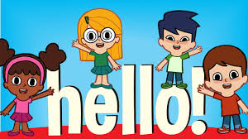  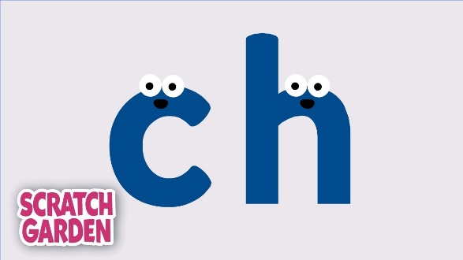
Middle  4 minutes  6 minutes  4 minutes  14 minutes | Activity 1  Home task checking (learn new words)  Let’s watch the video  Activity2  Pupils, lets learn new words. Look at the board and repeat:  Get up – ояну  Have dinner – түскі ас ішу  Go to school – мектепке бару  Come home from school – мектептен үйге қайту  Watch tv – тв көру  Have breakfast – таңғы ас  Go to bed – ұйықтау  Do my homework - үй тапсырмасын жасау  Let’s watch the video!  Activity 3  Warm-up break “I go to school ”  Activity 4  Let’s do some more exercises. Open your books on page 35 Exercise 1 (Look at Gulnara”s routine and number)  Activity 5  Ok, Very good! Let’s continue! Exercise 2 page 35 (Look, read and write “Yes” or “No”)  Activity 6  Exercise 3 page 27 (from activity book)  Look, read and match. | https://youtu.be/taoCF1cKZSY  https://youtu.be/7OvDm18nLm8  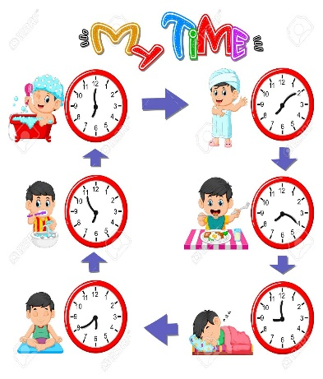  https://youtu.be/eUXkj6j6Ezw    PICTURE 1  PICTURE 2  PICTURE 3
Ending  4 minutes | That’s all for today!  - Let’s answer for my questions about today’s lesson!  So our lesson is over. Thank you for your lesson. You are hard - working children. I'm satisfied with you. Never forget we are what we eat. If you want to be healthy, nice, strong, try to use healthy food, avoid junk one.  Homework- Exercise 4 page 27 (from activity book)  Read and draw the times | 
Additional information
Differentiation – how do you plan to give more support? How do you plan to challenge the more able learners? | Assessment – how are you planning to check learners’ learning? | Cross-curricular links  Health and safety check  ICT links  Values links
More support will be given to weaker learners by giving them a modified worksheets in some tasks with greater support (fewer letters to complete) | Through feedback in sounding, word search and un-jumbling tasks | Value links: empathy and awareness that people from different cultures have different names / short names

