School No.244 named after Y.Zhakhayev

DEMONSTRATION LESSON

Time. Arrangements P.40

TEACHER: Tashenova Alfia

GRADE: 5B

DATE:

2018-2019 school year

Short term planning

Unit 3: Value |  | School No.244 named after Y.Zhakhayev
Date: 5 |  | Teacher’s name: Tashenova Alfia
Theme of the lesson: |  | Time. Arrangements p.40
Learning objectives(s) that this lesson is contributing to |  | 5.R6 recognise the attitude or opinion of the writer in short texts on a limited range of general and curricular topics  5.S6 communicate meaning clearly at sentence level during, pair, group and whole class exchanges  5.S7 use appropriate subject-specific vocabulary and syntax to talk about a limited range of general topics
Lesson objectives |  | All learners will be able to:  - Tell the time appropriately  - Understand new vocabulary words related to time: half, quarter, past and to.  - Listen for gist and answer the questions about time arrangements (teacher’s support).  Most learners will be able to:  - Tell the time appropriately  - Understand new vocabulary words related to time: half, quarter, past and to.  - Listen for gist and answer the questions about time arrangements (slight teacher’s support).  Some learners will be able to:  - Tell the time appropriately  - Understand new vocabulary words related to time: half, quarter, past and to.  - Listen for gist and answer the questions about time arrangements  - Ask time and give answers about time.
Assessment Criteria |  | Students achieve the lesson objectives if they can  - Use the words half, quarter, past, to in accuracy  - Ask and give answer about time
Level of thinking skills |  | Higher order thinking skills
Value links |  | To bring up being responsible for care of family, friends and respect elderly;
Cross curricular links |  | Time
ICT skills |  | Video; CD; DVD
Intercultural awareness |  | Students will be able to understand that every person, family and country has their own values.
Kazakh culture |  | Students will be able to differentiate values in Kazakh culture and family
Pastoral Care |  | Students will be able to understand the importance of respecting values
Health and Safety |  | Everyday classroom precautions will ensure that safety measures are provided to prevent the exposure of electrical power cords
Previous learning |  | Qualities of a Friend p.38-39. They understand the most part of comments to do true/false sentence task. They understand new vocabulary words related to friendship, they are: fun, kind, friendly, honest, helpful, loyal, real and etc. They listen for gist the information about Arsen and his friends
The lesson planning
Planned timings | Planned activities |  |  |  | Resources
Beginning  5 min  Brainstorming  2 min | Class organisation  Teacher introduces learning and lesson objectives  Divide the class with the help of candies  - Ss.watch the video “What time is is?”  - T. shows the time and asks the time. |  |  |  | http://www.dreamenglish.com
Middle  5 minutes  5 min  10 min  7 min | Aim: То practise telling the time  - T. hands out the time flashcards. If the students have any difficulties in asking or giving answers T. helps or writes question equivalents of asking time in English.  Suggested Answer Key  - A: What's the time, please?  B: It's four o'clock.  Have you got the time, please?  It's ten to four.  What time is it, please?  It's twenty to three.  What's the time, please?  It's half past eight.  Additional material for less-able students  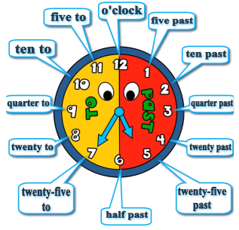  Aim: To identify the correct usage of time  - Students work in pairs and complete the tasks one by one assessing themselves.  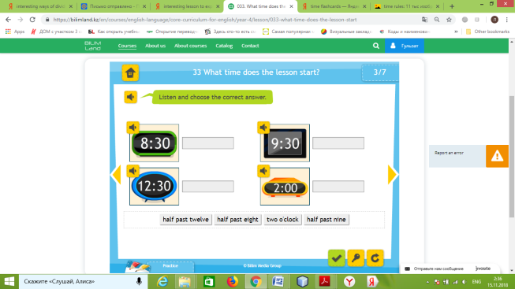  They get their results and assess within the traffic light assessment rules. (if all answers are right, they show green card, half – yellow, all - red)  Aim: To learn phrases  - Read the phrases aloud. Refer Ss back to the time arrangements and elicit some examples in English. Give time to Ss to complete the task by putting words into the right order.  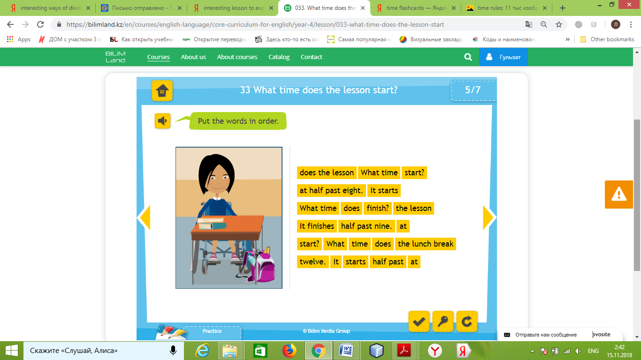  Aim: Check their understanding through the interactive game  - Ss play the game related to time. T. monitors their work.  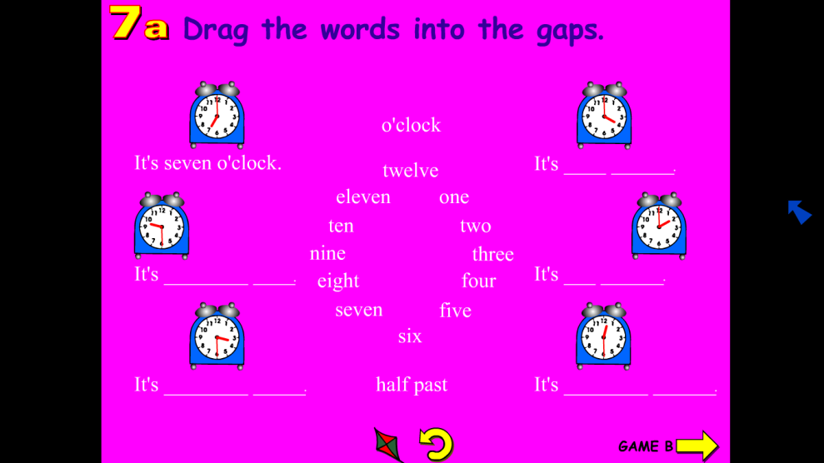 |  |  |  | Student’s Book  Excel  P.40  byteacherclara.wordpress.com  BilimLand  https://bilimland.kz/en/courses/english-language/core-curriculum-for-english/year-4/lesson/033-what-time-does-the-lesson-start  BilimLand  https://bilimland.kz/en/courses/english-language/core-curriculum-for-english/year-4/lesson/033-what-time-does-the-lesson-start  Macmillan  WayAhead 3  Game 7a
End  6 minutes | Homework: W&GB Ex 1-2 Page 26  - Reflection (W)  Teacher asks learners  1) What was difficult to do at the lesson?  2) What do you need to work on?  Feedback (I) |  |  |  | Reflexion lists
Additional information
Differentiation – how do you plan to give more support? How do you plan to challenge the more able learners? |  |  | Assessment – how are you planning to check learners’ learning? | Cross-curricular links  Health and safety check  ICT links  Values links
- More support can be given at the start and in middle of lesson by providing less-able learners with time flashcard so they can use to speak about time.  - Learners, who are less confident at putting words into right order, can be given some clues.  - More-able learners can be encouraged to use the full range of language to tell the time. |  |  | - Monitor how well they can ask and answer the questions about time  - Monitor learners as they complete the tasks within the BilimLand resources.  - Conclude the lesson to find out if they can make up sentences about time arrangements. | - Links to the L1: Do learners know words in their native language?  - Make sure learners have sufficient space to work in groups or pairs.  - As one of the main grammar rules T. explains how to tell the time
Summary evaluation
What two things went really well (consider both teaching and learning)?
1:

2:

What two things would have improved the lesson (consider both teaching and learning)?
1:

2:

What have I learned from this lesson about the class or individuals that will inform my next lesson?

