## Summative assessment for term

## Grade________________ Name________________________

**READING .**

**TASK 1.Read the text and complete the sentences.**

**My friend**

Hi . My name is Tom. I have a friend, Bob. He is 10.He is in my class. He is a clever boy. He has got a big family: a mummy, a daddy, a brother and two sisters. He likes cats and dogs.

1. My friends name is_____________.

2. He has got a _______ family.

3. Bob is my _________.

4. Bob likes _____________.  **[4]**

**Task 2. Writing**

**Look at the pictures and write their names with colours.**

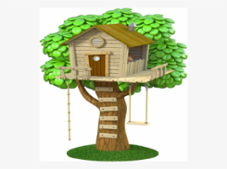_____________ ___________________

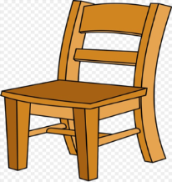_______________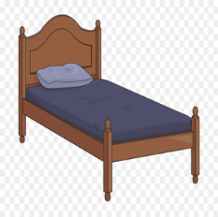__________________

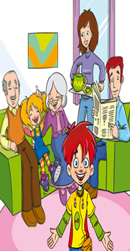_______________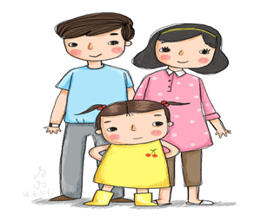______________

### [6]

**Task 3. Complete the words.**

|  |
| --- |
| **Tr C H** |

|  |  |
| --- | --- |
| 1. http://cdn.grid.fotosearch.com/CSP/CSP507/k5070560.jpg | **___at** |
| 1. http://www.frugalhappyfamilies.com/clipart.images/coat.13.jpg | **____ oat** |
| 1. http://images.clipartpanda.com/trousers-clipart-jTxEdajec.gif | **_____ ousers** |
|  |  |

**[3]**

|  |  |  |  |  |  |
| --- | --- | --- | --- | --- | --- |
| **Task №** |  | **Answer** | | **Mark** | **Additional**  **information** |
|  |  | | |  |  |
|  | 1.BOB | | | 1 |  |
|  | 2.BIG | | | 1 |  |
|  | 3. FRIEND  4.CATS AND DOGS | | | 1  1 |  |
|  |  | | |  |  |
|  | 1.treehouse,radio  2.chair,bed | |  | 1  1 |  |
|  |  | |  |  |  |
| 3. | 3.big family, small family | |  | 1 |  |
|  | 4.triangle,circle | |  | 1  **8** |  |

### 