Lesson plan

Unit of a short term plan “Healthy habits” |  |  |  | School: Almaty regional boarding school №15  15
Date:09.10.2020 |  |  |  | Teacher name: Baibukasheva Aigerim
CLASS:7 |  |  |  | Number present:14 | absent:
Lesson title |  | Healthy habits
Learning  objective(s) that  this lesson is contributing to: |  | 7.S7 use appropriate subject-specific vocabulary and syntax to talk about a range of general topics, and some curricular topics  W5. Develop with some support coherent arguments supported when necessary by examples and reasons for a limited range of written genres in familiar general and curricular topics.  R9. Recognise inconsistencies in argument in short, simple texts on a limited range of general and curricular subjects.
Lesson objectives |  | All learners will be able to  Listen and divide words into healthy and unhealthy habits groups
Most learners will be able to

Give advice according to healthy and unhealthy habits.
Some learners will be able to
Discuss and give their opinion according to the health problem using own words
Assessment criteria |  | Should recognize particular information and details about healthy and unhealthy habits.  Should give advice according to healthy and unhealthy habits.  Should discuss and give their opinion according to the healthy habits using own words
Values links |  | Educated generations formation of a healthy lifestyle ,trust ,respect according to “Mangilik El ”
Cross-curricular links |  | Sport
Previous learning |  | Names of food and sport
Plan
Planned timings | Planned activities (replace the notes below with your planned activities) |  |  |  |  |  | Resources
Start  5 min | - Greeting: Hello, children! How are you?  The students are divides into two groups according to the word with “Eating for health” and “ Drinking for sport ”  The teacher introduces the objectives of today's lesson and assessment criteria  Checking up the home task:  What was your home task?
Middle  5 min  5 min  2 min  5 min  2 min  8 min  - min | Task 1 . Make a sentences  Speaking  I/W  Activity : Making  Action : Learners should take a picture connected with healthy and unhealthy habits . First group must find a picture connected with healthy habits . Next group must find unhealthy habits and put pictures on a green board . Then make the sentences with should, shouldn’t modal verbs and say.  What should/shouldn’t we do to have a healthy lifestyle?  I team “Healthy” II team “Unhealthy”  - Get a good night’s sleep 1. Eat too much junk food  - Have a hobby 2. Eat late at night  - Do a physical activity 3. Surf the internet for too long  - Drink plenty of water 4. Play video games too often  - Eat fruit and vegetables 5. Watch too much TV  - Don’t smoke 6. Smoke  Example: We should get a good night’s sleep.  We shouldn’t eat too much junk food.  Descriptor a learner:  Finds healthy and unhealthy habits.  Makes right sentences with should/shouldn’t and say them  Formative assessment : by comments  Task 2  Speaking  I.W  Activity : question  Action : Ex 1 page 92  Learners look at the eat well plate . Learners should say name the food and drinks and which of them do you eat or drink most often  Formative assessment : by comments  Descriptor a learner:  Name the foods and drinks correctly  Answer the question  Task 3 Read the text  Reading , speaking  Individual Work  Activity : Retelling  Action : Read the text and translate , retell and answer the question .Every group should read the text connected with your team name and discuss it .  Formative assessment : by comments  Descriptor a learner:  Correctly read the text  Retell the text  Answer the question  Task 4 Ex 3 Read the text and mark the sentences  Writing  Individual and pair work  Activity : Choosing  Action : Read the text and mark the sentences True \false , doesn’t say . Correct the false statements  Formative assessment : by comments  Descriptor a learner:  Can correctly choose True \false  Task 5 Make a poster about “ Conversation pyramids”  Speaking  Group work  Activity: Poster  Action : Complete the pyramid and talk about their food pyramid.  Which food/drinks give us a lot of energy?  Which ones keep our muscles strong?  Which food/drinks give us a lot of Harmful?  What is the damage to the body?  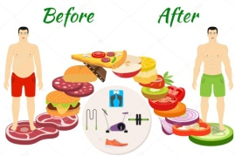  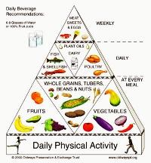  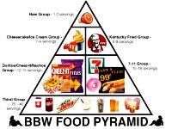  Fill in pyramids  Formative assessment : by comments  Descriptor a learner:  Make a poster  Give opinion using new words |  |  |  |  |  | Picture cards healthy and unhealthy habits  Excel 7 grade  Module 8 ex 1/2 on page 87    Excel 7 grade  Module 8 ex 2 on page 94  Leaves and tree  Pyramid puzzle
End  5 min | Self-assessment: writing letter feedback  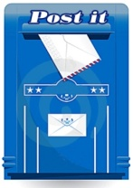  Ask students to look at lesson objectives they set at the beginning of the lesson and think and say what they did well in the lesson and what needs improvement.  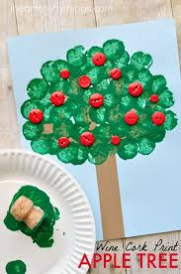  - What have I learnt?  - What have I found easy?  - What have I found difficult?  - What do I want to know?  So, the lesson is over. Goodbye |  |  |  |  |  | 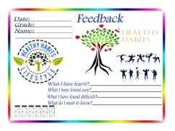  stickers  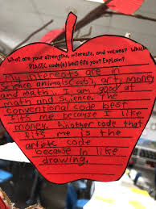
Additional information
Differentiation – how do you plan to give more support? How do you plan to challenge the more able learners? |  |  | Assessment – how are you planning to check  Learner’s learning? |  |  | Health and safety check
Differentiation by outcome: more able learners will be given a task to make their own sentences about their future plans.  Differentiation by support: less able learners will be given more support by given them key words: eat, do morning exercises, go, run, drink  Descriptor a leaner:  - develops his/her personal objectives  - writes their sentences  - presents their words to the class |  |  | “Brain storm”, “Self - assessment paper”, “stickers” “Conversation pyramids” |  |  | 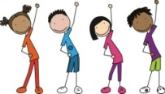  Physical exercises
Reflection
Were the lesson objectives/learning objectives realistic?
Did all the learners achieve the lesson objectives/ learning objectives? If not, why?
Did my planned differentiation work well?
Did I stick to timings?
What changes did I make from my plan and why?
Summary evaluation
What two things went really well (consider both teaching and learning)?
1:
2:
What two things would have improved the lesson (consider both teaching and learning)?
1:
2:
What have I learned from this lesson about the class or individuals that will inform my next lesson?

