|  |  |  |
| --- | --- | --- |
| Name: | Grade: 2____ | Date: 06/10/2020 |

Summative assessment for the unit

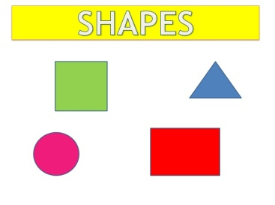**Task 1**

Say shapes and colours

**Task 2.** Look at the pictures. Say name of the clothes

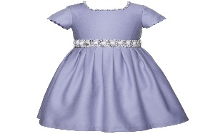

|  |  |  |
| --- | --- | --- |
| Name: | Grade: 2____ | Date: 06/10/2020 |

Summative assessment for the unit

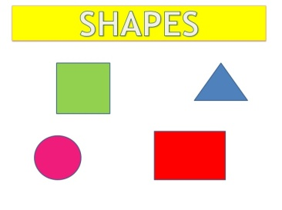**Task 1**

Say shapes and colours

**Task 2.** Look at the pictures. Say name of the clothes



**Task 3**

**2.S8 Give simple instructions for others to follow**

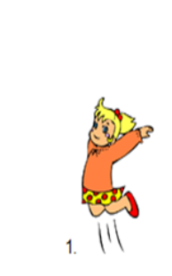

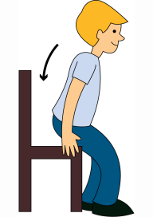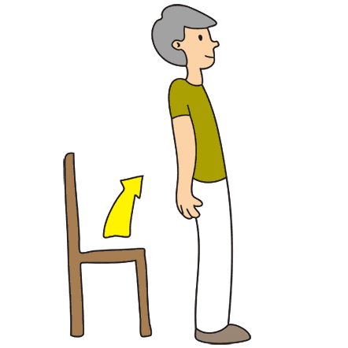

**Task 3**

**2.S8 Give simple instructions for others to follow**