Unit title : Holidays and Travel |  |  |  |  | School: Secondary school №44 named after by Sh.Smaлhanuly
Lesson title: Life is - Journey |  |  |  |  | Teacher’s name: Baglanuly R.
Grade : 7-A |  |  |  |  | Number present:13 | absent:0
Learning objectives |  |  | 7.C 6 organize and present information clearly to others  7.C8 develop intercultural awareness through reading and discussion  7.S2 ask simple questions to get information about a limited range of general topics.  7.S6 communicate meaning clearly at sentence level during ,pair group and whole class exchanges  7.W3 write with support factual descriptions at text level which describe people, places, and objects
Lesson objectives |  |  | - listen and speak about the “journey”  - listen and understand with little or no support the main points “ journey”  - write some information for describing about travelling
Assessment criteria |  |  | - speak about the theme journey  - describe the main points  - argue the quotations of countries and language using present continuous
Language object |  |  | Country, language, flag, place, capital, forest, river, lake, mountain
Values links |  |  | Common history, culture and language
Cross- curricular links |  |  | Geography & History
Previous Learning |  |  | Students will be asked about journey and tavelling
Plan

Planned things | Planned activities |  |  |  |  |  |  | Resources
Start  2 min  3 min  3 min  6 min | Organization moment  Lead-in  Greeting: Teacher greets the learners; learners respond to greeting of the teacher and take their places.  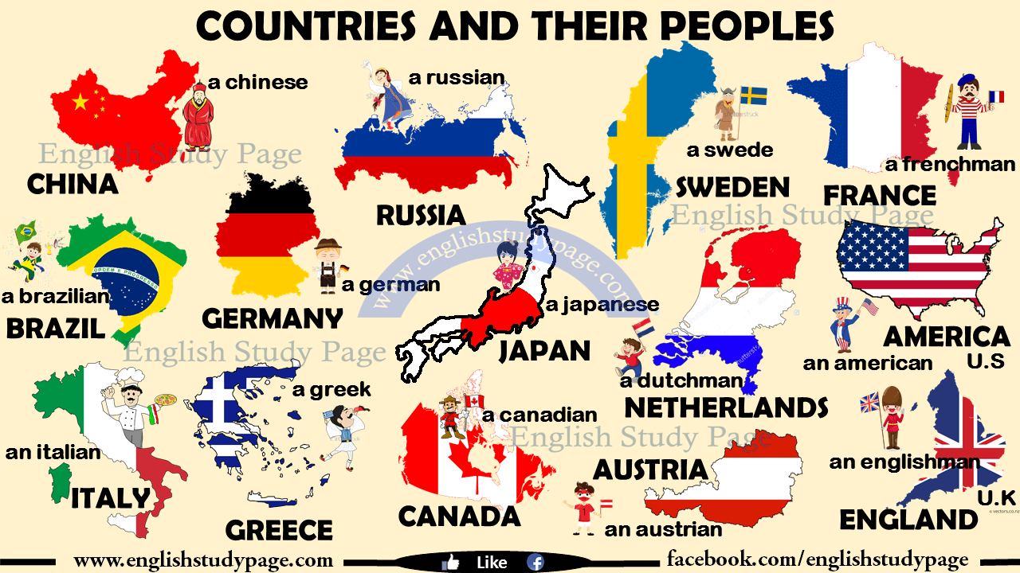  Brainstorming . For eliciting STT teacher asks for describe (W)  Group Division: Students are divided into two subgroups using cutting pictures. First group choose the picture “USA” . The second group choose the picture “England”.  Checking home task. Students answer vocabulary each other with the methods “Free microphone”  Pre- watching task 1 (G). Video about journey . Method “VvV” Virtual video vocabulary. Give the description of this video and answer next question  - What kind of new words do you see in this video?  - What kind of and vocabulary did you saw?  Descriptor:  - Give right answer  - Keep in mind an information |  |  |  |  |  |  | Picture  countries-nationalities-and-languages_8215_4.jpg  FREE MICROPHONE  Video around the world
Middle  6 min  10 min | Presentation a new theme  Task 2. Teacher hands out a worksheet with pictures and repeat new words. Give them a poster . Students should write where they want to go?  Task 3. Active learning : working in group and analyze the meaning of words, match each words with correct picture.  Grammar : Present continuous.  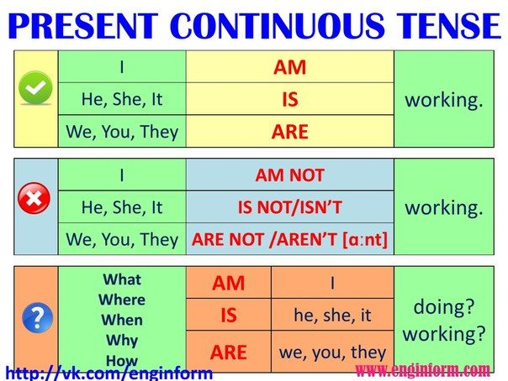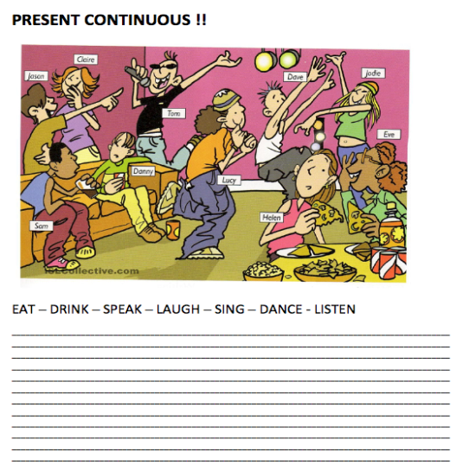  Differentiation: less able learners match the words with pictures with the help of peers, more able learners give examples and make sentences  Teacher demonstrates the new words using pictures:  Descriptor  - Divide into 2 groups  - Answer without mistakes  Puzzle time song : Hello to all the children in the world |  |  |  |  |  |  | Power point Presentation 2  Power Point Presentation 3  HELLO TO ALL THE CHILDREN OF THE WORLD.mp4
End  7 min  3min | Conclusion. Project work  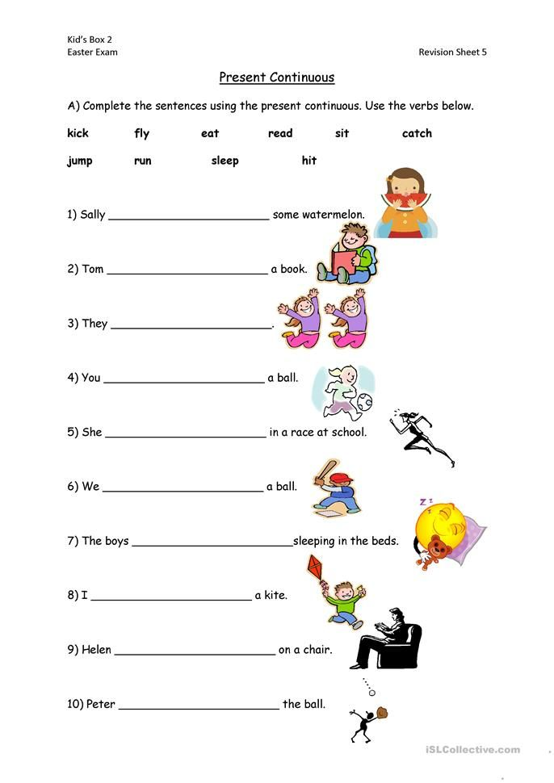  Reflection  Strategy “Draw your brain and dialogue in a stick”. Learners draw the outline of a brain in a sheet of paper and fill it with words that explain what they have learnt during that lesson and write the wors in their mind to the sticker.  Home task: Do all the task about journey from your work book and worksheet. |  |  |  |  |  |  | Power Point Presentation 4  Power Point Presentation 5  brain1.jpg  
Additional information
Differentiation – how do you plan to give more support? How do you plan to challenge the more able learners? |  |  |  | Assessment – how are you planning to check lea Number present: students learning? |  |  | Health and safety check
Work with vocabulary  Most support : by providing reading instructions  Some support : by pronouncing orally some words.  Minimal support: giving opportunity to describe the pictures themselves.  Listening a video information  Most support : highlight the key words, with the definition after the video  Some support : highlight the key words combined with pictures  Minimal support: video left blank for pupils to highlight key words |  |  |  | Pre – watching: (Group assessment) students should assess their partner traffic lights  Green- all answers are right Yellow-some answers are right Red-no right answers.  Teacher makes observation and makes notes. Provides with correct answers.  Active learning (Pair assessment) students assess each other by answers saying right or not  Project work (Group assessment) leaners show thumbs up , middle or down according to the criteria.  - Thumbs up – all criteria are done  - Thumbs middle – some criteria are done  - Thumbs down - not fit the criteria |  |  | Health saving technologies.  Using physical exercises and active activities.  Rules from the Safety Rules book which can be applied in this lesson.  -Health promoting techniques  -Breaks and physical activities used.
Reflection  Were the lesson objectives/learning objectives realistic?  Did all the learners achieve the lesson objectives/ learning objectives? If not, why?  Did my planned differentiation work well?  Did I stick to timings?  What changes did I make from my plan and why? |  | Use the space below to reflect on your lesson. Answer the most relevant questions from the box on the left about your lesson.  - The lesson learning objectives realistic  - The learners learn today sport for all  The learning atmosphere like pair work and competition
- Actually yes, it should good results and deal with the set objectives

- Of course, followed the time I tried to keep up.

- I tried not to depart from the topic and followed the set tasks

Summary evaluation

What two things went really well (consider both teaching and learning)?

1: pre-listening task (the words were familiar)

2: timing and group activities (because all task are limited )

What two things would have improved the lesson (consider both teaching and learning)?

1: differentiation activities (providing support)

2: according to students’ abilities

.

