Unit 4 |  |  | School: Secondary school №42, Nur-Sultan
Date: |  |  | Teacher name: Gulaiym Kairbekova
CLASS: 5 А |  |  | Number present: |  | absent:
Lesson title: Professions |  | Unit 4: The world of work
Learning objectives(s) that this lesson is contributing to (link to the Subject program) |  | 5.L1understand a sequence of supported classroom instructions  5.C8 develop intercultural awareness through reading and discussion  5.UE10 use present continuous forms with present and future meaning on a limited range of familiar general and curricular topics
Lesson objectives |  | All learners will be able to answer the questions according to the picture.  Most learners will be able to describe the pictures according to the Present Continuous and they use pair work.  Some learners will be able to give opinion according to the certain pictures and they use pair work.
Assessment criteria: |  | Learner can:  -understand sequence of supported classroom instructions  - develop intercultural awareness through reading and discussion  -use present continuous forms with future and present meanings
Values links |  | 3) A secular society with high spirituality
Cross-curricular links |  | Self-knowledge
Previous learning |  | Names of formal and informal professions.
PLAN
Planned timings | Planned activities (replace the notes below with your planned activities) |  |  | Resources
Start | Org. moment  -Greeting.  -Dividing into 3 groups by colored sheets  Warm up. Stay in a circle. Take colored sheets and there are wishes for every pupil, they should read and translate the wishes.
Middle | Presentation  Brain storm. A learner looks at the picture and names the profession.  1) Who is he?  - He is a builder.    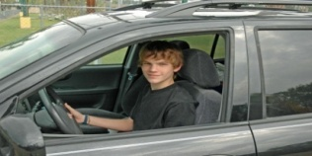  2) Who is he?  - He is a driver.  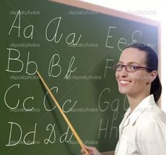  3) Who is she?  - She is a teacher.    4) Who is he?  - He is a dentist.    5) Who is he?  - He is a cooker.    6) Who is he?  - He is a pilot.  Task1. Listening. Presentation with professions. From the book. They listen and say in chorus.  Assessment criteria Descriptor  - Apply speaking and listening skills A learner: -works on new words - listen to the speech attentively - guess the pictures according to the text  Task 2. In pairs, match the sentences (1-8) to the pictures (A-H), then they should check each other, then we will check all together.  Assessment criteria: Descriptor  Complete the sentences A learner: -match the sentences -work with pictures -works with each other  AFL: Traffic light cards    Working with new vocabulary.  an accountant [ә’kauntәnt] – есепші  a baker – [beikә] – нан пісіруші  a cashier [kæ’ʃiә] – кассир  a lawyer [‘lɔ:jә] – заңгер  a librarian [lai’breәriәn] – кітапханашы  a builder [‘bildә] – құрылысшы  Task 4. Divide professions into two groups  Indoor Outdoor  accountant gardener  teacher taxi-driver  AFL:  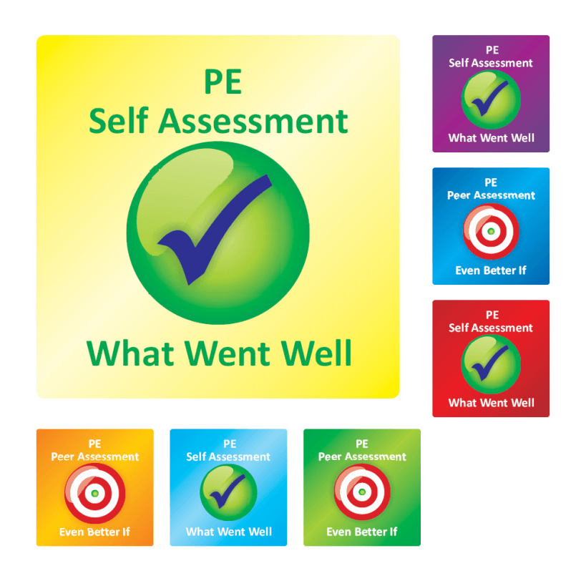  Task 5. PW. Make up a dialogue. (S-S interaction)  "What do you want to be?"  D: Hello!  S: Hello!  D: How are you?  S: I'm OK. And you?  D: I'm fine, thanks.  S: What is your hobby?  D: My hobby is listening to music. What is your hobby?  S: My hobby is drawing pictures.  D: What do you want to be?  S: I want to be a doctor. And what do you want to be?  D: I want to be a teacher.  S: Good bye!  D: Good bye!  Assessment criteria: Descriptor  make up a dialogue according to the theme A learner: -Make up a dialogue -Use closed questions. -Use opened questions.  AFL:  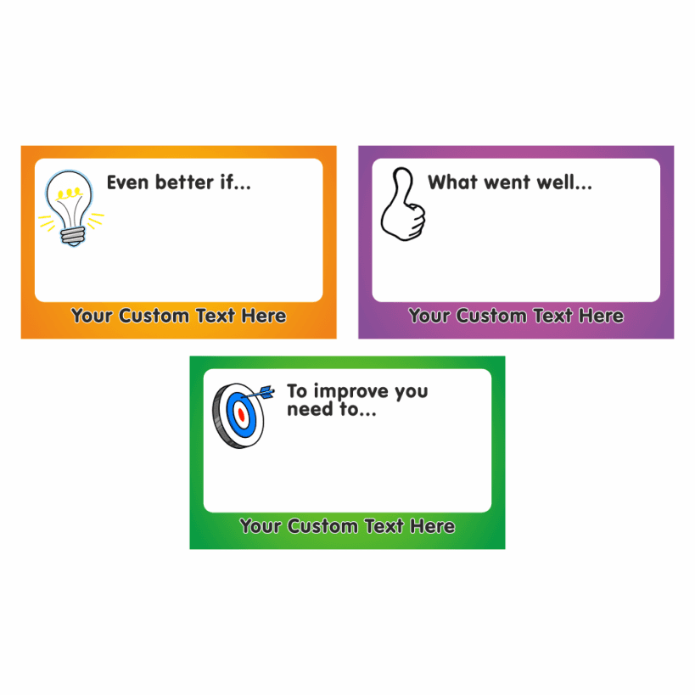 |  |  | Pictures  http://  www.google.com  From the book  From the book  From the book  From the book  From the book
End | At the end of the lesson, students reflect on:  - what they learned  - what remained unclear for them  - what they need to continue working on  Feedback  Name __________________________  I understand I can use this knowledge I can teach someone

