Lesson plan
LESSON: Our class |  |  |  | School:
Date: |  |  |  | Teacher name:
CLASS: 6 |  |  |  | Number present: |  | absent:-
Theme of the lesson: My class’s hobbies and interests.
Learning objectives(s)  that this lesson is  contributing to |  | 6.1.1.1 Use speaking and listening skills to solve problems creatively and cooperatively in groups:  6.2.2.1 understand more complex supported questions which ask for personal information:  6.4.9.1 recognize the difference between fact and opinion in short, simple texts on a wide range of general and curricular topics  6.5.2.1 Write with some support about real and imaginary past events, activities and experiences on a limited range of familiar general topics and some curricular topics.
Lesson objectives |  | All learners will be able to:  - talk about their hobbies and interests  - read the text about people’s interests  - ask and answer the questions about interests with SOME support  - write a short paragraph about their interests with key words  Most learners will be able to:  - ask and answer the questions about interests with LITTLE support  - write a short paragraph about their interests with SOME key words  Some learners will be able to:  - ask and answer the questions about interests without support
Assessment criteria: |  | Learners have met the learning objective, if they can:  - apply speaking and listening skills in discussion to find out solution  - identify difficult questions which ask for personal information with SOME support  - distinguish the main idea of the text  - compose a short paragraph about real events
Value links: |  | A secular society with high spirituality
Cross-curricular links: |  | Self-knowledge
ICT skills: |  | Audio, vocabulary book, pictures, cards.
Previous learning: |  | Vocabulary for describing people, places, things \hobby \interests\free time\I really like\ to be\fond of \to be interested in
PLAN
Planned timings | Planned activities |  |  |  |  |  | Resources
Start  5 min  Middle  5 min  12 min  5 min  8 min  End  5 min | Organizational moment:  (T-S) (W) Greeting. Good day, my pupils. I’m very glad to see you! I hope you all feel well today! Sit down, please, and be ready for the lesson.  Present smiles each other and say wishes Such as I wish… health to be successes etc.  Teacher divides into 3 groups using pictures:  1) Sport 2) Music 3) Computer  Warm-up: T uses the strategy “If this is the answer, what’s the question”. T shows the picture of the theme of the lesson, and asks “If this is the answer, what’s the question”?  Ss answer the question, by giving different questions. In this way Ss identify the theme of the lesson.  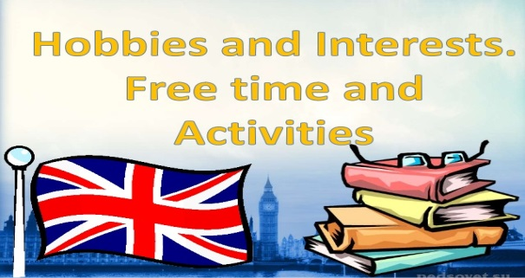  Task 1  (T-S) (S-S) (W) Teacher uses the strategy “Conscripts and Volunteers” using “Thinking time”, Teacher asks questions to students. First students listen to the CD for the dialogue. Then students answer the questions. Teacher allows time for thinking.  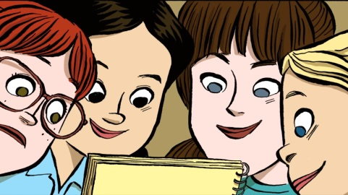  Assessment criteria Descriptor  - Apply speaking and listening skills in discussion to find out solution A learner: - works on new words - listens to the questions - answers for questions - checks the answers  AfL: Smiles    Task 2  (S-S) (G) Teacher uses the strategy: “Mind map”.  Students work in groups of 3.  Each group works with different texts.  Each group reads text and identifies the main idea of the text.  1 group  Hobbies  A hobby is a special interest or activity that you do in your time off. Some people keep pets as hobby. They keep rabbits, or fishes. They train dogs to do tricks, or keep pigeons to race and carry messages. Some are crazy about plants. They try to grow cacti or rare tropical flowers in their kitchens and sitting rooms. Others are mad about their car or their motorbike. They spend their Saturdays and Sundays washing them, painting them, or buying new bits and piece to make them go even faster. Children and teenagers are great collectors. They collect stamps, or postcards or matchboxes, or pictures or a favourite footballer or pop star. Many people make things as a hobby. Some teach themselves at home, but a lot of people go to evening classes at their local college. A hobby is usually something that a person does alone.  2 group  My hobby  There are many interesting things that can be people s hobbies. Some people discover their talent in playing musical instruments, singing or painting. People fascinated by sports find it in football, tennis or ice-skating etc. There are also some options for calm people e.g. collecting things or making models.  As for me I have always been a very energetic person and have always had plenty of hobbies. I was interested in sports, especially volleyball and tennis. I collected stickers, toys and coins, had painting and language lessons, took part in a choir. I think it was the perfect hobby for my body and my soul. I have learned how to express myself through the body movements.  3 group  Hobby  Hobby is what a person likes to do in his spare time. Hobbies differ like tastes. If you have chosen a hobby according to your character and taste you are lucky because your life becomes more interesting. The most popular hobby is doing things. It includes a wide variety of activities from gardening to traveling, from chess to volleyball. Both grown-ups and children are fond of playing different computer games. This hoppy is becoming more and more popular. Making things include drawing, painting, handicrafts. Many people collect something-coins, stamps, compact discs, toy, and books. Some collections have some value. Rich people often collect paintings, rare things and other art objects .Often such private collections are given to museums, libraries.  As for me, I like to listen to music. 3 months ago my parents bought me compact discs. I like different music, it should be good. collect discs of my favorite groups and singers. I carefully study the information printed on discbooklets. I try to find everything about my favorite singers.  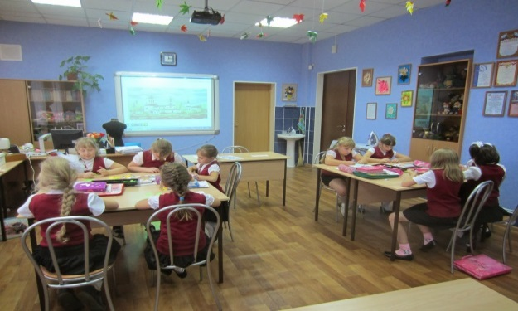  Assessment criteria: Descriptor  Distinguish the main idea of the text A learner: - reads the text - understands the meaning of the text - discusses in groups - draws on mind map - presents the poster  AfL: “Three stars and one wish”    Task 3  (T-S) (S-S) (P) Teacher uses the strategy “Pre listening and Post listening.  Students work in pairs and listen to an audio twice then make interrogative.  Possible questions:  - Who is Rob’s favorite actor?  - When Rob celebrate his birthday?  - What is Naomi’s favorite sport?  Possible answers:  - Keira Knightley.  - In October.  - Tennis.  Assessment criteria: Descriptor  - identify difficult questions which ask for personal information with SOME support A learner: - listens to an audio twice; - memorizes information from dialogue; - answers the questions.  AfL: “ Traffic light cards”  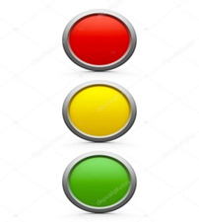  Task 4  (S-T) (I) Teacher uses the strategy “text message”  Students writes short essay about their hobbies.  My Hobby Essay  My favourite hobby is playing football in spare time. After completing my home work at home, I generally spend my lot of free time in playing football. I was so interested to play football from my childhood however sterted learning to play well when I was 5 years old. My father asked to my class when 5 years old. My father asked to my class techer in the PTM about my hobby of hobby of football. And my teacher told him that there is a facility of playing sports daily in the school from class 1 so you can admit your child. How, Ireally enjoy playing footdall and participate in the inter scholl competitions.    Assessment criteria: Descriptor  Compose a short paragraph about real past events A learner: - writes essay about their hobby; - write 50 words.  AfL: “Heads down, thumbs up ”  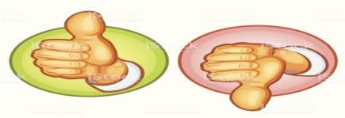  Plenary Ticket to exit the class  (T-S) (S-T) (I)  Give learners a piece of paper with a question about their learning which they should answer and hand over to the teacher before they are allowed to leave the classroom. |  |  |  |  |  | Smart board  pictures  Ex.4 p.12  Smart board,  cards  Speakers  CD .1.09  Smart board
Additional information
Differentiation – how do you plan to give more support? How do you plan to challenge the more able learners? |  |  | Assessment – how are you planning to check students’ learning? |  | Cross-curricular links  Health and safety check  ICT links  Values links
- Task 1. Less able learners differentiate by task. Learners ask for questions using key words. More able learners ask for questions using their own words.  - Task 2. Less able learners differentiate by support. Teacher helps learners to translate topical vocabulary. More able learners find the definition of words, make a poster and present it.  - Task 3. Less able learners differentiated by task. Teacher gives sentences with missing words. Learners while listening find missing words. More able learners listen and identify the main information from dialog.  - Task 4. Less able learners differentiated by outcome.  Teacher gives some ideas for learners to write essay.  More able learners writes essay with their own words to describe their thoughts and ideas. |  |  | - Task 1. Whole class. Learners assess by descriptor and Smiles.  - Task 2. Group work. Learners assess by descriptor and Three stars and one wish  - Task 3. Pair work. Learners assess by descriptor and Traffic light cards.  - Task 4. Individual work. Learners assess by descriptor and Heads down, thumbs up. |  | - Self-knowledge  - Make sure that cords in safe place.  - Audio, vocabulary book, pictures, cards.  - A secular society with high spirituality
Reflection  Were the lesson objectives/learning objectives realistic? What did the learners learn today? What was the learning atmosphere like?  Did my planned differentiation work well?  Did I stick to timings?  What changes did I make from my plan and why? |  | Use the space below to reflect on your lesson. Answer the most relevant questions from the box on the left about your lesson.
Summary evaluation

What two things went really well (consider both teaching and learning)?
1:
2:

What two things would have improved the lesson (consider both teaching and learning)?
1:
2:

What have I learned from this lesson about the class or individuals that will inform my next lesson?

Lesson plan
LESSON:  Unit 5 "Reading for pleasure" |  |  |  | School: №29
Date: 28.06.2019 |  |  |  | Teacher name: Mashurova Zarina Kutlukjanovna
CLASS: 8 |  |  |  | Number present: 12 |  | absent:-
Theme of the lesson: Movie technology.
Learning objectives(s)  that this lesson is  contributing to |  | 8.2.1.1 Understand with little or no support the main points in extended talk on a wide range of general and curricular topics  8.3.2.1 Ask more complex questions to get information about a growing range of general topics and some curricular topics  8.4.6.1 Recognise the attitude or opinion of the writer on a growing range of unfamiliar general and curricular topics, including some extended texts  8.5.5.1 Develop with support coherent arguments supported when necessary by examples and reasons for a growing range of written genres in familiar general and curricular topics
Lesson objectives |  | All learners will be able to:  - read the text  - talk about cinema history  - make a scheme in the correct order on the timeline  -  Most learners will be able to:  - introduce author`s opinion to the class  - complete the sentences with suffixes –er, -or  Some learners will be able to:  - discuss complex questions to get information about Movie technology
Assessment criteria: |  | Learners have met the learning objective, if they can:  -  -  -  -
Value links: |  | ?
Cross-curricular links: |  | ?
ICT skills: |  | ?
Previous learning: |  | ?
PLAN
Planned timings | Planned activities |  |  |  |  | Resources
Start  ? min  Middle  ? min  ? min  ? min  ? min  End  5 min | Organizational moment: ?  (T-S) (W) ?  Warm-up: ?  (T-S) (W) Teacher ?  Task 1  (T-S) (S-S) (W) Teacher uses ???  ?  ?  Assessment criteria Descriptor  A learner:  - ?  - ?  - ?  - ?  ?  ?  ?  Task 2  (T-S) (S-S) (G) ?  ?  ?  ?  ?  ?  Assessment criteria: Descriptor  - ? A learner: - ? - ? - ? - ? - ?  AfL:“???”  Task 3  (S-S) (P) ?  ?  ?  ?  ?  Assessment criteria: Descriptor  ? A learner: - ? - ? - ? - ?  AfL: “???”  Task 4  (S-T) (I) ?  ?  ?  ?  ?  Assessment criteria: Descriptor  ? A learner: - ? - ? - ? - ?  AfL: “???”  Plenary  “???”.  (T-S) (S-T) (I) ?  ?  ?  ? |  |  |  |  | ?  ?  ?  ?  ?  ?  ?  ?  ?  ?  ?  ?  ?  ?  ?
Additional information
Differentiation – how do you plan to give more support? How do you plan to challenge the more able learners? |  |  | Assessment – how are you planning to check students’ learning? |  | Cross-curricular links  Health and safety check  ICT links  Values links
- ?  - ?  - ?  - ? |  |  | - ?  - ?  - ?  - ? |  | - ?  - ?  - ?  - ?
Reflection  Were the lesson objectives/learning objectives realistic? What did the learners learn today? What was the learning atmosphere like?  Did my planned differentiation work well?  Did I stick to timings?  What changes did I make from my plan and why? |  | Use the space below to reflect on your lesson. Answer the most relevant questions from the box on the left about your lesson.
Summary evaluation

What two things went really well (consider both teaching and learning)?
1:
2:

What two things would have improved the lesson (consider both teaching and learning)?
1:
2:

What have I learned from this lesson about the class or individuals that will inform my next lesson?

