Unit of a long term plan “Kazakhstan in the world of the sport” |  |  |  | School: Secondary school №9
Date: |  |  |  | Teacher name: Harshinbay Milliona
CLASS: 4 |  |  |  | Number present: |  |  | absent:
Lesson title |  | Children’s games 2
Learning objectives(s) that this lesson is contributing to (link to the Subject programme) |  | 4.3.2.1 ask questions to find out about present and possibly past experiences on an increasing range of general and some curricular topics;  4.4.3.1 write with support short sentences which describe people, places and objects;
Lesson objectives |  | All learners will be able to:  ask questions to find out about present and possibly past experiences of children’s games;  write with support short sentences about children’s games;  Most learners will be able to:  Differentiate children’s games;  Describe children’s games with short sentences in written form;  Some learners will be able to:  Compare children’s games;  compose mini text with support about their favourite games.
Assessment criteria |  | Ask questions to find information and write short sentences about children’s games.
Values links
Cross-curricular links |  | PE
Previous learning |  | Children’s games 1
Plan
Planned timings | Planned activities (replace the notes below with your planned activities) |  |  |  |  | Resources
Start  5 min | Greeeting  Match the pictures with the definitions and find the words.  a) 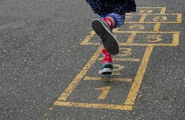 b)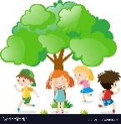 c) 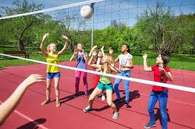  1.() The game when children are hiding and one of them is seeking.  2.() For playing this game you need a ball  3.() In this game you should jump  Teacher divides pupils into 4 groups by the strategy “Greeting card”.  Students should find pieces of their card. Then they find their partners in a group. |  |  |  |  | PPT  Cards
Middle  3 min. | Task 1. (W) Read the text about the children’s game Strategy “Jigsaw”.  Descriptor:  - Understand the main points of the text  - Discuss each parts of the text  Task.2. (I, f) Find your corresponding question or answer. Strategy “Partner”  Descriptor:  - Read the answer or question clearly  - Find corresponding answers  Task 3. (G, f) Make convergent questions according to the puzzle (Strategy “Puzzle”)  .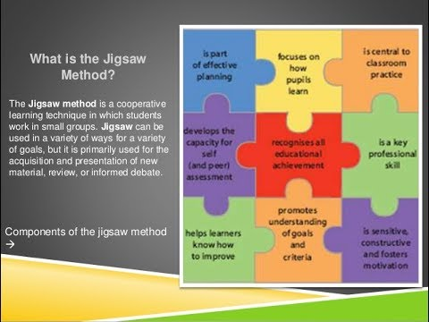  Descriptor:  - Collect the puzzles  - Make questions  - ask questions to find out about games  Task 4. (G,f) Write on the paper description of your game with short sentences using an example with table and key words and find the game. (Strategy: “Meaning graph”)  (They must exchange their descriptions with other groups. If the descriptions are unclear, they can ask questions. In the end the chief of each group will name the game.)  Descriptor:  - write the descriptions using key words.  - Ask questions if it unclear  - Find the name of the game  - Describe the games  Task 5. (I, f). Write your own favorite game on the given paper with the help of example. (Informative Writing Graphic organizers)  Descriptor:  - Use the words according to the topic  - Write sentences correctly |  |  |  |  | Pieces of text  Cards  Puzzle  Worksheet  Worksheet
End  5 min. | Reflection “Write around” |  |  |  |  | Papers
Additional information
Differentiation – how do you plan to give more support? How do you plan to challenge the more able learners? |  |  | Assessment – how are you planning to check learners’ learning? |  | Health and safety check
Differentiation by tasks For example Task 5. Write your own favorite game.  I plan to give more support the less able learners to write your favorite game using the words and phrases in the box according to the topic  I plan to challenge the more able learners to describe the games and write complex sentences about favorite children games.  Differentiation by group.  it's an efficient way to teach a concept or skill to multiple students at one time. It is useful to address distinct learning needs. Students may be working independently, in small groups, in pairs, or using technology. |  |  | Response cards.  “First of five”.  Peer assessment |  | Use active methods of effective learning

