Date: | 21.12.2018
School: | School-gymnasium №1
Teacher’s name | Firuza Akhmetova
Grade: | 7 A
Unit: | Holiday and traveling
The theme: | Discussing unusual and interesting journeys across Kazakhstan and around the world
Learning  objectives(s)  that the lesson is  contributing to | 7.C6 organize and present information clearly to others  7.L5 understand most specific information and detail of supported, extended talk on a range of general and curricular topics  7.S3 give an opinion at sentence and discourse level on an increasing range of general and curricular topics  7.S4 respond with limited flexibility at both sentence and discourse level to unexpected comments on a range of general and curricular topics
Level of thinking skills | • Higher order thinking skills
Assessment criteria | - Present and explain information clearly to others  - Find specific information from the text  - Apply an opinion on a growing range of general and curricular topics  - Interpret the main points in extended talk on a limited range of general and curricular topics
Lesson  objectives | All learners will be able to:  - revise the topic vocabulary;  - make questions with some grammatical mistakes.  Most learners will be able to:  - do 65% of the listening task;  - use wide range of the topic vocabulary in their speech.  Some learners will be able to:  - make grammatically correct questions;  do 85% of the listening task correctly.
Cross curricular links | Geography
Value links | Be a responsible traveller
TIT | Activeboard, computer, CD, projector, handouts, cards
Prevoius learning | Revision
Pl anned timings | Planned activities (replace the notes below with your planned activities) | Resources
Start  1min  1 min  3 min+1min for checking the answers | I. Org.moment: a) Greetings: Teacher starts the lesson with questions  – What date is it today?  –What is the weather like today?  – What is the temperature?  -What kind of day is it today?  Revision of previous theme: Teacher asks learners to fill the columns with advantages and disadvantages of technology. Ss share ideas.    Descriptor A learner  - completes the task  II. Brainstorming  . Warm-up activities.  SS look at the pictures and guess the theme  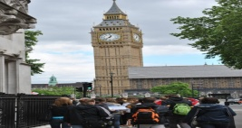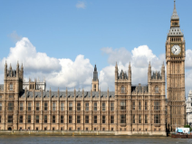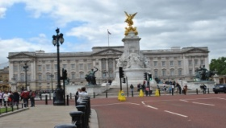  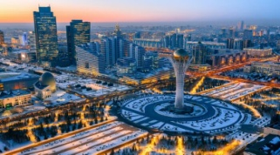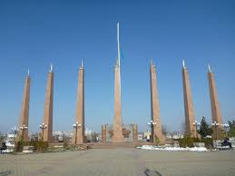  [P] pair assessment  New vocabulary  Ss match new words with their definitions  - traveling  - quickly  - tour  - hiking  - sightseeing  - learn  - expensive  - improve  - prefer  - possible  - like better; choose rather than:  - a traveling around from place to place  - to go from one place to another, as by car, train, plane, or ship; take a trip; journey:  - the act of visiting and seeing places and objects of interest  - with speed; very soon.  - that may or can be  - to make more useful, profitable  - a long walk or march for recreational activity, military training, or the like.  - very high-priced  - teach’  Descriptor A learner  - demonstrates a good skill in matching the information  - works cooperatively in pairs
Middle  Middle  5min  5min  10min+5 min | Task 1  [I]- self assessment  Pre- Listening students listen tape script then find the answers for the questions  - What is the main idea of the topic?  - What are the main sights of London?  - What is Millennium wheel?  - What is Big Ben?  - Where is an Open Air theatre?  - In what street is the British museum?  - What is the Tate modern museum?  - Where is the new Docklands area?  - Where is St. Pauls cathedral?  - How do the police keep an order in parks?  Descriptor A learner  - -understands the video material  - -answers the given questions;  - -evaluates the other’s answers  Task 2 [G] – group assessment  Ss listen one more time for finding specific information while reading  - 135  - 32  - 2000  - 1815  - 10th of June  - 530  - At 11 a.m  - 40  - 15  - 2  Descriptors A learner  - -finds specific information from the video  - -writes the appropriate information.  Task 3  Group work [G] –student assess according to the descriptors  T: Now students, imagine that we have tourists from foreign countries. What places would you like to show them. Make a poster “Where to go in Kazakhstan.”  Descriptor A Learner  - uses topical vocabulary.  - pronounces words correctly  - presents information to the class clearly  - spells the words accurately.  - works cooperatively in a group;  - answers classmates’ questions | A2 format posters  Felt-tip pens
6 min | - Listening and reading.  T: Now students, listen to the recording and write missing words to fill in the gaps.  Travelling gives you many 1______________ experiences you cannot find in your own country. You meet local people and get to understand 2_____________ cultures. It’s so exciting. I love planning trips and doing some research on the country or countries I want to visit. Sometimes I like to plan everything in advance, my flights, hotels and tours, etc. For me, the most 3 _____________ thing is arriving in a country with no hotel reservation and no fixed plans. I prefer staying in hostels and guest houses. You get to meet and talk to different and 4_______________ people and share information. I also like to visit places that are off the beaten track. Being 5 ________________ with thousands of other tourists? It’s not my cup of tea.  Descriptor A learner  - completes sentences with right words while listening  Key: 1) wonderful 2)different 3)exciting 4)interesting 5) somewhere | http://www.listenaminute  .com/t/travelling.mp3  Worksheets
3 min | Plenary: Student take the card with questions which I gave them at the beginning and answer them. We wrap the lesson.  Descriptor A learner  - Answers the questions  Reflection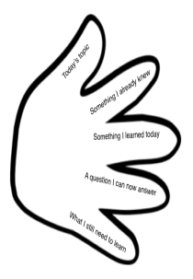 | Reflection cards (hands)
Typescript for video material
Text A
This is London, the capital city of England and the United Kingdom. The big wheel you can see is the Millennium Eye or London Eye as it’s known. It is 135 meter high with 32 glass capsules. The wheel was opened in March, 2000 to mark the beginning of the new millennium. Opposite the Millennium Wheel you can find Big Ben, the famous clock tower and the Palace of Westminster, also known as the House of Parliament. This is where the Government meets. One of the best things about the London is its parks. In Regent’s Park you have the largest grass area for sports in Central London and an Open Air theatre. You relax, walk and run in the parks but you can’t cycle – only police can do that. Horses are another good and ecological way of keeping order in London. This is Trafalgar square with the National Gallery art museum in the background. Nelson s Column is a monument to Admiral Nelson who died at the battle of Trafalgar in 1815.You can also visit British museum in Great Russell street or walk over the new Millennium Bridge to the Tate Modern Museum When it opened on the 10th of June, the Bridge had to be closed after just a few days because it was moving too much. Don’t worry it’s ok now. The Tate Modern museum is a converted old power station. On the other side of the Millennium Bridge is St.Paul’s Cathedral. It’s a tourist attraction and you can walk the 530 steps up to the Gallery and see London. Another feature of London is the Changing of the Guard which takes place inside the grounds of Buckingham Palace every day at 11 a.m. You can take a boat along the Thames. This is Tower Bridge it opens up for big boats and all the car traffic has to stop for about 15 minutes. You can also walk along the top bridge that joins the two towers. If you keep going east, you arrive in the new Docklands area. There are a lot of big offices and expensive new apartments on the river there. Time certainly files when you’re travelling around the London.

