Ministry of education and science of the Republic of Kazakhstan

Turkestan region, school №20 by named Amangeldi

**Report**

**Theme : Creating methodological resources to implement CLIL language integrated learning**

**Teacher: Ospanova D**

**Content**

1. **Introduction**

**CLIL in the educational process**

1. **Main part**
2. **Core features of CLIL Methodology**
3. **What are the benefits using CLIL?**
4. **Planning a CLIL lesson**

* **Maths in English lessons**
* **Animal Planet**

1. **Conclusion**
2. **References**

***«The key priority of educational programms should be the development of the skills***

***which allow students to constantly adapt to changes and assimilate new knowledge»***

address by the President N.A.Nazarbayev dated by January 10, 2018

«New Opportunities under the Fourth Industrial Revolution»

The modern world is changing very fast day by day. Technology is developing so rapidly. New machines and gadgets which were considered to be the most modern ones a year before become out-of-date today. And skills which made you successful yesterday might not help you to cope with the problems you are faced today. So, one should be able to adapt to any changes, to gain skills which can be useful to overcome difficulties and achieve goals.

And what can schools of our country teach their students to use their knowledge effectively in real life? Do our graduates have enough skills to be competitive in the modern world of globalization and modernization? The results of PISA, TIMSS and PIRLS conducted by OECD and IEA showed that our students are not so bad at memorizing and recalling, but, unfortunately, they are not so good at applying gained knowledge in different situations of real life i.e., they are lack of twenty-first century skills (created by OECD) such as critical thinking, ability to creatively apply knowledge, ability to solve problems, research skills, communication skills (including language skills), ability to work in groups and individually, ICT skills.

President Nursultan Nazarbayev in his Address to the Nation «Socio-economic modernization is the main vector of Kazakhstan's development» today the Nazarbayev University and intellectual schools are successfully working on the basis of international standards. It is necessary to extend our experience to the entire Kazakhstani education system and to involve all educational institutions in their level». [1] And Nazarbayev Intellectual schools have changed their educational program to include the best international practices and incorporate them into the learning process. The program is aimed at the development of Kazakh, Russian and English languages, as well as support for teachers and students in Kazakhstan.

We all know that the system of education in society depends on the foundation of the future society. It is important to note the role of language, which is the most important one and taking the central place in society and its system of relations. In its term the educational institution creates and develops conditions for successful foreign language learning.

That is why there are new educational technologies in the educational process and one such technology is the subject and language integrated learning called CLIL.  
 The abbreviation CLIL means Content and Language Integrated Learning — integration of foreign language teaching and other disciplines. For the first time the term was suggested by David Marsh in 1994. The first time this term meant the process by which an academic discipline or their separate parts were taught in a foreign language. To achieve the ultimate goals of the educational process posed a twofold purpose: studying of the subject and the simultaneous learning of a foreign language. Marsh conducted his research for several years, and by 2001 had developed a methodology of learning-language integration and described it as follows: **CLIL considers learning a foreign language as a tool for learning other subjects.**[1].  
 This method is considered to be one of the most successful, as it allows you to combine the study of two or more subjects, one of which is a foreign language.  
You must also consider the principle of “C” 4 » with» CLIL methodology: content, communication , cognition , cultural knowledge. [2].

Like any other technology, this method has its pros and cons. First, by means of this technology the study of the English language becomes purposeful, because language is used for solving specific communicative tasks, increases motivation, forming socio-cultural competence, updated vocabulary of subject terminology.  
However, having such a lot of positive aspects, in the implementation of this methodology there can be some problems in the educational process.

There are  two main reasons :

1.the lack of teachers of a foreign language who have sufficient knowledge on a particular subject and

2.language deficiencies of a teacher. Negative aspects include the imperfection of some English textbooks, and an insufficient number of training sessions according to the educational program.

The application of the technique also makes a different proficiency level foreign language learners, which may lead to an increase in teaching load and, consequently, to a number of psychological and psychosomatic problems. The teacher, in turn, also has to face certain requirements, such as the use of various forms and methods of presentation of educational material and organization of educational activities, to take into account individual abilities of students and to be in constant creative search.

Over time, working on the CLIL methodology, the teacher takes on specific competencies.  
A lesson with the use of approach (CLIL) has two goals: the subjective and lingual. Lesson planning assumes that the teacher must foresee the possible language difficulties of the students in mastering the subject material and to provide support for «solving» these problems. [4,25].  
 In class (CLIL) should  attend all kinds of speech activity, although the features of the approach (CLIL) is such that the reading takes most of the training time. However, the teacher can plan the lesson so that some of the material can be presented in the form of text, using search methods of learning may come to understand the material through dialogue and conversation. Listening can be combined with the letter (completing tables, constructing schemes, restoration of missing). In the selection of educational material, you need to choose diverse style authentic texts that meet the age peculiarities and level of language proficiency of students. You can also use audio and video materials. Texts are perceived better when they are broken into small chunks, and accompanied by illustrations, diagrams, maps, etc. Texts should contain rereading and after reading tasks [3,12].  
**During the lesson you must:  
-to name the goals clearly and expected results of the lesson.  
-to create a favorable educational environment for the study of languages;  
— to develop four kinds of speech activity (reading, listening, writing, speaking);  
-to repeat the incomprehensible sentences and phrases a few times to the students if needed;  
— to use the vocabulary available to perception;  
— to work with key words;  
— to encourage the students  for using the lesson in a second language;  
to use different types of activities to increase motivation.  
The CLIL approach entails the integration between linguistic and non-linguistic objects not only in the classroom but also outside the lessons [5,20].**

CLIL as a method has the following benefits:



Integration of content and language teaching poses a number of questions and challenges for the teachers. The biggest challenges lie in incorporating development of both students subject and language knowledge and skills, selecting and adapting materials to meet the CLIL purposes : to communicate subject content orally, to develop listening and reading strategies , and to support written or physical production . It is crusial to carefully plan a CLIL lesson , taking into account the CLIL context and teaching aims and objectives by applying the 4Cs Framework: content ( subject matter ) , communication ( language learning and using ), cognition ( learning and thinking processes ) and culture.

There are several important factors and considerations that must be taken into account when planning an integrated lesson : the teacher should think about content area skills and concepts that can interrelate most effectively with the language goals, about the language competences that are needed for studying the content , about the cognitive skills necessary to perform the tasks related both to the content and foreign language, and finally about to the potential for integration of the content with language goals and cultural concepts and goals.

As a result , the first step in planning is related to choosing the content area. The concepts may come from any of the academic subjects in the curriculum : mathematics, language, music ,physical education . The teacher has to find out which concepts lend themselves best to teaching in English. This decision can be made in cooperation with the subject teacher or the class teacher who teaches respective academic subjects to the class.

The next step is choosing a theme or topic. The theme should be motivating, interesting and relevant to the learners and to the teacher. It must be connected to real-life situations and provide a context for meaningful, authentic discourse and interaction and thus facilitate the development of appropriate, useful and real-life language functions and communication modes, and connect to the target culture(s), wherever possible (Shin, 2007, p. 4).

It is now important to make a list of the activities that will facilitate achievement of goals and outcomes in the above two areas. The tasks should appeal to learners of different learning styles (visual, auditory, kinaesthetic, or tactile, to mention the most prominent ones) and provide the context for real-life communication.

Activities should provide the balance of all four skills, starting with pre-listening or pre-reading activities that prepare students for listening and reading input, and proceeding with listening or reading input activities, building listening or reading skills, and finally involving speaking and writing activities. Shin (2007, 5) argues that activities should be organised and ordered by:

* **varying the task and language skills**
* **choosing the activities that are the most useful to particular group of learners**
* **ordering the tasks to mirror the real life application of the tasks**
* **connecting one activity to the next (from receptive to productive skills)**
* **sequencing the content in order to recycle language and scaffold students’ learning.**

The aim of this presentation is to show a practical example of a CLIL lesson. Cross-curricular exercises from various sources have been shaped into a PPT presentation used in the 3rd grade classroom to introduce the English used for basic arithmetic. The 40 minute lesson consists of introducing the numbers from 10to 20 and the words for sums, followed by practicing doing sums and problem solving. The aim of the lesson is doing sums in English, as well as doing sums in general, which is a part of the regular Maths syllabus for the 3rd grade. Each of the stages of the lesson is accompanied with a brief explanation.

### Maths in English – Stages of a PPT lesson

Stage 1: Introduction

- The children are asked to revise the numbers shown in the presentation. The teacher can point at numbers in random order, and ask the whole group or individual children to say the number.



Say the numbers

2 14 6 13 5

13 18 8 19

12 9 11

20

Numbers 20 - 50

* Listen and repeat.

20 twenty

30 thirty

40

5fo0rtyfifty

- The ten numbers from 20 to 50 are introduced. The children’s attention is drawn to pronunciation of –ty ending.



Write the missing symbols

* 1. 24 7 = 17
* 2. 40 4 = 10
* 3. 5 x 5 25
* 4. 13 14 = 27
* 5. 7 7 = 49
* 6. 25 5 = 25
* 7. 30 13 = 17
* B Say the sums aloud.

*Twenty-four minus seven equals seventeen.*

* + Show your student
  + Show your students the sums without symbols. Ask them to write the missing symbols in their exercise books. Then present on the slide the correct answers. ( Use entrance by mouse- click option in the PPT).

Ask the students to say the sums aloud in order to practice the English for basic arithmetic.

The English for basic arithmetic can be practised in almost each following lesson. Instead of saying *Open your books, please, page 24.*, you can check their arithmetic and language skills by saying *Page 6 times 4, please* . The language for basic mathematical skills is rather simple as well as enjoyable, and maybe the best point of it is that even the children who aren’t amongst the strongest in the language classroom, can cope well with Maths in English.

After years of teaching the same vocabulary and using the same coursebook, don’t you want to freshen up your lessons with some new activities? Whether you are using various internet tools, making original crafts, doing a project or connecting English as a second language with some other subjects, always make sure your students have fun.

Although some teachers keep denying that we need 21st-century skills for teaching, the fact is our students are 21st-century students and we have to be up to date. This paper, by exploring different activities, enables me to share some ideas and emphasize the importance of combining traditional approaches, activities and materials with modern resources. As a result, students are presenting, sharing, collaborating, and using higher order thinking.

### Crafts, crafts, crafts!

When teaching young learners, using crafts is almost a must. Except from allowing students to express their creativity, it also promotes pair and group work and fullfils the most important aim at this age - it makes English fun!

Examples:

1. 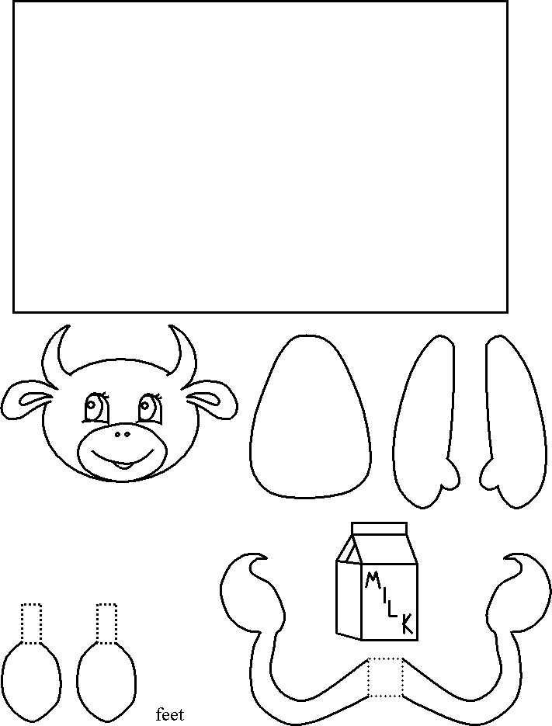Make a cow using a roll of toilet paper and this pattern.
2. Draw and cut the elephant. Cut the circle where the trunk is supposed to be and put your arm through the hole. Use your arm to mime a trunk and to move it while speaking. Children love it!



### A magazine

When consolidating certain topis we tend to ask our student to create a poster. Why not go a step further and create a magazine. In many ways a student magazine is the ideal project for language learning. There is a clearly-defined end product while there is also plenty of room for choice regarding content. The students can focus on individual interests such as animals, sport, computers, the environment, music, etc. - with obvious motivational benefits - while at the same time working within a clear structure to a common aim.

The 'four skills' of reading, writing, listening and speaking are integrated naturally. Within the overall school context a magazine is useful in providing a focus for written work: students know that a particularly 'good' piece of writing might go into the magazine. This potential for communication with a real audience provides motivation and encourages attention to style and accuracy. Students have a chance to practise a variety of text types - articles, reviews, letters, crosswords, cartoons, graphs and tables.

### Who wants to be a millionaire?

This is one of the best teaching games ever invented. This incteractive power point presentation combines English language and fun. It is used for almost any kind of revision, however the fun part is it includes sounds, images and effects same as in the original version of this world famous quiz. Technically, ‘millionaire’ is played individually, but you can have teams competing against each other.

This is a great lesson for revision as you can cover lots of topics quite painlessly. You can download it by visiting <http://www.teachnet.com/lesson/misc/index.html>

### Conclusion

These are only some of the ways we can collaborate and share with our students. I want to analyze, create, evaluate, apply, understand and remember. I want that for my students, too.

I do not want them to feel like they are powering down when they enter my classroom. I want to meet them where they are and not expect them to meet me where I am. I am a teacher with tools available to me. I want to know how to use them. I am a continuous learner myself and I want and can learn these 21st-century skills.

Things have now changed and the previous ‘why’ generations are being replaced by the ‘how’ generations. These are young people who need to feel an immediacy of purpose when they learn; young people who resist learning now for use later. ‘Learn as you use and use as you learn’, is very much a mantra of the new generations, and CLIL is particularly suitable for tapping into this modern learning mindset.

CLIL has often been a grassroots movement, energized by innovative educators, parents and students, or otherwise by equally innovative administrators and decision-makers, and has developed in different ways according to the needs and interests of those involved. There is great potential in now collecting different types of CLIL practice in order to both strengthen existing practice, and open doors for others to see what can be achieved, even when operating with limited resources. This is the strength of this type of publication which seeks to articulate and share insight and good practice on this fast-moving and exciting educational phenomenon.

**References**

1. Ackerl, C. (2007) ‘Lexico-grammar in the essays of CLIL and non-CLIL students: error analysis of written production’ *VIEWZ, Vienna Working English Papers* 16(3) 7
2. ([*www.univie.ac.at/anglistik/ang_new/online_papers/views.html*)](http://www.univie.ac.at/anglistik/ang_new/online_papers/views.html))
3. Baetens Beardmore, H. (2009) CLIL Symposium, IATEFL Conference, Cardiff, UK Clegg, J. (2009) ‘Education through a second language: conditions for success’ *CLIL Conference Proceedings* Norwich Institute for Language Education
4. Cummins, J. 1979. ‘Cognitive/academic language proficiency, linguistic interdependence, the optimum age question and some other matters’ in *Working Papers on Bilingualism*, No. 19, 121-129.
5. Gradoll, D., 2005. IATEFL CLIL debate, Cardiff, UK
6. Hutchinson, John: Project 1, Student’s book, OUP 2008 <http://www.tlsbooks.com/turtlemath.pdf> British Council’s Teaching English
7. . (<http://www.teachingenglish.org.uk/think/articles/clil-a-lesson-> framework), Retrieved in May 2010
8. CLIL Cascade network (<http://www.ccn-clil.eu/)>Retrieved in May 2010
9. CLIL Consortium (<http://www.clilconsortium.jyu.fi/)>Retrieved in May