2 grade. Сheck point 3

**1. Look and write 2. Write**

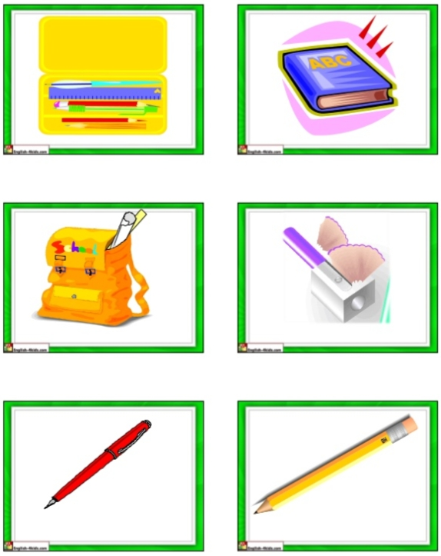 1. bruerb -

2. pne-

3. npeilc-

4. ookb-

**3. Complete**

1. s_ _oo_ 3. ho _s_ 5. f_ _ nta _n

2. s_ r_ _t 4. p_ _k 6. st_ _u_

2 grade. Сheck point 3

**1. Look and write 2. Write**

 1. bruerb -

2. pne-

3. npeilc-

4. ookb-

**3. Complete**

1. s_ _oo_ 3. ho _s_ 5. f_ _ nta _n

2. s_ r_ _t 4. p_ _k 6. st_ _u_