Lesson plan

Unit of a short - term plan |  |  |  | School:
Date: |  |  |  | Teacher name: Nokhayeva Indira Nurlanovna
CLASS: 5 |  |  |  | Number present: |  | absent:
Lesson title |  |  | Nationalities
Learning objectives(s) that this lesson is contributing to (link to the Subject programme) |  |  | 5.L.10 recognise words similar to words in student native language  5 L.6 deduce meaning from context in short, supported talk on an increasing range of general and curricular topics  L USE 9 use simple present and simple past regular and irregular forms to describe routines, habits and states on a limited range of familiar general and curricular topics  5.W.3 write with support factual descriptions at text level which describe people, places and objects
Lesson objectives |  |  | All learners will be able to: Say some nationalities and countries with some support  Most learners will be able to: say most of the given words with little support and write 3 short sentences about themselves using Present Simple and Past simple  Some learners will be able to: given personal details and say to the class and identify the main meaning from the task.
Assessment criteria |  |  | Say12 Nationalities,12 countries and write short sentences using Past and Present Simples.
Language objective |  |  | Learners can: use about Grammar Structure  Key words and phrases: write all the 5-6 nationality and country  Useful classroom language for writing.  Discussion points:  At home correct it  How many nationalities are there in the world?
Values links |  |  | Respect and cooperation
Cross-curricular links |  |  | Geography
Previous learning |  |  | Learner know Grammar Structure possessive pronouns /This That
Plan
Planned timings | Planned activities (replace the notes below with your planned activities) |  |  |  |  |  | Resources
Start  5-10 min | I.Greetings;  Duties repost;  Teacher creates the friendly atmosphere:  Ss stands in circle and greet each other with wish.  Pre - listening  ‘Brainstorming’ strategy  T: show video materials and to give the task.  [G] Ss look at the video and the names of the countries below them.  Ss match the countries to the nationalities. Ss say the words in their language.  Ss check and write the answer in their copy book.  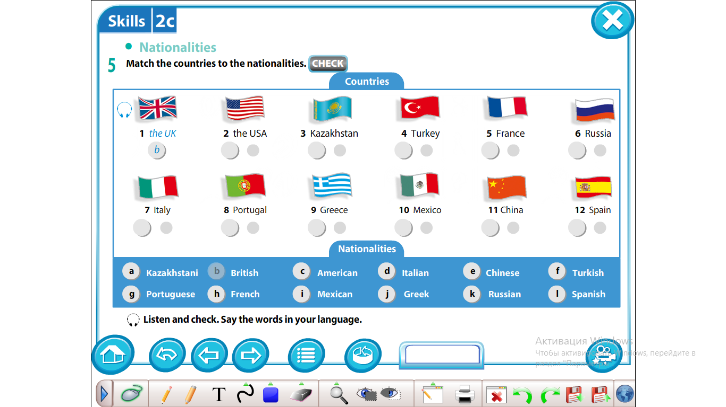 |  |  |  |  |  | Video  SB Excel p 27 ex 5
Middle  10-25min | While-listening  Task 2 [G] A Ss work in group Ss listen to the CD and find the missing information and fill in it. Then Ss say of the nationality of each person.  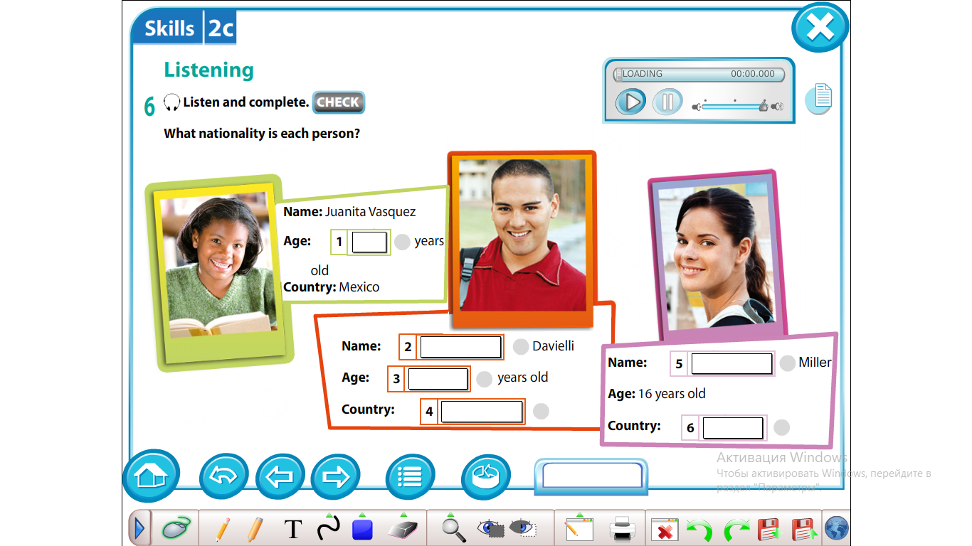  Activity 1: Find some one ‘Who?’  [W] Ss use a checklist as they walk around the class try to find a personal details. Ss ask and answer personal question then Ss use the give details.  For. example: 1. Whose name is Marika?  Who lives in Spain, Valencia?  Who is 15 years old?  Do Physical exercise.  Task 3.  [I] First Ss listen CD and complete the sentences about themselves. Present themselves to the class.  Hi! My name’s ____________ and I’m ________ years old. I’m  from ______________. I’m ____________. My favourite subject  is_________________ and my favourite sport is_______________.  Ss assess themselves with a sticker according to the task.  What have I learnt at the lesson?  - If a student writes 2 sentences he/she goes to the board and stick one sticker to the red line.  - If a student writes 3 sentences he/she goes to the board and stick one sticker to the yellow line.  - If a student writes all sentences he/she goes to the board and stick one sticker to the green line.  SELF ASSESSMENT CHECKLIST  Name: Red Yellow Green  I can write 2 sentences  I can write 3 sentences  I can write all sentences |  |  |  |  |  | SB Excel p 27 ex6  CD [audio]  SB Excel p 27 ex7  CD [audio]  Cards  SB Excel p 27 ex8  CD [audio] and  cards  Appendix
End  5min | Plenary [I] Match the countries [1-12] with the nationalities  [a-l] and check each other.  - The UK a] Kazakhstani  - The USA b] Spanish  - Kazakhstan c] French  - Greece d] American  - Portugal e] British  - Spain f] Greek  - France g] Italian  - Turkey h] Chinese  - Mexico i] Russian  - China j] Mexican  - Mexico k] Turkish  - Italy l] Portuguese  Giving home task:  How many nationalities are there in the world?
Additional information
Differentiation – how do you plan to give more support? How do you plan to challenge the more able learners? |  | Assessment – how are you planning to check learners’ learning? |  |  | Health and safety check
Most support:  Use words with little support and write 3 short sentences about countries a nationalities.  For example: My name is …  I’m 15 age old  Some support:  Use words without support and write 5 sentences about countries and nationalities.  For example: Complete this sentences in correct form.  1.he/she /in/lives/  China.  2. He/she/from/  came/in Spain.  3. He/she /Russian/nationalities /is  Minimal support:  Use personal details write 5-7 sentences about  countries and nationalities and present themselves to the whole class. |  | Feedback:  What did you learn at the lesson?  3 4 5  I soft of get it.  I’m still a little confused  I mostly get it.I understand most of it.  I get it.  Understand everything. |  |  | [W] Ss stands and do exercises whole class  As the number of students with low vision has been steadily increasing, the teaching should be carried out in the form of discharge exercises for the eyes.  Look left, look right,  Look up, look down,  Look around.  Look at your nose,  Look at that rose,  Close your eyes,  Open, wink and smile.  Your eyes are happy again.
Reflection  Were the lesson objectives/learning objectives realistic?  Did all the learners achieve the lesson objectives/ learning objectives? If not, why?  Did my planned differentiation work well?  Did I stick to timings?  What changes did I make from my plan and why? |  | Use the space below to reflect on your lesson. Answer the most relevant questions from the box on the left about your lesson.
Summary evaluation
What two things went really well (consider both teaching and learning)?

1:

2:
What two things would have improved the lesson (consider both teaching and learning)?
1:

2:
What have I learned from this lesson about the class or individuals that will inform my next lesson?

Appendix
Formative assessment activity
English 5 grade
Unit  Topic | Living things  Nationalities
Learning objectives | L USE 9 use simple present and simple past regular and irregular forms to describe routines, habits and states on a limited range of familiar general and curricular topics  5.W.3 write with support factual descriptions at text level which describe people, places and objects.
Level of thinking skills | Comprehension and Aplication
Assessment criteria | - Write short sentences about themselves and tells about themselves to the class.
Task

Listen CD and complete the sentences about yourself. Present yourself to the class.
Hi! My name’s ____________ and I’m

________ years old. I’m from ______________. I’m ____________.

My favourite subject is_________________ and my favourite sport

is________________.

Descriptor
A leaner:

Works individually.
- Completes sentences about herself/himself.
- Works in pairs and check each other.
- Tells about himself/herself to the class

