Unit of a long term plan:  Unit 3 Our Countryside. |  |  |  | School: Kazakh secondary school
Date: |  |  |  | Teacher's name:
CLASS: 6 |  |  |  | Number present: |  |  | absent:
Lesson title |  | The red list
Learning objectives(s) |  | 6.C7 develop and sustain a consistent argument when speaking or writing  6.R2 understand specific information and detail in texts on a growing range of familiar general and curricular topics, including some extended texts  6.S3 give an opinion at sentence level on a limited range of general and curricular topics( Ex.3 - 4 p.34)
Lesson objectives |  | All learners will be able to:  - Identify the theme, facts, setting in the reading passage "Danger! Humans!" and use them as the basis for discussion.  - Transfer information from the reading passage "Danger! Humans!" into a mind - map "Animals in dander".  - Offer constructive peer-feedback.  Most learners will be able to:  - Select, compile, and synthesize information from the reading passage "Danger! Humans!" for an oral presentation.  Some learners will be able to:  - Respond to and discuss the reading passage "Danger! Humans!" using interpretive, evaluative and creative thinking skills and speak about another problem, connected animals in danger in Kazakhstan.
Level of thinking |  | Higher order thinking skills (according to the revised Bloom's taxonomy).
Assessment criteria |  | - Read the given passage and identify the general information.  - Demonstrate skills of organizing and expressing ideas accurately.  - Illustrate a viewpoint in a discussion.
Target language |  | Hero, popular, important ,space mission, to do research, to fly non - stop, perform popular songs, career, tour the world singing, paintings, artist, art museum.
Values links |  | Appreciating the love to nature and value to save animals and plants
Cross-curricular links |  | Kazakh Science, Natural Science, Social Science
Previous learning |  | Vocabulary related to animals.
Plan
Planned timings | Planned activities (replace the notes below with your planned activities) |  |  |  |  | Resources
Start  5 min | The lesson greeting.  Warm up.  Hangman  T. thinks of a word from previous lesson and writes the number of letters on the board using dashes to show many letters there are. Then asks learners to suggest a letter. If it appears in the word, T. writes it in all of the correct spaces. If the letter does not appear in the word, T. writes it off to the side and begins drawing the image of a hanging man. The game is continued until the learners guess the word correctly (they win) or T. completes the picture of a hangman (T. wins). (T. can watch the video with instructions https://www.youtube.com/watch?v=ywzCUesB61s)  Let’s read the tongue twister.  A black cat sat on a mat and ate a fat rat.  What animals from the last lesson you remember?  Look at this word and guess what are we going to speak today?  THE RED LIST - THE RED BOOK  The teacher sets the lesson objectives, letting students know what to anticipate from the lesson. Sts watch a video about animals in a red list in Kazakhstan. https://www.youtube.com/watch?v=HDfyrt-p8IE  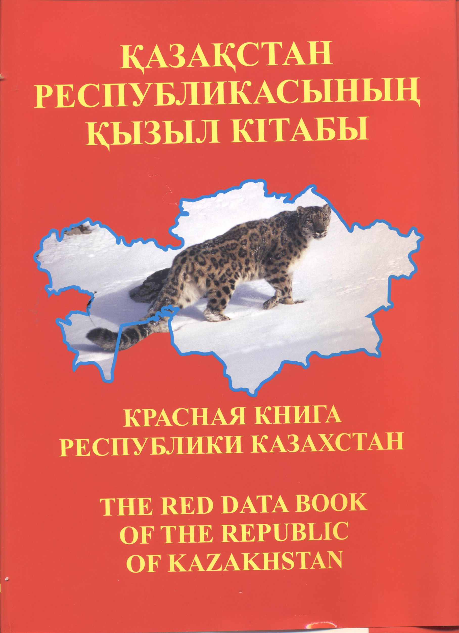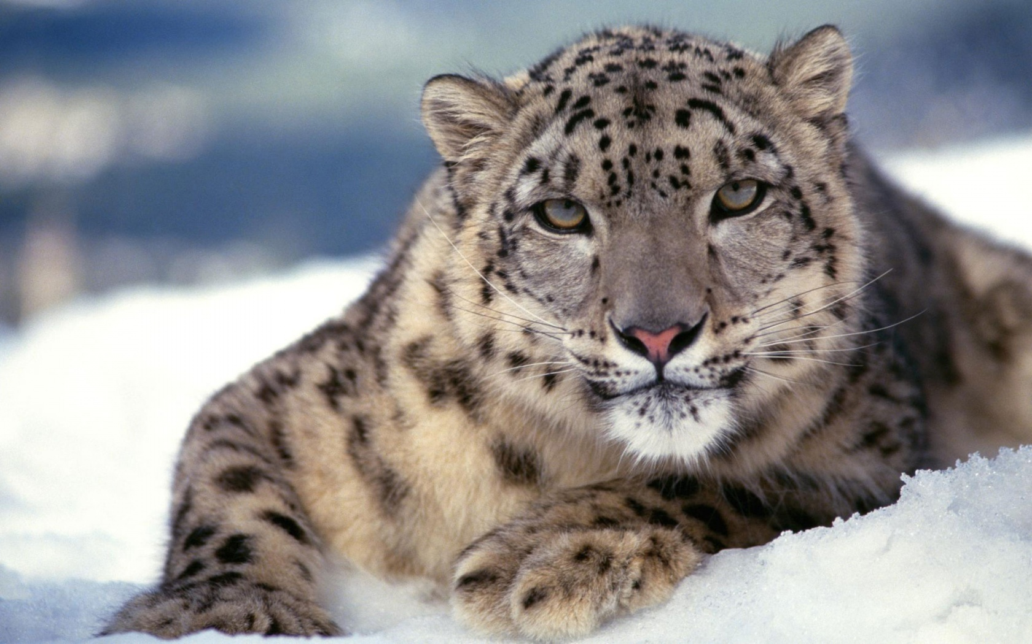  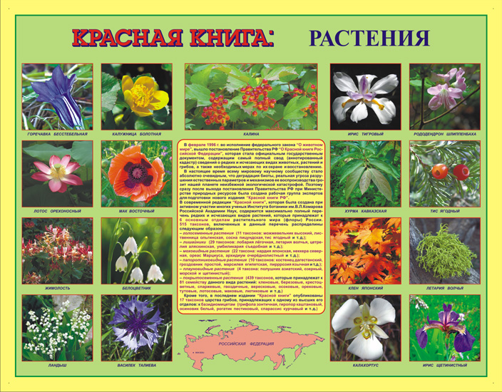 |  |  |  |  | Slide (useful phrases)  Slide (useful phrases)  Slide (objectives)  A video  Pictures
Middle | Pre-reading stage.  As Sts guess, the lesson will be devoted to the theme connected with animals which are in danger. Look at the title of the text: " Danger! Humans!". It's a newspaper article with only two words. Read firstly questions of Ex.2 p.84.  New words:  1. approximately - about, nearly  2. attack - strike, run at  3. accident - casualty, misadventure, mischance  4. pollution - impurity  5. action - act, influence  6. save - protect, take care.  Find the sentences with these words and translate them.  While - reading the text, pay attention to the sentences with main facts.  Prove that:  a) People are more dangerous than animals.  b) Animals aren't a problem for people.  c) People don't hunt animals only for food.  d) Our pollution and construction is changing the climate and animals' habitats.  Which is more dangerous: a shark, a chair or a person?  Ex. 2 - 3 p. 34( pair work).  Read another text and say what is common with the first text, write down some facts too in a form of a graphic organiser.  Animals in danger  By the year 2030, 25% of all animals, birds, fish and insects may be extinct. Why is this happening? Well, there are some three main reasons. The first is pollution. Millions of animals die every year because man has polluted their natural home or “habitat”.  The second reason is the environment itself. It is becoming smaller. Every year man cuts down more trees, builds more roads and uses more land for farming. This leaves fewer jungles, fields and forests for wildlife.  Today, many more species are in danger not only because man destroys and pollutes their habitat, but because man hunts them. Man has always been a hunter. But many modern hunters don’t kill for food- they kill for profit.  If it doesn’t happen, many wild animals will soon have just one habitat-the Zoo.  Ex. 4 p. 34. speak about animals in a red list in Kazakhstan.  Make a cinquain (cинквейн) of words " animal"/ red book / pollution.  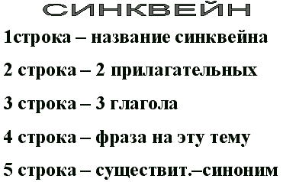 |  |  |  |  | Student's book p.34  Writing  Worksheets  Dictionary  Student's book p.34  Writing  Worksheets  A cinquain
End | Home task. WB p.28  Group presentation about an animal in danger.  Students express their attitude to the lesson and give self-assessment using the method: “Six thinking hats”:  - Green: How can you use today's learning in different subjects?  - Red: How do you feel about your work today?  - White: What have you leant today?  - Black: What were the weaknesses of your work?  - Blue: How much progress have you made in this lesson? (Now I can, I still need to work on, I've improved in, Today I learnt... )  - Yellow: What did you like about today's lesson? |  |  |  |  | Slide (Homework)  Slide "Six thinking hats"
Additional information
Differentiation – how do you plan to give more support? How do you plan to challenge the more able learners? |  |  | Assessment – how are you planning to check learners’ learning? |  | Health and safety check
Differentiation can be achieved through content (Based on the theory of Multiple Intelligences different tasks are used with the same text).  By support:  Less able learners will be supported through step-be-step instructions, glossaries, thinking time.  By task:  For more able learners additional leveled tasks are offered. |  |  | Assessment criteria:  - Read the given passage and identify the general information.  - Demonstrate skills of organizing and expressing ideas accurately.  - Illustrate a viewpoint in a discussion.  Descriptors:  A learner  - reads the text for global understanding;  - selects meaningful information, constructs the answer;  - presents information in the group discussion.  - evaluates the peers’ answers.  Teacher's observation using observation checklist (Appendix 2 - reference to the resource "Literature Circle Role Sheets" by Christine Boardman Moen. p.28) and monitoring.  Self-assessment.  Peer-assessment using rubric (Appendix 1).  Constructive teacher and peer feedback. |  | Health saving technologies.

