Lesson plan

Long-term plan unit: Our world |  |  |  |  | School:№15
Date: |  |  |  |  | Teacher name: Kutlymuratova N.
CLASS: 8 |  |  |  |  | Number present: |  | absent:

Theme of the lesson: Saving the Aral Sea
Learning objectives(s) that this lesson is contributing to |  |  |  | 8.4.1.1. understand the main points in texts on a growing range of unfamiliar general and curricular topics, including some extended texts. 8.5.3.1. write with moderate grammatical accuracy on a growing range of familiar general and curricular topics 8.3.1.1. use formal and informal registers in their talk on a growing range of general and curricular topics
Lesson objectives
 |  |  |  | 1.All learners will be able to read and understand the main points in texts on a growing range. 2 Most learners will be able to read and understand the main points in texts, answer the questions about problems in the Aral Sea. 3. Some learners will be able to read and understand the main points in texts, answer the questions and write an essay.
Language objectives |  |  |  | Learners can: read the text, to talk about environmental problems, to talk about the Aral Sea problems Subject-specific vocabulary and terminology:restore,litter,shrink,increase,irrigate,flow,split,harm Useful sets of phrases for dialogue and writing: -What do you know about the Aral Sea problems? -What can people do to save the Aral Sea?
Level of thinking skills |  |  |  | Knowledge, understanding, analysis
Assessment criteria |  |  |  | 1.Read and identify the main idea in the text 2. Identify details in a text with little support 3.Discuss and analyze the main idea of the text
Value links |  |  |  | Respect, openness, Kazakh patriotism and civil responsibility
Cross curricular links |  |  |  | Geography
Previous learning 5 min

Planned | Planned activities |  |  |  |  |  |  | Resources
Start | I. Organization moment Teacher greets with the pupils and checks their attendance.  II. Warm-up and lesson objectives presentation.  Circle of saving our planet. Standing in a circle pupils say about environmental problems of our planet.  -Pupils, what environmental problems do people have nowadays? Pupils: - air pollution - water pollution - global warming - acid rains Can you say, how can we help our planet, our nature? What should we do? - to plant trees - to save endangered animals - to use water with economy Of course, you are right! Pupils, todays theme is saving the Aral Sea. Pupils divide into groups by the colours of sticks. 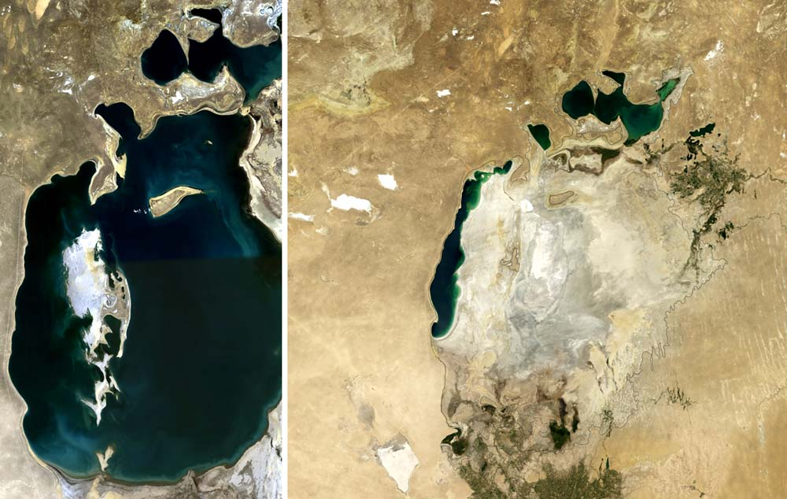 III. Active vocabulary: restore[ri:sto:r]-восстанавливать shrink[ ]- сокращать increase[inkri:s]-увеличение irrigate[irigeit]-орашать flow[flou]-течь, течение split[split]-раскол IV. Task 1.(1)Use the method Scaffolding .Learners should make word phrases from the given words and match with lines. restore cotton fields flow the northern part split water level begins increase into several parts irrigate into the lake Descriptor: A learner • matches word phrases |  |  |  |  |  |  | 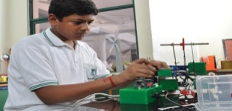
Middle | V. Task 2. (G).Use the method High Challenge. Differentiation task. Read the text Saving the Aral Sea and complete the text with new words then answer the questions. Lakes and seas are disappearing around the world, partly as a result of climate change, but mainly because of human activity. Less than seventy years ago, the Aral Sea was one of the biggest lakes on Earth. It had an area of about 68,000 km². Then in the 1960s, people built canals to¹ ____ cotton fields in Uzbekistan and Turkmenistan. They used a large amount of water from the Syr Darya and the Amu Darya, the two big rivers which flow into the lake. As both rivers got smaller, the Aral Sea started to ____ ,too. By 1997,it was only 30,000 km²- less than half its original size. Some areas completely dried up and the lake³ ____into several parts. The biggest are the North Aral Sea in Kazakhstan and the South Aral Sea which crosses both Kazakhstan and Uzbekistan. Today, the South Aral Sea is still shrinking, but there is hope for the North Aral Sea. In 2003, The Kazakh government and the World Bank started working on a project to⁴ ____ the northern part of the lake. The first step was to build the Kok-Aral Dam between the northern and southern parts of the lake. The dam was completed in 2005. Additional structures built on or around the Syr Darya allow more water from the river to⁵ ____ into the lake. The project was very successful and the North Aral Sea is slowly coming back to life. Water levels have begun to⁶ ____ in recent years. When the lake shrank, it became very salty and all the 24 freshwater fish species disappeared, but now a small number of species are back. Fishermen are hoping that one day there will be plenty of fish in the water again. Questions: -Where is situated the Aral Sea? -Why did the Aral Sea dry up and the lake split into several parts? -How did Kazakh government and world bank save the Northern part of the lake? -Is North Aral Sea or South Aral Sea coming back to life? -Is there fish in the lake? -How many freshwater fish species disappeared? -What you think, will the Aral Sea come back to life? Descriptor: A learner •reads the text •answer the questions •discusses main problems of the Aral Sea •suggest the ways of solutions. VI. Task 3.(I) Read to the text, write T (true) or F(false). Correct the false sentences. 1. The Aral Sea was the largest lake in the world. 2. The North Aral Sea is in Uzbekistan. 3. The Kok-Aral Dam separates the North and South Aral Seas. 4. Today, there are no fish in the North Aral Sea. 5. Local people think it is possible to save the lake. Descriptor: A learner • chooses T or F • correct the false ones |  |  |  |  |  |  | 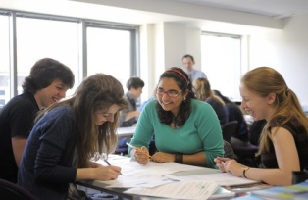  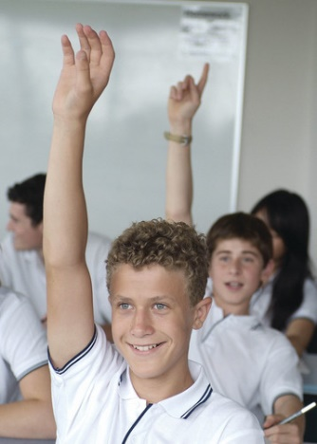
End | VII. Task 4.Choose the correct words.  1.There is a large amount/number of rubbish on this beach. 2. It’s only two o’clock. We ‘ve got plenty/ all of time. 3. Several /Both my parents are scientists.  4. There are half/several small lakes in this area.  5. I haven’t got any money. I spent all /half of it.  Descriptor: A learner :  •chooses right answer
End | Learners reflect on their learning:  -what has been learned? -what remained unclear? -what is necessary to work on?  Homework:.
Additional information
Differentiation – how do you plan to give more support? How do you plan to challenge the more able learners? |  |  | Assessment – how are you planning to check learners’ learning? |  |  | Health and safety check  ICT links
- More support will be given to weaker learners by giving them a modified worksheets in some tasks with greater support |  |  | - Through formative assessment  - Through observation of the stage of revision  - Through peer assessment |  |  | - Health promoting techniques  - Breaks and physical activities used.  - Points from Safety rules used at this lesson.
Reflection  Were the lesson objective/learning objectives realistic?  What did the learners learn today?  What was the learning atmosphere like?  Did my planned differentiation work well?  Did I stick to timings? What changes did I make from my plan and why? |  | Use the space below to reflect on your lesson. Answer the most relevant questions from the box on the left about your lesson.
Summary evaluation

What two things went really well (consider both teaching and learning)?

1:

2:

What two things would have improved the lesson (consider both teaching and learning)?

1:

2:

What have I learned from this lesson about the class or individuals that will inform my next lesson?

