Term 1  Unit 1 "Hobbies and qualities" |  |  | School:
Date: |  |  | Teacher’s name:
Grade 9 |  |  | Number present: |  | Number absent:
Theme of the lesson: |  |  | Reading: Comparing generations.
Learning objectives(s) that this lesson is contributing to |  | 9.C7 develop and sustain a consistent argument when speaking or writing  9.R2 understand specific information and detail in texts on a range of familiar general and curricular topics, including some extended texts  9.R9 recognise inconsistencies in argument in extended texts on a range of general and curricular topics  9.UE14 use an increased variety of prepositions before nouns and adjectives use a growing number of dependent prepositions following nouns and adjectives and an increased variety of dependent prepositions following verbs on a range of familiar general and curricular topics
Lesson objectives |  | All learners will be able to:
- Synthesize information from the reading passage about life in the 1950s.
- Demonstrate the correct use of adjectives + prepositions.
 |  | Most learners will be able to:
 |  | - Interpret a text comparing past and present generations.
 |  | Some learners will be able to:
 |  | - Express their opinions about different generations building extended sentences.
Assessment criteria |  | Make an argument and evolve reasoning while speaking.  Identify particular information and details in reading passage.  Find claim, reasons and evidence in the text to recognise inconsistencies in argument.  Employ the rule for nouns and adjectives in common prepositional phrases in practice.  Descriptor. A learner:  - concludes ideas and arguments based on own experience.  - finds necessary information in the text and completes the task.  - analyses the information in the text and gives the right answers.  - completes the sentences with appropriate prepositions.
Value links |  | Respecting yourself and others.
Cross curricular links |  | Social studies.
Previous learning |  | Previously learned vocabulary on the topic "Attributes and personality".
Use of ICT |  | Smart board for showing a presentation, getting additional information, playing the audio, video files.
Health and Safety |  | Switch off the active board if you do not use it.  If students are tired, do physical exercise with them.  Open the window to refresh the air in the classroom during the break.
Plan
Planned timings | Planned activities |  |  | Resources
Beginning the lesson | The lesson greeting.  The teacher sets the lesson objectives, letting students know what to anticipate from the lesson.  Warm up.  1/ Describe the given picture.  2/ What is the message conveyed by it?  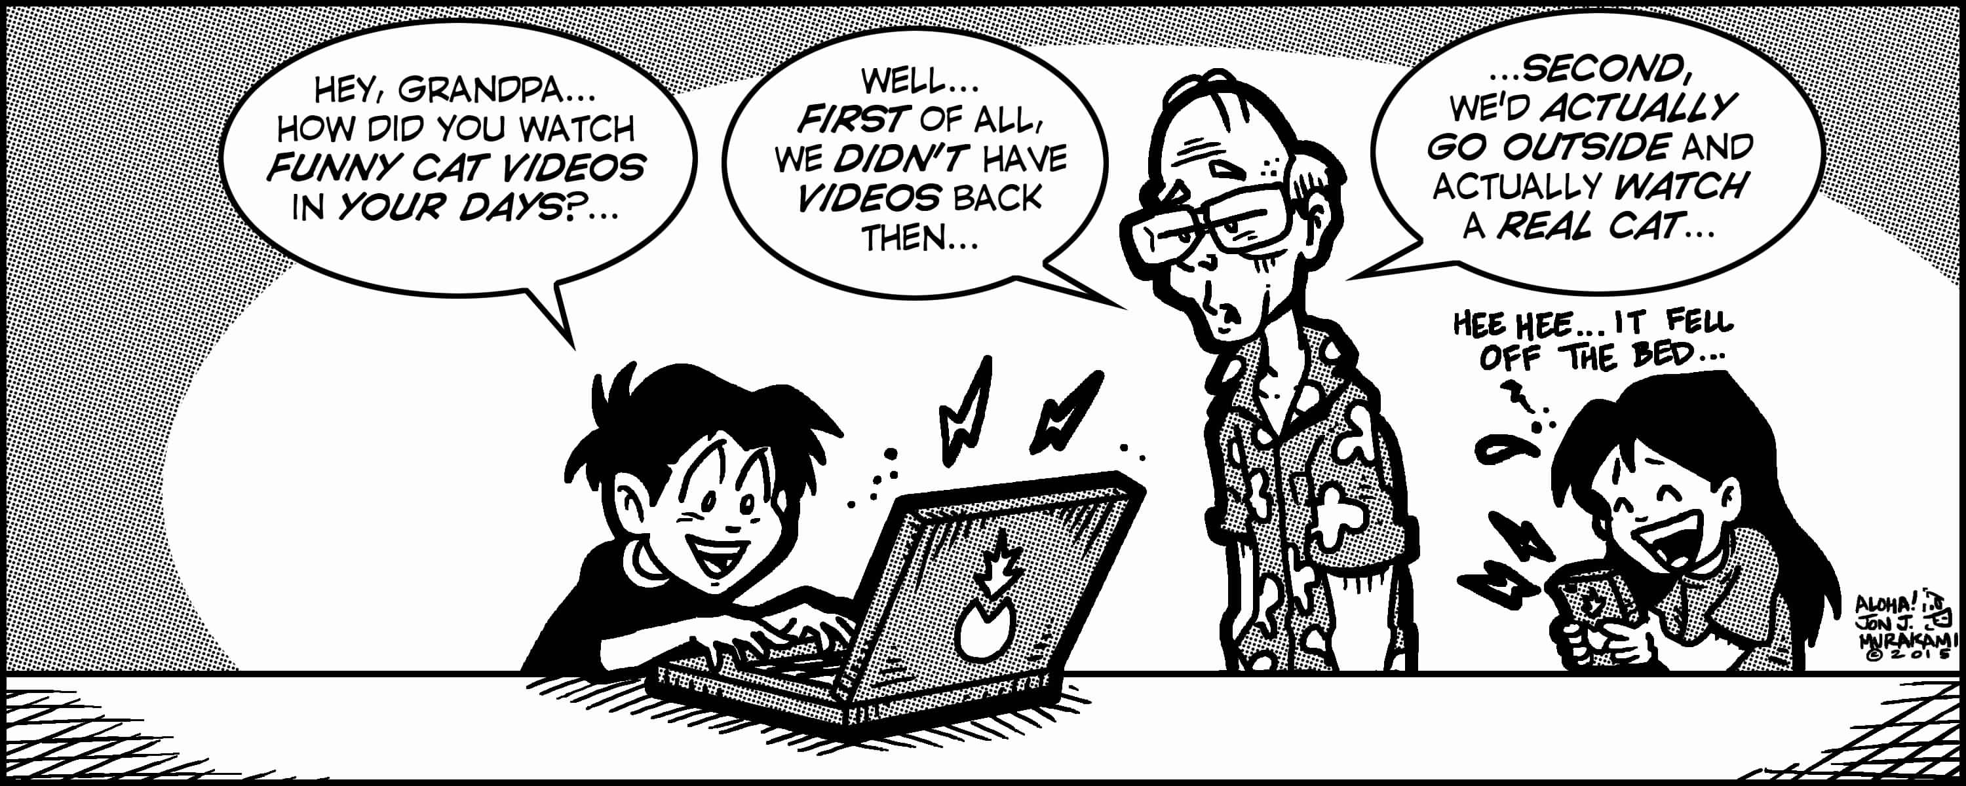 |  |  | Training “I wish you……”
Main Activities | Task. With books closed, ask SS if they have seen photographs of their parents and grandparents when they were young. Ask: What were their clothes like? What were their hairstyle like?  Ask: What do you think life was like in the 1950s?  Ex.1 p.10. Prediction based on the vocabulary.  Detailed reading.  Comparing.  Ex.2 p.10. Justifying True/False statements with reference to the text.  Ex.3 p.10. Gap-filling.  Ex.4 p.10. Sentence completion.  Ex.5 p.10. Class discussion. |  |  | Board  Internet  Presentation  Video and images  Task with kahoot.it  Method Journalist”
Ending the lesson | Giving the hometask. WB p.10  Self-reflection.  My participation in the lesson My feelings and emotions during the lesson My difficulties Valuable thoughts for me from the lesson
End  1min | Feedback: Teacher asks students what task was difficult to them and which pair worked well.
Additional information
Differentiation –  how do you plan to give more support? How do you plan to challenge the more able learners? |  |  | Assessment –  how are you planning to check learners’ learning? |  |  | Critical thinking
Differentiation can be achieved by task (selection of learning materials and resources based on student strengths).  By support. Less able learners will be supported through step-by-step instructions, graphic organizers, sentence frames, glossaries, thinking time. Small group learning.  By outcome providing challenge, variety and choice. |  |  | Observe learners when participating in use of English activities.  Record what they considered they had learned from the lesson. Could they express what they had learned about content and language? Could they express which skills they had developed?  Formative assessment is held through observation/monitoring. |  |  | Students think critically, exploring, developing, evaluating and making choices about their own and others’ ideas.

