Module 3: Treasure and Heritage  4. LESSON:  Theme: Our planet’s treasure |  | School: K.Satpaev
Date:21.11.2019 |  | Teacher’s name: Ermekkizi M
CLASS: 4^{g} |  | Numberpresent: | absent:
Learning objectives(s) that this lesson is contributing to | 4.1.3.1 understand the main points of short supported talk on an increasing range of general and some curricular topics;  4.2.3.1 give short, basic description of people and objects, begin to describe past experiences on an increasing range of general and some curricular topics;  4.3.3.1 recognise basic opinions in short, simple texts on an increasing range of general range of general and some curricular topics;  4.4.4.1 write with support a sequence of short sentences in a paragraph to give basic personal information
Lessonobjectives | All learners will be able to: use interrogative pronouns who, what and where, how many, how much, how often, how big, what kind of to ask questions
 | Most learners will be able to: use interrogative pronouns who, what and where, how many, how much, how often, how big, what kind of to ask questions
 | Some learners will be able to: use interrogative pronouns who, what and where, how many, how much, how often, how big, what kind of to ask questions
Assessment criteria | to talk about natural features.
Language focus | Structures: articles (a/an,the).  Language in use: Everest is a mountain. Mr.Smiles is an explorer. He travels all over the world.
Target vocabulary | Our planet’s treasure 1: waterfall, rainforest, river, desert, ocean, island, lake, mountain.
Cross - curricular  Links | Literature, languages
ICT skills
Plan
Plannedtimings | Planned activities (replace the notes below with your planned activities) |  |  | SmilesResources
Opening  10 min | Teacher introduces learning and lesson objectives  Teacher: Good afternoon Children!  How are you?  Now lets star our lesson?  What date is it today? Today the twenty first of November  What day is it today? Thursday  Them our lesson <Our planet’s treasure>  .  Now we repeat new words from the last lesson.  Divide the class into two teams  First teams<Sun>  Second teams< Moon>
Middle  15 min  4.2.5.1  10 min  4.1.4.1  5 min | PRESENTATION AND PRACTICE  (Activities to present and activate the new language.)  POSTER  Our Planet’s Treasure 1  14 Listen, point and repeat. Then match.  Pupils’ books closed. Put up the Our planet’s treasure poster on the board. Point to the natural features, one at a time, and say the corresponding words. The pupils repeat, chorally and/or individually. Point to each natural feature in random order. Ask individual pupils to name them.  Extension activity (Optional)  Ask the pupils to look at the poster, choose an item and make a sentence.  e.g. Pupil 1 : (pointing to the island ) I’m going to go to an island this summer. etc  Pupils’ books open. Play the CD. The pupils listen, point to the words and repeat. If you wish, play the CD again pausing after each word. The pupils repeat, chorally and/or individually. Then the pupils look at the pictures and match them to the words. Check their answers.  Answer key  2 G 4 A 6 F 8 H  3 E 5 C 7 B  17 Let’s play  Play the Correct The Teacher game. give one blue and one red card to a pupil from each team. Say aloud a sentence. If the sentence is correct, the pupils raise the blue card. If the sentence is wrong, they raise the red card. Then the pupils give the card to other member or their team and you repeat with other sentences. Each correct answer wins a point. The team with the most points wins the game.  Suggested sentences  1.Caspian is a river ( no, Sea)  2. Kazigurt its mountain ( yes)  3.Fish can’t live without water (yes)  4. There is no water is the ocean (no)  5. Whaterfall consists of water (yes)  Now we will match words and pictures  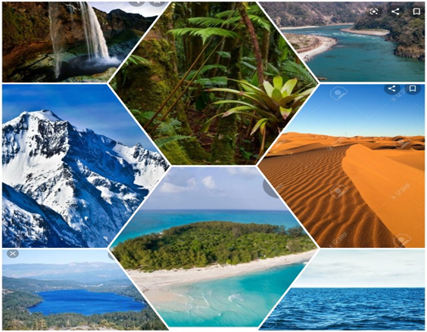 |  |  | (Track 35 CD1)
End | Good job well done.  Home task ex:  OK. Thank you, good bye, good bye

