**Theme of the discussion area:** “Effective methods in teaching subject through integrating language learning”

**Aims:**

1. Broadcasting experience on the use of technology CLIL in English class

2. Introducing with the main methods and techniques of CLIL

**Resources:** presentation, task cards, glossary

**Duration**: 40 minutes

**Plan:**

1. Motivational target stage

• Forming groups

•Brainstorm

• goal setting

2. Activity-generalizing stage

• What is CLIL for?

• CLIL theoretical foundations

• The main stages of the introduction of teaching subjects in English

• Ways to introduce teaching subjects in English

3. Reflexive evaluation stage

Summarizing. Reflection.

Course of the seminar:

**1. Motivational target stage:**

• Forming groups

• Brainstorming “What do you know about CLIL?” (The abbreviation is given: content and language integrated learning - subject-language integrated learning).

• goal setting

• In modern society, the issues of socialization of a modern person in interethnic and intercultural space become priorities, while the knowledge of a foreign language is considered as one of the tools to expand professional knowledge and capabilities. In this regard, there are new educational technologies for teaching foreign languages. One of such technologies is CLIL (Content and Language Integrated Learning) subject-language integrated learning.

• The term CLIL was first proposed in 1994 by David Marsh and Anna Maullers (Finland) as a methodology for teaching non-language subjects in a foreign language. This approach includes various forms of using a foreign language as a means of learning, provides an effective opportunity for students to apply their new language skills in practice now, rather than wait for the right moment in the future. Thus, learning English has an interdisciplinary character and is closely related to other subjects from the school curriculum.

**2. Activity-generalizing stage**

• What is CLIL necessary for?

**CLIL: What It Is, and Why Language Teachers Will Find It Delightful**

Why?

Because with a rich, meaningful context, [your students can learn language](https://www.fluentu.com/educator/blog/task-based-language-teaching-activities/) without needing you to explicitly teach it.

And that’s where the revolutionary [teaching approach](https://www.fluentu.com/educator/blog/foreign-language-teaching-methodology/) **CLIL** comes in, which stands for Content and Language Integrated Learning.

We’re going to take a look at what it is, how it works and why you’ll definitely want to apply it [to your own classes](https://www.fluentu.com/educator/blog/language-class-activities/).

- Kazakhstanis will take a leading role in all spheres of life

- The younger generation will study Russian and English on a par with the Kazakh language.(слайд)

Questions to participants:

• Why do teachers of Kazakh, Russian and English need to support the study of both the language and the subject content

(English is taught only in English lessons, and content is learned only in subject lessons).

• Problem question for participants

What are the main characteristics of the CLIL methodology?

The specificity of the CLIL-method is that knowledge of the language becomes a tool for studying the content of the subject. At the same time, attention is focused both on the content of the texts and on the necessary subject terminology. At the same time, the language is integrated into the curriculum, and the need to dive into the language environment to allow discussion of thematic material significantly increases the motivation for using the language in the context of the topic being studied.

This is facilitated by carefully selected educational materials not only for studying a specific subject, but also for learning the language: lexical and grammatical units and structures, all types of speech activity (reading, speaking, writing and listening).

Types of tasks should be developed according to the level of complexity, constructed with an emphasis on the subject content, its understanding, verification and subsequent discussion.

At various stages of working with text, attention is focused on the vocabulary, on the content of the text, and then on the specific grammatical material.

You might or might not have heard this term before, but I can assure you: it’s a key term in CLIL. Scaffolding is not just an important part of regular education, its use is even more important in a language learning environment like CLIL education.

**What is scaffolding?**

The obvious thing to do when you don’t know a word is to look it up right? So, that’s what I did. According to the [online free dictionary](http://www.thefreedictionary.com/scaffolding) the definition of scaffolding is:

Scaffolding

 (ˈskæfəldɪŋ)

1. A scaffold or system of scaffolds
2. (Building) the building materials used to make scaffolds

But that’s not very helpful for us, is it?

A more “CLIL” way of looking at scaffolding is explained by Rosie Tanner and Liz Dale in their book “CLIL Activities”

In other words: Scaffolding is the process of supporting your students during their learning process and gradually removing that support as your students become more independent.

This is very different from helping, which is the process of figuring out an answer together with a student.

**Practical stage:** Working with worksheets

1.Group “Biology”

2.Group “Geography”

3.Goup “ICT”

4. Group “History”

5.Group “PE”

**CLIL Geography The water cycle and flooding**

# 1 Pre-reading

Read the sentences about water and write *T* (true) or *F* (false). Then check your answers by doing an Internet search for *water*. You can visit these websites to help you:

[www.sepakids.com](http://www.sepakids.com/)

www.sydneywater.com.au/Education/_global/waterfacts.cfm www.southeastwater.co.uk/pls/apex/f?p=101:waterfacts

1. Nothing on earth can live without water.

*T*

1. Water covers one third of the earth.
2. The water we can’t drink is either too salty or frozen **4** Water makes up around 40% of our body.
3. A person can survive longer without water than without food.
4. The chemical symbol for water is CO2.
5. Water is the only substance that can be liquid, gas and solid.
6. Water has chemicals, fats and minerals in it.
7. In the developed world, people often use 160 litres of water every day.
8. In the developing world, people often use 100 litres of water every day.

# 2 Vocabulary

Label the pictures with these words. Then go to the Macmillan Online Dictionary www.macmillandictionary.com and check your answers by typing the words into the search box.

~~cloud~~ dam glacier lake plant rain sewage snow stream water droplet

|  |  |  |  |  |  |  |  |  |  |  |
| --- | --- | --- | --- | --- | --- | --- | --- | --- | --- | --- |
| **1** |  |  | **2** |  |  | **3** |  |  | **4** |  |
|  |  |  |  |

# *cloud*

|  |  |  |  |  |  |  |  |  |  |  |
| --- | --- | --- | --- | --- | --- | --- | --- | --- | --- | --- |
| **5** |  |  | **6** |  |  | **7** |  |  | **8** |  |
|  |  |  |  |

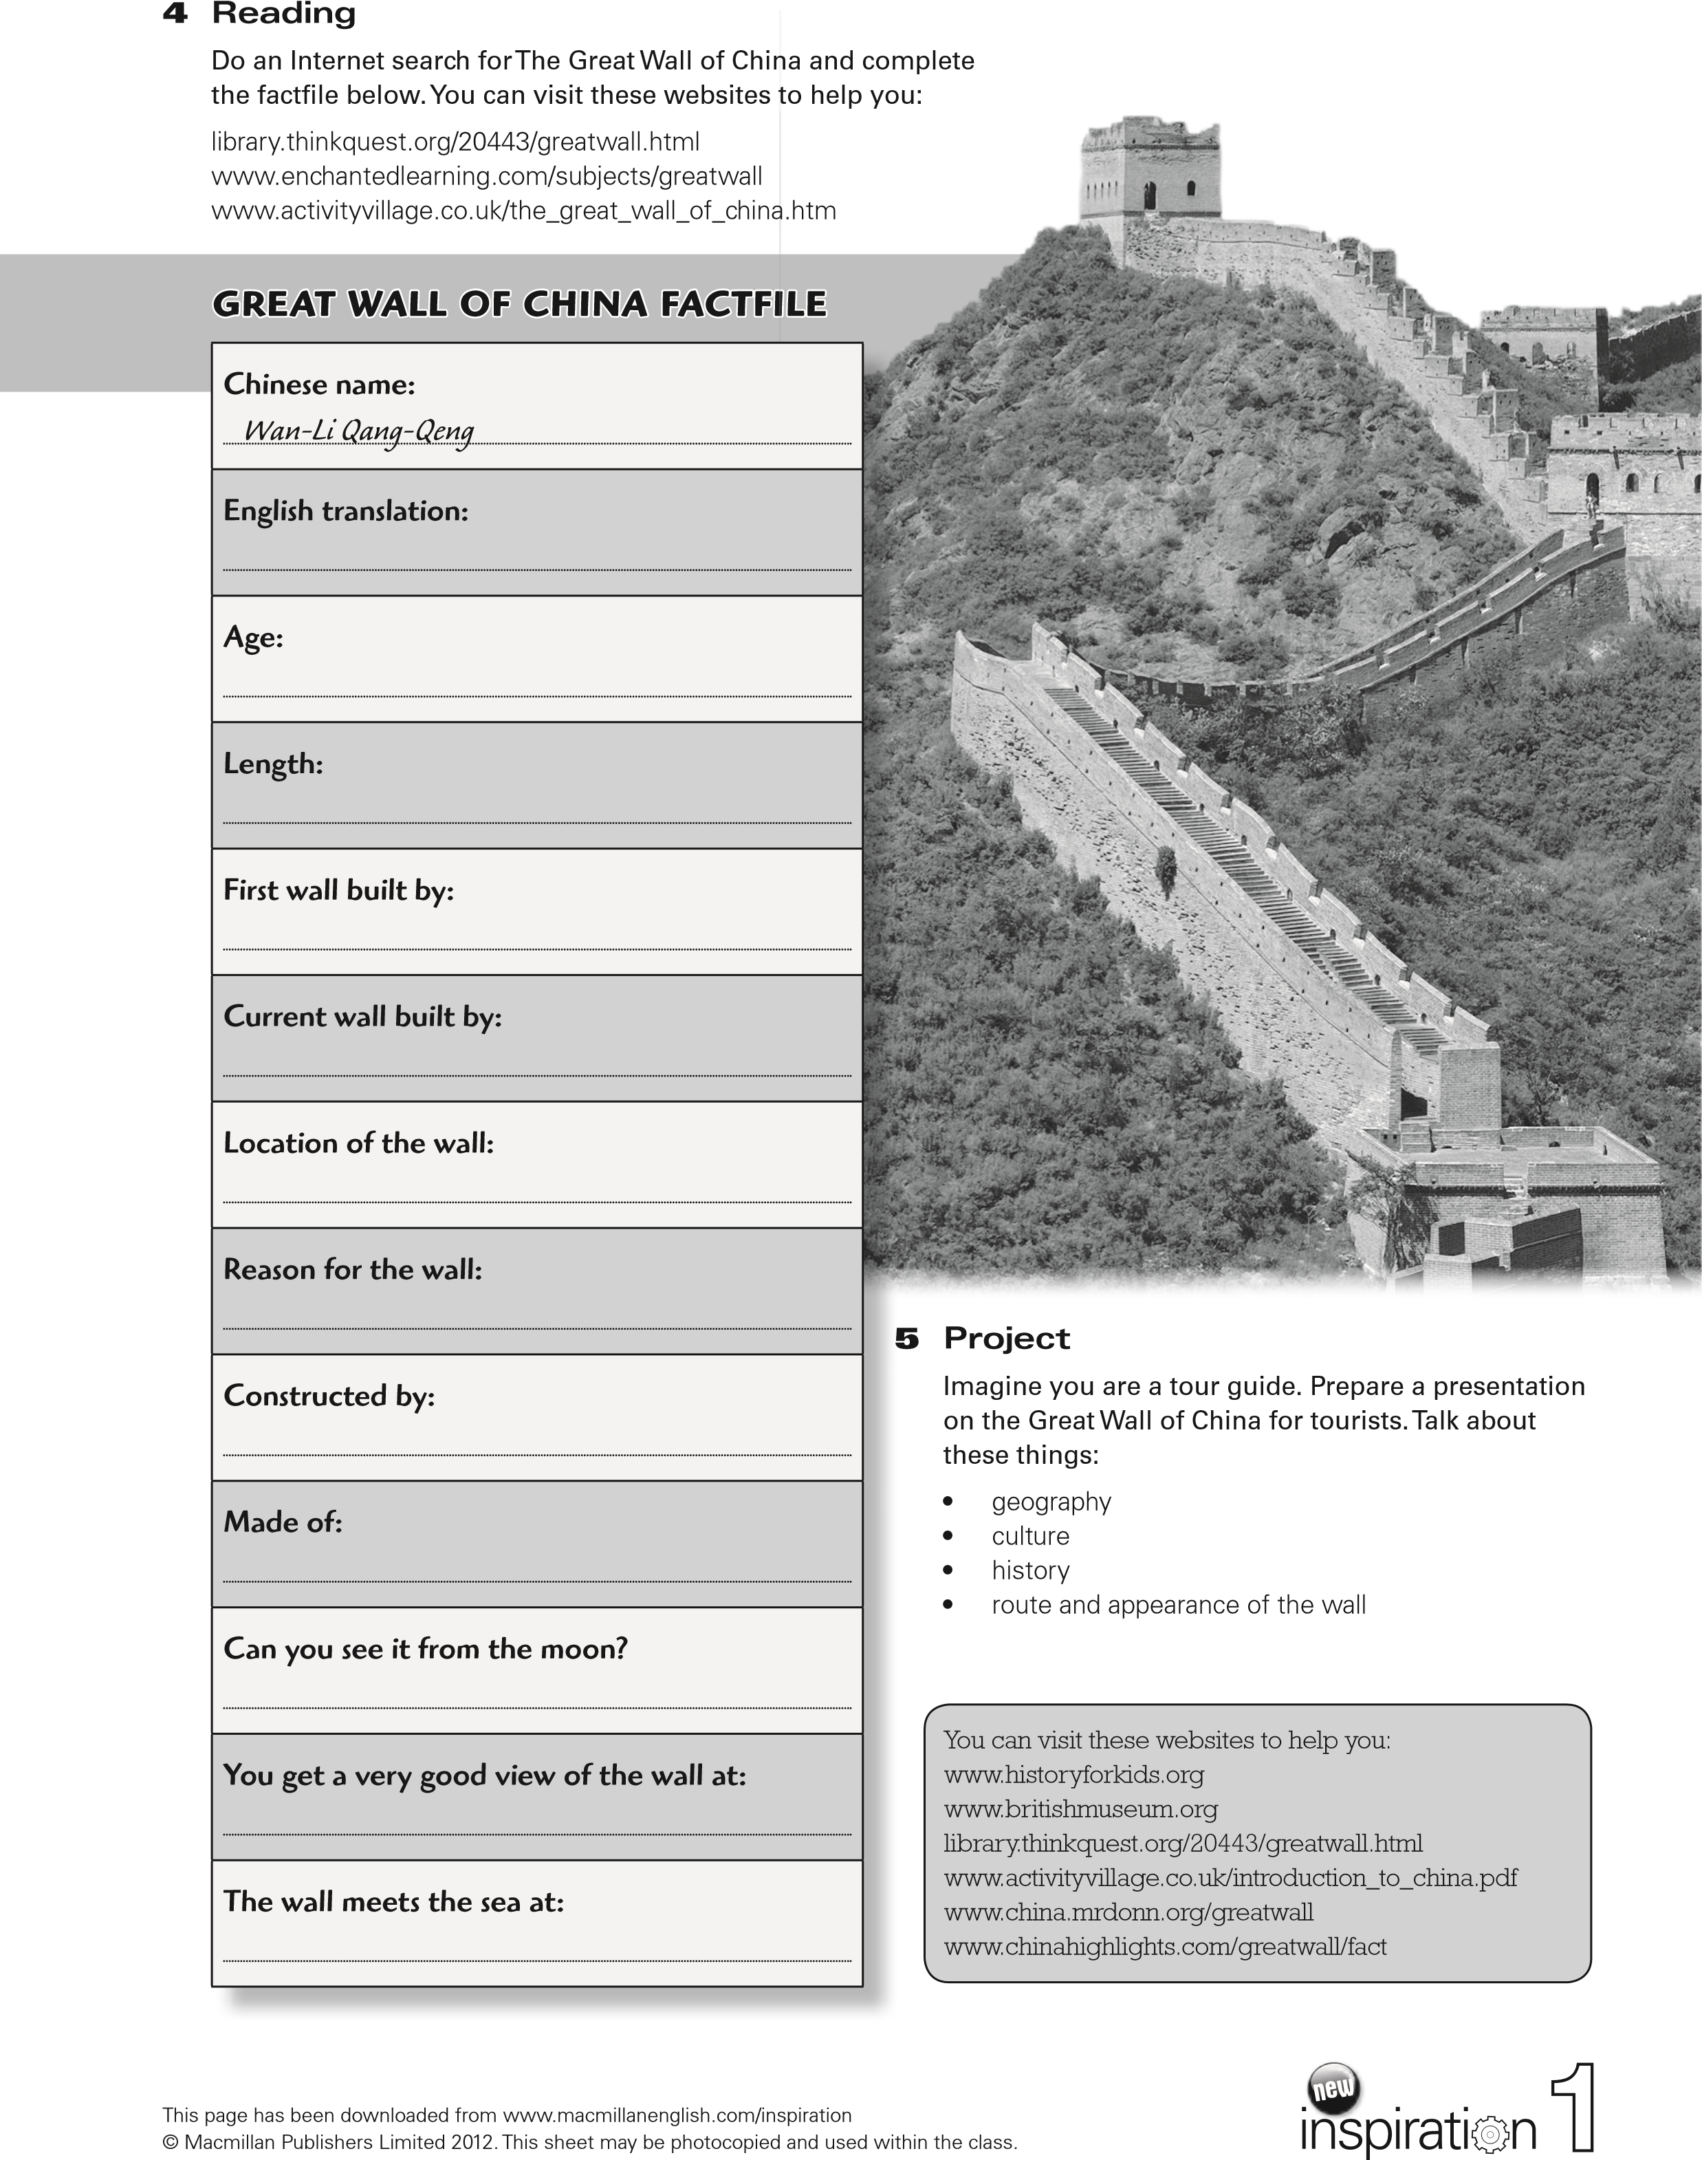

Reflection **"Restaurant"**

Satisfied ?

I would eat more of this: ______________________________________________________________

Most of all I liked ________________________________________________________________________________________________________________________________________________________________________________________________________

I almost digested information about : ______________________________________________________________________________________________________________________________

This restaurant _____________________________________________________________________________________________________________________________________________________________________________________________

I have overeaten _____________________________________________________________________________________________________________________________________________________________________________________________

Please add ____________________________________________________________________________________________________________________________________________________________________________________________