Long-term plan unit: Unit 6. Traditions and folklore |  |  |  |  | School:
Date |  |  |  |  | Teacher name:
Grade: 2 |  |  |  |  | Number present: |  | absent:
Theme of the lesson |  |  |  |  | Home cooking
Learning objectives(s) that this lesson is contributing to |  | 2.S3. use a limited range of basic words, phrases and short sentences to describe objects, activities and classroom routines  2. L9 Recognize the spoken form of familiar words and expressions  2.R1 Read and spell out words for others
Lesson objectives |  | All learners will be able to:  Understand the spoken form of familiar words and expressions  Most learners will be able to:  Read and understand the short words  Some learners will be able to:  To give an opinion to describe some objects
Success criteria |  | - Read words  - Spell out words for others  - Identify familiar words and expressions  - Talk about objects, activities  - Apply topical vocabulary, phrases and short sentences
Value links |  | To love their country, traditional food and to respect each other
Cross curricular links |  | Russian, Kazakh, Math, Art, PE
ICT skills |  | Lab top, white board
Previous learning |  | They know the names of some fruit. and read short words
Level of thinking skill |  | Knowledge-comprehension, Application
Plan
Planned timings | Planned activities |  |  |  |  |  |  | Resources  Visual aids:
Beginning  10 minutes  Middle  25min | Organization moment  Good afternoon!  Hello, how are you?  What date is it today?  What day is it today?  Teacher will invite Ss to stand in a circle and to great each other, they smile each other  Join into two groups which called vegetables and fruits  Pre-learning  (D) Teacher pre-teaches and revises basic food words  burgers, chips, apples, bananas, sandwiches , , rice, sugar, etc.  Watch the video  Cooking in the kitchen and asks learners  What are they doing?  Lead- in  (W) Teacher shows images of pictures and asks learners:  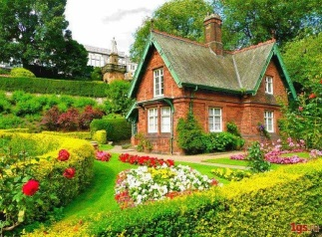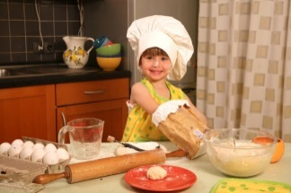  ‘What’s in it?  ’What can you see in this picture?  What she is doing in this picture?  What will be our theme for today?  Very well children  Lets begin our lesson. The theme our lesson: “Home cooking”  You will:  -Read and spell out words for others  -Use a limited range of basic words, phrases and short sentences to describe objects, activities and classroom routines  -Recognize the spoken form of familiar words and expressions  Look at the board. Today we are learn some new words  Rice – күріш  Bread – нан  Salad – салат  Chicken – тауық еті  Eggs – жұмыртқа  Fish – балық еті  Soup – сорпа  Meat – ет  Healthy food –  Fast food –  FA:  Task 1 Missing letters  B_ea_  Chi_ken  F_sh  Me_t  S_l_d  So_p  R_ce  Eg_s  Descriptor: A learner  1.Complete the missing letters  2. Read the letters correctly  FA: 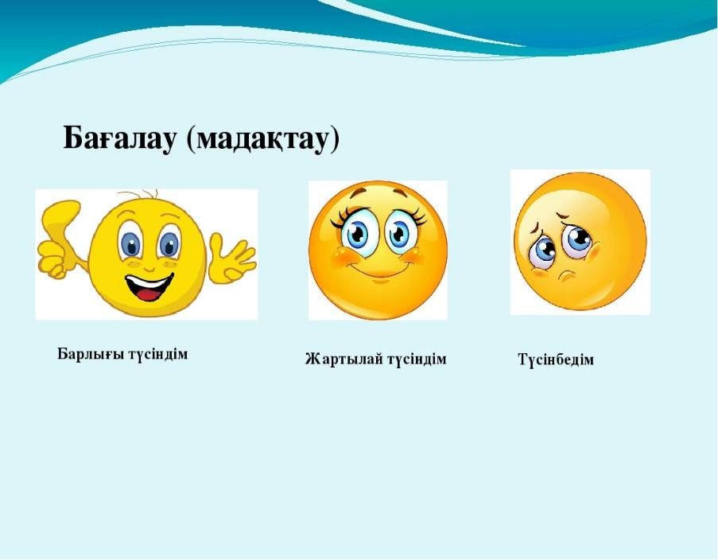  Task 2 Find the correct DISH and divided into two groups Healthy food and Fast food or unhealthy food glue the food picrutes  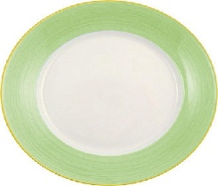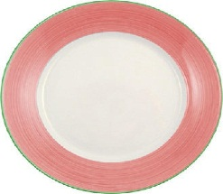  green dish healthy food red dish fast food or unhealthy food  Descriptor: A learner  - Find the dish correctly  - Glue the correct picture  - Name the healthy food and fast food  FA:  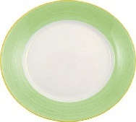Very good!  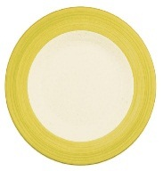Good !  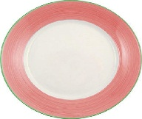Try harder !  Task3 L9.  (G)Stick the pictures onto the poster. Listen to the teacher and colour them. (Peer assessment)  Stick two apples and colour them in red.  Stick the banana and colour it in yellow.  Stick two eggs and colour them in orange.  Descriptor: A learner  - Makes the poster  - Sticks the pictures  - Colors the pictures  FA: Green apple – very good  Yellow apple – good  Red apple – try harder  Task 4 Make your menu  1 group lunch  2 group dinner  Teacher give them hand-out  Learners make your menu.  Descriptor A learners  - Glue the pictures correctly  - Name ingredients of your menu (there is/there are)  - Describe your menu (tasty, good, sweet)  Task5  Write the names of the food  Descriptor A learner  - names the letters of the underlined word  - reads the words appropriately;  FA:  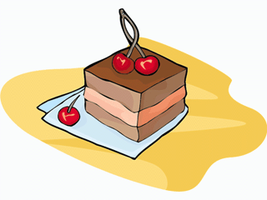 |  |  |  |  |  |  | Pictures of vegetables and fruits  Flashcards  pictures of home and cooking  Cards  Poster, pictures, glue  Pictures, posters, colored pencils  Poster, glue, pictures
End  5 minutes | Task.  KNOWLEDGE BASKET  Green basket and green food - I understand this lesson  Yellow basket and yellow food – I have some questions  Red basket and red food – I don`t understand this lesson  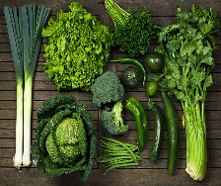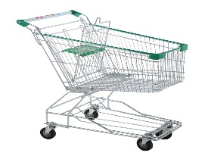  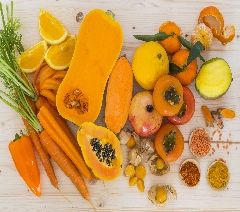  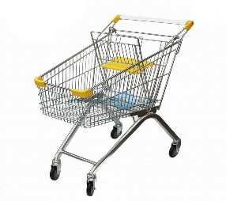  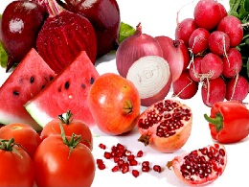  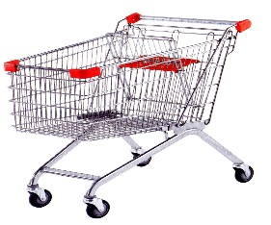  Home work: learn the new words  Your marks ….  The lesson is over  Good bye children! |  |  |  |  |  |  | Basket and pictures
Additional information
Differentiation – how do you plan to give more support? How do you plan to challenge the more able learners  the will be |  |  | Assessment – how are you planning to check learners’ learning? |  |  | Health and safety check  ICT links
More able learners read words and spell it  Less able learners read the words |  |  | Fact-based observation  Self-assessment  Peer assessment |  |  | Careful movement around the room  Boy-girl-boy-girl arrangement within sitting and standing circles to encourage positive behavior like keeping hands to self.
Reflection
Were the lesson objectives/learning objectives realistic?

What did the learners learn today?

What was the learning atmosphere like?

Did my planned differentiation work well?

Did I stick to timings? What changes did I make from my plan and why?
Summary evaluation

What two things went really well (consider both teaching and learning)?
1:
2:

What two things would have improved the lesson (consider both teaching and learning)?
1:
2:

What have I learned from this lesson about the class or individuals that will inform

my next lesson?

