Қызылорда облысы Шиелі ауданы
№127 Ш. Уалиханов атындағы орта мектеп-лицейі
Lesson theme: I get up at 7 o’clock!
Grade: 3 “v”, “b”, “g”
Aims: 1) Өткен сабақты қайталау
2) Жаңа сабақты түсіндіріп, жаңа сөздермен таныстыру.
3) Грамматикалық жаттығуларды түсіндіру
Org. moment: - Good afternoon boys and girls
- Good afternoon teacher
- How are you?
- Fine, thank you!
- So sit down please!
- What date is it today?
-Who is absent today?
Warm-up:
If you're happy and you know clap your hands
if you're happy and you know clap your hands
if you're happy and you know then your face will surely show it
if you're happy and you know clap your hands
If you're happy and you know stomp your feet
if you're happy and you know stomp your feet
if you're happy and you know then your face will surely show it
if you're happy and you know stomp your feet
If you're happy and you know say your ok
if you're happy and you know say your ok
if you're happy and you know then your face will surely show it
if you're happy and you know say your ok
(repeat and exchange clap your hands with stomp your feet and then say ok!)
Checking – up the home work:
Reading for pleasure “Kites”
Look!
Look up!

Look up at the kites!
Look up at the kites in the sky!
One kite is a tiger. It is orange and black.
One kite is a bird. It is pink and blue.
Look!
Look up!
Look up at the kites!
Look up at the kites in the sky!
One kite is a lion. It is yellow and brown.
One kite is a fish. It is purple and green.
Look!
Look up!
Look up at the kites!
Look up at the kites in the sky!

Presentation:
- to get up - тұру
- to have breakfast (dinner, lunch) –тангы ас ішу
- to go to school – мектепке бару
- to go for a walk - қыдыру
- to read books –кітап оқу
- to watch TV – теледидар кору
- to rest -тынығу
- to go to bed - ұйыктау
Practice:
Game. “The ball”.Мұғалім допты әр оқушыға береді, берген кезде сұрақ қояды. Сұраққа оқушы жауап беруі керек.
Children, look at me! I have a ball. This is a ball, a nice, red ball. Now we will play with the ball. Ramazan, take the ball!
T: What time is it? T: What time is it?
P: It is 10 o’clock P: It is 8 o’clock
T: What time is it? T: What time is it?
P: It is half past 6 P: It is half past 12
T: Do you usually get up at 7 o’clock?
P: Yes, I do.
P: Do you do exercises every day?
T: Yes, I do.
T: Do you go to school at half past 8?
P: Yes, I do.
T: Do you have lunch at school or at home?
P: Yes, I do.
T: When do you usually come home?
P: at 2 o’clock
T: Do you go to bed at 9 or at 10 o’clock?
P: Yes, I do.
T: Now give me the ball!
Look at the video “Peter Pumpkin”
PB Ex:1 Listen and read
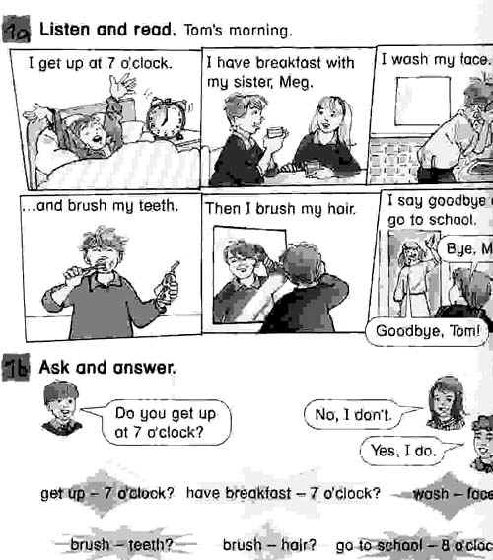
PB Ex:2 make a dialogue
Tom: Hi, Peter!
Peter : Hi, Tom!
Tom : How are you?
Peter : I’m well. Thank you.
Tom :When do you do your homework?
Peter : I usually do my homework in the evening.
Tom : Really? And as for me I read books and watch TV in the evening.
Peter : I see.
You have 3 minutes. Do yourselves this exercise.
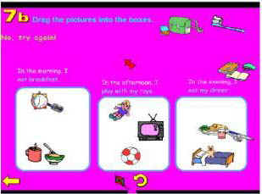
T: Let’s repeat new words and expressions. Say after me: to brush hair, to help mother, to have a bath, to watch TV, to have dinner, to play computer games.
Have a look at the screen and fill in the gaps.
Look at the slide show about “Sponge bob’s” day.
I am Sponge Bob! Glad to meet you!
My Daily Life
- I get up at 8 o’clock in the morning!
- When do you usually get up?
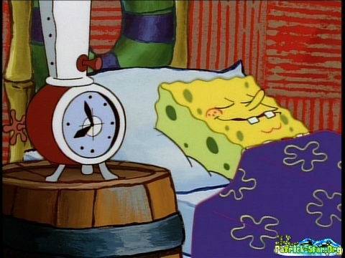
- I do my morning exercises every day!
- And you?
- I clean my teeth at 8 o’clock in the morning!
- And when do you clean your teeth?

- I take a shower at 8 o’clock in the morning! And you?
- I have breakfast at 9 o’clock in the morning!
- And when do you have breakfast?
- My friend STARFISH Patrick and me go to school at 10 o’clock in the morning!
- And when do you usually go to school?
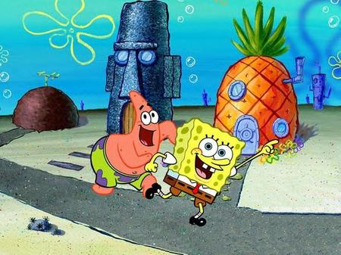
- I come home after school at 2 o’clock in the afternoon!
- And you?
- I go for a walk with my SNAIL Garry at 4 o’clock in the afternoon!
- And do you have a pet?
- At what time do you usually go for a walk with your pet?
- I usually have a cup of tea for supper at 7 o’clock in the evening!
- And what do you have for supper?
- I usually go to bed at 9 o’clock in the evening!
- What time do you usually go to bed?


Conclusion: Teacher:
Home task:
Күнделікті не істейтініңіз жайлы мәтін құрау:
7.00 –
7.30 –
8.00 –
10.00 –
3 p.m –
5 p.m –
7 p.m –
10 p.m -
Thank you for the lesson!
Have a nice day!

