Short-term plan  Unit6 |  |  | School:№3
 |  | Teacher’s name:Sydykova Zh.
Grade:4 |  | Number present:16 |  |  | Absent:0
Theme of the Lesson: |  | Healthy bodies 1/Health problems
Learning objective(s) that this lesson is contributing to and assessment criteria |  | 4.2.5.1 pronounce an increasing range of words, short phrases and simple sentences intelligibly  4.4.7.1 spell most familiar high-frequency words accurately when writing independently  4.5.9.1 use common simple present forms, including short answer forms and contractions, to give personal information and talk about habitual actions, facts and future timetabled events continue to use common past si07mple forms [regular and irregular] to describe actions and feelings and narrate simple events including short answer forms and contractions  4.5.12.1 use adverbs of time and frequency: sometimes, often, always, never to indicate when and how often,begin to use simple adverbs of manner example given well, badly, use common -ly manner adverbs to describe actions example given slowly, quickly
Lesson objectives |  | Most learners will be able to:  - Name the problems correctly
Some learners will be able to:
- Read the text and understand the main points
A few learners will be able to:
- Use Present simple forms to talk about health problems
Success criteria |  | Learners apply the information about health problems
Value links |  | Independent work
Cross curricular links |  | Science
ICT skills |  | PPT
Pastoral Care |  | Treat student’s as individuals and address their learning and personal needs
Previous learning |  | Health problems
Health and safety |  | Short physical exercises in between the activities
Plan
Planned timings | Planned activities |  |  |  |  | Resources
Beginning  5 mins | Starter:  The teacher greets pupils. Teacher revises new vocabulary.  Backache/ Earache/ Toothache/ A cold/A cough/A stomachache  A fever/ a sore throat/sore eyes  The teacher demonstrates the pictures of health problems and asks students to name as many health problems as possible. They check them at the next slide.  Introducelesson objectives. |  |  |  |  | PPT-  Slide 1,2,3
Middle  5-mins  10 min  10-mins  5-mins | (Whole class)  The teacher explains the rules from the slide. Students ask questions to each other to practice.  Students match the illness with the symptoms. This task could be done orally with the whole group or as a differentiation for able students.  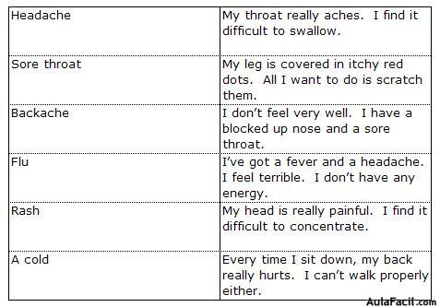  Grammar  Students fill in the blanks with the correct form of the verb (to have):  1. I __________ a cold. I feel ________________.  2. He __________ a sore throat. He feels ____________  3. My daughter __________ the flu.3es s  4. Do you __________ a headache? Yes, I feel ___________.  5. My husband __________ a toothache. He ___________awful.  6. The children _______________ stomachache. They _________________ terrible.  Reading practice  Students read the text and answer the questions.  Now students are going to read a story about Nina. Please read the story and then answer the questions with your classmates and teacher.  4. Read the story one more time. Underline the verbs.  Act out  Reading a dialogue students read the dialogue and role play it. |  |  |  |  | PPT  Slide 4  PPT  Slide 5  worksheet – task 1  worksheet – task 2
End  5 mins | Plenary  Students elicit the facts about climate and weather in Kazakhstan they have learnt.  Home task students should choose one season and describe it. |  |  |  |  | Home task worksheet
REFLECTION
Were the lesson objectives/learning objectives realistic?
What did the learners learn today?
What was the learning atmosphere like?
What changes did I make from my plan and why?
Summary evaluation
What two things went really well (consider both teaching and learning)?
1:
What two things would have improved the lesson (consider both teaching and learning)?
1:
What have I learned from this lesson about the class or achievements/difficulties of individuals that will inform my next lesson?

