LESSON: Unit 2. Helping and heroes |  |  |  | School: Secondary school #5 of Pavlodar city
Date: 18.10.2019 |  |  |  | Teacher name: Kassimova A.A.
CLASS: 6 A |  |  |  | Number present: 13 |  | absent:

The Theme: Practice pronunciation (Heroes)
Learning objectives |  |  | 6.4.2.1 understand independently specific information and detail in short, simple texts on a limited range of general and curricular topics  6.3.7.1 use appropriate subject-specific vocabulary and syntax to talk about a limited range of general topics, and some curricular topics
Lesson objectives |  |  | - practice pronunciation with new words in the text  - apply topical vocabulary to talk about heroes
Assessment criteria |  |  | - recognize particular facts and details in the text  - use topic related vocabulary in speech appropriately according to words and phrases into well-formed sentences
Value links |  |  | The Patriotic Act “Mangilik Yel” Civil responsibility, respect.
Cross curricular links |  |  | History
Previous learning |  |  | Adverbs of degree
Plan
Planned timings | Planned activities |  |  |  |  |  | Resources
Beginning  5 min  4 min  Middle  30 min  2 min  4 min  8 min  6 min  2 min  4 min  End  5 min | CLASS ROUTINE: Teacher greets learners, asks questions “How are you?”, “What’s the date today?”  STARTER: Random grouping.  Teacher divides learners into 2 groups. Learners choose a colour from the box (green, yellow).  1 group – green colours  2 group – blue colours.  Check home task with active method “Magic Ball”. (teacher throws the ball to the student and asks for homework. Ex 4 p 23.  Choose the correct adverb.  - Enough  - Too  - Quite  - Very  Teachers oral comment.  INTRODUCTION: Teacher shows the pictures and asks the questions:  -Who are the famous figures in the picture?  -What do you know about them?  - What are they famous for?  -What do you think, what is the topic of our lesson today?  -Please, try to guess what we are going to talk about today.  Learners share the ideas.  The teacher introduces learners the topic of the lesson and objectives.  The topic of the lesson “Heroes” (practice pronunciation).  Lesson objectives:  - practice pronunciation with new words in the text  - apply topical vocabulary to talk about heroes  DEVELOPMENT: Teacher shows new words on the topic of the lesson on an interactive whiteboard (educated, rural, military, leader, battle, several, include, charity, poor) and pronounce them.  Learners pronounce in group, in pairs, individually.  (W) Pre-reading stage.  Learners watch the slides about “Heroes”.  Assessment criteria: understand specific text information  Task: Answer the questions and define specific information of the slide.  Differentiation: by difficulty of task  Questions for All learners (simple questions) :  - What is the video about?  - Who are the famous figures in the picture?  Questions for Some learners (complex questions):  - What did the author of the video want to convey?  - What is the general idea of this information?  Descriptors: A learner  - answer the questions  - defines specific information  (f) Assessment: Teacher’s oral comment  (I, P) While-reading stage.  Teacher gives texts about Heroes for each group. The texts are different for each group.  1 group – Bauyrzhan Momyshuly  2 group – Angelina Jolie  Bauyrzhan Momyshuly  Bauyrzhan Momyshuly was born in Mynbulak village in Zhambyl region in 1910. He was very educated. Bauyrzhan began working as a rural policeman, but after a few years he joined the army and became a military leader. He fought in many battles and was famous for his bravery. Bauyrzhan wrote several books including One Night’s Tale and Moscow is Behind Us. To this day, people remember him as a People’s Hero of Kazakhstan.  Angelina Jolie  Angelina Jolie was born in 1975 in Los Angeles. Her father is called Jon Voight and he is a famous actor. In 1991, Angelina became an actress too and acted in many films. These days, though, most of her time is spent looking after her six children and doing work for charity. She also works for the United Nations and helps the poor people from countries at war.  Assessment criteria: understand detail text information  Task: read the text. Define detail information in the text and complete the table.  Active learning method: JIGSAW (all learners of each group read the texts and make a classter, then one learner of each group tells the information about his text to the learners of the second group. Learners complete the tables of different level)  Differentiation: Group ability, by type of task  Descriptors: A learner  - defines detail information  - completes the table  (f) Assessment: peer assessment with feedback  For less able learners:  For more able leaners (learners identifies the details in the text on its own):  Venn diagram  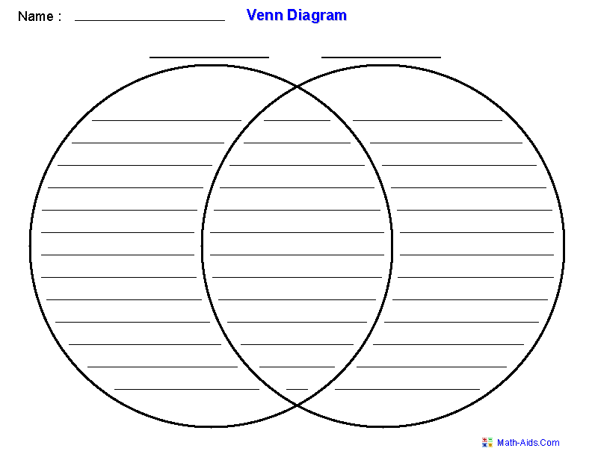  QUIZZ WITH NEW WORDS. There are 2 pictures Bauyrzhan Momyshuly and Angelina Jolie. Call the words from the text . describing these heroes using new words.  Bauyrzhan Momyshuly and Angelina Jolie  Military actress  Leader charity  Descriptors: A learner  - describe the heroes  - compusing new vocabulary  (f) Assessment: teacher’s feedback  (G) Post-reading stage..  TEST  - Baurzhan Momyshuly was …..  - a brave hero  - a singer  - a actor  - When was born Angelina Jolie?  - 1991  - 1975  - 1894  - Who is famous actress?  - Mynbulak  - Angelina Jolie  - Leader  - Where was born Bauyrzhan Momyshuly?  - Los Angeles  - Charity  - Mynbulak village Zhambyl region  - What is the United Nation?  - Organization of military.  - The United Nation is an organization that tries to solve global problems like war.  - The United Nation is an organization of actors.  Assessment criteria: choose the right answer  Task: test  Active learning method: test  Differentiation: all group  Descriptors: A learner  - Choose the correct answer  - Check yourself (timing: 2 min)  (f) Assessment: Self Assessment through keys.  PLENARY: The teacher hands out stikers. “Knowledge stairs ” to each learner in order to check how the students achieved the lesson objectives.  Feedback: put stickers on the stairs and comment.  CLASS ROUTINE: Teacher gives homework: to write about hero from your country.  Who is he/she?  What he/she is famous for?  What he/she did?  The lesson is over! Thank you for your activity. |  |  |  |  |  | PB  Active board,slide  Handout 1  PB p.25  Handout 2  Handout 3  Handout 4  “Knowledge stairs”, stickers
  Details:
  Name
  Date of birth
  Place of birth
  Profession
  How he/she is remembered?
Additional information
Differentiation: |  | Formative assessment: |  |  | ICT links  Health and safety links
By difficulty of task:  Less able learners: answer simple questions  More able learners: answer complex questions  Group ability:  Less able group: completes the table with the details in the text  More able learners: identifies and compares details on its own  Roles within group:  Each learner in the group has the definite role |  | Teacher’s oral comment  - helps to learners develop the ability to provide full and accurate answers  -peer assessment with feedback  - self assessment through keys |  |  | Health saving technologies.  ICT: watching the video and demonstration vocabulary in the lesson on the whiteboard.  In the lesson whiteboard is used 6 minutes, according to requirements

