Lesson plan

Long-term plan Unit 6: Traditions and customs. |  |  | Teacher name:
Date:
Grade: 2 |  |  | Number present:  umber present: |  |  | absent:
Theme of the lesson: |  |  | Home cooking
Learning objectives(s) |  |  | 2.W3 write familiar words to identify people, places and objects  2.S4 respond to basic supported questions about people, objects  2. L9 recognise the spoken form of familiar words and expressions  2.UE9 use common present simple forms [positive, negative and question] to give basic personal information
Lesson objectives |  |  | All learners will be able to:  - name the main vocabulary words;  Most learners will be able to:  - develop his or her ability to express likes and dislikes:  Some learners will be able to:  - complete all worksheets correctly.
Success criteria |  |  | Learners have met this learning objective if they can:  - say what kind of food he or she likes and dislikes  - use structure Do you like…? And respond on a question;  - do most of tasks correctly.
Value links |  |  | Ls will work together as a group showing respect and being polite with each other, respect to the tradition food of Kazakh people and customs
Cross curricular links |  |  | Primary Science
ICT skills |  |  | PPT, Video, the use of whiteboard
Previous learning |  |  | Home cooking
Plan
Planned timings | Planned activities |  |  |  |  |  | Resources
Beginning  8’ mins | Greeting: Teacher and students greet each other.  - Hello! Children. How are you today?  - “What day is it today?”  - “What date is it today?”  Warm up activity: Teacher shows cards in order to revise the theme of the lesson.  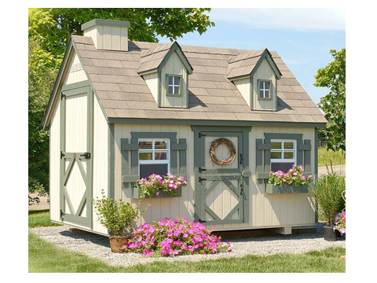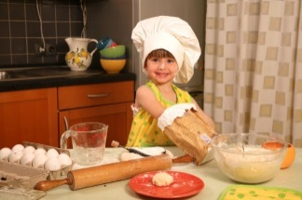  Learners guesses theme of lesson. “Home cooking”  Brainstorming.  Teacher offers students to take cards with pictures, then put it into baskets.  Checking up the home task. |  |  |  |  |  | memory cards 1,2,3,4
Middle  8’ mins  3’  5’  6’  6’ | Presentation of assessment criteria  I can…  Learners are introduced the success criteria of the lesson.  Presentation.  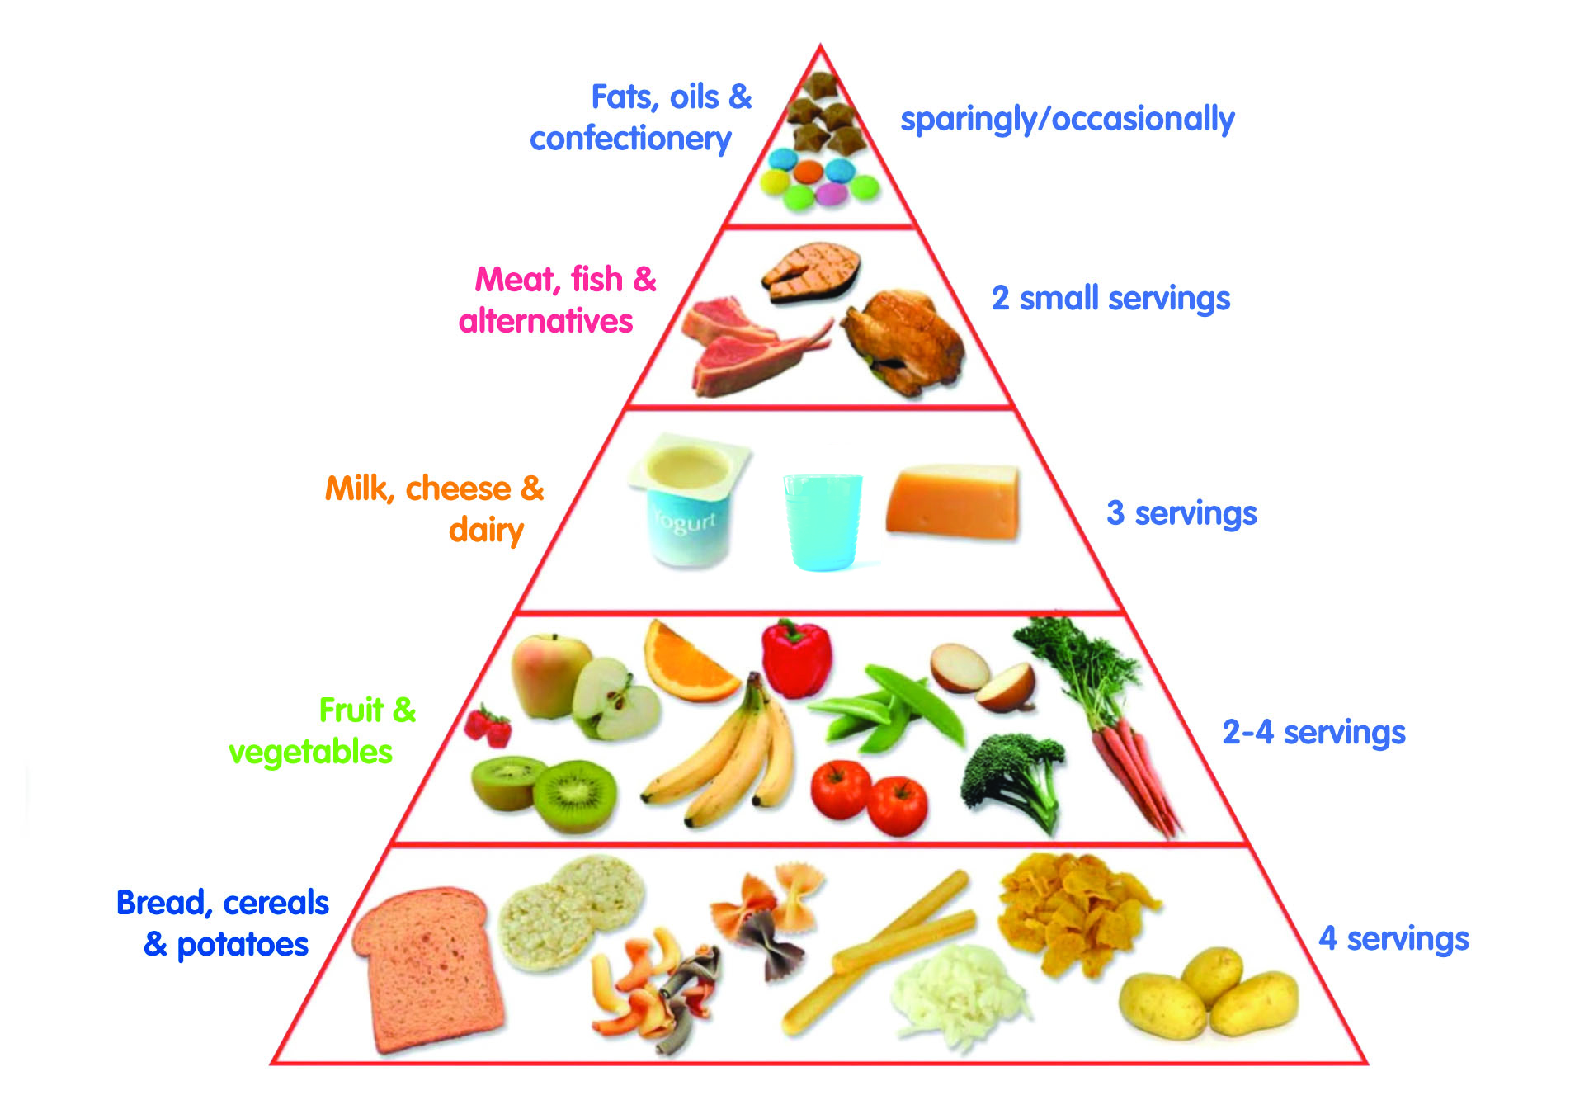  Then ask learners to  • Name foods in the Grain group.  • Name foods in the Vegetable group.  • Name foods in the Fruit group.  • Name foods in the Milk/Dairy group.  • Name foods in the Meat  • Name foods in the Sweets and oil  Vocabulary practice. Free practice ‘Food Pyramid’  Stick the names of 6 groups of food on the boards.  FRUIT  VEGETABLES  DAIRY  GRAINS  MEAT  Sweets and oil  Pupils are given 2-3 cards of different items of food. They should come up to the board and stick the card under a certain category.  Differentiation by support: Less able learners work with teachers` assistance.  Dynamic break  The game “CATCH A FLY”  Teacher gives many words to the groups of pupils with new words, then gives swatter. Teacher names a word, pupils must beat it with swatter.  FA/Task. Learners complete the worksheet.  Discriptor:  -Learners are able to match at least 10 words out of 12  - Learners are able to write at least 3 words out of 4  After that teacher show a short video for practicing construction Do you like….? Yes I do/ like…., no I don’t /like….  Speaking (P)Role-play. After watching video, students go on to the carpet sit as they feel comfortable and practice structure do you like..? by asking questions with help of cards. |  |  |  |  |  | https://youtu.be/qpYD_nCo-AU  PPT ‘Food Pyramid’  Hand-out 1  Hand-out 2 ‘Cards’ + flashcards from Primary colors  Hand-out 3  PPT  Worksheet1  https://www.youtube.com/watch?v=frN3nvhIHUk  https://www.youtube.com/watch?v=cabZLpTaJ2E  worksheets 2, 3,4
End  4’ mins | Closing Reflection/Self-Assessment & Goodbye  Check students understanding by asking the following….  What foods from the food pyramid is useful and useless?  If learners like the lesson they will put in pyramid healthy food/unhealthy food  H/T: to make a project about national food.  Sing a song |  |  |  |  |  | Goodbye Song  https://www.youtube.com/watch?v=WyfH-wwJUcY
Additional information
Differentiation – how do you plan to give more support? How do you plan to challenge the more able learners?  Support for weaker students: working in pairs/groups, phrases  Challenges for moreable students: Encouraged to do more writing; assist weaker students. |  | Assessment – how are you planning to check learners’ learning?  Monitoring  Checking the task  Feedback on the work |  | Health and safety check  ICT links  Video, online PPT  Ph.Training
Differentiation can be by task, by outcome, by individual support, by selection of teaching materials and resources taking into account individual abilities of learners (Theory of Multiple Intelligences by Gardner).  Differentiation can be used at any stage of the lesson keeping time management in mind  Pair work, group work |  |  |  | Health promoting techniques  Breaks and physical activities used.  Points from Safety rules used at this lesson.
Reflection  Were the lesson objectives/learning objectives realistic? Did all learners achieve the LO?  If not, why?  Did my planned differentiation work well?  Did I stick to timings?  What changes did I make from my plan and why? |  |  |  |  | Use the space below to reflect on your lesson. Answer the most relevant questions from the box on the left about your lesson.
Summary evaluation

What two things went really well (consider both teaching and learning)?
1:

2:

What two things would have improved the lesson (consider both teaching and learning)?
1:

2:

What have I learned from this lesson about the class orachievements/difficulties of individuals that will inform my next lesson?

