|  |  |  |  |  |  |
| --- | --- | --- | --- | --- | --- |
| **Unit: Holidays** | | **School:** #149 | | | |
| **Date:** The 5th of May | | **Teacher’s name:** Kazhiyeva Aidana Talgatbekovna | | | |
| **Grade:** GRADE 6 | | **Number present:** 12 | | **Absent:** - | |
| **Theme of the Lesson:** | | **Happy Victory Day!**  **ТHE 75th ANNIVERSARY OF THE GREAT PATRIOTIC WAR. IMMORTAL REGIMENT MARCH.** | | | |
| **Learning objective(s) that this lesson is contributing to and success criteria** | | * *to activate the lexical material, to improve writing skills and reading.* * *develop language guesswork, memory, cognitive activity, attention, increase motivation to learn a foreign language.* * *expand knowledge about the history of your country.* * *to foster respect for people who defended their Homeland, the culture of communication in different types of speech activity, respect for the cultural traditions of their native country, love for the Motherland, a sense of patriotism.* | | | |
| **Lesson objectives** | | Most learners will be able to:   * Express their opinion with insufficient reasoning and show respect to others while they speaking. * Attempt to understand the context to guess meanings of words. * Recognize some topic vocabulary items in the flow of speech. * Understand some specific information in a talk. | | | |
| Some learners will be able to:   * Express their opinion with sufficient reasoning. * Understand the context and attempt to deduce meanings of words. * Recognize most topic vocabulary items in the flow of speech. * Understand most main points in a talk. | | | |
| A few learners will be able to:   * Express their opinion with extensive reasoning. * Understand the context and deduce meanings of words accurately. * Understand all implied meaning in speech. | | | |
| **Equipment:** | | multimedia projector, computer, video, handout (poem, crossword, leaves with letters) | | | |
| **Value links** | | Respect value is instilled through the class discussions. | | | |
| **Cross curricular links** | | History | | | |
| **Kazakh culture** | | Students will have an awareness of national and local celebrities and heroes. | | | |
| **Health and safety** | | Short physical exercises in between the activities | | | |
| **Plan** | | | | | |
| **Planned timings** | **Planned activities** | | | | **Resources** |
| 5 min | **I. Warming-up.**  **Teacher:** Good morning, children! I’ m glad to see you here again, sit down! How are you? Are you fine today? That’s nice. If you are ready, let’s start our lesson. Who is on duty today? Who is absent today? What day is it today? What day of the week is it today?  **Teacher:** Listen to the following poem and try *to guess what’s the topic of our lesson…*  Red tulips  Scarlet flame  As over the Reichstag  Red flag!  Battle, hiking -  All experienced,  The joy of victory!  No! Not forgotten!  A peaceful morning  Sunlight,  Our Victory.  People are happy.  **Teacher:** You are quite right. Today we are going to talk about one of the main holidays in our country***. It is Victory day which we celebrate on the 9th of May. The 75th Anniversary in May.*** Seventy-five years ago our grandfathers and great-grandfathers won the Great Patriotic War. Thanks to our country the Second World War ended and peace was restored.  *Учитель делит класс на 3 команды. Каждая команда выбирает лучшего чтеца из команды. Дети соревнуются в чтении.*  Well done, children! All groups showed your great knowledge of reading English poem. Very good!  **II. Phonetic drill.**  We fight for the peace! Hooray!  It’s Victory Day! Hooray  It’s the end of our tears. | | | | Приложение № 1 |
| 15 min  10 min  10 min | **III. Giving to students exercises and activities.**  **The main word of our lesson is *«VICTORY»***  **1. Let’s play *the game «Typist».***  **Teacher:** Children, imagine that you are English letters, and you are writing the main message. *Assyl* is letter *V*, *Maksat* is letter *I*, *Baglan* is letter *C*, *Aidana* is letter *T*, *Laura* is letter *O*, *Masha* is letter *R*, *Aknur* is letter *Y*, *Olga* is a letter *W*, *Daulet* is a letter *E*, *Kerim* is a letter *N*, *Dina* is a letter *T*, *Anna* is a letter *H*, *Saltanat* is a letter *A* and *Kirill* is a ***typist***. He serves in the Soviet Army and types a very important message to the soldiers. Listen to him attentively and type this message on the magnetic board. Then we all read the message.  **Children:** *V-I-C-T-O-R-Y. W-E W-I-N-T-H-E W-A-R.*  **Teacher :** Look at the pictures on the board.  **2. Cross out the words that you cannot see.** *(Ребята посмотрите на нашу доску на ней есть фотографии зачеркните слова, которые вы не видите на изображениях)*  Veterans, children, planes, soldier clothes, ﬂowers, George’s ribbon, tank, eternal ﬂame, parade, red carnations, ﬁreworks, medals, Red Star medal, tulips, field cap, red flags.      **IV. Physical activity.**  **Teacher :** You’ve worked hard and *it’s high time to have a rest.*  Fly your planes like Russian pilots! Children, I’m sure you want to be brave and strong like Kazakh pilots! Let’s fly!  *Fly a plane!*  *Don’t be afraid!*  *Your hands are wings!*  *Hooray! Hooray!*  *Take off! Take off!*  *Now fly your plane.*  *And now landing.*  *You’re doing great!*  **3. Read the text and fill in the missing** **words***(Holidays, Victory Day, Great Patriotic War , firework , veterans, parade, meetings and demonstrations, celebrating, silence).*  ***Victory Day***  In Kazakhstan, …….is one of the great ….. of the year. It is celebrated in 9th May. It is a holiday of all people. There are decorations, flags and posters in the streets, in the shop windows and on the front of large buildings.  On Victory Day morning there are ……….of the …… who fought in the Great Patriotic War. On that day there is military ……. in all big cities of our country. (such as Almaty). Flowers and souvenirs are given to those who took part in the………….. There are a lot of people in the streets and squares, at theatres, cinemas and concert halls. They are all …… its magnificent holiday. Many people go to see their friends or go for walks in the parks. In the evening there is a holiday ……… and a minute of …. to remember all those who did not come back from the war. Our country is proud of the Victory. Hooray!  **4. State if the sentences true or false.** *Учащиеся выполняют письменное задание на карточках, обмениваются с соседом по парте, проверяют его, ставят оценки. Проверяем в классе.*  1. Victory Day is celebrated only in Almaty. (False)  2. People prepare for Victory Day a lot. (True)  3. There is military parade on Victory Day. (True)  4. Our country is proud of the victory (True)  5. A few people celebrate Victory Day. (False)  6. People can present flowers to our veterans and say thank you for life. (True)  7. People like watching the fireworks and following a minute of silence to remember all those who did not come back from the war in the evening. (True)  **5. Do the crossword puzzle.** *Учащиеся в группах отгадывают кроссворд, выходят к доске и пишут ответы.*  **Teacher:** This song is played every Victory Day.  **6. Listen to the following song and give the Russian equivalent of it, please.**  This Victory Day is scented with gunpowder,  this is a holiday with grey hair on the temples.  This is happiness with tears in your eyes  Victory Day  Victory Day  Victory Day  *Учитель исполняет песню «День Победы» на английском языке. Ученики угадывают песню. Учитель включает видеоролик с песней, ученики поют все вместе. Дети соревнуются по группам на лучшее исполнение припева песни «Victory Day»* | | | | Handout pictures  Приложение № 2  Приложение № 3  Ccылка на видеоролик https://youtu.be/knEvCkN5OBw |
| 5 min | **V. The end of the lesson.**  Dear boys and girls thank you for your work.  Did you like the lesson?  What have you done at the lesson?  Was our today’s lesson useful for you?  What new words have you learnt?  What task was the most difficult?  *(Учитель раздает листы самооценки, которые ребята заполняют)*  **Teacher:** You have learnt a lot of interesting information about Victory day. I hope you will improve your English knowledge.  Your homework is to make greeting card for a veteran.  *Выставление оценок.*  *Учитель выставляет оценки ученикам, комментируя их.*  **Teacher:** Your marks for the lesson are …  *Подведение итогов занятия.*  **Teacher:** Dear children, our lesson is over. You were active and worked not bad. Victory Day! Victory Day! Victory Day! Hooray! We remember! We are proud! Goodbye! | | | |  |
| **REFLECTION** | | | | | |
| Were the lesson objectives/learning objectives realistic? | | |  | | |
| What did the learners learn today? | | |  | | |
| What was the learning atmosphere like? | | |  | | |
| Did my planned differentiation work well? | | |  | | |
| Did I stick to timings? | | |  | | |
| What changes did I make from my plan and why? | | |  | | |
| **Summary evaluation**  **What two things went really well (consider both teaching and learning)?**  **1:**  **2:**  **What two things would have improved the lesson (consider both teaching and learning)?**  **1:**  **2:**  **What have I learned from this lesson about the class or achievements/difficulties of individuals that will inform my next lesson?** | | | | | |

***Приложение № 1* Стихотворение**

Red tulips

Scarlet flame

As over the Reichstag

Red flag!

Battle, hiking -

All experienced,

The joy of victory!

No! Not forgotten!

A peaceful morning

Sunlight,

Our Victory.

People are happy.

***Приложение № 2***

Victory Day

In Russia, **Victory Day** is one of the great**holidays** of the year. It is celebrated in 9th May. It is a holiday of all people. There are decorations, flags and posters in the streets, in the shop windows and on the front of large buildings.  
On Victory Day morning there are **meetings and demonstrations** of the **veterans**who fought in the Great Patriotic War. On that day there is military **parade** in all big cities of our country. (such as Sevastopol). Flowers and souvenirs are given to those who took part in **the Great Patriotic War**. There are a lot of people in the streets and squares, at theatres, cinemas and concert halls. They are all **celebrating**its magnificent holiday. Many people go to see their friends or go for walks in the parks. In the evening there is a holiday **firework** and a minute of **silence** to remember all those who did not come back from the war.

***Приложение № 3* (Crossword puzzle)**

|  |  |  |  |  |  |  |  |  |  |  |  |  |  |  |  |  |  |  |  |  |  |  |  |  |  |  |  |  |  |  |  |  |
| --- | --- | --- | --- | --- | --- | --- | --- | --- | --- | --- | --- | --- | --- | --- | --- | --- | --- | --- | --- | --- | --- | --- | --- | --- | --- | --- | --- | --- | --- | --- | --- | --- |
|  |  |  |  |  |  |  |  |  | |  | |  | |  | |  | |  | |  | | |  | |  | |  |  |  |  |  |  |
|  |  |  |  |  |  |  |  |  | |  | |  | |  | |  | |  | |  | | |  | |  | |  |  |  |  |  |  |
|  |  |  |  |  |  |  |  |  | |  | |  | |  | |  | |  | |  | | |  | |  | |  |  |  |  |  |  |
|  |  |  |  |  |  |  |  |  | |  | |  | |  | |  | |  | |  | | |  | |  | |  |  |  |  |  |  |
|  |  |  |  |  |  |  |  |  | |  | |  | |  | |  | |  | |  | | |  | |  | |  |  |  |  |  |  |
|  |  |  |  |  |  |  |  | 2. | |  | |  | |  | | 6. | |  | |  | | |  | |  | |  |  |  |  | 7. |  |
|  |  |  |  |  |  |  |  |  | |  | |  | |  | |  | |  | |  | | |  | |  | |  |  |  |  |  |  |
|  |  |  | 1. |  |  |  |  |  | |  | |  | |  | |  | |  | |  | | |  | | 3. | |  |  |  |  |  |  |
|  |  |  |  |  |  |  |  |  | |  | |  | |  | |  | |  | |  | | |  | |  | |  |  |  |  |  |  |
|  |  |  |  |  |  |  |  |  | |  | |  | |  | | 7. | |  | |  | | |  | |  | |  |  |  |  |  |  |
| 5. |  |  | 5. |  |  |  |  |  | |  | |  | |  | |  | |  | |  | | |  | |  | |  |  |  |  |  |  |
| 6. |  |  |  |  |  |  |  |  | |  | |  | |  | |  | |  | |  | | |  | |  | |  |  |  |  |  |  |
|  |  |  |  |  |  |  |  | |  | |  | |  | |  | |  | |  | |  |  | |  | |  |
|  |  |  |  |  |  |  |  |  | |  | |  | |  | |  | |  | | 4. | | |  | |  | |  |  |  |  |  | 8. |
|  |  |  |  |  |  |  |  |  | |  | |  | |  | |  | |  | |  | | |  | | | | |  |  |  |  |  |
|  |  |  |  |  |  |  |  |  | |  | |  | |  | |  | |  | |  | | |  | |  | |  |  |  |  |  |  |
|  |  |  |  |  |  |  |  |  | |  | |  | |  | |  | |  | |  | | |  | |  | |  |  |  |  |  |  |

**Решите кроссворд, заменив картинки и слова на английский язык.**

**По горизонтали:**

**1**. ВЕТЕРАН

**2.** 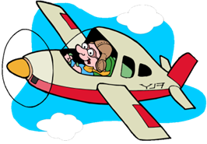

**3.** 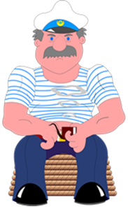

**4.** .

**5.**  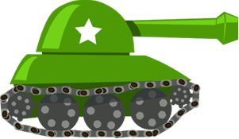

**6.** ГЕРОЙ

**7.** 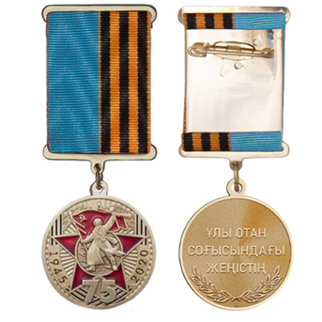

**Из цветных букв составьте и переведите ключевую фразу**

**По вертикали:**

**1**. ПОБЕДА

**2.** 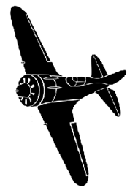

**3.** 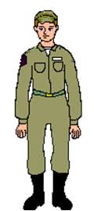

**4.** 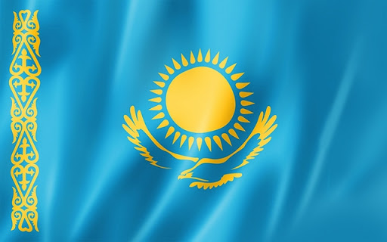

**5.** 

**6.** ТАНКИСТ

**7.** ПАРАД

**8.** 

|  |  |  |  |  |  |  |  |  |  |  |  |  |  |  |  |  |  |  |  |  |  |  |  |  |  |  |  |  |  |  |  |  |  |  |
| --- | --- | --- | --- | --- | --- | --- | --- | --- | --- | --- | --- | --- | --- | --- | --- | --- | --- | --- | --- | --- | --- | --- | --- | --- | --- | --- | --- | --- | --- | --- | --- | --- | --- | --- |
|  |  | **W** | **E** |  | | **P** | **R** | | **O** | | **U** | | | **D** | |  | | **O** | | **F** | |  | | **V** | | **I** | **C** | **T** | | **O** | **R** | **Y** |  |  |
|  |  |  |  |  | |  |  | |  | |  | | |  | |  | |  | |  | |  | |  | |  |  |  | |  |  |  |  |  |
|  |  |  |  |  | |  |  | |  | |  | | |  | |  | |  | |  | |  | |  | |  |  |  | |  |  |  |  |  |
|  |  |  |  |  | |  |  | |  | |  | | |  | |  | |  | |  | |  | |  | |  |  |  | |  |  |  |  |  |
|  |  |  |  |  | |  |  | |  | |  | | |  | |  | |  | |  | |  | |  | |  |  |  | |  |  |  |  |  |
|  |  |  |  |  | |  |  | |  | | 2 p | | | i | | l | | o | | 6t | |  | |  | |  |  |  | |  |  |  | 7p |  |
|  |  |  |  |  | |  |  | |  | | l | | |  | |  | |  | | a | |  | |  | |  |  |  | |  |  |  | a |  |
|  |  |  | 1 v | e | | t | e | | r | | a | | | n | |  | |  | | n | |  | |  | |  | 3 s | a | | i | l | o | r |  |
|  |  |  | i |  | |  |  | |  | | n | | |  | |  | |  | | k | |  | |  | |  | o |  | |  |  |  | a |  |
|  |  |  | c |  | |  |  | |  | | e | | |  | |  | |  | | 7m | | e | | d | | a | l |  | |  |  |  | d |  |
| 5s |  |  | 5t | a | | n | k | |  | |  | | |  | |  | |  | | a | |  | |  | |  | d |  | |  |  |  | e |  |
| 6h | e | r | o |  | |  |  | |  | |  | | |  | |  | |  | | n | |  | |  | |  | i |  | |  |  |  |  |  |
| i |  |  | r |  |  | | |  | |  | |  |  | |  | |  | |  | |  | |  | |  | | e |
| p |  |  | y |  | |  |  | |  | |  | | |  | |  | |  | |  | |  | | 4f | | i | r | | e | w | o | r | k | 8s |
|  |  |  |  |  | |  |  | |  | |  | | |  | |  | |  | |  | |  | | l | |  | | |  |  |  |  |  | t |
|  |  |  |  |  | |  |  | |  | |  | | |  | |  | |  | |  | |  | | a | |  |  | |  |  |  |  |  | a |
|  |  |  |  |  | |  |  | |  | |  | | |  | |  | |  | |  | |  | | g | |  |  | |  |  |  |  |  | r |