Short term plan

Unit of a long term plan Unit 1 |  | School: #54
Date: |  | Teacher name: Igenbayeva D.A
CLASS: 5 |  | Number present: |  |  | absent:
Lesson title | Homes 2
Learning objectives(s) that this lesson is contributing to (link to the Subject programme) | S1. Provide basic information about themselves and others at sentence level on an increasing range of general topics.  S4. Respond with limited flexibility at sentence level to unexpected comments on an increasing range of general and curricular topics.  UE14. Use constructions “ there is/there are” to talk about things in singular and in plural
Lesson objectives | All learners will be able to:  - Understand specific information related to the target.  - Pronounce and name some words, according to the topic.  - Recognize the theme and grammar material;  Most learners will be able to:  - To write short sentences in a paragraph.  - Answer the questions.  - Do exercises with grammar material;  Some learners will be able to:  - Use prepositions to make sentences.  - Speak about things in a room.
Assessment criteria | To ask simple questions to get information about rooms  To develop the learners’ correct pronunciation of active vocabulary  To write and complete the sentences by putting names of the room
Values links | To respect each others opinion, to awake of their patriotic senses. To teach pupil to love our motherland.
Cross-curricular  Links | Kazakh and Russian
Previous learning | Learners have an information about rooms. New vocabulary according to the previous lesson.
Plan
Planned timings | Planned activities (replace the notes below with your planned activities) |  |  |  | Resources
Start | - Greeting. Good afternoon children!  - Checking the homework  III .Group devision by “Mosaic”strategy.Students build pictures of rooms and divide into 3 groups  1st group-living room  2nd group bedroom  3rd group kitchen  IV.Warming –Up.Strategy “Sing a song” Listen and guess the theme of the lesson!
Middle | Today we will speak about your houses, rooms, furniture. We’ll work with new words and grammar, play the games. You’re very good students. So I wish you good luck! Let’s go on!  - Working with new vocabulary.  English Translation  a desk жазу үстелі  a dishwasher ыдыс жуатын машина  VCR (Video Cassette Recording) видеомагнитофон  a washing machine кір жуатын машина  a cupboard шкаф  a towel орамал  a fire камин  a curtain перде  chest of drawers комод  a rug кілем  a wardrobe гардероб,шифонер  VI .Grammar :There is/ there are  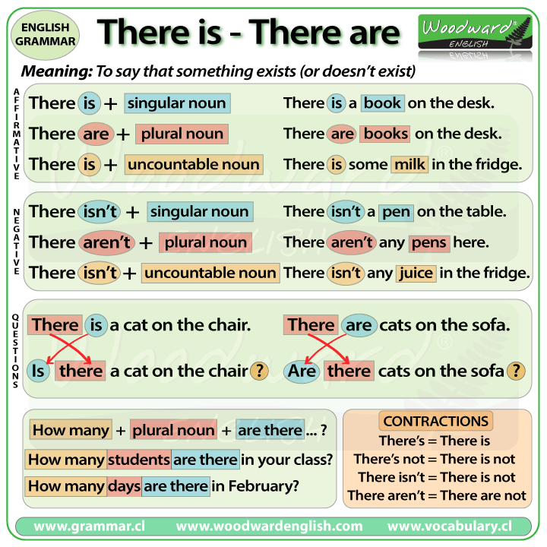  VII.: Speaking.Active strategy “Magic dice”  Throw a dice corresponds to the number of questions  Use constructions there is/ there are  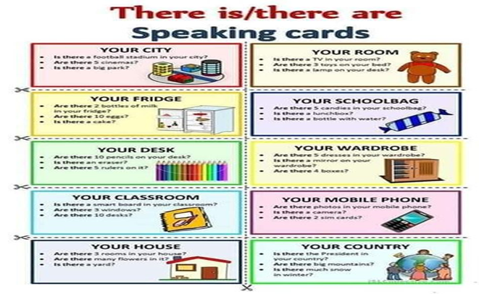  Descriptor A learner:  - Works cooperatively in a group;  - Throws a dice and asks complex questions  VIII .Group work  Let's play the game "Guess the room"  I - group  1. We have breakfast, lunch, dinner, supper there.  We eat in it. What room is it?  2. We cook dinner, wash up dishes there. There is cooker a fridge, a dishwasher there. There are plates, cups, cupboards there.  What room is it?  II - group  3. There is a bed, a picture, a window, a curtain, a toilet table in it.  What room is it?  4. There is a towel, a bath, a soap, a mirror, a sink, a shelf in it.  What room is it?  III - group  5. There is a sofa, a fire, a carpet, an armchair, a picture, a television in it. What room is it?  6. There is a computer, a desk, a bookshelf, a chair, a lamp, a flower, a plant, a clock in it. What room is it?  Descriptor A learner:  - Reads and translates  - Defines rooms and furniture’s  - Answers the questions  IX.Complete the sentences:  1. We cook in the …  2. We sleep in the …  3. We wash in the …  4. We watch TV in the …  5. We eat in the …  6. We read books in the …  Descriptor A learner:  - Reads and translates  - Fillings in the gaps |  |  |  | PPT (slide – 3)  Picture, dictionaries  PPT (slide – 6)
End | Assessment.  Reflection  - What is the topic of the lesson?  - What did we do in the lesson?  - What did you learn in the lesson?  Home task: Writing and speaking “My room” Use what you know  Draw your room and furniture’s in the paper. Make a dialogue with your partner about your room. |  |  |  | Stickers  PPT (slide – 7)
Additional information
Differentiation – how do you plan to give more support? How do you plan to challenge the more able learners? |  |  | Assessment – how are you planning to check learners’ learning? | Health and safety check
Task –completing the description  All learners will understand specific information related to the target, pronounce and name some words, according to the topic.  Most learners will answer the questions, do exercises with grammar material;  Speak about things in a room |  |  | I will assess the learners works by praise orally and will give smilies for active pupils. | To pay attentions to learners safety during the doing activates, be careful in moving to places, in dividing to groups
Reflection  Were the lesson objectives/learning objectives realistic?  Did all the learners achieve the lesson objectives/ learning objectives? If not, why?  Did my planned differentiation work well?  Did I stick to timings?  What changes did I make from my plan and why? |  |  | Use the space below to reflect on your lesson. Answer the most relevant questions from the box on the left about your lesson.  Use there is/there are like to describe things and about to denote topics  All learners achieve the lesson objectives and learning objectives.  The lesson was exciting. The atmosphere was very positive.

