Short term plan

Unit of a long term plan |  |  |  |  | School:
Date: |  |  |  |  | Teacher name:
CLASS: 5th |  |  |  |  | Number present: |  |  | absent:
Lesson title |  |  | Rooms , furniture and appliances
Learning objectives(s) that this lesson is contributing to (link to the Subject programme) |  |  | 5C6 Organize and present information clearly to others  5L1Understand a sequence f supported classroom instructions  5S2 ask simple questions to get information about a limited range of general topics  5UE1Use appropriate countable and uncountable, including common  noun phrases describing times and location, on a limited range of curricular topics
Lesson objectives |  |  | Describe their rooms, write a few sentences about it  Complete the gaps with the correct form of there is/ there are  Practice there is/there are through personalization
Assessment criteria |  |  | Introduce the rooms of your own flat.  Name the furniture and use it in your sentences  Complete the sentences with there is/ there are
Values links |  |  | This lesson is connected with responsibility because we should be responsible for our house.
Cross-curricular links |  |  | computer studies
ICT skills |  |  | Multimedia board. Robot’s dance
Previous learning |  |  | Fill in the gaps with appropriate form of the nouns  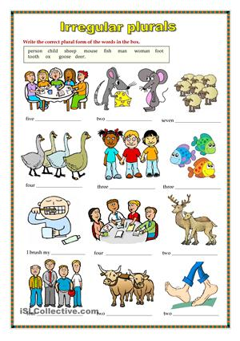  Descriptor:  -Make plural forms
Plan
Planned timings | Planned activities (replace the notes below with your planned activities) |  |  |  |  |  | Resources
Beginning | [W]  Give the pupils the pictures of appliances and furniture. And they should divide into two groups according to the pictures. Kitchen and bedroom will be the 1st group, living room and bathroom will be the second group. Ask the students what about will be the theme and they will answer. Look at the blackboard and listen to the words ’pronunciation and writing.  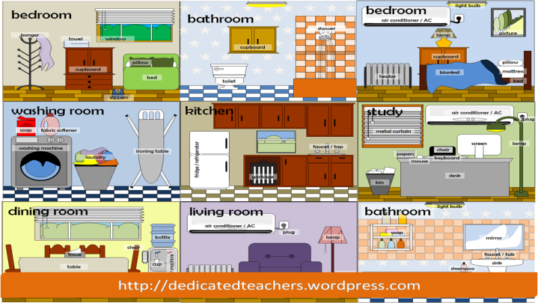  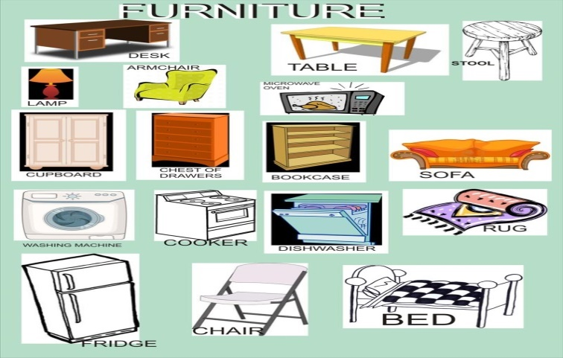  “Crossword puzzles” activity is given there. As they have the pictures of the furniture and appliances, ask them find the correct names and stick them according to the devices and write it. (kitchen and bedroom, living room and bathroom).  Bathroom and living room  Kitchen and bedroom  -match correctly  -write the names without mistakes and remember it |  |  |  |  |  | www.weekenglish.ru/english  pictures
Middle | Let’s watch a video. According to the video read the questions on the blackboard. Answers sharing activity (student to student)  - How many rooms are there in this video?  - How many windows are there in the living room?  - Is there an armchair in the living room?  - What are there in the living room?  - Is there a wardrobe in the bedroom?  - How many beds are there in the bedroom?  - What is there in the kitchen?  [W ]Pupils should ask these question each other and assess it themselves.Ask them about grammar structure used there. After their explanations give them the structure of there is/there are and examples. We use there is with uncountable nouns and countable in singular form. We use there are with plural form. Descriptor:  - Share answers  - Use there is/there are  [G] Project work: My ideal room.  Draw your ideal room using new vocabulary in posters  Descriptor:  -use new vocabulary while presenting |  |  |  |  |  | http//YouTube/my house/furniture/daily routines
End | [P] Jigsaw activity :give students mixed sentences and they should piece together parts of information to complete the whole.  - A book the table on there is.  - Two sofas there the in living room are.  - Is a TV the in bedroom there ?  - Four in kitchen are the chairs there?  - Five are rooms there my in house.  - Are pillows the in bedroom there four?  Descriptor:  -complete the sentence.  Feedback. “Success stair”  I ________________________know  I _______________________understood  I ______________________.can do.  I ____________________don’t know. |  |  |  |  |  | Card made by me
Additional information
Differentiation – how do you plan to give more support? How do you plan to challenge the more able learners? |  |  |  | Assessment – how are you planning to check learners’ learning? |  | Health and safety check
I used different kinds of activities during my lesson. First they discovered the theme themselves according to the pictures, made matching tasks in groups, do tasks according to the video. I tried to make my lesson student-centered. Students could remember the words and make their own sentences using there is/there are. Using different approaches helped me to achieve my goals. |  |  |  | I assessed them formatively during the lesson.  Pair assessment |  | Safety rules are agreed and told  Energizing  ICT
Reflection  Were the lesson objectives/learning objectives realistic?  Did all the learners achieve the lesson objectives/ learning objectives? If not, why?  Did my planned differentiation work well?  Did I stick to timings?  What changes did I make from my plan and why? |  | Use the space below to reflect on your lesson. Answer the most relevant questions from the box on the left about your lesson.  My lesson objectives were realistic because they could use these words in their speaking, describing.  In my opinion all learners could achieve the objectives.
Yes, it worked well, because there were a lot of tasks.

Yes, I did.

I only should use more illustrated pictures.
Summary evaluation

What two things went really well (consider both teaching and learning)?

1: Discovering the theme

2: matching

What two things would have improved the lesson (consider both teaching and learning)?

1: using some/any in the sentences

2:project work

What have I learned from this lesson about the class or individuals that will inform my next lesson?
I should use more additional materials to active students.

