Unit of a long term plan Module 6 Lesson 3 Save our animals 1 |  |  |  |  | School:№17
Date: 26.02.2020 |  |  |  |  | Teacher’s name: Yeshenkeldiyeva Gulnur
CLASS: 4 А |  |  |  |  | Number present: |  |  | absent:
Lesson title |  |  | Аnimals
Learning objectives(s) that this lesson is contributing to (link to the Subject programme) |  |  | 4.W2 begin to use joined-up handwriting in a limited range of written work
Lesson objectives |  |  | All learners will be able to - name the types of animals according to the picture.  Most learners will be able to  -ask and answer the questions can describe the animals  Some learners will be able to  - give opinion according to the certain pictures and they use pair work.
Values links |  |  | Using videos & pictures, working with URLs
Cross-curricular links |  |  | History
Previous learning |  |  | Target vocabulary Food items: salt and pepper, cabbage, pizza, sausage, olive oil, mayonnaise, lettuce, cucumber, mushrooms, mustard
Plan
Planned timings | Planned activities (replace the notes below with your planned activities) |  |  |  |  |  | Resources
Start | The produce of the lesson  I. Organization moment.  T: Good morning, pupils!  P: Good morning, teacher!  T: Who is on duty today?  P: I’m on duty today.  T: Who is absent today?  P: All are present today.  T: OK. Sit down.  II. Checking the homework.  T: What was your homework for today?  P: Our homework to learn new words about food.  Brainstorming:  Teacher introduces lesson objectives and criteria to the students.  Teacher shows a video about “Animals” and follow the instructions  T: I’ll divide you in to 2 groups, please, choose the pictures from the blackboard.  The 1st group “domestic”  The 2nd group “wild”  What words have you seen in these pictures?  - Teacher reads new vocabulary  New words:  Wild [waild]- жабайы  Domestic [dәmestik]- үйдегі  crocodile – қолтырауын ['krɔkədail]  wolf — қасқыр [wo͝olf]  tiger — жолбарыс [ˈtīgər]  sheep — қой [SHēp]  horse — ат [hôrs]  hare — қоян ['heə]  goat — ешкі ['gəut]  giraffe — керік [ʤə'rɑ:f]  deer — олень, елік ['diə]  duck — үйрек [dək]  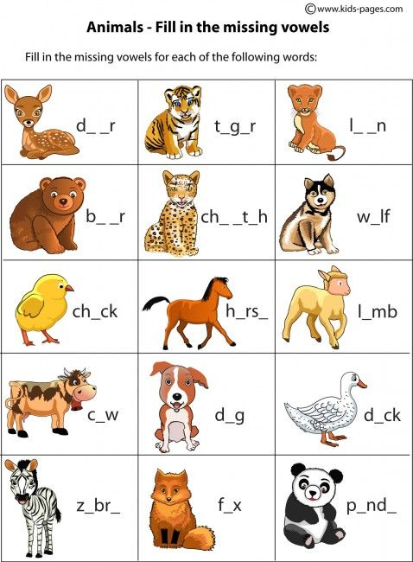  Descriptor:  A learner:  - Match the words correctly  Differentiation by support: read and match the words  Formative assessment: by rotating station method |  |  |  |  |  | Box with things  worksheet
Middle | 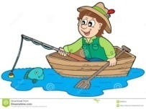  Activity “Fisherman game” (I): Explain the task to students; they must “catch the fish” and answer a question and translate the sentence  1. This animal sleep all day in winter [bear]  2. It lives in the desert it needs very little water [camel]  3. It has got long ears it eats carrot [rabbit]  4. It lives in Africa and India it eats grass leaves [elephant]  5. It is a big cat it lives in jungle [tiger]  6. This animal looks like a dog but it is wild.[wolf]  7. It lives in the house. It likes fish. What is it? (cat)  8. It lives in the forest. It likes bananas. What is it? (monkey)  9. It is very big and grey. What is it? (an elephant)  10. This animal likes grass. It is a domestic animal. It gives us milk. (cow)  11. This animal lives at home or in the street. It is man’s friend. What is it? (dog)  12. It is green and big. It likes meat. It lives in the river. What is it? (a crocodile)  13. It eats carrots. It has got long ears. [rabbit]  Descriptor:  A learner:  - Answer with new words correctly  - Read and say  Differentiation by support:  - Less able learners answer the question with a little support of teacher.  - More able learners answer the questions quickly.  Formative assessment: The teacher assesses the students giving for the correct answer one “fish”  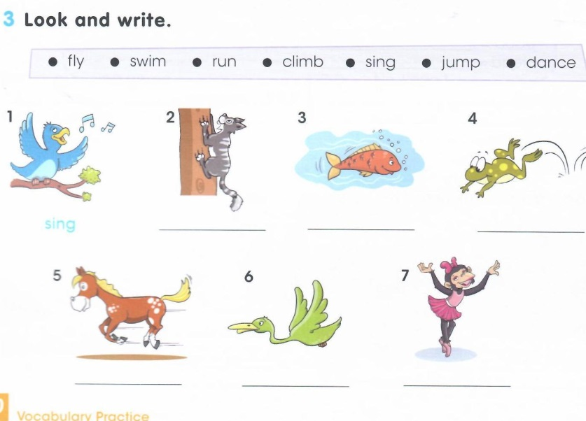  - Game “Who I am?” Each student's ear should tell the name of one animal. It shows the pupil without the name of the animal, or shows what the animal does.  The rest of the pupil will find out in English what animal he is showing.  Descriptor:  A learner:  - shows the pupil without the name of the animal, or shows what the animal does.  Differentiation by support: more support will be given for ability of learners.  Formative assessment: the teacher assesses active participants by saying Well Done!, Good for you! Good job!
End |   For the feedback we will talk about “Color balloons”  According to their mood after the lesson students will stick pins to the balloon`s stick that standing on the table  - Red The lesson is clear for me  - Blue I have got some question  - Yellow I don’t understand anything  Home work: To write Essay and draw a picture “My favourite animal”
Additional information
Differentiation – how do you plan to give more support? How do you plan to challenge the more able learners? |  |  |  | Assessment – how are you planning to check learners’ learning? |  | Health and safety check
Checking homework  Differentiation by support: read and match the words  Read and mark the sentences True (T) or false (F).  Differentiation by support: read and mark sentenses  Activity “Find me game” (G):  Differentiation by support: more support will be given for ability of learners.  Activity “Fisherman game”  Differentiation by support:  Less able learners answer the question with a little support of teacher.  More able learners answer the questions quickly. |  |  |  | Formative assessment: by rotating station method  Formative assessment: Verbal assessment (Leaners assess pair)  Formative assessment: the teacher assesses active participants by saying Well Done!, Good for you! Good job!  Formative assessment: The teacher assesses the students giving for the correct answer one “fish” |  | Health saving technologies.  Using physical exercises and active activities.  When they were working in a group, they were controlled attentively how they sat, what they were talking about and so on. Physical exercise was offered after 20 minutes. They were warned to be careful to use electronic tools during the lesson.
Reflection  Were the lesson objectives/learning objectives realistic?  Did all the learners achieve the lesson objectives/ learning objectives? If not, why?  Did my planned differentiation work well?  Did I stick to timings?  What changes did I make from my plan and why? |  | Use the space below to reflect on your lesson. Answer the most relevant questions from the box on the left about your lesson.
Summary evaluation

What two things went really well (consider both teaching and learning)?

1:

2:

What two things would have improved the lesson (consider both teaching and learning)?

1:

2:

What have I learned from this lesson about the class or individuals that will inform my next lesson?

Тексерген: ДОЖЖО

