Term 4  Unit 9 "The world of work" |  |  | School: Sh.T.Erkinov
Date: |  |  | Teacher’s name: Bisembaeva N.
Grade: 8 |  |  | Number present: | Number absent:
Theme of the lesson: |  |  | Should, must and have to.
Learning objectives(s) that this lesson is contributing to |  | 8.C7 develop and sustain a consistent argument when speaking or writing  8.UE13 use a growing variety of modal forms for different functions: obligation, necessity, possibility, permission, requests, suggestions, prohibition on a range of familiar general and curricular topics
Lesson objectives |  | All learners will be able to:
 |  | - differentiate should, must and have to.
 |  | Most learners will be able to:
 |  | - produce the sentences with should, must and have to to make recommendations and talk about school.
 |  | Some learners will be able to:
 |  | - apply should, must and have to in speech fluently.
Value links |  | Students will be able to understand that every work is important and worthy.
Cross curricular links |  | Social studies.
Previous learning |  | School life: nouns.
Use of ICT |  | Bandicam, Youtube
Intercultural awareness |  | Comparison of modal verbs in English, Russian and Kazakh languages.
Health and Safety |  | Breaks and physical activities used.
Plan
Planned timings | Planned activities |  |  |  | Resources
Beginning the lesson | The lesson greeting.  The teacher sets the lesson objectives, letting students know what to anticipate from the lesson.
Main Activities | Teacher show a video to explain “Difference of using should, must and have to.  Task 1. p. 73. Complete the sentences  with must/mustn't or should/shouldn’t.  - 1. I shouldn’t text friends in class.  - 2. You must revise before the English test.  3.We should go home before it gets dark.  4.You mustn’t fail these exams. They’re very important.  5. Your dad should stop smoking. It’s unhealthy.  6. You mustn’t shout in the library.  7. You shouldn’t copy people’s work.  8. Should I tell the teacher about the bully?  Task 2. Order the words to make sentence.  1. 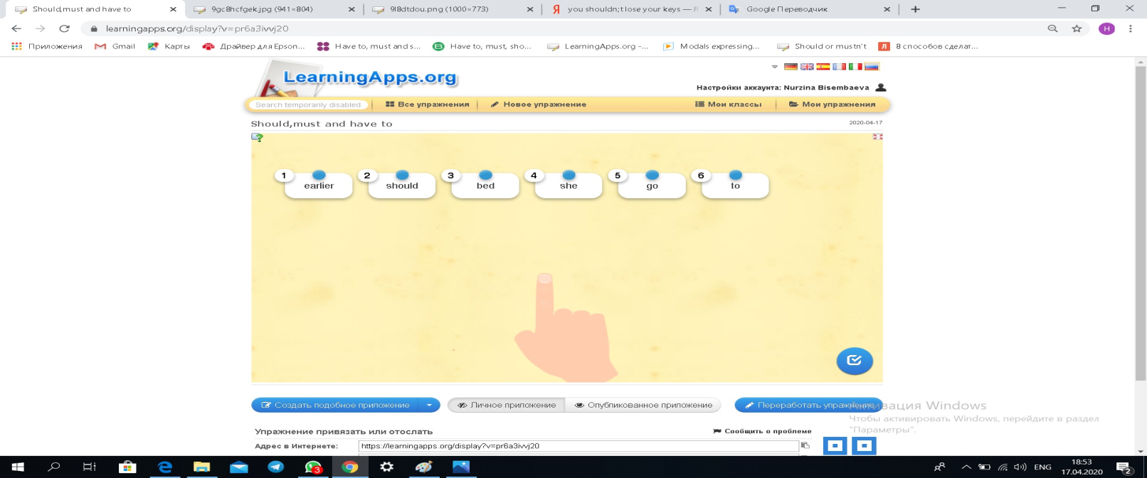  She should go to bed earlier.  2. 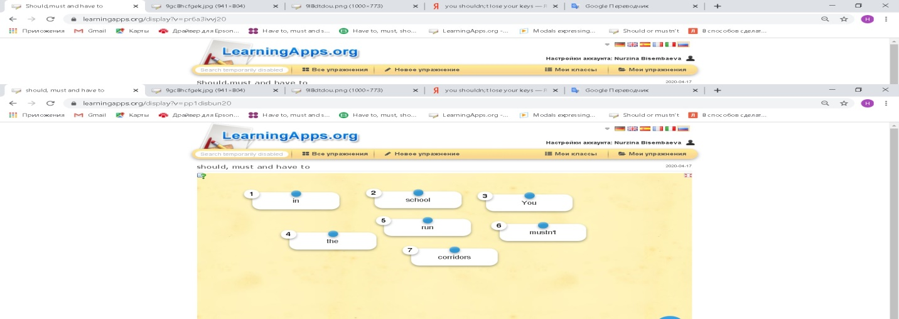  You mustn’t run in the school corridors.  3. 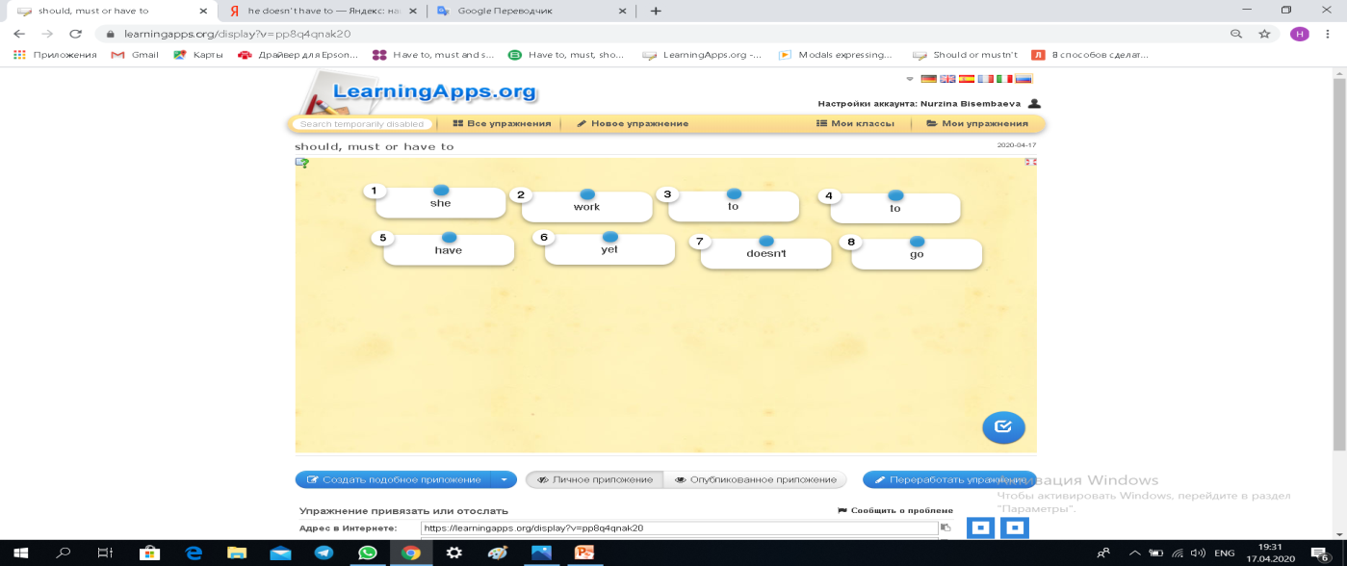  She doesn’t have to go to work yet.  4. 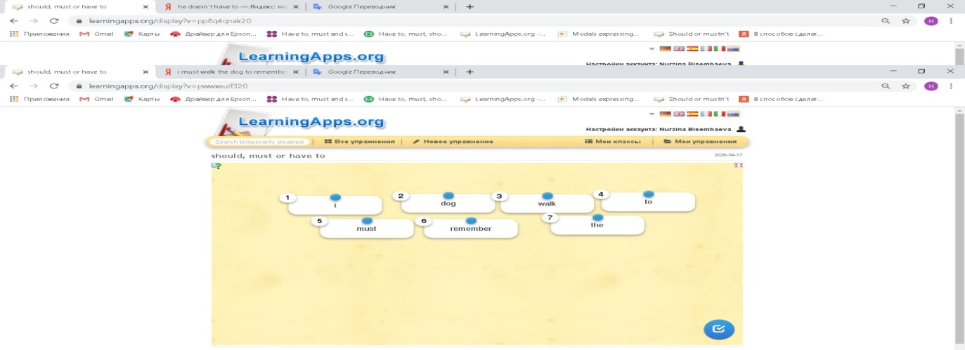  I must walk the dog to remember.  5. 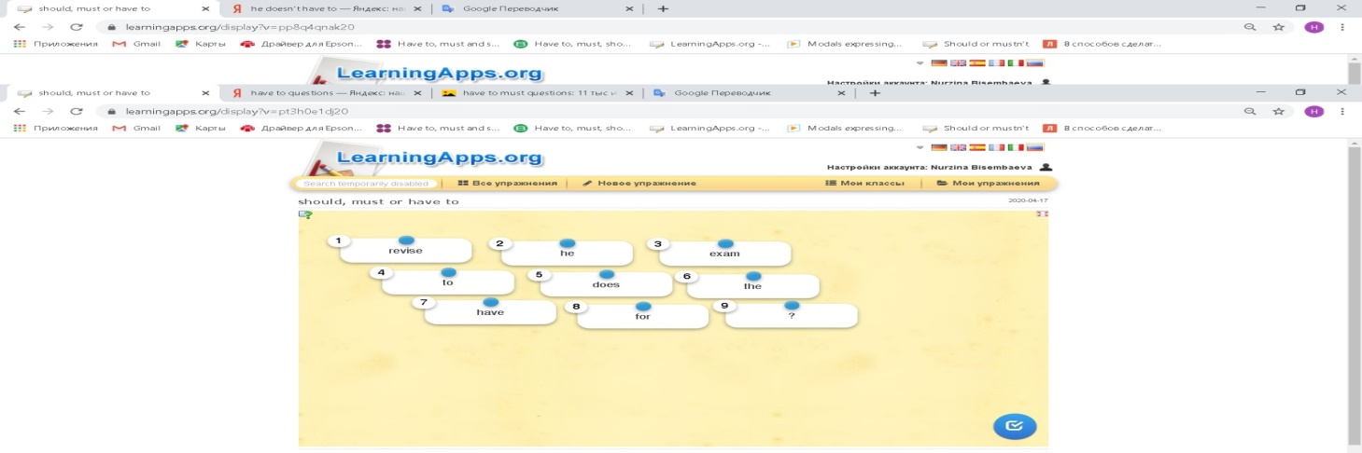  Does he have to revise for the exam?  6. 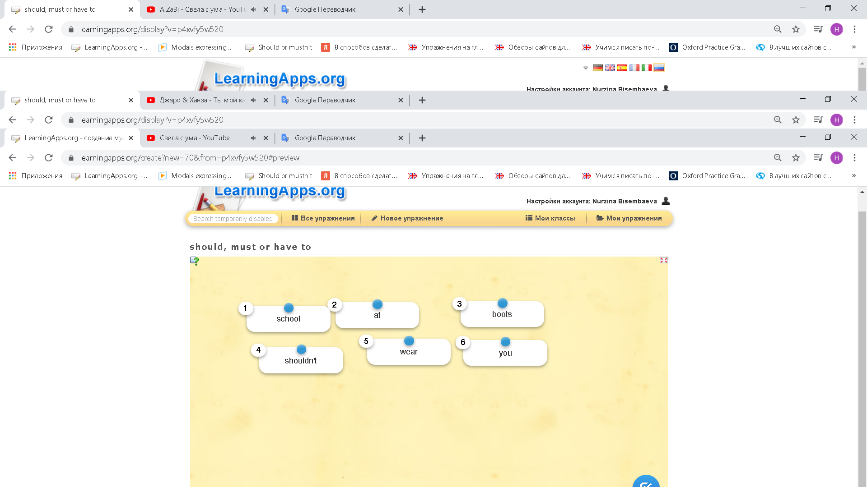  You shouldn’t wear boots at school.  7. 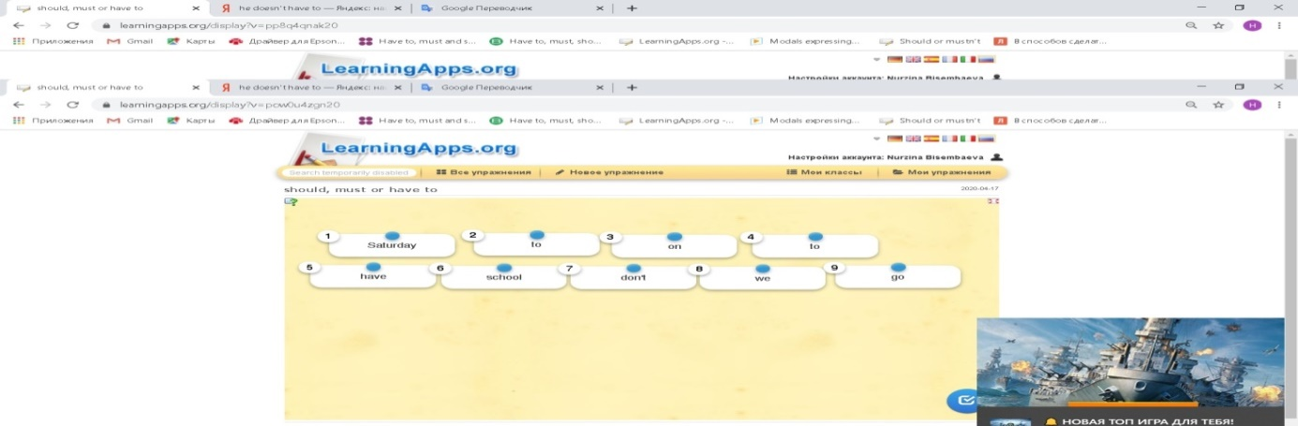  We don’t have to go to school on Saturday.  8. 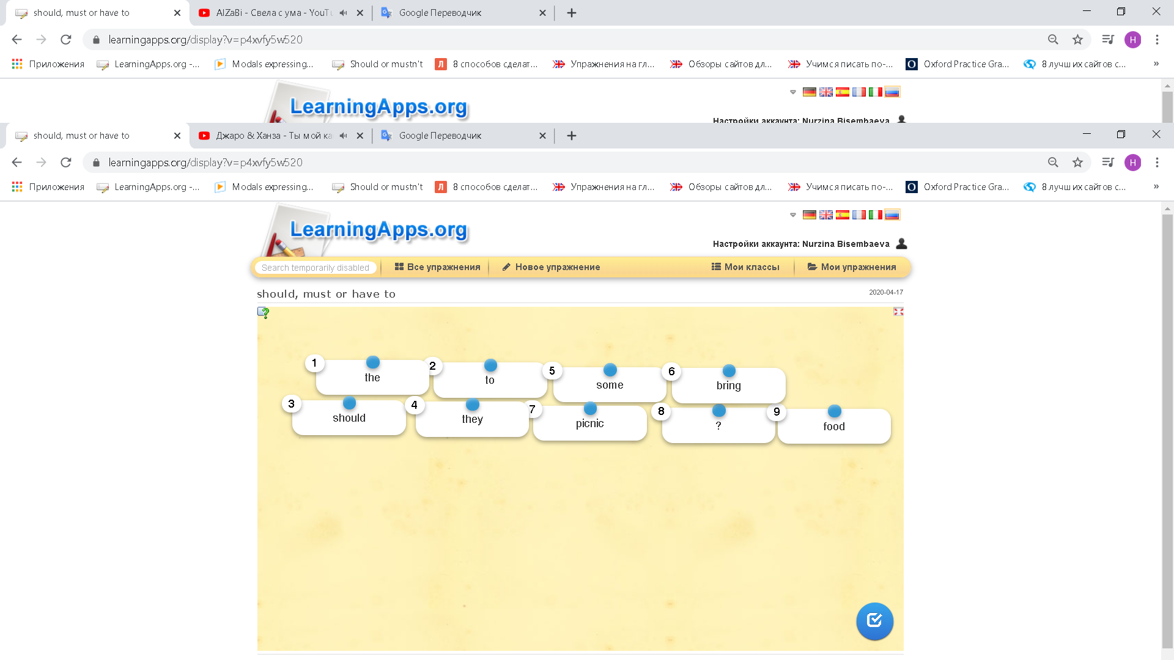  Should they bring some food to the picnic.  Task 3. Complete the sentences with must, mustn’t, should or shouldn’t. Choose the correct variant.  1.You _____ watch the new film Will Smith film if you can get tickets. It’s great.  A) shouldn’t B) must C)should D) mustn’t  2. They _______ wear sports clothes in the gym or they won’t be allowed to play.  A) shouldn’t B) must C) mustn’t D) should  3. You ________ lose your keys. We don’t have another set.  A) mustn’t B) should C) shouldn’t D) must  4. She _______ borrow so much money.  A) shouldn’t B) should C)must D) mustn’t  She _______ save her pocket money.  A) should B) shouldn’t C) mustn’t D) must  5. He ______ relax. The exams have finished.  A) must B) mustn’t C) should D) shouldn’t  6. We ______ bully people.  A) mustn’t B) must C)should D) shouldn’t  7.We ______ copy our homework from the internet.  A) shouldn’t B) mustn’t C) should D) must  8. They ______ worry. I’m sure evertything will be fine.  A) should B) mustn’t C) must D) shouldn’t  Task 4. Who will win a million?  School rules.  Choose the correct variant (must, should, have to)  Condition: It consist of six question.  First test -500 tg  Second test – 1000 tg  Third test– 5000 tg  Fourth test– 50 000 tg  Fifth test – 250 000 tg  Sixth test - 1 000 000 tg  If learner find the correct variant all tests, he’ll be win a million.  500 tg 1) You……. wear a school uniform. ___  - Have to B) should C) mustn’t D) must  1000 tg 2) You……. talk in class.  - mustn’t) B) don’t have to C) shouldn’t  D) should  5000 tg 3. You ……. Use mobile phones at the lesson.  - Should B) mustn’t C) shouldn’t  - D) don’t have to  50000 tg 4. You ……. be polite to your teacher.  - Don’t have to B) should  C)must D) have to  2500 000 tg 5.You …… stand up when a teacher comes up into the classroom.  - Should B) must C) mustn’t D) have to  1000 000 tg 6. You …… make a noise during the lesson.  - Don’t have to B) shouldn’t C) mustn’t  - Have to |  |  |  | https://www.youtube.com/watch?v=kZ3rHYcWFlA&t=412s  https://learningapps.org/display?v=p9opzoynk20  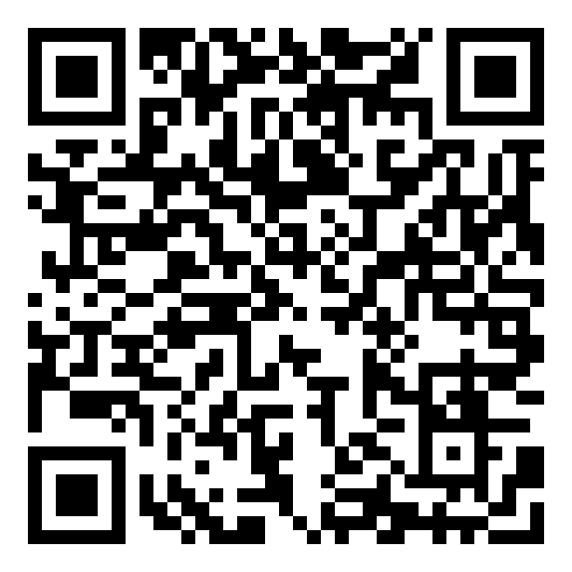  English Plus (Workbook, p.73)  Grade 8  https://learningapps.org/display?v=pp8q4qnak20  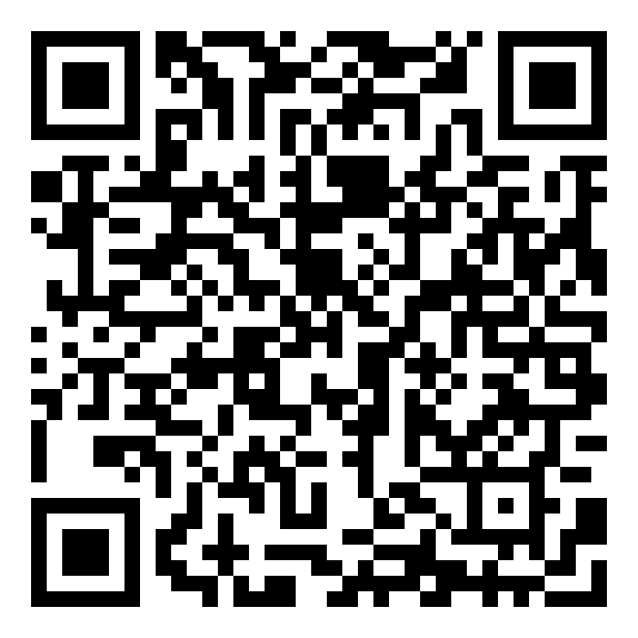  English Plus (Workbook, p.97)  Grade 8  https://learningapps.org/display?v=p089kjx7c20  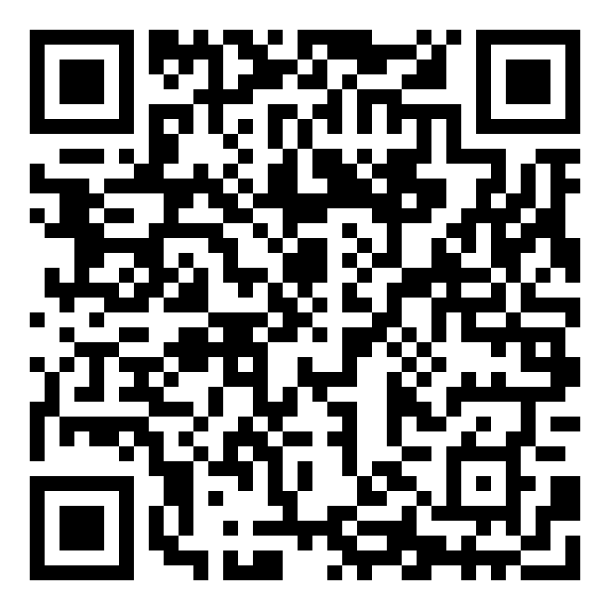  https://learningapps.org/display?v=pnzeac5sa20  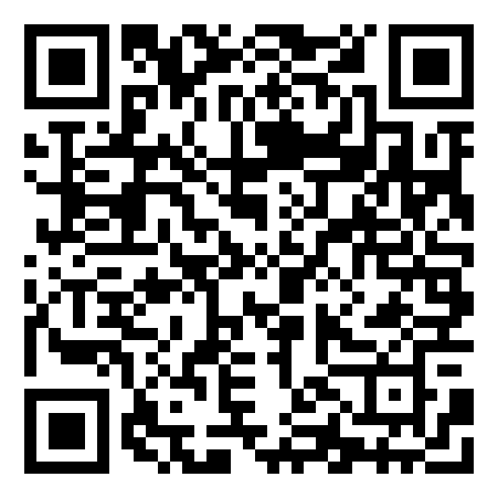
Ending the lesson | Feedback  - Do you understand the lesson?  -Have you got any question?  “Content reflection”  Learner will be answer the question and complete the table and evaluate themselves.  Questions Learner’s answer  What did you learn today?  Was it hard for you or not?  Did you understand the material or were there any difficulties?  Did you learn something new?  Were you able to achieve results? |  |  |  | https://trendexmexico.com/obrazovanie/82577-refleksiya-v-konce-uroka-primery-po-fgos-refleksiya-kak-etap-sovremennogo-uroka-v-usloviyah-fgos.html
End  1min | Feedback: Teacher asks students what task was difficult to them and which pair worked well.
Additional information
Differentiation –  how do you plan to give more support? How do you plan to challenge the more able learners? |  |  | Assessment –  how are you planning to check learners’ learning? |  | Critical thinking
Differentiation can be achieved through the selection of activities, identification of learning outcomes for a certain student, provision of individual support to learners, selection of learning materials and resources based on the individual abilities of learners. |  |  | Assessment criteria:  1. Make an argument and evolve reasoning while speaking;  2. Apply modal verbs for different purposes.  Descriptor:  A learner:  - concludes ideas and arguments based on own experience;  - completes sentences using modal verbs.  - Observation  - Feedback on the work  - Self-assessment |  | Students think critically, exploring, developing, evaluating and making choices about their own and others’ ideas

Сабақтың Youtube.com каналындағы сілтемесі https://www.youtube.com/watch?v=kVnbWcZ209Y&t=73s

