Long term plan unit:  The world around us |  | School : “ Bolashak”
Date: |  | Teacher name: Tuyak Zarina
Grade: 1 |  | Number present: | Absent:
Theme of the lesson: Animals.
Learning objectives (s) that this lesson is contributing to |  | 1.S3 pronounce basic words and expressions intelligibly;  1.S6 produce words in response to basic prompts;  1.L1 recognise short basic instructions for a limited range of classroom routines spoken slowly and distinctly;
Lesson objectives |  | All learners will be able to:  - pronounce basic words and expressions intelligibly with lots of support;  - produce words in response to basic prompts with lots of support;  - use some short form answers correctly with lots of support;  Most learners will be able to:  - pronounce basic words and expressions intelligibly with little support;  - produce words in response to basic prompts with little support;  - use some short form answers correctly with little support;  Some learners will be able to:  - pronounce basic words and expressions intelligibly without support;  - produce words in response to basic prompts without support;  - use some short form answers correctly without support;
Assessment criteria |  | - name at least 4 out of 6 words correctly by the end of the lesson;  - pronounce all the words correctly;  - pronounce familiar words and expressions.
Value links |  | Lifelong learning
Cross curricular links |  | Science
ICT skills |  | Active board, PPT
Previous learning |  | Colours
Plan
Planned timings | Planned activities |  |  |  | Resources
Start  Middle  End | Greeting.  Hello, children! Hello, teacher!  How are you?  Warming up.  Let’s sing a song “Hello”  Hello, hello, hello,  Hello,hello,hello  Hello, hello, hello,  Hello, how are you?  Hello, hello, hello,  Hello,hello,hello  Hello, hello, hello,  I am fine, thank you.  Now, my dear, children, please, look at the picture and guess the theme of our lesson:  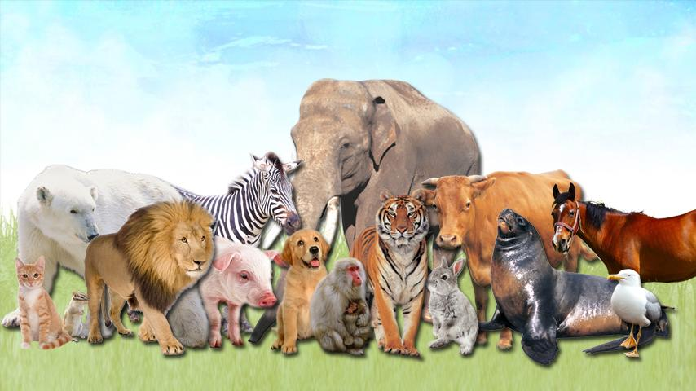  Yes, you are right, theme of our lesson is “Animals”.  Speaking. Look at the puppets and answer their questions.  Hello, I am a cat, how are you?  Hello. I am a rabbit, how are you?  Hello, I am a dog, how are you?  Hello, I am a fox, how are you?  Hello, I am an elephant, how are you?  Hello, I am a lion, how are you?  Hello, I am a wolf, how are you?  Hello, I am a tiger, how are you?  Hello, I am a horse, how are you?  Teacher shows the puppets to learners and asks questions “ What is it?”  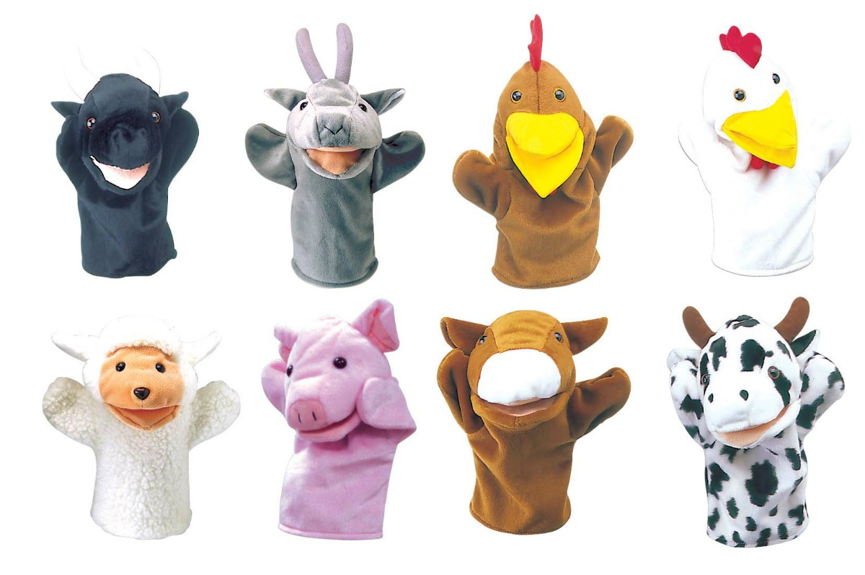  Descriptor:  - Identify the names of animals;  - Answer the questions correctly.  Speaking. Play a game “ A What?”  Make a circle.  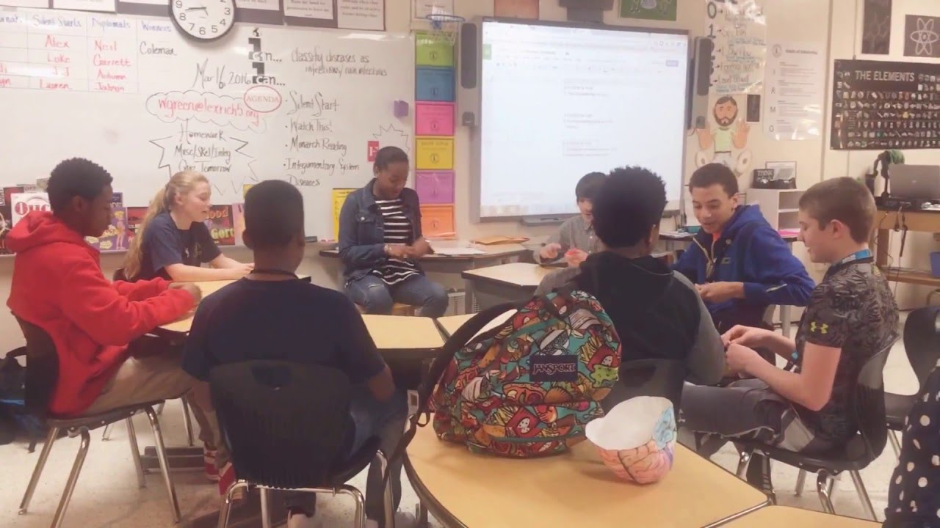  First player gives any flashcard to the next person and says, “This is a dog .” The second says, “A what?”  The first repeats, “A dog .” The second says, “Oh”, and gives it to the third person saying, “This is a dog ,third says, “A what?” The second person then turns back to the first person and asks again, “A what?” Second tells third “a dog .”  It continues in this manner.  After the flashcard reaches the last person, the first learner starts over again with a new animal flashcard to others. So they will remember the names of the animals.  Listening.  Learners look at the picture of animals , listen, point and colour:  Cat is pink.  Dog is blue.  Horse is purple.  Fox is orange.  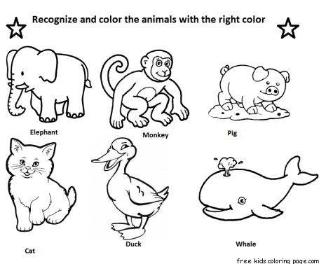  After colouring every learner share with their pictures.  Descriptor:  - Identify the names of animals;  - Correctly use paints in colouring.  Listening. Watch the video “ Animal Train.”  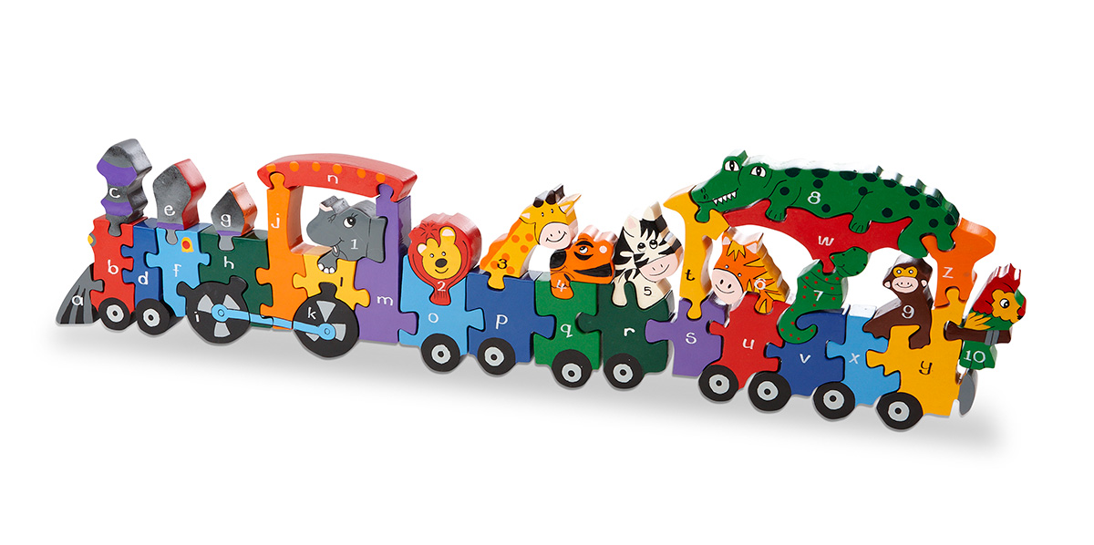  Repeat every word after the video.  Feedback “ Show your mood!”  Ask learners to draw an animal which was difficult/easy to remember.  Good like a cat.   Sad like a dog.   Bad like a rabbit. 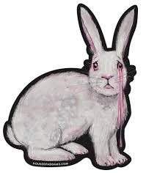  Dear learners, our lesson is over!  Thank you for your activity!  Good bye! |  |  |  | CD-player  Worksheet  Puppets of animals  Flashcards  Worksheets by teacher  https://www.youtube.com/watch?v=94NuFTMBBOY
Additional information
Differentiation – how do you plan to give more support? How do you plan to challenge the more able learners? |  | Assessment – how are you planning to check learners’ learning? |  | Health and safety check?
All learners – greater support by means of prompts about animals.  More able learners – independent work on speaking tasks with little support.  Some learners – independent work on speaking tasks without support. |  | - Oral feedback |  | - Work with the Active board not more than 10 minutes;  - Make a dynamic break in the middle of the lesson;  - Check sockets’ safety.

