Long-term plan unit: Sound. Sound Features. |  |  |  | School: №61
Date: 16.10. |  |  |  | Teacher name:Aituarova Aigul
Grade: 9 |  |  |  | Number present: - |  | absent: -
Theme of the lesson  (сабақтың тақырыбы) |  |  | Sound. Sound Features.
Learning objectives that are achieved at this lesson  (оқу мақсаттары) |  |  | 9.2.5.15 mentioning the conditions of sound generation and spread;
Lesson  Objectives  (Сабақттың мақсатты) |  |  | - explain the sound waves, the types of sound, the sound characteristics, and the sounds of musical sounds by simple examples.  - Captures formulas and can analyze physical units in units of measure  - easy-to-read reports, identifying formulas and measurement units
Success  Criteria  (Бағалау критерийі) |  |  | Students have achieved if they:  -explain the sound waves, the types of sound, the sound characteristics, and the sounds of musical sounds by simple examples.  - Captures formulas and can analyze physical units in units of measure  - easy-to-read reports, identifying formulas and measurement units
Language  Objectives  (Тілдік мақсаттар) |  |  | sound waves-дыбыс толқындары- звуковые волны  acoustics- акустика – акустика  camerton- камертон- камертон  sound volume- дыбыстың қаттылығы- громкость звука  high sound- дыбыстың жоғарлығы- высокий звук  timbre – тембр – тембр  noise – шу - шум
Values instilled  at the lesson  (Құндылықтарды дарыту) |  |  | Work and creativity (ability to work, activity, initiative, honesty, enthusiasm, achievement of the best results).  Еңбек және шығармашылық (өз жүмысын ұйымдастыра білу, белсенділік, бастамашылдық, адалдық, жұмысқа құлшыныс, үздік нәтижелерге жету).
Cross-curricular links  (Пәнаралық байланыс) |  |  | Биология пәнімен құлақ арқылы тыңдау,құлақтың құрылысы туралы білімдерін қолдана алады.  Музыка пәні арқылы әуендерді тыңдау білімдерін қолдана алады.  Be able to use the knowledge of the ears to listen through the subject of biology and the construction of ear.  Can use music listening skills through music.
ICT skills  (Акт дағдылары) |  |  | https://www.youtube.com/watch?v=32q5x-81H5Q  https://www.youtube.com/watch?v=_H1abPcHFwk  https://www.youtube.com/watch?v=BFWLb_MKyRE
Previous learning  (Алдыңғы оқу) |  |  | дыбыс толқындардың ортада таралуы туралы біледі.  the sound waves in the medium
Course of the lesson
Planned stages of the lesson | Planned activities at the lesson |  |  |  |  |  |  | Resources
Beginning  5 min. | Starting point  Organization  1.Greetings  2. complete    3.purpose orientation  Home work  1.What is wave?  2. In what environment does the horizontal wave arise?  3.What do you know about seismic waves?  4. What is the velocity of wave?  5. What is wavelength? |  |  |  |  |  |  | Presentation  Slides  1
Middle  5 min  20 min  7 min | STQ  Nowadays, it is impossible to imagine life without a radio-telegraph, phone call.  In the world of mechanical waves, we do not see, but thereby communicating with each other, there is a kind of wave of music and radio.  What is it called? (Sound)    So, our new theme today Sound. Sound Features.  Open the book. page 168 ,§34  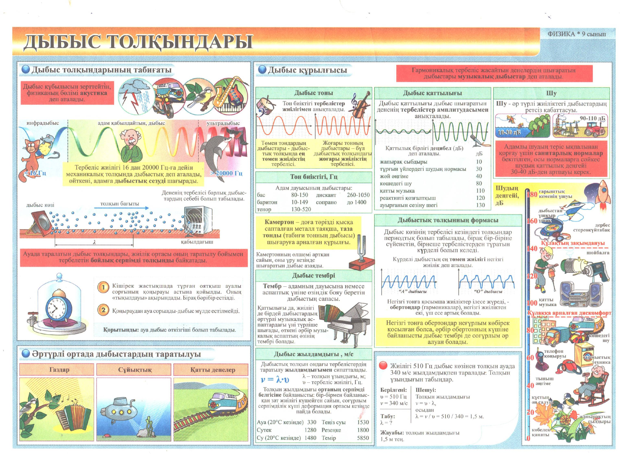  The nature of the sound  - Sound waves are longitudinal waves.  - Sound waves need a medium to travel through.  - Sound cannot travel through a vacuum.  - Sound waves can travel through solids, liquids, and gases.  - Any vibrating object can be a source of sound waves.  - Sounds carry energy without carrying matter.  Дыбыс толқындарының табиғаты  - Дыбыс толқындары бойлық (қума) толқындар.  - Дыбыс толқындары таралу үшін ортаны қажет етеді  - Дыбыс вакуумда таралмайды.  - Дыбыс толқындары қатты денелерде, сұйықтарда және газдарда тарала алады  - Механикалық тербелістер жасайтын кез келген дене дыбыс кӛзі болуы мүмкін.  - Дыбыстар энергия тасымалдайды, орта бөлшектерін тасымалдамайды.  The human ear is adjusted to perceive longitudinal waves in the frequency range 20 – 20000 Hz. Thus, waves in this range are called (audible) sound waves. Longitudinal waves of frequency below 20 Hz are called infrasonic. Longitudinal waves of frequency above 20000 Hz are called ultrasonic. Infrasonic and ultrasonic waves inaudible to the human ear but various animals can hear them.  - The speed of sound depends on the temperature of the air.  - The speed of sound does not depend on the pressure of the air.  - Sound travels through gases, liquids, and solids at considerably different speeds.  - Дыбыстың жылдамдығы ауаның температурасына тәуелді.  - Дыбыстың жылдамдығы ауаның қысымына тәуелді емес.  - Дыбыс газдар, сұйықтар және қатты денелер арқылы әртүрлі жылдамдықпен таралады.  Exercise -26.27 Equal to all groups  №2 №2.  Given Solution  ν=510Гц υ=λν  υ=340м/с λ= = =0,7м  т/к λ-?  №3  Given Solution  t=10с υ=  υ=343 м/с s=υt=343м/с·10с=3430м  т/к s-?  №5  Given Solution  ν=740Гц υ=λν  υ=1480м/с λ= = =2 м  т/к λ-?  27- жаттығу  №1.  Given Solution  s=200м s= t= ==1,2с  υ=340м/с  т/к t-?  №2  Given Solution  t=4,5с s= = =765м  υ=340 м/с  т/к s-?  №4  Given Solution  ν=435Гц υ=λν  υ=340м/с λ= = =0,78 м  т/к λ-? |  |  |  |  |  |  | Presentation  Slides  2  Presentation  Slides  3
3 min | Feedback: Bloom shows the current degree by painting on the stairs  Pupils explain their mutual appreciation.  Homework: Read the topic. Issue reports.  The goal.Sound. Description of the sound  Criteria Deskripts Topic  А. Perform a task according to the given new topic 1  В. Open the subject, express ideas Reliable response by members of the group 1 1  С. Participation of team members, organization of group work Active members of the team members Saving time, working timely, answering 1 1 1  Collected score  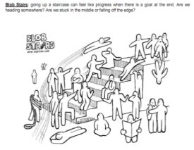  Total: 6 points  1-2 points - "3"  satisfaction 3-4 points - better than "4"  5-6 points - "5" is very good  Expected result:  A. Performs the task  B. Knows and knows the subject  С. Team members actively participate in the timely manner  He writes his homework seriously.
Differentiation – how do you plan to give more support? How do you plan to challenge the more able learners? |  |  |  |  | Assessment – how are you planning to check students’ learning? |  | Health and safety regulations
Reflection  Were the lesson objectives/learning objectives realistic? Did all learners achieve the LO?  If not, why?  Did my planned differentiation work well?  Did I stick to timings?  What changes did I make from my plan and why? |  | Use the space below to reflect on your lesson. Answer the most relevant questions from the box on the left about your lesson.
Summary evaluation

What two things went really well (consider both teaching and learning)?
1:

2:

What two things would have improved the lesson (consider both teaching and learning)?
1:

2:
What have I learned from this lesson about the class or achievements/difficulties of individuals that will inform my next lesson?

