

|  |  |  |  |  |  |  |
| --- | --- | --- | --- | --- | --- | --- |
| **Long-term plan unit:**  **Unit 6 “Entertainment and media”** | | **School-gymnasium 47** | | | | |
| **Date: 20.02.2018** | | **Teacher’s name: Gulnur Dzhakasheva** | | | | |
| **Grade: 7 V** | | **Number present:** | | | **absent:** | |
| **Theme: Writing a review about a film**  **vvvvv** | | | | | | |
| **Learning objectives** | | **7.S6 begin to link comments with some flexibility to what others say at sentence and discourse level in pair, group and whole class exchanges**  **7.W4 use with some support style and register appropriate to a limited variety of written genres on general and curricular topics**  **7.C7 develop and sustain a consistent argument when speaking or writing** | | | | |
| **Lesson objectives** | | **All learners will be able to:**  **Understand the opinion of others, working with whole class, in groups and pairs**  **Most learners will be able to:**  **Write a film review with some support style*.***  **Some learners will be able to:**  **Express their opinion about the given film speaking and writing.** | | | | |
| **Criteria** | | **1. Discuss partners’ opinion working in group, pair and whole class.**  **2.Write a film review with some support style.**  **3.Express their opinion about the theme speaking and writing.** | | | | |
| **Bloom’s taxonomy** | | **1 Knowledge and understanding**  **2 Application**  **3 Analysis and synthesis**  **4 Assessment** | | | | |
| **Value links** | | **Respect and cooperation by:**  **1.Listening to the teacher**  **2.Taking turns**  **3.Encouraging each other**  **4.Helping each other**  **5.Work in group** | | | | |
| **Cross curricular links** | | **Journalism** | | | | |
| **ICT skills** | | **Using internet** | | | | |
| **Previous learning** | | **Structure and criteria for a good film review** | | | | |
| **Plan** | | | | | | |
| **Planned timing** | **Planned activities** | | | | | **Resources** |
| **Beginning**  **2 min**  **3 min**  **5 min** | **The teacher greets students;**  **Brain storming:**  The students will guess the topic of the lesson  1.The first letter of “favourite”  2.The third letter of “exiting”  3.The fifth letter of “popular”  4.The sixth letter of “sentimental”  5.The ninth letter of “hilarious”  **Students name the word Film**  **The aims and description**  **Regrouping :( students are divided into three groups with the help of cards).**  **I group -Slytherin II group –Gryffindor III group -Ravenclaw**  **Questions**  1.Do you like watching films?  2. What films do you like to watch?  3.What Kazakhstan films do you like ?  4.How do you think what determines the success of any film?  **Check up the homework**  -Describe a favorite actor.  -Guess who is it? | | | | | **Slide 1**  **Slide 2**  **Sweets**  **Projects** |
| **Middle (30 min)**  **2 min**  **5 min**  **5 min**  **3 min**  **10 min**  **5 min** | **Task 1**  -Now we’ll watch some episodes of different films. You should:  1 name the genre of the movie  **Task 2**  **1group Find definition and synonyms**   * **Frightening Scary** * **Gripping Very exciting** * **Predictable Not surprising** * **Spectacular Amazing to see** * **Slow Doesn’t move quickly** * **Violent Shows physical harm and damage** * **Moving Touching** * **Entertaining Funny and interesting** * **Main character Lead character** * **Hilarious Comedy** * **To be into Like** * **True-to-life Realistic**   **2group Find antonyms**  **Moving Unemotional**  **Historical Contemporary**  **Spectacular Calming**  **Gripping Boring**  **Entertaining Ordinary**  **Violent Peaceful**  **Serious Dull**  **Slow Active**  **Scary Funny**  **Tragic Comic**  **3 group Complete the sentences with appropriate word.**   1. **My wife and I love film about the Wild West, especially ones with cowboys and Indians. __western _____   2.My younger sister enjoys watching films about wild animals. __Documentary____   3.I like films about the future ,aliens from space or space travel .____Sсienсe-fiction film     4.My brother likes watching these films because they are fast and exciting _______Action film_______   5.This is a very funny film with lots of laughs and the ending was hilarious !_______Comedy _______   6. My grandparents enjoy watching films about life in the seventeenth century. _______Historycal films________**   **Group assessment**  **Task 3**  **Watching a film episode .**  **-How well do you know the plot of the story?**  **Put in order the pictures and retell the plot of the story**  **Descriptor:  Learners put in right order the pictures and retell the plot of the story**  **Task 4**  **Writing a review about a film using Bloom’s 6 hats**  **Descriptor:**  **1gr.Write facts about the film “Harry Potter and philosopher's stone”**  **2gr. Describe the main hero.**  **3gr. Write about negative sides of the film.**  **4gr. Write about positive sides of the film.**  **5gr. Define the main idea of the film.**  **6gr. Summarize all given answers and make decisions about the film.**    **Task 5**  **Make up a dialogue**  **Reflation**  Underline the suitable word:  1. My work at the lesson was active/passive.  2. I am satisfied/ dissatisfied (доволен/недоволен) with my activity.  3. The lesson seemed long/short to me.  4. I feel tired/not tired after the lesson.  5. The material of the lesson was interesting/boring/useful/useless/easy/hard/for me. (you can underline some words).  6. I can speak about films. Yes/no.  7. I can say my own opinion on movies. Yes/no.  8. I can give arguments. Yes/no.)??????  2. Homework  T : At home write the review of your favourite film according to the plan. | | | | | **Card**  **And posters**  **Worksheets**  https://i.pinimg.com/originals/d1/a5/5e/d1a55ed285d496abe27123714501d537.jpg  https://i.pinimg.com/736x/19/da/69/19da69467aa8a3b0a162b0260cf52c62.jpg  **Cards with tasks**  https://en.islcollective.com/preview/201408/b2/harry-potter_72238_1.jpghttps://www.eslprintables.com/previews/241057_1-HARRY_POTTER.jpg |
| **Homework** | | **Write a review about your favourite movie** | | | | |
| **Additional information** | | | | | | |
| **Differentiation – how do you**  **plan to give more support?**  **How do you plan to**  **challenge the more able**  **learners?** | | | **Assessment – how are you planning to check learners’**  **learning?** | **Health and safety check ICT links** | | |
| **Less able students – greater**  **support by means of prompts,**  **visuals or writing difficult words**  **on the cards.**  **More able students –**  **independent work on definite**  **tasks with little/no support.** | | | **Through the feedback. Students answer the questions by analyzing the lesson and themselves.** | * **Ensure proper ventilation** * **Check sockets’ safety** | | |

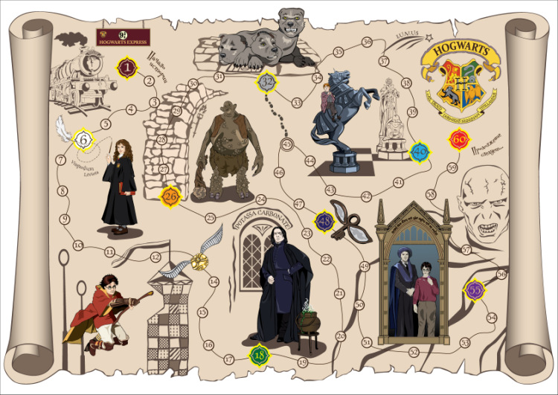

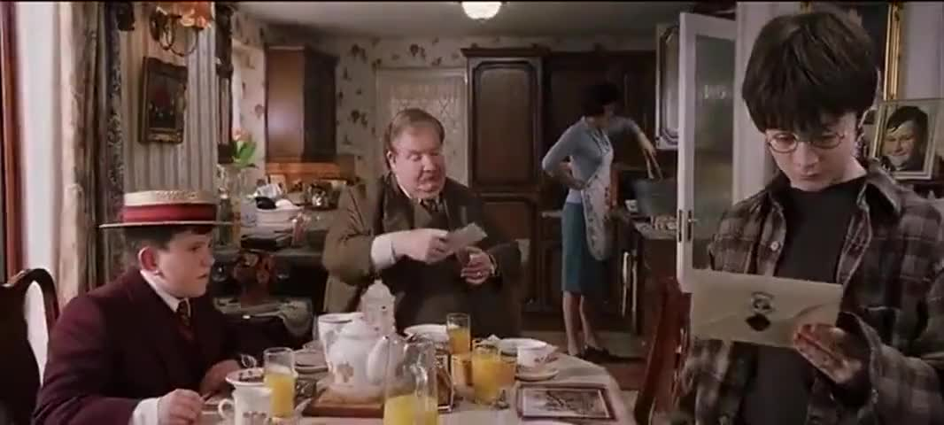

 I don't think dreams change reality (I really am fairly sane). Of course a dream can change the way one thinks and acts, as Phil Dick's dream or vision changed his thinking. Some writers can use dream fairly directly as story source, as Stevenson did in Dr Jekyll and Mr Hyde, but I do better when awake.

Chronicles of Earthsea

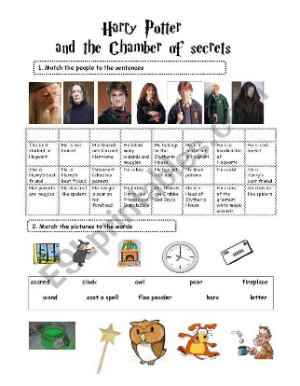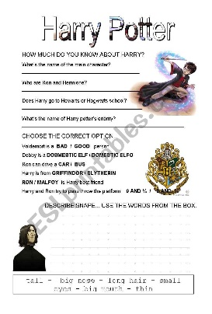

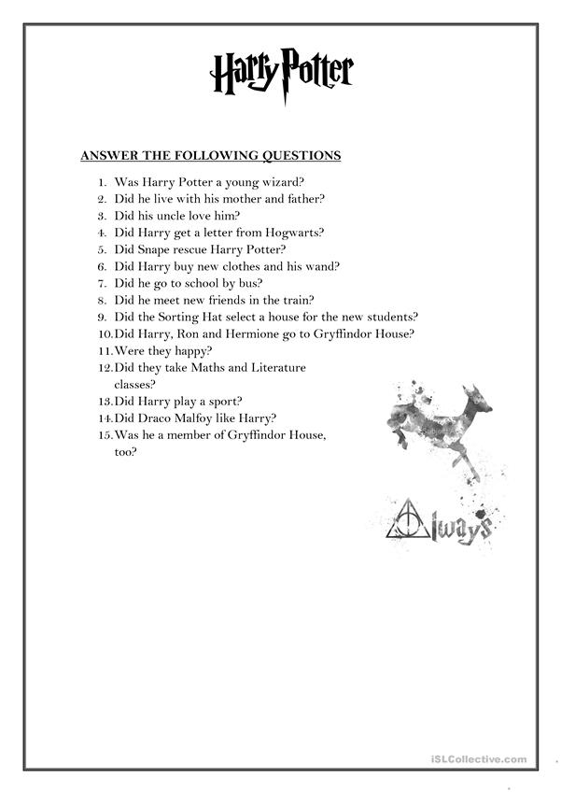

**Reflation**

Underline the suitable word:

1. My work at the lesson was **active/passive.**

2. I am **satisfied/ dissatisfied** (доволен/недоволен) with my activity.

3. The lesson seemed **long/short** to me.

4. I feel **tired/not tired** after the lesson.

5. The material of the lesson was **interesting/boring/useful/useless/easy/hard**/for me. (you can underline some words).

6. I can speak about films. **Yes/no.**

7. I can say my own opinion on movies. **Yes/no**.

8. I can give arguments. **Yes/no.**

**Reflation**

Underline the suitable word:

1. My work at the lesson was **active/passive.**

2. I am **satisfied/ dissatisfied** (доволен/недоволен) with my activity.

3. The lesson seemed **long/short** to me.

4. I feel **tired/not tired** after the lesson.

5. The material of the lesson was **interesting/boring/useful/useless/easy/hard**/for me. (you can underline some words).

6. I can speak about films. **Yes/no.**

7. I can say my own opinion on movies. **Yes/no**.

8. I can give arguments. **Yes/no.**

**Reflation**

Underline the suitable word:

1. My work at the lesson was **active/passive.**

2. I am **satisfied/ dissatisfied** (доволен/недоволен) with my activity.

3. The lesson seemed **long/short** to me.

4. I feel **tired/not tired** after the lesson.

5. The material of the lesson was **interesting/boring/useful/useless/easy/hard**/for me. (you can underline some words).

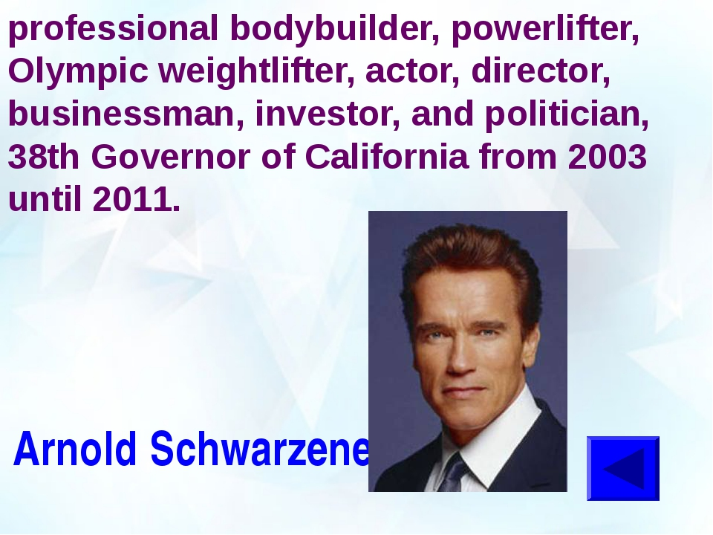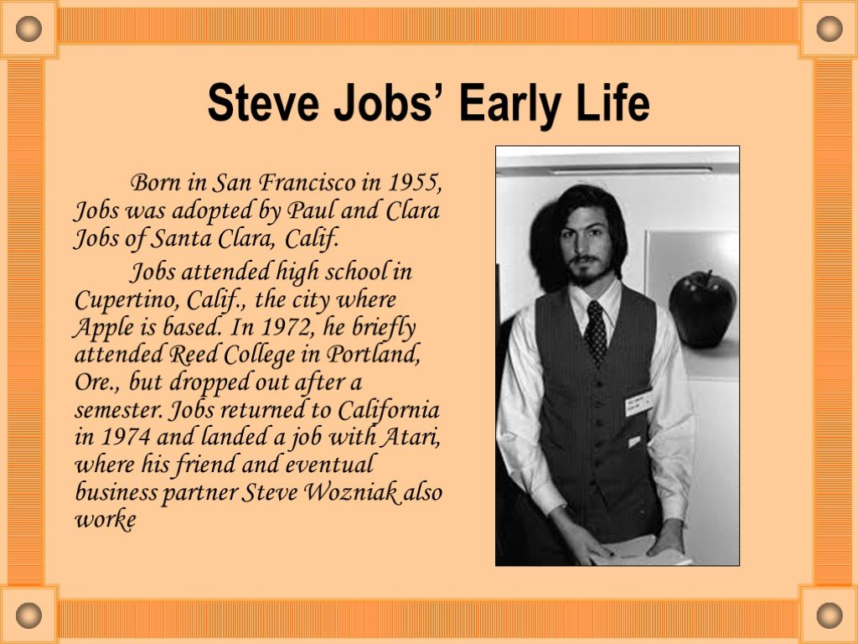 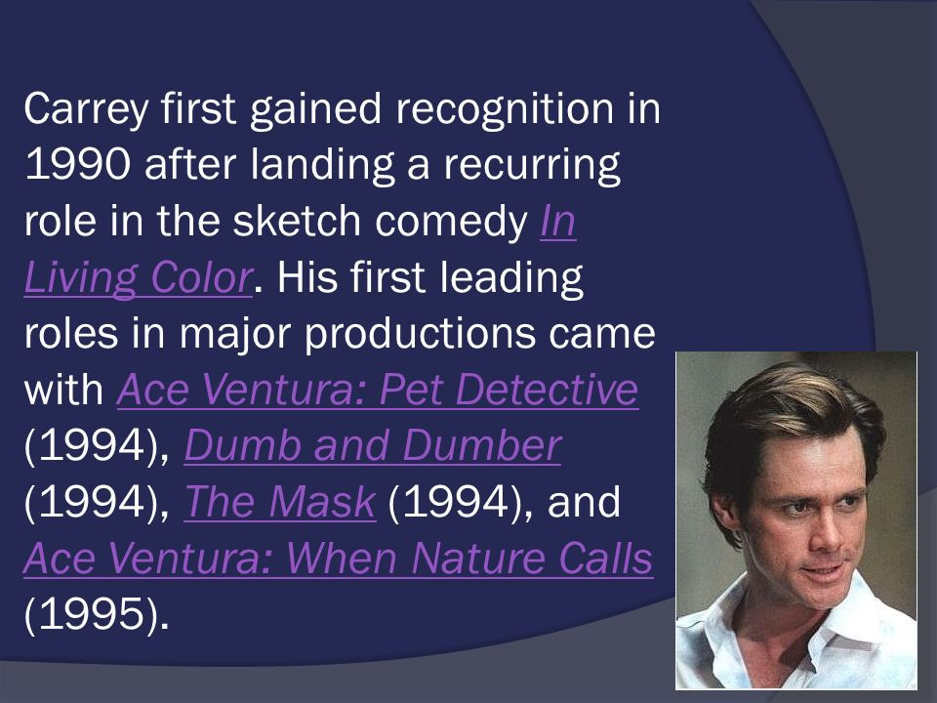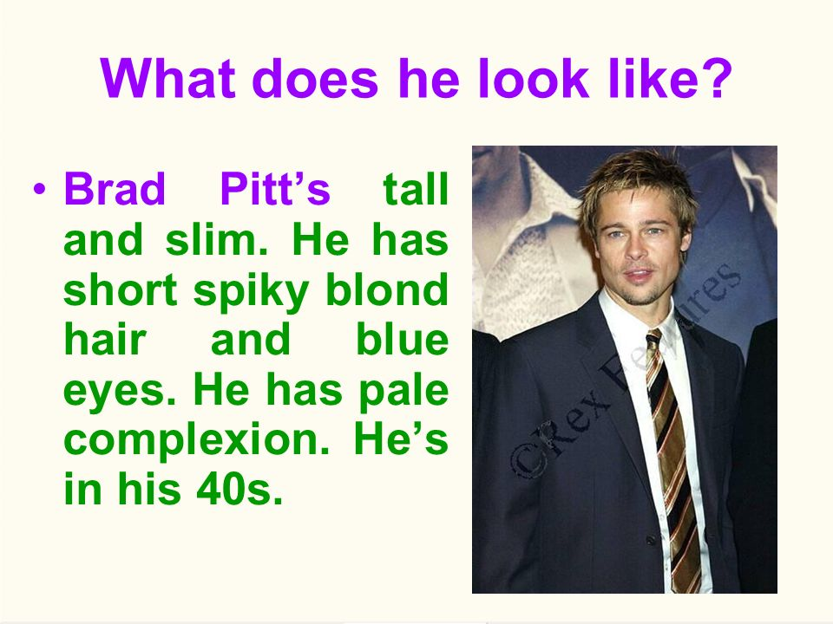

Harry Potter and the Sorcerer's Stone (or Philosopher's Stone, as titled outside the United States) introduces one of the most popular heroes of fantasy fiction in recent years. It also made J.K. Rowling, the author of the Harry Potter novels, a household name worldwide. Naturally, a popular book series such as Harry Potter would stir up interest in a series of film adaptations. It may, of course, have the risk of displeasing the die-hard fans. As someone who read the series, I am happy to say that this film version of the first Harry Potter book has done a very good job being faithful to the story.   
  
The first scene already presents one great thing about the movie: the well-chosen cast. We see two professors of magic, Albus Dumbledore (Richard Harris) and Minerva McGonagall (Maggie Smith), slowly approaching a house on Privet Drive. A giant named Rubeus Hagrid (Robbie Coltrane) arrives with a baby who has a lightning-shaped scar on his forehead. This boy is Harry Potter, who grows up into an eleven-year-old boy played by Daniel Radcliffe. Harry lives in a miserable household with the Dursley family: Aunt Petunia (Fiona Shaw), Uncle Vernon (Richard Griffiths), and cousin Dudley (Harry Melling). All of these actors play their parts well.   
  
Soon, the movie begins to present its other strong element: production design. Whether or not you have read the novel, you will likely find it pleasing to look at the various locations in the story, including the magically hidden Diagon Alley, Platform 9 3/4, and all of the rooms and passages of the Hogwarts School of Witchcraft and Wizardry. You can tell that much effort went into making these places look as realistic as possible and match how they're described in the novel. While this is happening, other interesting characters are introduced, including Harry's new friends Ron Weasley (Rupert Grint) and Hermione Granger (Emma Watson), Defense Against the Dark Arts professor Quirrel (Ian Hart), potions professor Snape (Alan Rickman), and an arrogant student named Draco Malfoy (Tom Felton).   
  
This story, as with most of the Harry Potter stories, has a two-part structure. One pertains to life in the school. Harry and the students go to classes, get assigned to one of four school houses - Gryffindor, Ravenclaw, Hufflepuff, and Slytherin - by a magical Sorting Hat, and participate in or watch a broomstick-riding sport called Quidditch. The other part is the story's central mystery. Here, it pertains to something called the Sorcerer's Stone (or Philosopher's Stone). What's interesting is how you might think the two parts are separate from each other, but you'll be surprised by the ways they connect.   
  
For Harry Potter fans, this film does not disappoint. It is true that many scenes are shortened versions of the ones in the book. I would have liked to see more of things like Harry's back story, Professor Snape's nastiness towards Harry Potter, and more moments in the Hogwarts classes. Still, the characters are likable and unique, the plot is easy to follow, and the production value is just outstanding. Once I saw the film end, I knew I could not wait to see the next

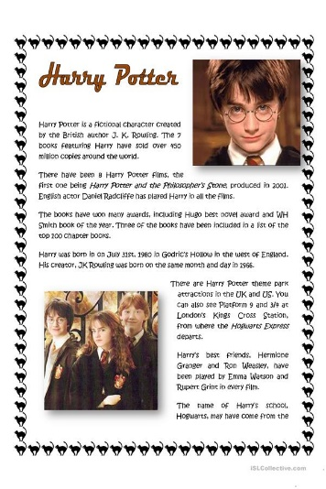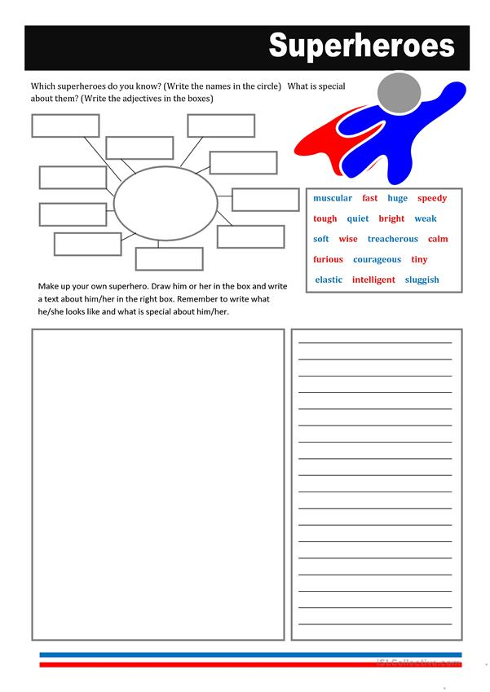

We (don’t) like ____________________________________________________________________,

because _____________________________________________________________

He\ She worth

For his\her **best\ bad\ worse** role in the film

Harry Potter (our hero)  
Hermione Granger  
Ron Weasley

And that’s it! Supporting main character summaries will be coming soon, and we will announce it here when they are published. On with the main character summaries:

Harry is a young boy who is the son of two wizards, although he is not aware of that. He believes that he is simply an orphan who has been raised by his horrible aunt and uncle. On his eleventh birthday, however, Harry gets the shock of his life when Hagrid (a huge, gruff wizard) tells him who he actually is. It turns out that Harry’s parents were murdered by the most powerful wizard in the world (Voldemort), and that Voldemort himself was killed when he tried to kill Harry as a young infant. Harry is world-famous among the wizarding world (and he’s also rich, by the way)! He is known as “the boy who survived.” As with other young wizards, Harry receives a letter on his eleventh birthday, informing him that he has been summoned to the Hogwarts School of Witchcraft and Wizardry to begin his training as a wizard. Harry quickly meets and makes friends with Ron Weasley and Hermione Granger, two other first-year students, and they will turn out to be his best friends for the rest of the series. Harry goes on to have many adventures, and he is faced with the fight of his life when it turns out that The Dark Lord (Voldemort) might not be dead after all!

Hermione comes from a Muggle family, meaning that neither of her parents are wizards. For this reason, some of the snootier wizard families look down on her and her kind, calling them “mudbloods”, which is a word that carries the same weight as some real-world racist epithets. When we meet her, she is a young girl who is fascinated by magic, which is of course very new to her, since she was unaware that she was a wizard until her eleventh birthday. She buckles down and studies, and she is often the first in her class to catch on to new spells, and she is also magically powerful (she casts strong and effective spells, which cannot be said for all of the young wizards). She is a good girl who doesn’t want to do anything that will get her in trouble, but she is also loyal, so she can be counted on to help out a friend in need. It could be said that she pushes herself too hard, exhibiting a sort of “Type A” personality, meaning that she is driven to succeed beyond the point where it is normally considered healthy. She has a mind that recalls spells and facts quickly, and she is also fast to make connections that other people might overlook. She is, quite simply, smart.

Ron is a ginger (a red-head, for our American readers!) who comes from a large wizarding family. He has many brothers and one sister, and his father works at the Ministry of Magic, which is the wizarding world equivalent of the federal government. Ron is the sixth boy in a row born to his family, and he has always felt that he disappointed his mother, who was still hoping for a girl (she did get a girl on her next try!) Ron has a sort of classic middle-child syndrome, where he is not as talented or as powerful with magic as his older siblings, but he is a loyal friend, and he has a good sense of humor. Ron Weasley could be best described as a boy’s boy, or an average, good-natured, normal lad. Ron’s family is not a wealthy one, so Ron often has to wear his older brothers’ hand-me-downs, and he gets modest presents for Christmas. He is always up for adventure, and he doesn’t mind risking getting into trouble. While Ron would not be described as “smart,” exactly, he also isn’t dumb.

That’s it for our three main *Harry Potter Characters*. We could say much more, but it’s hard to describe them without giving away the plot and events. Trust us, the books are great, so if you’ve never read them, or if you’ve only seen [**the movies**](http://harrypotterspells.net/62/list-of-harry-potter-movies-in-order/), do yourself a favor and read the [**Harry Potter books**](http://harrypotterspells.net/372/list-of-harry-potter-books-in-order/)!

We recommend this film for

