Date: 07.02.2020 |  |  |  | Teacher name:Nusipakyn M
Grade: 9 |  |  |  | Number present: |  | Absent:
Theme of the lesson |  |  | Traditional dress
Learning objectives that are achieved at this lesson (Subject Programme reference) |  |  | 9.2.2.1 understand most specific information in unsupported extended talk on a wide range of general and curricular topics  9.4.5.1 deduce meaning from context in extended texts on a range of familiar general and curricular topics
Lesson objectives |  |  | Students will be able to:  - Watch a video about national clothing and identify most specific information;
Assessment criteria |  |  | Students will achieve speaking objective if they answer most of the questions correctly.  Students will achieve reading objective if they label the saukele properly (4-5 words written correctly).
Value links |  |  | Responsible citizenship – students learn cultural values
Cross-curricular links |  |  | This topic is linked to History
ICT skills |  |  | Students may use online dictionaries to check the meaning
Previous learning |  |  | Students have some knowledge about the History of national clothing and vocabulary on clothing
Course of the lesson
Planned stages of the lesson | Planned activities at the lesson |  |  |  |  |  | Resources
Beginning  2minutes  5minute  10minute  5minute  G/W  10minute  G/W  10minute  P/W | Organization moment  Talking with a pupil on duty, about date, day, season and marking absentees.  II. Checking the home task: customs and traditions.  After hometask Learners divided into 3 groups. They must choose one of the picture. On the table have a mosaic and badge. Everyone must choose their own badge.  The 1st group called is “Saukele”  The 2nd group called is “Shapan”  The 3rd group called is “Takiya”  Watching video about “Traditional dress”  III. Introduction of the new material: “Traditional dress”  The Kazakh traditional costumes are actually the dresses of an ancient nomad. Many kinds of European clothes also originated here in Central Asian steppe. Europeans deeply impressed when they first saw the nomad's clothing. Trousers are the invention of nomads which were used for riding. Such words as 'camisole' and 'caftan' were borrowed from the languages of Turkic nomadic tribes. The Kazakh traditional costumes are kimeshek, shapan, camizole, kebis. takhia, tymak.  Shapan. The shapan is man's outer robe made of velvet, velveteen or velour. It is worn with a belt and its bottom and flaps are decorated with a pattern made of braid in traditional style. Usually the shapan is presented to a noble and honored quest as a sign of one's special favour and attention.  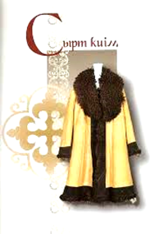  Camisole. The camisole is an overcoat both for men and women put over a shirt or dress. It is usually sleeveless, ending at the hips or waist and closed with special fasteners. Women's camisoles are more brightly colored than men's.  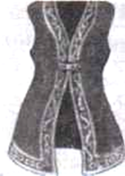  Kimeshek. For a married Kazakh woman to uncover her hair was considered indecent. Often she covered it with a head-dress with a turban arranged as a cylinder on the head and a shawl which had a special cut for her fac  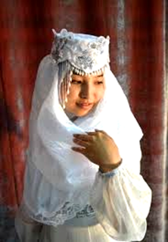  Takhia. The takhia is a men's everyday cap which covers the top and back of the head. Different forms are worn by the different people groups of Central Asia.  Tymak. The tymak is a traditional men's head-wear consisting of two flaps protecting the ears and a third part covering the" back of the head and neck down to the shoulder-blades. It is made from animals fur. The upper part is usually decorated with cloth.  IV. New words:  Camisole - қамзол Shapan - шапан  Kimeshek - кимешек Takhia - тақия  Tymak - тымақSew - тігу  Braid – көмкеретін жіпVelour - велюр  Velvet – барқыт, вельвет  Task 1. Do the wordsearch and see if you can find words about the Kazakh traditional costumes.  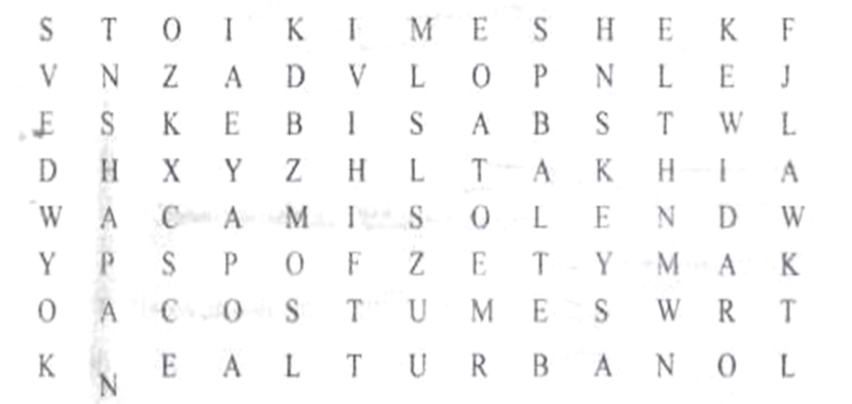  Descriptor.  A learners find the words correctly  Task 2. Match the word True or False  1. The Kazakh traditional costume is actually the dress of on ancient nomad.  2.The shapan is presented to a noble and honored quest as a sign of one's special favour and attention.  3.The takhia is not men's everyday cap which covers the top and back of the head.  4. The tymak is not traditional men's head wear.  5.The tymak is made from animals fur.  Task 3. Strategy Fan.  Learners must write question on the paper.  Differentation.  By the teacher support  Give Home task . |  |  |  |  |  | Flashcards  Video  PPT
End  3minutes | Reflection (W)  Teacher asks the questions, which were asked at the beginning, again.  - What function did clothing have in old times?  - Can you tell anything about people of that period by their dresses?  - Will Kazakh clothing be identified if included in the quiz?  - How to promote information about national clothing to foreigners?
Differentiation – how do you plan to give more support? How do you plan to challenge the more able learners? |  |  | Assessment – how are you planning to check students’ learning? |  | Health and safety regulations
Reflection  Were the lesson objectives/learning objectives realistic? Did all learners achieve the LO?  If not, why?  Did my planned differentiation work well?  Did I stick to timings?  What changes did I make from my plan and why? |  | Use the space below to reflect on your lesson. Answer the most relevant questions from the box on the left about your lesson.
Summary evaluation

What two things went really well (consider both teaching and learning)?
1:

2:

What two things would have improved the lesson (consider both teaching and learning)?
1:

2:

What have I learned from this lesson about the class or achievements/difficulties of individuals that will inform my next lesson?

Approved by___________________________

