**Module 2 Natural Disasters Checked by: ____________**

|  |  |  |  |  |  |
| --- | --- | --- | --- | --- | --- |
| **LESSON: Prediction and prevention of natural disasters** | | **School: 74** | | | |
| **Date: 16.10.2019** | | **Teacher name: Smagulova D.A** | | | |
| **CLASS: 10th “B”** | | **Number present:** | | **absent:** | |
| **Learning objectives(s) that this lesson is contributing to** | 0.1.1 - use speaking and listening skills to solve problems creatively and cooperatively in groups;  10.1.5 - use feedback to set personal learning objectives;  10.1.9 - use imagination to express thoughts, ideas, experiences and feelings;  10.2.1 - understand the main points in unsupported extended talk on a wide range of general and curricular topics, including talk on a limited range of unfamiliar topics; | | | | |
| **Lesson objectives** | **All learners will be able to:** | | | | |
| Learn natural disasters, listen and read for gist and special information, learn phrasal verbs with *give*  **Most learners will be able to:**  Learn natural disasters, listen and read for gist and special information, learn phrasal verbs with *give*, listen for specific information  **Some learners will be able to:**  Learn natural disasters, listen and read for gist and special information, listen for specific information, talk about the ASCE Foundation | | | | |
| **Assessment criteria** | Learners have met the learning objective if they can: speak about natural disasters and write an email | | | | |
| **Value links** | Solutions to global issues, natural disasters and global citizenships | | | | |
| **Cross - curricular links** | Global issues | | | | |
| **ICT skills** | Using videos& pictures, working with URLs | | | | |
| **Previous learning** | Natural Disasters | | | | |
| **Plan** | | | | | |
| **Planned timings** | **Planned activities (replace the notes below with your planned activities)** | | | | **Excel Resources** |
| BEGINNING THE LESSON | **Greeting**   * Good morning! I am glad to see you. Sit down, please. * Is anybody absent today?... * OK. I hope everybody is ready to start. Well, today we are having a summary lesson. * To revise the to-infinitive and the -ing forms   **Checking up the home task.**   * St.book: p. 23 ex.6   **To divide pupils into 2 group: “Natural disasters” and “Disasters influenced by human”**   * Pupils, before starting our new lesson, I would like you to be divided into 2 groups and tell me what topic we are going to discuss. Let’s try to guess… In order to do these you should come here and choose one picture which you like, then translate. * How do you think what about we are going to speak on our lesson? * Have you got any ideas? … * **Pupils answer.** * Also, there are some differences. Because some of them are natural and some of them are influenced by man, isn’t it? * **Yes!** * Now you should be divided into 2 groups. Pupils whose pictures belong to the natural disasters you can take your places in the 1st group and students whose pictures belong to the disasters which influenced be man you can take you places in the 2nd group. | | | | Teacher’s ideas  Cards |
| PRESENTATION AND PRACTICE  Conclusion of the lesson | To present disasters  To present the aims of the lesson.   * As a rule each lesson has the specific goals. Look at the screen.   ______________________________________________  -Look at the screen. Which accident / disaster best matches each of the headlines?  Group «Natural disasters» you should find A,B,C,D and group “Disasters influenced by man” you should find E,F,G,H sentences  A-1, B-10, C- 8, D- 6 , E-4, F-7, G- 3, H-2.  -Boys and girls ,now pay your attention on the screen , listen to people describing the disasters in the pictures, then tell me which description belongs to which picture.  Pupils: Description “A ” is for picture number 1 etc.   * Good job!   __________________________________________   * Now I offer you a video. Attention please * I think that you understand the video, and according these let’s do ex.4. * Read the text again and five sentences are missing. Match the sentences from “A” till “F”. there is one extra sentence. * Take the magnet and stick it on the board your card.   Answers:   |  |  |  | | --- | --- | --- | | 1-d | 3-b | 5-c | | 2-a | 4-f | “e”  extra sentence |   - In Kazakhstan flooding is common, we think that this sentence belong to a recurring phenomenon…  _______________________________________________  - The next task for you is completing the short dialogues according ex. 7 p. 25  Giving bad news and reacting.  Each group please give 2 bad news and reacting.  ________________________________________  “Just dance”  _________________________________________   * Pupils, now you’ll hear a radio report. For questions 1-5, listen and tick (V), T (true), F (false)   -Did you understand the report?   |  |  |  |  |  | | --- | --- | --- | --- | --- | | 1- F | 2- T | 3-T | 4-F | 5-F |   _______________________________________________   * Now , let’s watch a video about the girl, who spoke at the summit in this year! * What is the name of this girl? * What about does she spoke ? * Ok! Let’s do the last task “Present your poster”   Reflection:  Our lesson is finished.  To sum up I’d like to say that you worked hard today. Thank you very much for your interesting conversation. Now I want you to write if you liked the lesson and what you liked best of all.  I understood everything.  It was difficult for me to speak English.  I am satisfied with my work.  I liked the presentations.  I learnt something new at the lesson.  Give me the papers.  Thanks to everybody! I give excellent marks to …, good marks – to…, satisfactory marks to… I will not have home task for the next lesson. Enjoy your holidays.  The lesson is over. Bye! | | | | *Active board*  *____________*  *White board*  *p. 24 ex. 1*  *Listening*  *p. 24 ex. 2*  *____________*  *Video : Water, water everywhere!*  *2 min. 15 sec.*  *____________*  *On the board*  *(cards and magnets)*  *____________*  *Speaking*  *(complete the dialogue)*  *____________*  *Physical activity*  *____________*  *Listening the radio news report*  *________*  *Video about Gretta* |
| **Additional information** | | | | | |
| **Differentiation – how do you plan to give more support? How do you plan to challenge the more able learners?** | | **Assessment – how are you planning to check learners’ learning?** | **Cross-curricular links Health and safety check ICT links Values links** | | |
| **Reflection**  Were the lesson objectives/learning objectives realistic?  Did I stick to timings?  What changes did I make from my plan and why? | | **Use the space below to reflect on your lesson. Answer the most relevant questions from the box on the left about your lesson** | | | |

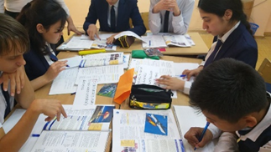

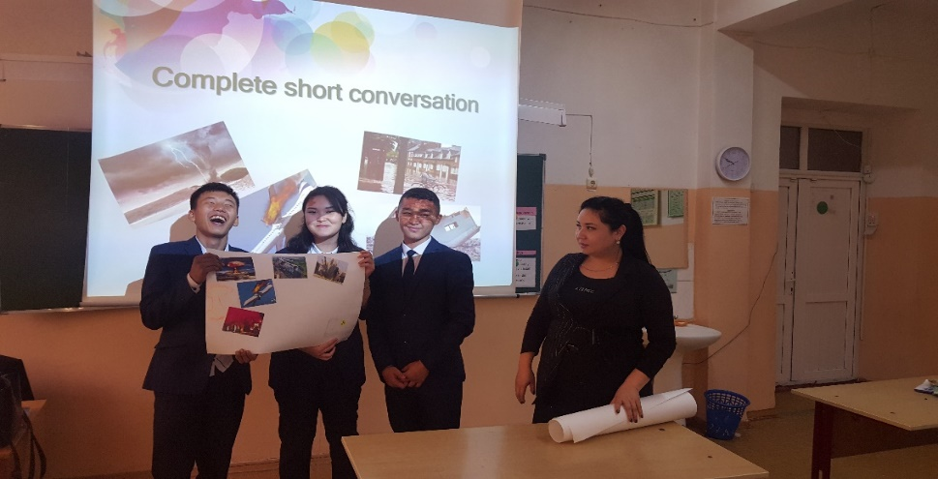

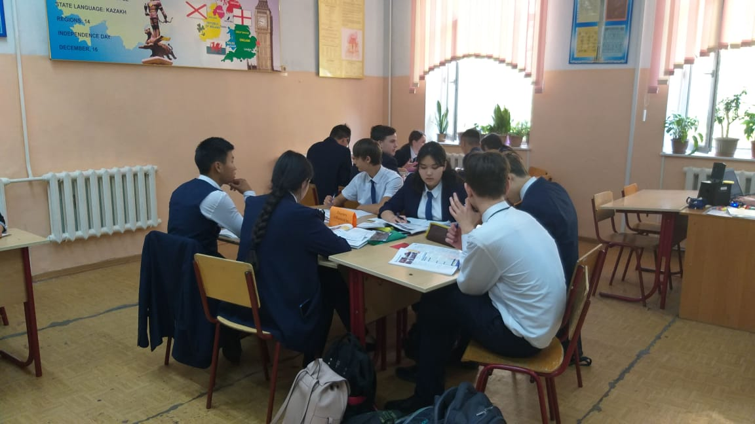 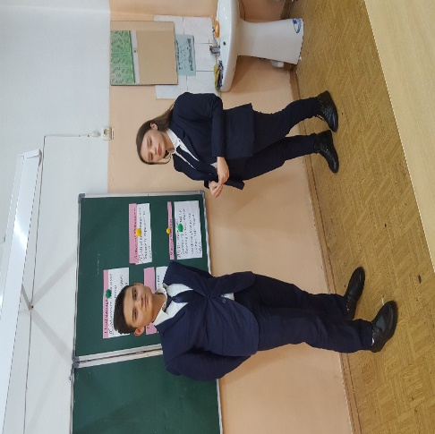

**Comprehensive school №74**

**named after S.Seifullin**

**The open lesson**

**The theme:**

**«Prediction and prevention of natural disasters»**



**Prepared by: Smagulova D.A**

**Almaty 2019.**