Plan for the lesson

Week 4 | Grade 6 Б | Lesson 5 | English
The theme of the lesson Holidays
Taking programme | Methodical programme
The aims of the lesson | * Educational: To introduce students with a new material about holidays and to travel by some transports  Consolidation of all learnt materials (past simple).  To enrich student`s knowledge concerning the theme.  * Development: To develop understanding, logical thinking & students abilities in speech.  To control the student`s speaking without mistakes, help them to make conclusions.  - Upbringing: To be carefully when they relax somewhere, to teach friendly and to work with group and to help each other.
The result of the lesson for the teacher | - Pupils can learn new words with meaning without any mistakes ;  - To work with group and to listen each other;  - They can discuss their opinion themselves.
The main idea of the lesson | They can take more information about holidays
1-action Dividing into groups At the break time they go out and when it `s time I give them tickets for the three transports they are for planes, for the trains and for the ferry, so they take it and stand their places also their chairs has sticked pictures which are the planes, trains and ferry 1 minute  2-action Warming-up (1 minute)  - Phsychological action in the class  There are pictures of the weather in the corner and they choose one of them after that I see their mood 1 minute  3-action I ask from pupils that what kind of rules we need save in our lesson. They say own opinions after that I introduce pupils with a gold rule pupils have to keep these rules. It `s on the blackboard, they read rules loudly one by one.  2 minutes  4-action Evaluation card Each group choose their group leader and I `ll give evaluation paper and different flowers as evaluation themselves.At the end of the lesson we will count them and define which group is winner. 2 minutes  5- action Checking-up the home task.  Exercise-7 page-29 from student`s book Complete the sentences with the past simple of verbs in exercise-6  1 Walter walked from Dover to Calais.  2 Columbus …. Across the Atlantic.  3 Phineas Fogg …. Around the world in eighty days.  4 Romeo and Juliet …. In a city called Verona.  5 When Seb was at sea, he… a special telephone.  Correct answers: sailed, travelled, lived, used, walked  3 minutes  6-action New Theme before this theme I ask some questions from pupils which they can find the theme How do you think why we stick oyui on our jacket and why we divided into three groups by transports and do you remember I have given ticket at the begining of the lesson Why? Do you have any idea? 2 minutes  7-action Evaluation card  I give evaluation card to the leader pupil, because leaders put their marks for every task after lesson so pupils put formative assessment I will put summative assesment.1 minute  8-action Exercise-1 page-30 Listen and say the words. Find the things in the photos. Which things aren`t in the photos?  I`will give the words to each pupil and they will write at home in their copybook.2 minutes  9-action Exercise -2 page-30 Close your book and listen to Matt`s story.What was Matt`s sleeping bag?  After reading text I will ask some question.  Where do they go in the summer? Where do they get?  Did he scare? What did his parents say? 5-minutes  10-action Role play  There are three things in the classroom. There are rucksack, sleeping bag and things for the campsite. They choose one of them and role play with the things how can we use and when or why like these etc. 5 minutes  11-action Group work Pupils find the words with these functions and they stick on the blackboard with the letters. 5-minutes  Find this word with these functions:  -‘see’ the first letter of this word;  -the first letter of the transcription word ‘ие болу, бар болу’  -we can eat …ce-cream  -the first letter of the word ‘pen’  Find this word with these functions:  - the first letter of the verb ‘be’  - we can eat …gg  - red and green and yellow, it`s fruit we can eat, the first letter of it.  - the last two letters of the verb ‘catch’  Find this word with these functions:  -the first letter of this verb ’have’  -‘dog’ in the middle letter of this word  -we can drink …ea  -we can eat …gg  -the first letter of the verb’learn’  Method of the To play tennis  Pupils throw the tennis ball and catch it but they say irregular verb at the same time. 3-minutes  Work with the interactive blackboard  This exercise is taken from the text www.bilim land it`s concepts of the grammar past simple 6-minutes  Method of the journalist. One pupil will be journalist and ask some question according the theme Holiday for example What can you say about holiday? Where do you want to travel? Do you like campsite? What do you take to the caravan? 3-minutes  Conclude the lesson. Method of the theme bottle  There are some words and pupils read them and put the next bottle  Reflection Pupils write about their opinion and stick on the blackboard. 2-minutes |  | Pupils take tickets and stand in their group.  I group is Plane  II group is Trane  III group is Ferry        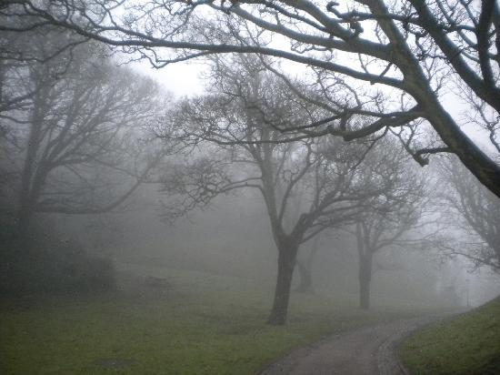  There are following way : A gold rule  To keep silent;  To respect each other;  To try to speak English;  To speak politely;  Don`t argue each other;  Don`t interrupt;    Pupils read correct answers and they change their copybook with each other and check it, put marks  Without any mistake-5  One mistake-4  Two or three mistakes-3  Pupils find it the theme is HOLIDAYS  Names of pupil Checking-up the home task Answer the questions Role play Do the exercise Method of the stick Irregular verb “To play tennis”  New words  beach-[bi:tʃ]-теңіз жағасы  caravan- [`kærəvən]-керуен  tent- [tent]-шатыр  campsite- [kæmpsáit]-лагерь  ferry- [`feri]-паром  sleeping bag- [`sli:piŋ bæg]-ұйықтайтын қап  rucksack-[`ruksæk]-қоржын, рюкзак  Pupils can answer the questions according to the text.  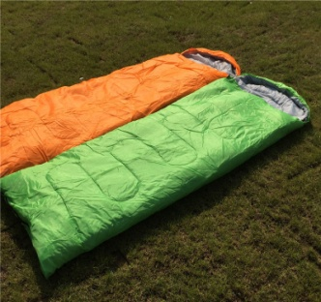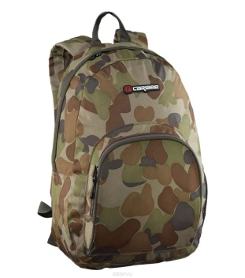  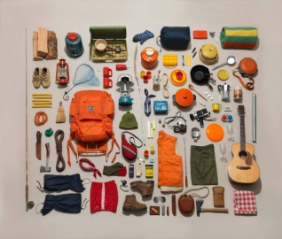  Pupils work with the group and fin the words and stick them.  To be-was/were/been  To run/ran/run  To cut/cut/cut  To come/came/come etc  Pupils have to on their copybook and after that we check together.  Pupils take a microphone and answer it.  Campsite, caravan, sleeping bag, tent, to explain, to write, bag, pen and others.
Visual aids: Pictures, car, sleeping bag, rucksack, things for the campsite, CD, interactive blackboard and computers, stickers paper A4
Home task | Exercise-5 p-31 and work book exercises

