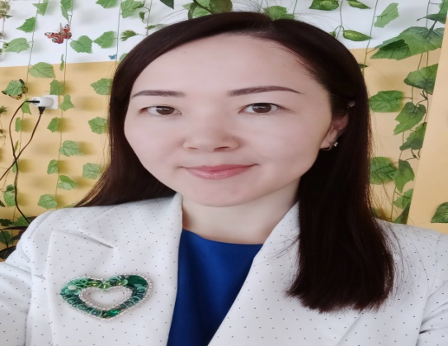

Маңғыстау облысы, Түпқараған ауданы,

Ақшұқыр мектеп-лицейінің

ағылшын тілі мұғалімі

Дәуітова Жұлдыз Өскенбайқызы

Importance of distance learning

In the 2019-2020 academic year, significant changes took place in the field of education in the Republic of Kazakhstan. One of the reasons was the worldwide outbreak of COVID-19. This epidemic, which shocked the whole world, did not pass by Kazakhstan. After this spring holiday, the educational process will continue at home, and not at school, as usual. Kazakhstan schools switched to distance learning under the leadership of the Minister of Education and Science A. Aymagambetov.

Distance learning - is carried out using information and communication technologies and telecommunications with indirect (distance) or incomplete indirect interaction of the student and teacher.

Before switching to this system, there were many questions in the minds of teachers as well as parents. However, thanks to the well-developed information technologies of our country, access to resource materials for teachers and students on the basis of Bilimland, Imektep, Daryn online, you are a pipe, and the availability of all the necessary information for the lessons seems to be the answer to these questions.

The Ministry of Education and Science has introduced this system with great training. Given all the circumstances, he was able to combine television with education to make it accessible to everyone. In particular, the lesson was broadcast on the Balapan TV channel in all regions. I think this is a great opportunity to get an education at home in the first place. Because most of us today have a television.

This required a lot of patience and skill on the part of teachers. Because it was necessary to master a new format of education and use it in raising a child. Teachers prepared lessons in various formats using their skills. Some teachers created video tutorials, while others used social media to teach the child a new topic. Teachers gain new knowledge by providing feedback, comments, and, if necessary, additional information to each child.

It should be noted that this method of raising a child first of all creates a burden for parents. Because parents had to help the child understand the information. In this case, it is clear that the role of a qualified teacher is different. However, all parents do everything possible for their child and his future. At the same time, relations between parents and teachers have become closer. Parents appreciate the work of the teacher and thank him.

Undoubtedly, the features of this school year will forever remain in memory. However, it’s not enough to give in to various emotions, explain the lesson to thirty children in front of you, discuss it and exchange ideas. I hope that we can overcome this temporary difficulty and meet with our lovely students.