Long term plan module:Unit 2 Communication and Technology  Lesson:Social network profile |  |  | School: Abylai khan secondary school
Date 09/10/18 |  |  | Teacher’s name: Raymbekova S
Class: 7в |  |  | Number of present: |  | Absent:
Learning objective(s) that this lesson is contributing to: |  | 1.7 .R1Understand the main points in the texts on a limited range of unfamiliar general and curriculum topics.  2.7 C7. Develop and sustain a consistent argument when speaking and writing.  7.C2 use speaking and reading skills to provide sensitive feedback to peers
Level of thinking skills |  | Knowledge  Understanding  Application
Lesson objectives: |  | All learners will be able to: read the text and understand the main point in the text ;  recognize new words in the given sentences;
 |  | Most learners will be able to: express their opinion about Social network profile.
 |  | Some learners will be able to: make up doing according to the task .
Assessment criteria |  | read the text and understand the meaning  understand the meaning of new words;  say own opinion about Social networking profiles use modal verb Should
Value links |  | Values of the national idea “Mangilik Yel” - economic growth based on industrialization and innovation.
Cross-curriсular link |  | Computer Science
Previous learning |  | Social networking websites. Modal verb.
Plan
Planned timing | Planned activities |  |  |  |  | Resources
Start (Beginning  of the lesson)  5 min | Greeting: Teacher greets with learners; Ask about weather and date.  Check homework with game “Football”. Teacher divide learners in 2 group. Then learners read their sentences. If sentences right, they give point.  LEAD IN :  Teacher to show video about social network and ask questions  What is your favorite social network?  What social network is popular in Kazakhstan?  Then check vocabulary about internet with showing PPT slide |  |  |  |  | Interactive board  PPT
Middle ( of the lesson)  5 min  5 min  10 min  - min  10 min | Task 1. Teacher explain grammar modal verbs Should and Should not.  Show how we use modal verb? PPT. Write in your copy book.  I should (should not/shouldn’t) We should (should not/shouldn’t)  You should (should not/shouldn’t) You should (should not/shouldn’t)  He/She/It should (should not/shouldn’t) They should (should not/shouldn’t)  Task2 Listen and repeat after teacher  Advantages and Disdvantages the internet  - Use save websites  - To create webpage  - To send messages  - To chat with friends  - To post email, comments, a video, a photo  - Download information in which we need  - Study online  - Create STRONG PASSWORD  - Be careful with what you share  - give bad comments  - Using the Internet for many hours  - Visiting dangerous sites  - To spend all day online on social networks  - Never give strangers your personal information  - to meet online friends  Task 3 Read the sentences on the worksheet presented by your teacher and write them in the correct column with modal verbs  SHOULD and SHOULD not: Pair work  ADVANTAGES OF THE INTERNET DISADVANTAGES OF THE INTERNET  SHOULD 1 Use save websites 2 To create webpage 3 To send messages 4 To chat with friends 5 To post email, comments, a video, a photo 6 Download information in which we need 7 Study online 8 Create STRONG PASSWORD 9 Be careful with what you share SHOULD not 1 give bad comments 2 Using the Internet for many hours 3 Visiting dangerous sites 4 To spend all day online on social networks 5 Never give strangers your personal information 6 to meet online friends  Descriptor:  1. write words in correct column  2 Understand how to use modal verb Should  Task 4. Group work  Read about Kenta Suzuki and Megan McDonald.  Mark the sentences TRUE and FALSE  1) Kenta is from Australia. False  2) Megan is older than Kenta. False  3) Megan likes water sports. True  4) Kenta's got blond hair and dark brown eyes. False  5) Both Kenta and Megan like karate. False  6) Kenta likes playing soccer. True  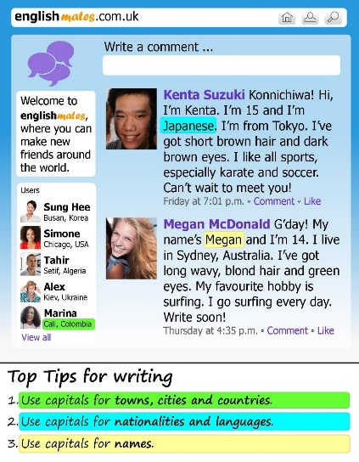  Descriptor:  1.A learner understanding the text  2.A learner can work with group  Task 5 Write a comment about yourself and read  Descriptor:  1. can write about yourself  2 Use correct vocabulary |  |  |  |  | PPT  Slide with photos of new words  Worksheet  Worksheet
End (of the lesson)  5 min | Do you know about pluses and minuses of social internet?  Giving homework: create your webpage  Feedback  I need a lot of help. I need a little help. I understand everything  Core i3 Core i5 Core i7   |  |  |  |  | Give  stickers
Additional information:
Differentiation - how do you plan to give more support? How do you plan to challenge the more able learners? |  | Assessment - how are you planning to check learners’ learning? |  | Cross – curricular links safety  health and  check ICT links  Values links
Less able learners :  -Giving students more support and direction.  -Using different form of grouping in the classroom.  -Using different resourses.  More able learners:  -Students work in small group for a few minutes to make and answer questions.  -Get help from others  -Allow additional space to answer question on work sheet |  | Concept checking;  Feedback on the work;  Assessment sheet |  | Computer.  Work with smart board not more  then 10 minutes.  Make short breaks.
Reflection
Were the lesson objectives / learning objectives realistic?
What did the learners learn today?
What was the learning atmosphere like?
Did my planned differentiation work well?
Did I stick to timings? What changes did I make from my plan and why?
Summary evaluation
What two things went really well (consider both teaching and learning)?
1.
2.
What two things would have improved the lessons (consider both teachings and learning)?
1.
2.
What have learned from his lesson about this lesson about the class or individuals that will inform my next lesson?

